Hello, my name is Betul.
I’ve got something really interesting to ask you. I am doing a research study, and I want children like you to be a part of it. It's all about understanding pain and how it makes you feel.
Take a moment to read this and talk to your family, friends, or doctor if you have questions. You can ask us if something isn't clear. You can decide if you want to join in.

What is the research about?
We are trying to make things better for children who've had cancer. Sometimes they feel pain, and we want to help them. We're creating a special online place where carers and children can learn about managing pain together.

Why did we ask you?
You know about cancer pain. Your thoughts and feelings are important, and we would love to learn from you!

Do you have to join in?

No, you do not; it is your choice. If you decide to join but later change your mind, just tell your parents or carers you do not wish to continue.

What will I have to do if I join in?

You and your parent or carer will meet me online to talk about the study and check you are happy to take part. Then, you will create a piece of art (more about that in the next box) and you will come along to an online group to talk to the researcher with your parent or carer. In the group there will be other children like you and their parents or carers. I will be asking you to share your thoughts about pain and what your art tells us. If you prefer not to talk about your pain and art in a group we can have an online meeting with just me, you, and your parent or carer.

What sort of art?
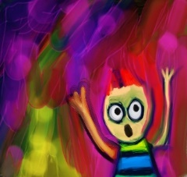 | Now, here's the fun part! I want you to create something that shows how pain makes you feel. It can be any sort of art you like. You can paint, draw, take photos, write poems, or make something from clay or wool or mud.  You will have two weeks to complete your art after our first meeting.  When you completed your art, your mom, dad, or carer will send us a picture or video.

What might be hard about taking part?
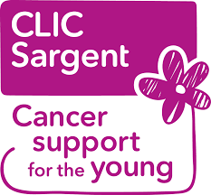 | Sometimes talking about pain is hard. But if you need a break or want to stop, that is okay. We are here to help. If you are really upset, we can suggest places where you can get support, like CLIC Sargent or Childline.  You also can call 0800 1111. You could also speak to me, Betul Bay.
What are the good things about joining in?
Some children like join in research because they know it will help children in the future. Also talking about how your experiences can sometimes help make it a little better.

What will happen when the study ends?
After the study stops, you will continue to get the same help from your healthcare professionals. We will also tell you what we found out in a special newsletter.

What will happen to the information you collect about me?
All the information you tell us will be kept private. Your name will be replaced by a number on the documents we keep about you so that you cannot be identified from them.

Who is asking you to take part?
I am Betul BAY, a PhD student at the University of Birmingham. I am interested in knowing more about your experiences of pain after cancer.

Ask your parent or carer if you would like to know more about the research.

You may also speak with me, Betul Bay. You will need permission from your carer to do this though.
Telephone number: 07470 587 311
Email address: bxb179@student.bham.ac.uk

THANK YOU for reading this leaflet!

