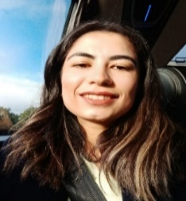
Hello, my name is Betul.
I am studying for a PhD at the University of Birmingham because I want to improve cancer pain management for children and young people. I am being supported by a team of researchers whose details are at the end of this information sheet.
I would like to invite you to take part our research study which help designing of a home-based online platform for pain assessment and management for children and young people who have cancer pain, and their parents or carers.
We want to help improve pain management at home in the UK for children and young people who have any type of cancer pain.
Before you decide if you would like to take part, please read this information carefully and talk to your parent or carer about the study. Ask us if there is anything that is not clear or if you want to know more.

What is the research study about?
The study is about your experiences of pain after cancer. We would like you to help us and share your pain experience after the cancer. Therefore, that we can improve the care for all children/young people with cancer pain, like yours. We are going to use the information we collect from you and your parents or carers to design a digital resource that can provide advice and help for managing pain at home.
Why have I been invited?
You have been chosen because you have now or have in the past had cancer pain.
How will taking part help me?

The study will help us to know more about children who experience pain and what we can do to help them. It will take a number of years to collect the data we need and to design and build the resource. In the meantime, it can be helpful for some people to talk through their experiences.
What will happen if I take part?
We will ask you to sign a form to record that you have chosen to take part and that you understand what taking part involves.
We will ask you to create a piece of art that represents how you feel about your cancer pain. You will have two weeks to do this from our first meeting.
The art can be any format you like – poetry, video, painting, drawing, sculpture, photographs, collage, music – anything you like. Once it is completed your parent or carer will send an image or file to me at the University of Birmingham.
Once you have completed your artwork, we will invite you and your parent or carer to come to an online group with other people who are taking part in the study. I will ask you to describe your work and talk about what it represents. You can choose whether you want to show your work to the others in the group. If you do not want to come to the group we could have an online call between you, your parent or carer and me instead.
You can choose whether you want to come to a second group meeting, or have a second interview, to talk about how we can use what we have learned to create a digital resource to help others like you and your parents or carers.

Do I have to take part?
No, you do not; it is your choice if you would like to take part. If you decide to take part but later change your mind, just tell your parents or carers you do not wish to take part anymore. Your parents or carers will then tell the researchers.
Are there any risks in taking part?
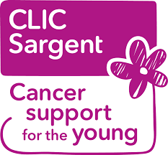
We do not believe so. However, some people can become upset when talking about their cancer and pain. If you become upset in an interview or group meeting, we can pause and have a private talk about whether you need a break, and whether you want to continue. You will probably have contacts who are providing you with support and you should use those if you need them.
What will happen to the information I share and my artwork?
You will keep your original artwork and can do whatever you like with it. We would like to use an image of some of the art we collect in publications or conference presentations when we tell other people what we have learned. You can choose whether you will allow us to use your art in this way.
We will record the group meetings or interviews and use them to create a written transcript that we can analyse. Once we have created the transcript, we will delete the audio and video files. All the data from this study will be in secure storage at the University of Birmingham and can only be accessed by members of the research team.
Although we collect information about your name, age, and gender (we call this identifiable information), you are given a unique identifier for the study so that you remain anonymous except to Betul.
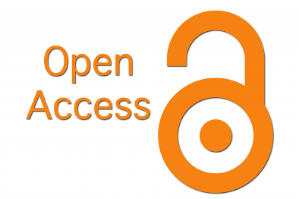
The information we gather during this study might be shared in a place called an "open access data repository." This is like a big library where researchers and even the public can go to learn from the information we collect. This helps us all learn more and work together better. We will not share provide any identifiable information with that repository. You can choose whether to allow us to share your data in this way.
We will share our findings with you and with anyone else we think will benefit. You would always be anonymous in any materials we use to publicise what we have found out.
What happens when the study is complete?
Your care should carry on as normal during and after the study. Although it will take quite a long time, we will share with you what we learn. We also aim to build, test, and release the digital resource. You can choose to be part of that process.
If you are interested in taking part, we will talk together online and there will be a chance for you to ask questions. If you want more information in the meantime, you can contact me by email or ‘phone but please let your parent or carer know you are doing this.
Thank you for taking the time to read this information.
Chief investigator
Betul Bay
Bxb179@student.bham.ac.uk
07470 587 311
Supervisors
Dr Amelia Swift
a.swift@bham.ac.uk
Dr Susan Neilson
s.j.neilson@bham.ac.uk
Dr Lucy Kelsall-Knight
l.m.kelsall-knight@bham.ac.uk
Dr Alison Twycross
a.m.twycross@bham.ac.uk

