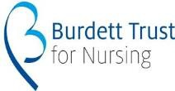
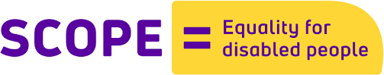
Participant Eligibility Form (for women)
eternal: healthcare for girls and women with cerebral palsy across the life course

Thank you for providing this information. No detail from this form will be shared with anyone outside of the research team and will not be linked to your participant details. It merely helps us to gain as broad a sample as possible so that we obtain a broad range of voices of girls and women with CP.

What year were you born?
Where do you live now?
Type of cerebral palsy (ref: scope.org.uk) (Please tick) | Hemiplegia (1 side of the body affected)
 | Monoplegia (1 limb affected)
 | Diplegia (2 limbs affected)
 | Quadriplegia (4 limbs affected)
What are the effects of your impairment? (Tick all that apply) | Mobility
 | Cognitive
 | Speech
 | Co-ordination
 | Other, please state
How would you describe your ethnicity?
(e.g. White British, Indian, Polish)
How do you describe your gender identity?  (Please tick) | Male
 | Female
 | Transgender
Other, please state:
…………………………………………...
Do you have children? | Yes
 | No

Can you communicate in English? | Yes  No

To be completed by research team. Participant Number ------------------------------------------------------

