<<INSERT TRUST LETTER HEAD>>

The SLEEP T2D Study
The Impact of Sleep Disorders in Patients with Type 2 Diabetes: A Cohort Study and Feasibility RCT
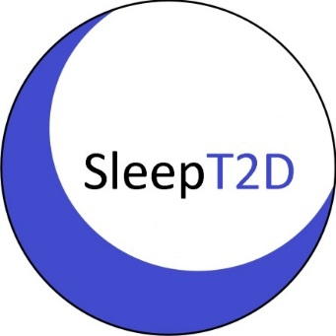

SUPPLEMENT
PATIENT INFORMATION SHEET

Patients with OSA who have 10 or more breath holds per hour of sleep and do not have sleepiness

Why have I been invited?
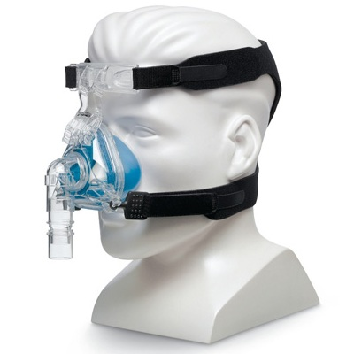
Above: nasal mask
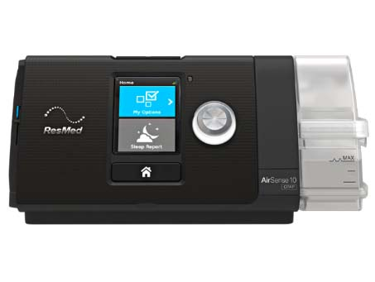
Above: CPAP machine
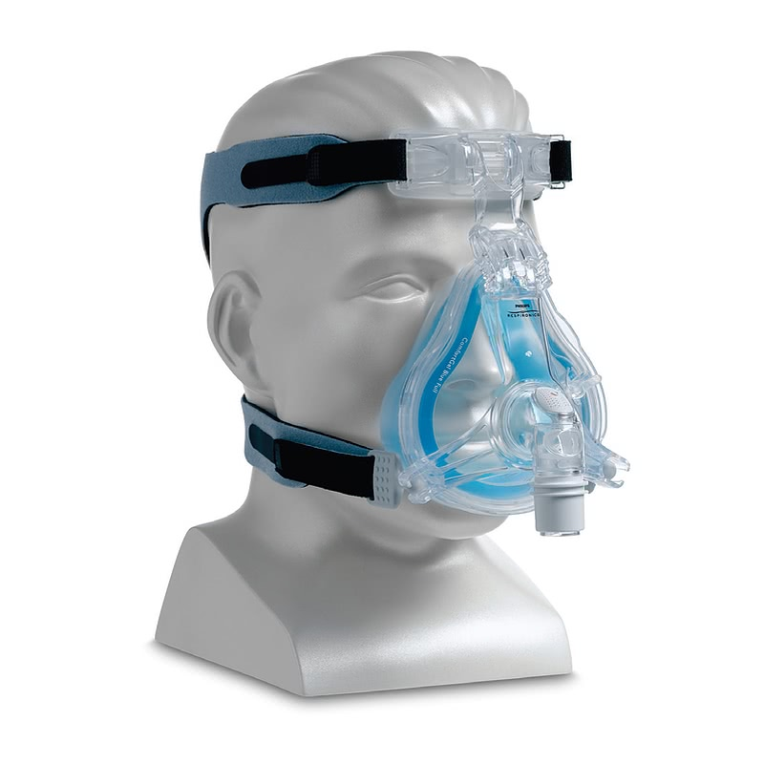Above: Full-face mask.
Illustrative purposes only, the masks used may differ
Based on the results of your study tests, you have been found to have Obstructive Sleep Apnoea (OSA) with 10 or more breath holds per hour of sleep but no sleepiness.

OSA can be treated using continuous positive airway pressure (CPAP). CPAP is a small device that delivers air at low pressure through a mask while you sleep. It keeps your airways open and prevents blockages happening whilst you are asleep.

Two examples of CPAP masks are shown on the right, with the device they connect to.

To benefit from CPAP, you need to use it for at least four hours per night. CPAP treatment has been shown to improve snoring, sleep quality, tiredness, blood pressure and quality of life.

We would like to invite you to join a part of the SLEEP T2D study comparing treatment with CPAP to no treatment for OSA.

This will help us test whether:
- Patients are more likely to use CPAP correctly if they get a higher level of support than normally given by the NHS.

- Treatment with CPAP has an impact on the risk of developing diabetes-related nerve, kidney and eye complications.

Do I have to take part?
No. Even though you have already agreed to take part in the SLEEP T2D study, you do not need to participate in this part of the study – it is up to you.

What will happen to me if I take part?
A member of the study team will contact you to explain the results of your sleep test. You will also have the chance to discuss them with the Sleep Technician and a doctor.

Then, if you are interested in taking part we will ask you to sign another consent form for this part of the study. This may be done either by post or in person at another hospital visit. You can withdraw from part or all of the study at any time, without giving a reason and without it affecting your medical care.

Sometimes we don’t know which way of treating patients is best. To find out, we compare treatments by putting patients into groups with each receiving a different treatment.

A computer will decide at random (like tossing a coin) which group you will go into. Half of the people taking part will go in the ‘CPAP group’ and the other half will go in the ‘no treatment group’.

If you are allocated to receive CPAP, study staff will explain how to use the equipment and will take measurements to see which mask will be most suitable for you. With your permission, we will provide your address, in confidence, to the trial organisers at the University of Birmingham and to an external company called ResMed so we can arrange to give you the CPAP equipment.

You will also be given instructions and helpline contact details. The Sleep Technician can also provide support and guidance (contact details are at the end of this leaflet).

If you are allocated to the ‘no treatment’ group you will receive no additional treatment unless it’s needed, and you will be able to contact us at any point during the study.

How many visits are there and how long will it take?
We want to minimise your hospital visits by doing most of the follow-up by telephone. We will call you at 6, 12, and 18 months with each telephone call lasting up to 30 minutes. The final study visit, at two years, will take place at your local research centre.

Taking part in this part of the study will not mean you have more phone calls, questionnaires or visits to do than if you only did the main part of the study.

**For patients allocated to treatment with CPAP**
As well as the telephone follow-up, if you are given treatment with CPAP, the research team will call you regularly for the first week after delivery of the equipment. This is to help you set up the CPAP equipment and to let you ask any questions.

Information on treatment (e.g. how many hours you use it each night) will be sent automatically using a network similar to what is used in mobile telephones. No identifiable data will be sent.

If you are not able to use the CPAP equipment for at least four hours per night (or have any other problems, such as equipment failure), you will be offered further support from the Sleep Technician. This support will be given in person (at the local research centre or your home) or by telephone, depending on what is most suitable for you.

When the study ends and if you still need CPAP treatment, we will arrange for you to keep using the CPAP device until normal NHS treatment can begin.

Are there any benefits to taking part?
Although there may be no direct benefit to you, we hope that this extra part of the study will benefit all patients with type 2 diabetes and OSA in the future. You may receive CPAP treatment with the best possible level of care.

What are the possible disadvantages and risks of taking part?
If you are allocated to receive treatment with CPAP treatment you may experience some side effects such as a dry mouth, or you may feel a little uncomfortable whilst wearing the mask. CPAP can sometimes take a little getting used to but the equipment we will provide you with will include a humidifier (a device that increases moisture in the air) and different sized masks to minimise any discomfort.

If you become pregnant during the study, CPAP treatment is not a risk to your pregnancy, but you should tell the study team so they can decide if any different treatment might be needed.

You should also tell the study team even if you are not allocated to CPAP treatment.

What happens when the research study stops?
After the study finishes, with your permission, we will write to your GP and ask them to refer you to your local NHS Sleep Clinic and they will manage your care.

What alternative treatments are available?
The NHS recommends weight loss for some patients who have been diagnosed with OSA and they also offer treatment with CPAP to patients with OSA who fulfil certain criteria.

If you would be eligible for treatment with CPAP as part of normal NHS care you will be informed of this and referred to the appropriate service – you will not be eligible to be randomised to CPAP or no intervention, but you may stay in the Sleep T2D study.

What will happen if I no longer want to take part?
You can withdraw from this part of the study, or the study as whole, at any time without giving a reason and this won’t affect the standard of care that you receive. Information collected until your withdrawal may still be used. Any stored blood or tissue samples that can still be identified as yours can be destroyed if you wish.

Will my CPAP treatment details be kept confidential?
As part of this study, we are using an online application called Airview which lets us monitor your CPAP treatment from a distance.
AirView is operated by a provider specialised in handling health data (currently Informatique de Securité SAS, Montceau-les-Mines, France), who ensure compliance with the EU General Data Protection Regulation 2018.
Data collected by AirView are used for our research and include the length of time the devices are used, leakage figures, pressure values and the severity of sleep apnoea, and these data are transmitted to AirView in encrypted form. The device is identified by the serial number; no personal data such as your name or address are sent. The data which has been transmitted can only be linked to you personally by the research team.
ResMed, the company that run the AirView system, will not have access to your data.
In AirView, the data is transferred in encrypted form either via a mobile communications network or online by the research team.
By giving consent, you agree to your data being transmitted, processed and used in AirView. If you want to revoke this consent, you can do so at any time without stating the reasons. To do that, please contact us in writing.
You also have other rights in relation to the data held on AirView, for example to see what information is held about you, to be informed how your data is being processed, to rectify any data held about you, to erase the data in certain circumstances and to object to its being used in certain circumstances. To do so, please contact us in writing.
Who else is taking part?
We aim to include 140 patients with OSA who have more than 10 breath holds per hour of sleep and do not have sleepiness in this part of the study.

Thank you for taking the time to read this information sheet and for considering taking part in this research project.

Should you require further information please do not hesitate to contact us using the contact details set out below. You can also contact us to find out what information we hold about you, to be informed at any time how your data is being processed, to rectify any data held about you, to erase the data in certain circumstances, and to object to its being used in certain circumstances.

If you have any questions, please contact <<INSERT LOCAL CONTACT DETAILS>> on:
Phone: <<INSERT LOCAL CONTACT DETAILS>>.
Email: <<INSERT LOCAL CONTACT DETAILS>>.

Sleep Technician: <<INSERT SLEEP TECHNICIAN DETAILS>>.

The study is funded by the National Institute for Health Research Clinician Scientist programme (project reference NIHR-CS-2013-13-029). The views expressed in this publication are those of the authors and not necessarily those of the NIHR, NHS, or the Department of Health.

