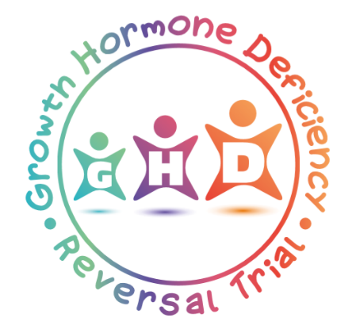

Would you like to take part in our research study for children and young people whose Growth Hormone Deficiency (GHD) has reversed?
What is the study all about?
Have you been diagnosed with GHD, and could you be producing a normal amount of growth hormone now?
If so, you could be one of many young people taking part in the GHD Reversal study.
The GHD Reversal study is investigating whether young people make enough growth hormone on their own as they enter puberty. This could stop the need for daily injections of growth hormone. All children in the study will be very carefully monitored.😊
How do I get more Information ?
You can contact your own doctor directly or the GHD Reversal Trial Office, at the Birmingham Clinical Trials Unit, University of Birmingham, B15 2TT.
Email: GHDReversal@trials.bham.ac.uk.
Website: www.birmingham.ac.uk/GHD

