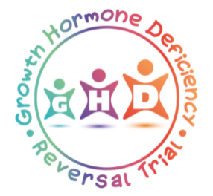
CONTACT DETAILS FORM: PARENTS/CARERS

The Growth Hormone Deficiency Reversal Trial: QualitativE Study

PARTICIPANT RESEARCH INTERVIEWS

Please provide the details requested below and indicate your preferred method of contact so that a member of the research team can get in touch to give you further information about the research interviews for the GHD Reversal Trial Qualitative study. Filling in this form does not mean that you or your child have to take part in an interview.

Contact Details
First Name
Surname
Home Phone/Mobile Phone Number
Email Address

Please indicate your preferred method of contact (Tick all preferred methods)
Phone call Email Text VOIP (e.g. FaceTime)

By completing and signing this form you are giving permission to be contacted by a member of the GHD Reversal Trial research team based at the University of Birmingham.

Signature: ..................................................................................................................................................................

Date: ..................................................................................................................................................................

Please see page 2

Recruiting Clinician Name
Recruiting Clinical Contact Details | Tel: | Email:
Recruiting Site

Thank you for taking the time to complete this form. Please give this form back to the person that gave it to you. If you have any questions about taking part in this research, please contact us at:
GHDReversal@trials.bham.ac.uk or call [insert name] on [insert tel. no.]
CONFIDENTIAL WHEN COMPLETED

