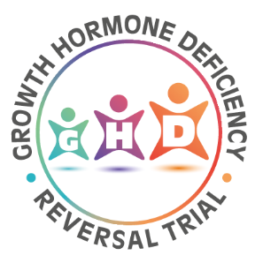

Insert Trust Logo

Participant Identification Number:

ASSENT FORM – Young People (under 16 years) – Audio and Contact

Title of Project: The Growth Hormone Deficiency Reversal Trial: Qualitative Study

IRAS ID: 281209

Name of Researcher:

- This study has 2 parts. Please show which ones you want to do by putting your initials in the boxes.

Part A: I agree that you can audio-record the conversation that the doctors and nurses
have with me about taking part in the GHD trial

Part B: I agree that you can send my family and me some information about taking part in
an interview

- Please put your initials in the boxes below to say that you understand:

- I understand the information that I have been given about this study. I have thought about it and have had my questions answered.
- I understand that taking part is my choice. I can leave the study if I want to (until the researcher starts to look at everyone’s information together). I do not have to tell you why I want to leave.
- I understand that my information will be kept private unless I am in danger or someone else is. No-one will be able to tell who I am from the information and it will be kept safe.
- I understand that information from this study may be looked at by people who check research is safe and being done properly.
- I agree that the researchers can make a recording of us talking and will have it typed up by a professional company who will take my name out.
- I agree that the researchers can use some of my words (without my name) as examples when they tell others about the results of the study.
- I agree to take part in the above study.

Your name……………………………………........................................................................................

Signature, name & date of the researcher…………………………………………………………………………………………………………………….

Action: File original in site file Give a copy to the participant

