TO BE PRINTED ON LOCAL TRUST HEADED PAPER

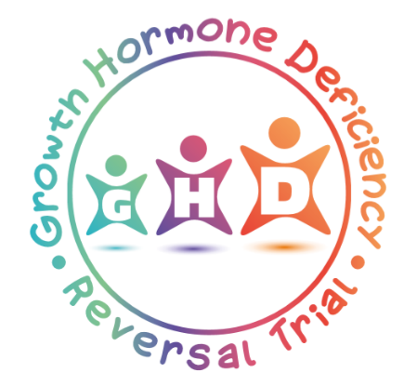

The Growth Hormone Deficiency Reversal Trial

Participant Information Sheet

For young people aged 8-10 years

We would like to invite you to take part in our research study .

Why have I been asked to take part and why is this project being done?
We are asking for your help to find out if people who have GHD need to continue taking medicine to help them grow.

What will happen to me if I take part in the research?
Your doctors will test you to find out if your body is making enough growth hormone on its own.

After this you will be put into one of two groups. One group will stop taking growth hormone medication, the other group will continue to take growth hormone medication. The group that you are put into is chosen by chance by a computer.

Just like when you go to hospital for your GHD check-ups, doctors and nurses will measure your height and weight, and they will take a blood sample from you.

Your doctors will also do an X-ray of your hand, and you will also be asked to fill in a short form.

After this you will go to hospital every 6 months for check-ups, like you usually would for your GHD check-ups. At these check-ups your height and weight will be measured, a blood sample will be taken from you, and you will be asked to fill in the short form again. At the end of the study your doctors will do another X-ray of your hand.

We will also collect other details about you, for example medicines that you have taken and other visits that you may have had to your GP or to hospital.

Your doctors will keep an eye on you the whole time that you are in the study to make sure that everything is safe.

If you don’t want to take part in the study, you will be treated by your doctors like normal.

How will joining affect me?
We cannot promise that the study will help you but the information we get might help other people with GHD in the future.

If you do want to take part in the study, you will either be in the group that stops growth hormone medication or the group that continues growth hormone medication. If you are in the group that stops taking growth hormone medication, your doctors will keep an eye on your height and if it looks like you might not be growing enough, they will re-start your growth hormone medication.

Do I have to take part?
You do not have to take part in this research study. It is up to you! If you decide that you do not want to take part, you will still get the best treatment from your doctor. If you take part, you can change your mind and stop at any time!

What if I don’t want to do the research anymore?
If you don’t want to do the research anymore, just tell your parents, doctor or nurse. They will not be cross with you . Your doctor will help you decide what treatment is best for you afterwards.

Did anyone else check the study is okay to do?
Before any research goes ahead it has to be checked by a Research Ethics Committee. They make sure that the research is fair. This study has been checked by Wales Research Ethics Committee 3 (Wales REC 3).

If you agree to enter this study then you may be asked to sign a form to say that you agree along with your mum, or your dad, or your legal representative and you can keep a copy of this information sheet.

Thank you for reading this!

