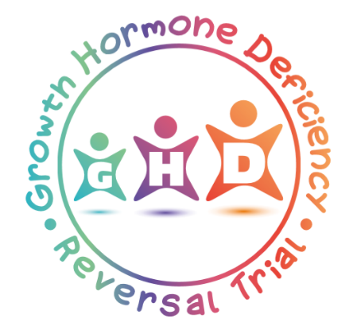

Participant Information Sheet

For young people aged 11-15 years

The Growth Hormone Deficiency Reversal Trial
We would like to invite you to take part in our research study

- Invitation and brief summary
Our study is about young people who have been diagnosed with Growth Hormone Deficiency (GHD) and who are taking growth hormone medication to help them to grow. When these children start puberty, we think their bodies may make enough growth hormone naturally, so they may not need to take growth hormone medication to help them grow anymore.
It is entirely up to you if you want to take part in the study .

- Why are we doing the study?
Growth hormone is a chemical that is made in the body naturally and it helps people to grow. Some young people with GHD start to make a ‘normal’ amount of growth hormone on their own when they start puberty. This means they might not need the daily injections of growth hormone to continue to grow.
If our research shows that young people make enough growth hormone on their own to carry on growing without growth hormone injections, it would be very important. It will stop them from needing to have daily injections and could stop them from taking a medicine that they don’t need.
Our study will involve 138 young people from hospitals in the UK and Austria who have been diagnosed with GHD, but who are now producing a normal amount of growth hormone on their own.
- Why have I been chosen?
You have been asked to take part in this study as you have been diagnosed with GHD. A recent test has shown that you are now making a normal amount of growth hormone on your own. This means that you might be producing enough growth hormone to reach your final height without needing any more growth hormone medication.

- What would I have to do?
If you want to take part in our study you will be put into one of two groups. One group will stop taking their growth hormone injections. The other group will carry on taking their growth hormone injections. The group that you are put into is randomly chosen by a computer.
In a similar way as when you go to hospital for your regular GHD checkups, your height and weight will be measured and a blood sample approximately 5 ml (about 1 teaspoon) will be taken. To make sure that we measure your height as accurately as possible, you will be measured at least 3 times at each appointment. You will be asked to fill in a short form to let us know how you feel on the day. We will also do an X-ray of your hand. This will be used to tell us about your bone growth.
After this, you will have your regular visits to your hospital every 6 months, during which your height and weight will be measured, a blood sample will be taken from you, and you will be asked to fill in the short form again. We will also collect other details about you, for example medicines that you have taken and other visits that you may have had to your GP or to hospital. Your doctors will keep an eye on your growth until you reach your near ‘final height’. When you get to this point you will have another hand X-ray to measure your bone age. This is one more X-ray than you would usually have.
If you are in the group that has stopped taking growth hormone and your doctors find that you are growing slowly you will have another growth hormone test. If this test shows that you are not making enough growth hormone then you will start your growth hormone injections again. If your doctor feels that you need to restart growth hormone for any other reason, you will be able to do this.
We think that most people will be in the study for around three years depending on the amount they grow.

- How will joining affect me?
You might not get any benefit from taking part in the study. However, the information that we get from the study might help us to improve how doctors treat young people with growth hormone deficiency in the future.
If you do want to take part in the study, you will either be in the group that stops growth hormone medication or the group that continues growth hormone medication. If you are in the group that stops taking growth hormone medication, your doctors will keep an eye on your height and if it looks like you might not be growing enough, they will re-start your growth hormone medication.

- Who has checked the study?
Before any research is allowed to go ahead it has to be checked by a group of people called a Research Ethics Committee. They make sure the research is safe and fair. This study has been reviewed by Wales Research Ethics Committee 3 (Wales REC 3).

- Will my information be kept private?
If you want to take part in the GHD Reversal Trial, all of the information we collect about you will be kept private. Your data will be coded so we won’t use your name to identify your data outside of the NHS.

- Involvement of your GP
If you agree to it, your GP or other doctor will be told about you taking part in the GHD Reversal Trial and we will keep them up to date about your progress.

- What if I do not want to take part?

It is entirely up to you if you want to take part in the study. You can change your mind at any point, and you do not have to give a reason why .
If you do not want to take part in the study, you can continue being treated by your doctor as normal.
If you change your mind about being in the study your doctor will talk to you about the best treatment for you going forward.

- What happens if new information becomes available?
Sometimes we get new information about the treatment being studied. If this happens your doctor will tell you and will talk to you about whether you should carry on in the study.

- What happens at the end of the study?
At the end of the study you will have another growth hormone test to see if you need to keep taking growth hormone as an adult. Your doctor will talk to you about the best treatment for you in future.

- What will happen to the results of the study?
The results and the information that we find will be published and presented at meetings. You won’t be identified in any research publications or presentations.
The research team will give you a summary of the results once the trial is finished.

- Where can I get more information?
You can contact me, [<Insert local PI name>]. I am the GHD Reversal Trial Principal Local Investigator and will reply as soon as possible.
Email: XXXXXXXXX
Phone: XXXXXX
For questions about the trial or to get more information please contact:
The GHD Reversal Trial coordinating centre is located at the Birmingham Clinical Trials Unit, Institute of Applied Health Research, University of Birmingham, B15 2TT.
Tel: 0121 415 9131,
Email: GHDReversal@trials.bham.ac.uk.

Thank you for reading this leaflet!

