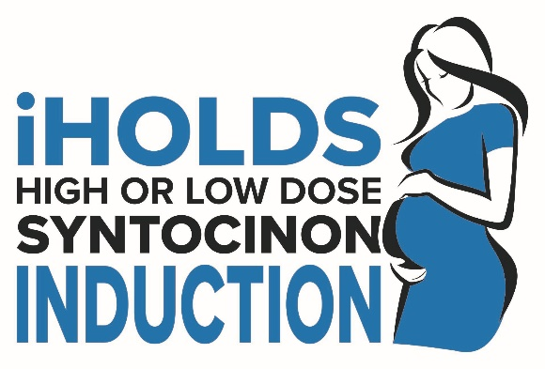

High or Low Dose Syntocinon for induction of labour

Labour Ward Manual

<Insert hospital name>
Randomisation Site Number: <add>

Your iHOLDS Principal Investigator: <add>

Your iHOLDS Midwife: <add>


Contents
(Video link attached )
Administrative Information 3
1. Summary of iHOLDS 4
2. iHOLDS Training Flow Chart 5
Delegated Duties 5
3. iHOLDS Flow Chart 6
4. Identification of Participants for iHOLDS 7
5. Suggested Phrases for discussing iHOLDS Study with Women 8
6. Who to recruit? 9
7. Responsibilities- Who can do what? 9
8. Information/Labour Pack 10
9. Obtaining Informed Consent 11
Informed Consent Form tips 12
Documentation 12
10. Trial Entry Form 13
11. Randomisation 14
12. Using the Trial Drug 15
Prescribing the Drug 15
13. Preparation of Treatment  16
Treatment Pack Stickers and Infusion/Syringe Label 17
Infusion/ Syringe label 17
14. Drug Accountability Log 18
Example of completed Drug Accountability Log 18
Damaged Ampoule 18
15. Drug storage 19
16. Temperature Deviation Reporting Process 20
17. Repeat Treatment Form 21
18. Data Completion 21
Definitions 22
Tachysystole 22
Hyperstimulation 22
Labour Form – Following Birth 22
19. Unblinding 23
20. Safety Reporting 23
Summary of Safety Monitoring and Reporting 23
Clinical Midwives Responsibilities 23
Pharmacovigilance Form 24
Any other serious adverse event 24
21. Documentation Completion Flow Chart 25
22. Withdrawal from the trial 25
23. Contact Details 26

Administrative Information
Local Site Contact Details
Research Midwife | <add>
Principal Investigator | <add>

Randomisation Line | 0800 2802 307

Trial Office Contact Details
Trial Manager | Dee Wherton
Lead Midwife | Kate Siddall
Email address | iHOLDS@trials.bham.ac.uk
Telephone number | Trial Office: 0121 415 8298, Lead Midwife: 07816 363 582
Trial website | https://www.birmingham.ac.uk/iHOLDS
Trial social media | Twitter: @iHOLDSTrial

Reference Numbers
Trial name | iHOLDS
EudraCT number | 2020-004387-26

Trial Organisation
Sponsor | Birmingham Women’s and Children’s NHS Foundation Trust
National Coordinating Centre | Birmingham Clinical Trials Unit, University of Birmingham
Chief Investigator | Professor Sara Kenyon

Summary of iHOLDS

Evidence is lacking as to the optimum dose regimen of oxytocin for women who require it for induction of labour.
Title
High or Low Dose Syntocinon for induction of labour in nulliparous women (iHOLDS).
Trial Design
Multicentre, randomised, double blind controlled trial of 2400 nulliparous women with singleton, cephalic pregnancy undergoing induction of labour for whom oxytocin is prescribed as part of the induction process.
Aims
Primary objective:
- Caesarean Section Rates
Secondary objectives are to:

- To assess the effect on maternal and neonatal outcomes.
- To assess the safety of high dose oxytocin.
- Maternal Satisfaction (Questionnaire completed 2 weeks postnatal).
NB: Check full inclusion/exclusion criteria. (Page 8 Section 6. Who to recruit?)

Targets
- Overall target: 2400 women
- Site target: (duration and per month)

Thousands of women are given oxytocin for Induction in the UK every day. We don’t know which dose of oxytocin works best, and this trial will find that out. We need your help…

‘Clinical research is the single most important way in which we improve our healthcare – by identifying the best means to prevent, diagnose and treat conditions”

iHOLDS Training Flow Chart
Before you discuss iHOLDS

Contact Research Midwife to arrange training or attend a training session provided by your Research Midwife
Access remote training by viewing the training presentation via the link provided by the Research Midwife

By signing the Training Log, you are agreeing to specific delegated duties
PI to sign Training Logs to confirm delegation of duties
Please complete electronic Training Log
Please complete the paper Training Log

Delegated Duties

B | Identification of potentially eligible women | G | Prescribing of trial drug (Obstetrician only)
C | Inform women of trial | H | Trial drug accountability
D | Obtain informed consent (if local practice permits) | I | Trial drug major temperature deviation reporting
E | Confirm woman’s eligibility (Obstetrician only) | J | Completion of data (Trial Entry Form, Labour Form, Repeat Treatment Form)
F | Randomisation of woman | J

- iHOLDS Flow Chart
Before Induction
Woman requiring induction of labour (IOL)
Women requiring induction of labour
(nulliparous with a singleton pregnancy)
IOL booked >5 days in advance?
Yes
Induction of labour (IOL) booked in advance?
IOL booked by Obstetrician, Clinical Midwife, or another source (e.g., Community Midwife)
The Trial may be discussed, and a Participant Information leaflet (PIL) given.
PIL and cover letter posted to all potentially eligible women (by Research Midwife)

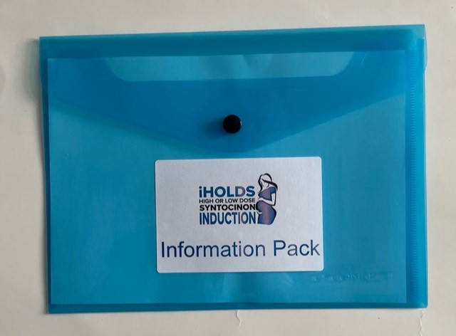
No

Woman admitted for IOL (Collect blue Information Pack)
During Induction

PIL given to all woman Trial discussed and consent can be obtained Consent prior to ARM or Oxytocin (by Obstetrician, Research/Clinical Midwife
(Use blue Labour Pack)

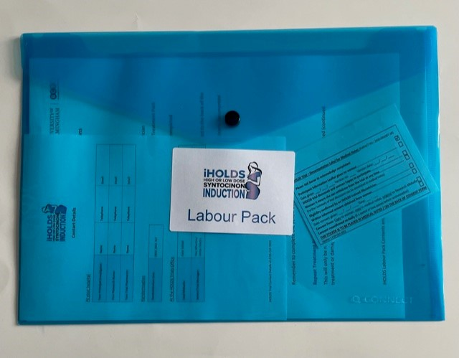

Decision made to administer Oxytocin

Eligibility confirmed and signed by Obstetrician Trial Entry Form

Consent Obtained (if not already)
Or reconfirmed verbally and documented
(If a period passes between written consent and randomisation)

Randomisation
Via 24-hour automated telephone system
Trial Entry Form completion

Standard dose Oxytocin
Higher dose Oxytocin
Data collection
Labour Form to be completed
Leave all documentation for the iHOLDS Research Midwife in allocated tray

After Induction

4. Identification of Participants for iHOLDS

* Induction of labour is defined as the process by which labour is started prior to its spontaneous onset.
- iHOLDS discussion can take place when induction of labour is booked
- If time permits the Research Midwife will send out a Cover Letter and Participant Information Leaflet to potentially eligible women
- When a nulliparous woman is undergoing induction, a Participant Information Leaflet (PIL) should be provided, and the trial discussed.
- Use the suggested phrases to help you discuss the study (Page 7 Section 5. Suggested Phrases for discussing iHOLDS Study with Women)

Women can be recruited if induced for the following reasons:

5. Suggested Phrases for discussing iHOLDS Study with Women

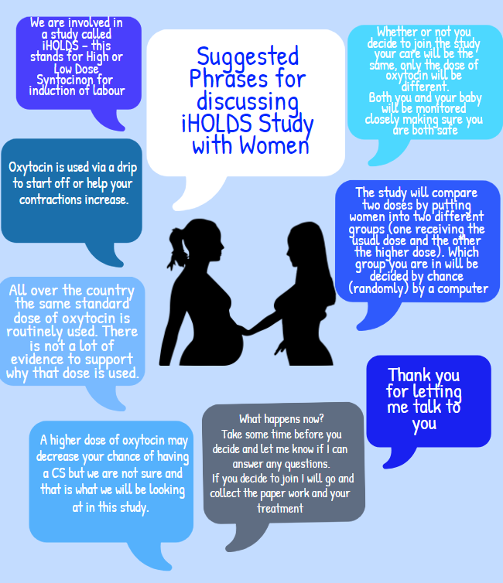

6. Who to recruit?

Inclusion Criteria | Exclusion criteria
Nulliparous, no previous births > 24/40 | Multiparous Women
Singleton cephalic pregnancy | Second stage of labour
Aged 16 years or above | BMI >40 at booking
Undergoing induction with ruptured membranes | Existing cardiac disease, bleeding disorders, previous uterine surgery, significant APH
Who give written informed consent to participate prior to randomisation | Have a known contra-indication to oxytocin therapy as listed in the Summary of Marketing Product Characteristics (SPC)
Prescribed oxytocin is indicated as part of the induction process | Are in any other IMP or procedure for induction of labour
Have received propess <30 mins ago
Have received Prostin <6hrs ago
- Ensure eligibility is confirmed by an iHOLDS trained Obstetrician
- Eligibility CAN be confirmed following consent if a period passes between written consent and randomisation. This should be documented in the medical notes.

7. Responsibilities- Who can do what?

Process | Timing | Person
Identify potentially eligible women | When induction of labour is booked or when women is undergoing induction as an inpatient | iHOLDS Trained Midwife or Obstetrician
Confirm eligibility | Use of oxytocin for induction indicated | iHOLDS Trained Obstetrician
Consent | Consent can be taken prior to confirmation of eligibility | iHOLDS Trained Obstetrician or Midwife  (where local practice permits)
Randomisation phone call | Following consent | iHOLDS Trained Midwife
Prescription of drug | Following randomisation | iHOLDS Trained Obstetrician
Collection from labour ward fridge and preparation of drug | Following randomisation | iHOLDS Trained Midwife
Labour data collection | During use of oxytocin | iHOLDS Trained Midwife
Return all completed forms to the Research Midwife | Following birth of baby | iHOLDS Trained Midwife

8. Information/Labour Pack

The packs will include everything you need to talk about the trial and to recruit women
Information Pack
The A5 BLUE pack contains all of the documents you need to approach a woman about the trial:
- Instructions
- Suggested Phrases for discussing the trial with women
- Participant Information Leaflet (PIL)
- Inclusion/exclusion criteria
- Contact details for assistance

Labour Pack
The A4 BLUE pack contains all the documents you need to recruit a woman into the trial and that you need during the course of the trial:
- Instructions
- Informed Consent Form
- Trial Entry Form
- Documentation Labels for Medical Notes
- Prescription Labels
- Oxytocin Regimen
- Labour Form
- Repeat Treatment Form

Please contact the iHOLDS Midwife if the Packs are running low

9. Obtaining Informed Consent
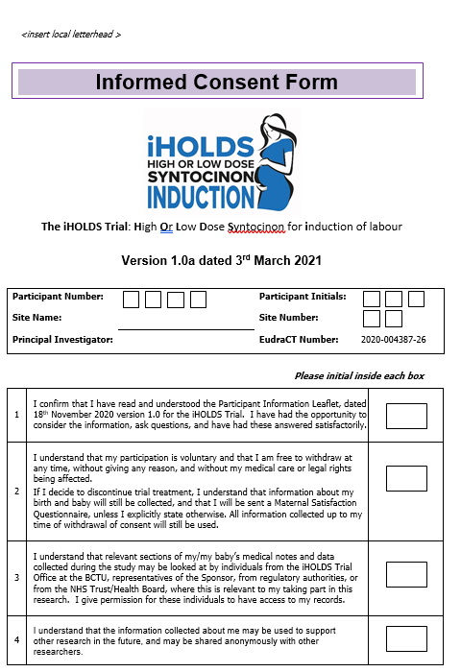

The woman needs to initial NOT TICK each box

Optional consent must be initialled Yes or No

To be completed
Insert details provided to you during the randomisation call

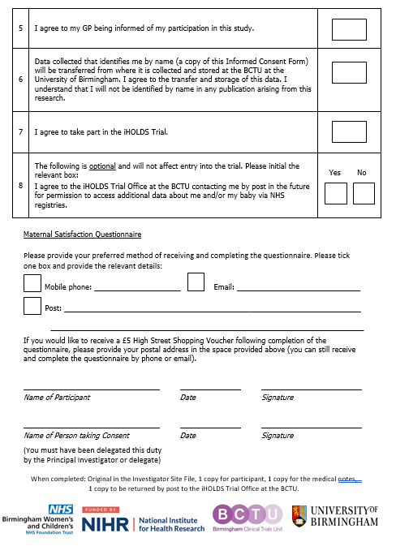
Woman and person taking consent must print name, sign, and date in the presence of one another

Informed Consent Form tips
 DON’TS
DO’s


Use hospital identification stickers

Pre-complete the form. The woman must write name, date, and sign the form

Cross out or alter any statements.

Participant to initial, not tick box

Insert the participant number

*File the consent form correctly

1x copy women, 1x copy in the medical notes, Original to Research Midwife (one to be filed in the Site File and a copy sent to Trial Office)

Documentation
- The documentation stickers can be used and placed in the medical notes as a record of recruitment to the trial.
- They can be found in the Labour Pack.
- If not used, all the fields still need to be recorded in the medical notes.
- If a site is paperless, please place the completed sticker on the back of the completed Informed Consent Form and return to the Research Midwife tray.

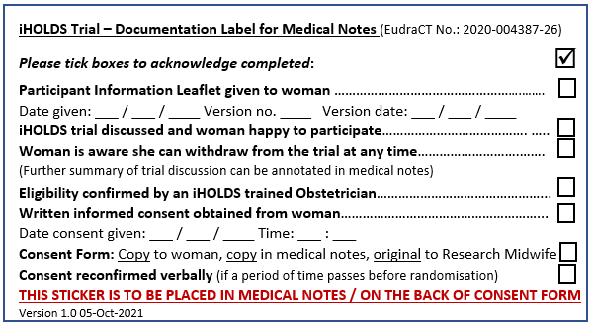
Check the version of the Participant Information Leaflet and the Informed Consent Form and complete the Documentation Label fully before adding it your documentation notes.
Always

10. Trial Entry Form

The Trial Entry Form contains a checklist for inclusion and exclusion criteria that needs to be completed and signed by an iHOLDS trained obstetrician. (Found in the BLUE Labour Packs).
- Women must meet all inclusion criteria and none of the exclusion criteria to participate

- Complete the Trial Entry Form before randomising a woman

- The iHOLDS trained Obstetrician needs to sign off confirmation of eligibility following completion of the checklist

- Following randomisation, write the Participant Number and Treatment Pack Number here

- Person randomising to sign and date

- Overleaf is a helpful checklist which outlines the next steps
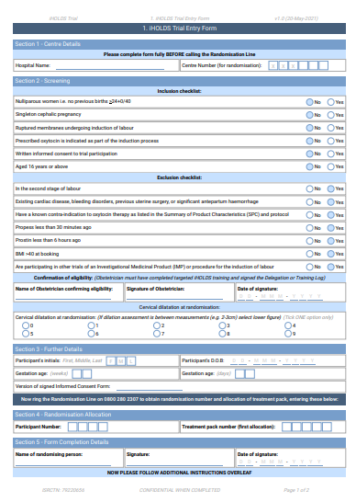

11. Randomisation

Randomisation will be via telephone using an automated secure system

Ensure an outside line is used

Only to be carried out once all eligibility is confirmed by an Obstetrician on the Trial Entry Form

Available 24 hours a day

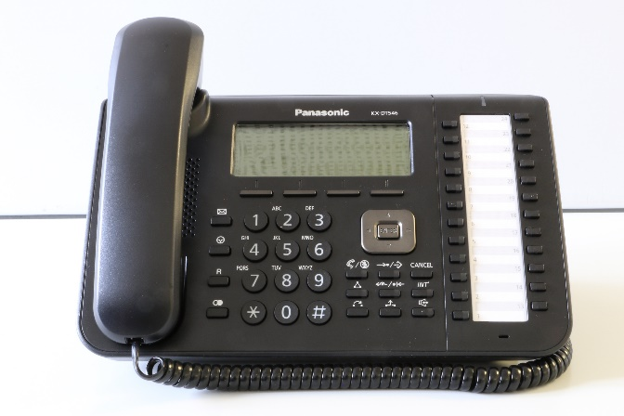
iHOLDS Trial ID 216***

Randomisation number:
0800 280 2307

Each trial will have its own ID number. The last 3 digits are site specific

Please do not end the call until you are given both a Participant Number (4 digits) and a Treatment Pack Number (5 digits), after which you are told to hang up

Follow the instructions given to you over the phone. You will be required to answer simple questions by responding by dialling a number on the keypad

Check to see if your site has a dedicated iHOLDS phone

12. Using the Trial Drug

Prescribing the Drug
Only an iHOLDS trained Obstetrician can prescribe the trial drug. Either handwritten as:
“10iu or 20iu Oxytocin for iHOLDS study”

OR


The pre-printed sticker can be used. You can find this in the Labour Pack.
Place the sticker where you would normally prescribe oxytocin.
COMPLETED BY PRESCRIBER |  |  | COMPLETED AND CHECKED BY MIDWIFE
DATE | DRUG TO BE ADMINISTERED | ROUTE | PRINT NAMES (must be on iHOLDS Training Log):  1)………………………..………  2)………………………….…….  SIGNATURES:  1)..….……………………………  2)……………………………………  DATE AND TIME OXYTOCIN ADMINISTERED  __ /__ /__ __ : __
__ /__ /___ | OXYTOCIN FOR iHOLDS Trial ONLY  10iu/2ml or 20iu/2ml  diluted to a total volume of either 50ml or 500ml  (Please circle total volume) | IV  INFUSION
PRINT NAME OF AUTHORISED PRESCRIBER (must be on iHOLDS Training Log):
SIGNATURE OF AUTHORISED PRESCRIBER:
V1.0 04.10.2021 iHOLDS Prescription Sticker EudraCT N°: 2020-004387-26

13. Preparation of Treatment

To collaborate with HOLDS, maternity units must fully comply with the regimens of oxytocin described in the protocols:

Oxytocin Regimen: Total Volume 500mls
Each ampoule contains 1ml of oxytocin

- WITHDRAW 2mls of the diluent (0.9% sodium chloride or appropriate alternative) BEFORE adding the x2 ampoules of oxytocin (2mls)
- The total volume of oxytocin plus diluent should always be 500mls
- Ensure the x2 ampoules of oxytocin are added to the diluent BEFORE inserting & priming the tubing
Time after starting  (mins) | Volume infused  (mls/hour)
 | Dilute x2 ampoules oxytocin with the diluent (0.9% Sodium Chloride or alternative) to a total volume of 500mls
0 | 6
30 | 12
60 | 24
90 | 36
120 | 48
150 | 60
180 | 72
210 | 84
240 | 96

Oxytocin Regimen: Total Volume 50mls
Each ampoule contains 1ml of oxytocin
- Ensure the x2 ampoules of oxytocin (2mls) are added to 48 mls of diluent (sodium chloride 0.9% or appropriate alternative)
- This may require 2mls of diluent to be withdrawn from 50mls BEFORE adding the x2 ampoules of oxytocin
- The total volume of oxytocin plus diluent should always be 50mls
- Ensure the x2 ampoules of oxytocin are added to the diluent BEFORE inserting & priming the tubing
Time after starting  (mins) | Volume infused  (mls/hour)
 | Dilute x2 ampoules oxytocin with the diluent (0.9% Sodium Chloride or alternative to a total volume of 50mls)
0 | 0.6
30 | 1.2
60 | 2.4
90 | 3.6
120 | 4.8
150 | 6.0
180 | 7.2
210 | 8.4
240 | 9.6

Treatment Pack Stickers and Infusion/Syringe Label

The treatment pack has TWO stickers on the outside of the box.
One to be placed onto the Labour Form and one in the Maternity notes (or on the back of the Informed Consent Fform if the site is paperless).

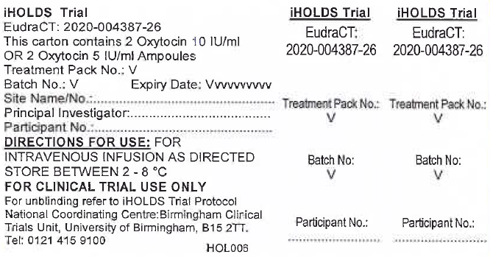

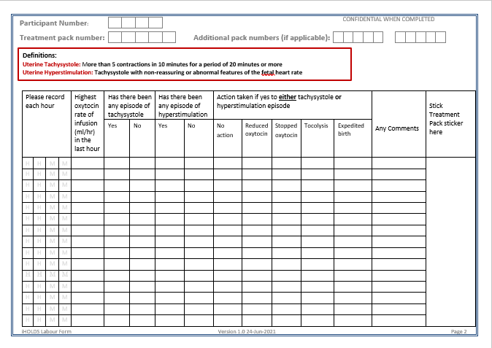

Infusion/ Syringe label
A syringe/bag label is also provided inside the treatment pack to ensure the infusion is labelled correctly. The participant identifiers should be added to the label. The label should be added to the infusion bag or syringe (See below).
A Stop! Infusion laminated label will be provided for you to attach to the syringe or infusion pump. This will outline the oxytocin regimen to use for your site and a reminder to complete the highlighted ‘following birth section’ of the Labour Form. You can find these in the back of the Labour Ward Manual.

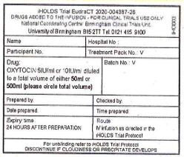
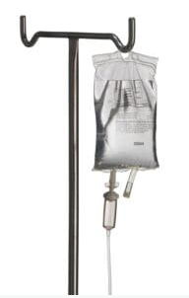
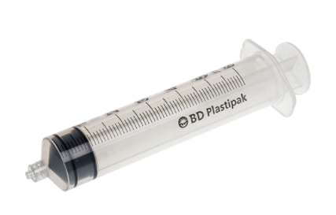

14. Drug Accountability Log
When you collect a treatment pack from the fridge you must complete the iHOLDS Labour Ward Drug Accountability Log.
Please note there will separate logs for HOLDS and iHOLDS, so please complete the relevant trial log.
This must be completed to maintain a log of the trial drug.

Example of completed Drug Accountability Log
Initial performed and checked by entered here
Treatment Pack Number, Batch Number and Expiry Date to be included
Date and Action Completed entered here

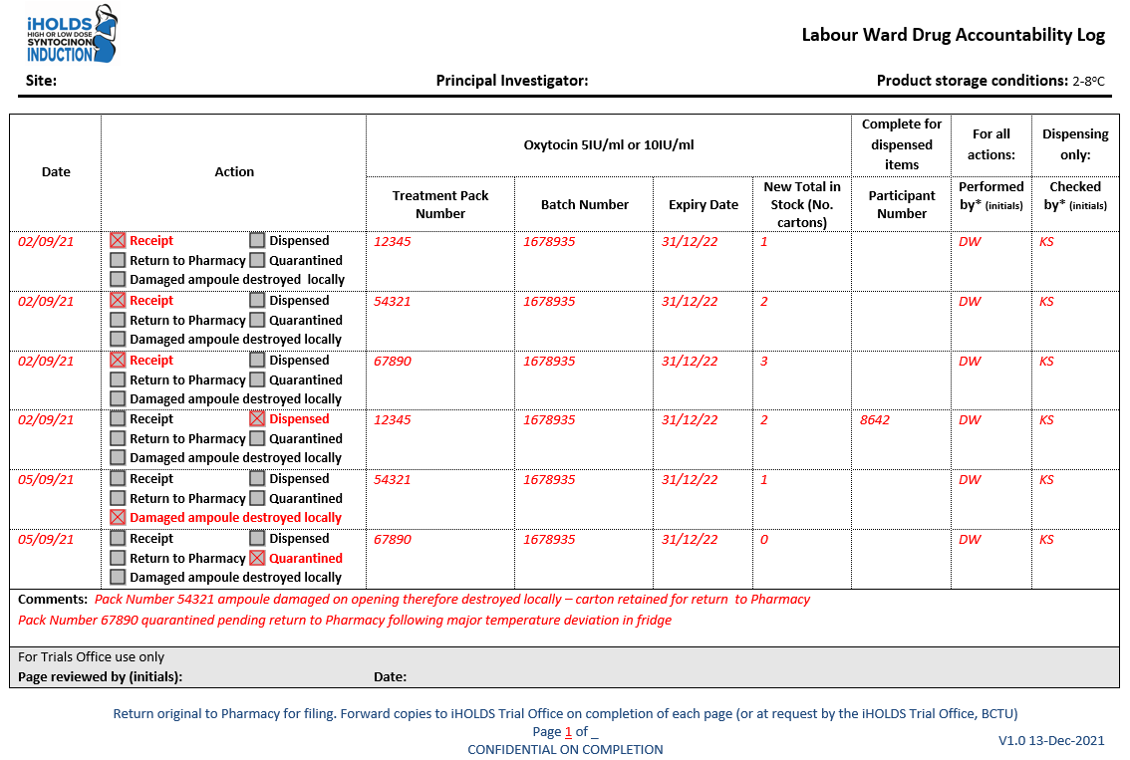
New total number of stock to be inserted

Damaged Ampoule

If you notice any ampoules are damaged, inform the Research Midwife, dispose of it safely, keep the empty box in the Labour Pack and update the Accountability Log. You will need to complete a repeat treatment form and go back to the randomisation line for reallocation of the drug.
The Treatment Pack box will be given to Pharmacy by the Research Midwife for accountability purposes who will check the Labour Ward Drug Accountability Log to make sure it has been completed accurately.

15. Drug storage

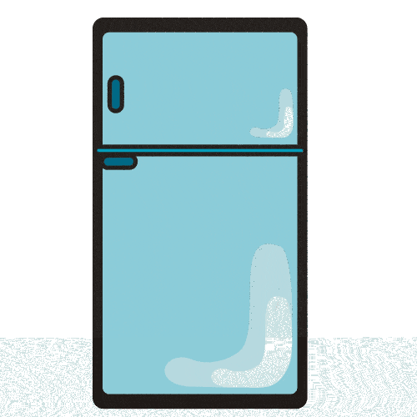

The trial treatment packs must be stored between 2°C - 8°C in either a separate fridge or in a designated compartment labelled ‘drugs to be used in the iHOLDS trial’

iHOLDS Treatment Packs are BLUE

The iHOLDS Midwife will be responsible for the storage and re-stocking the fridge on Delivery Suite.

Sites will be required to submit a monthly log detailing the daily temperatures.
If the drug is removed from the fridge for > 10 mins, please complete page 2 of the Log. This includes journeys between Pharmacy and Labour Ward that take over 10 mins.
The trial drugs must be transported in a provided cool bag.

A buffered thermometer records the temperature and will alarm if the temperature falls below 2⁰C or rises to or above 30⁰C (as the oxytocin cannot be used)

16. Temperature Deviation Reporting Process
If you discover the thermometer alarming, follow the flow chart instructions that are situated by your fridge (see below).
The thermometer will only alarm if the temperature falls below 2° C or rises to 30° C or above

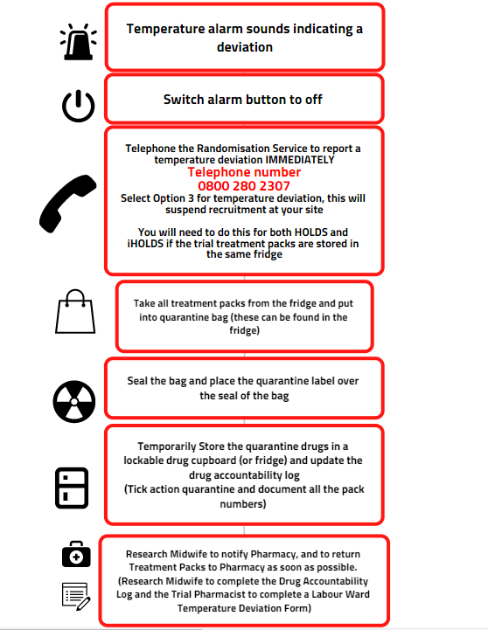

17. Repeat Treatment Form
If the allocated treatment has been used and/or needs to be replaced, you must complete a Repeat Treatment Form and telephone the randomisation line for the same treatment allocation.
You will be allocated a new Treatment Pack Number. The dose will remain blind, but it will be the same dose as previously randomised to.

18. Data Completion
We are asking you to collect information (data) during labour that is essential and we cannot get any other way. (Example of Labour Form below)

This is mininal extra documentation for Clinical Midwives

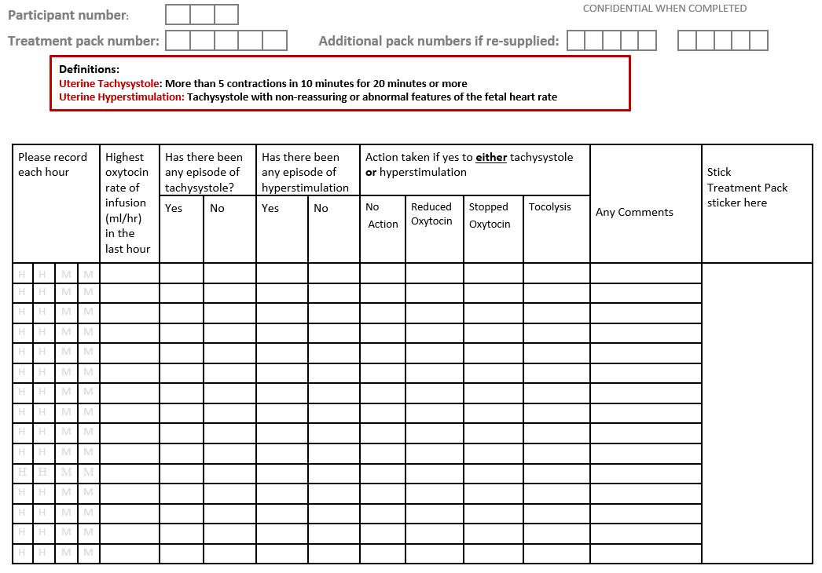
Please don’t forget….
Document the Participant Number and Treatment Pack number(s) on the form
Every Hour please record

- Maximum dose of oxytocin needs to be recorded.
- Any episodes of tachysystole and hyperstimulation.
If yes, any action taken.

Definitions

Tachysystole
More than 5 uterine contractions in 10 minutes for 20 minutes with a normal fetal heart rate.
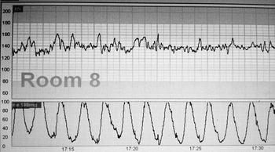

Hyperstimulation
More than 5 uterine contractions in 10 minutes for 20 minutes with suspicious or pathological CTG according to NICE guidleines

Labour Form – Following Birth

Please don’t forget…
To complete the highlighted part at the bottom of the Labour Form, this information is not retrievable anywhere else and is VERY important.
We need this information, so we know how much oxytocin the women receive. Thank you!
There is a laminated card for you to attach to the infusion to remind you to record the amount when the infusion stopped/taken down (Stop! Infusion Reminder Label).
COMPLETE THIS SECTION AFTER BIRTH
Date and time oxytocin infusion began _ _/_ _/_ _ at_ _: _ _
How much fluid was the oxytocin diluted in? 50mls □ 500mls □
How much oxytocin was infused during labour?(if more than 1 syringe/bag was made up, please add the total infused from all syringe bags) mls infused in total

19. Unblinding

Unblinding is the process of finding out which treatment arm a trial participant is randomised to and is required in some trials in an emergency.
Unblinding of iHOLDS participants as an emergency is not required, as management of these women will not change in light of this information.
The plasma half-life of oxytocin is approximately 5 minutes, so in the event of a safety issue, stopping oxytocin is the most common and effective treatment.

20. Safety Reporting

Summary of Safety Monitoring and Reporting


Safety monitoring and reporting is essential to protecting the women involved in the trial.
If any problems occur, standard procedure defined by your local maternity unit would be followed as normal practice.
The plasma half-life of oxytocin is approximately five minutes, so should any cause for concern be identified, stopping the oxytocin is the recommended course of action.

Clinical Midwives Responsibilities
Uterine tachysystole and hyperstimulation needs to be noted on the Labour Form every hour and if any action taken as a result (see page 22 Definitions)
You are responsible for additional safety reporting via completion of the final page of the Labour Form (Pharmacovigilance) and clear and concise medical notes.

Pharmacovigilance Form
The Back of the Labour Form captures any adverse events that may have occurred.
Please complete this section and accurately and in full.
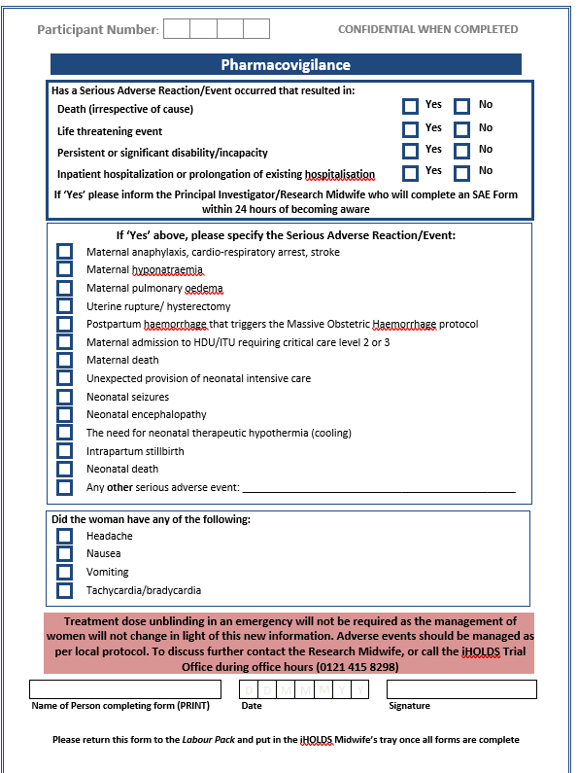
See any other serious adverse event

Any other serious adverse event
Any event not listed above which is considered a serious adverse event or reaction.
e.g. If a woman falls off the labour bed causing an injury that requires her to stay an extra night.
Whilst unrelated to trial treatment, this has prolonged the woman’s hospital stay and the information will still need to be completed on the Labour Form so the Research Team can report it within 24 hours of being notified
If you are unsure whether it is a safety reporting issue, please inform the HOLDS Midwife and she will investigate further.

21. Documentation Completion Flow Chart

Completed Consent
Form

Completed Consent
Form

Completed Consent
Form

Completed paperwork filed back in the recruitment pack for the iHOLDS Research midwife to collect

iHOLDS Research Midwife collects
Completed Labour Pack

iHOLDS Research Midwife enters birth and outcome data onto the online database

22. Withdrawal from the trial
Participants can withdraw from the trial at any time. This will not affect the care they receive

The Participant Information Leaflet states that unless a woman explicitly states she wishes to withdraw from all aspects of the trial, birth data will be collected and reported to the Trial Office

If a woman wishes to stop treatment it is not appropriate for the clinical midwife to question the woman further on which aspect of trial they wish to withdraw from

If a woman wishes to withdraw from all aspects of the trial, no data will be collected
This decision must be documented clearly in the woman’s medical notes

23. Contact Details

Your PI: Dr ………………….
The Research Midwife : …………….
Kate Siddall (Lead Midwife) Telephone: 07816 363 582
The BCTU HOLDS and iHOLDS Trial Office: Telephone: 0121 415 8298 (Voicemail outside office hours)
Email: iHOLDS@trials.bham.ac.uk
Website: https://www.birmingham.ac.uk/iHOLDS
Trial Social Media: Twitter: @iHOLDSTrial



For iHOLDS to succeed you are all a vital part of the team.
We cannot do this without you. We need you!
We need you to make this trial a
success!


