STOP-APE Trial Summary & Trial Schema
Title | Stopping anticoagulation for isolated or incidental subsegmental pulmonary embolism
Short title/ Acronym | STOP-APE
Type of trial | Randomised Controlled Trial
Trial design | An investigator led, multicentre, prospective, randomised controlled, open-label, pragmatic clinical trial designed to test both the non-inferiority and superiority objectives. A 12-month internal pilot will assess feasibility and acceptability with safety of randomisation based on acute reporting radiologists’ diagnoses assessed as part of a nested computed tomography pulmonary angiogram (CTPA) study.
Trial Treatment | Control arm: Usual care of full dose anticoagulation (clinician’s usual practice, which can include DOAC, warfarin or daily LMWH injections dependent on clinical context).  Experimental arm: No anticoagulation.
Primary Objective | The joint (multiple) primary outcomes are a composite of;  Recurrent VTE  - recurrent VTE (non-fatal)  - VTE related death (primary safety outcome)  Clinically relevant bleeding  - composite of major and clinically relevant non-major bleeding (CRNMB) (primary efficacy outcome).
Secondary Objectives | - Recurrent VTE at 6 and 12 months.  - Clinically relevant bleeding at 6 months and 12 months (as assessed through HES records).  - Net clinical benefit – composite of clinically relevant bleeding and recurrent VTE at 3 and 6 months.  - New diagnosis of pulmonary hypertension or right ventricular dysfunction within 12 months of SSPE, defined from HES clinical coding and supported where possible by additional radiological data and echocardiograms undertaken in tertiary pulmonary hypertension centres.  - All-cause mortality at 3, 6 and 12 months.  - VTE related mortality at 3, 6 and 12 months.  - Cardiovascular mortality at 3, 6 and 12 months defined as cardia deaths (e.g. cardiogenic shock, fatal arrhythmia, cardiac rupture) and vascular deaths (e.g. VTE-related, fatal stroke, ruptured aortic aneurysm, aortic dissection).  - Reclassification rate from thoracic radiologist review.
Accrual period | 32 months
Trial duration per participant | Overall period 12 months: telephone follow up at 4 weeks to collect patient safety data, 12 weeks for telephone follow up to collect data for the primary outcome. Further telephone follow up at 24 weeks and NHS Digital collection of Hospital Episode Statistics for a minimum of 52 weeks follow up.
Estimated total trial duration | 54 months (6 months set-up, 32 months recruitment, 12 months follow-up, 4 months analysis and write-up)
Setting | UK multi-site, up to 50 hospitals
Total number of participants planned | 1466 to allow for losses to follow up
Main inclusion/exclusion criteria | Inclusion criteria  - Age ≥18 years  - SSPE diagnosed by the radiologist at the trial site by CTPA or CT thorax with IV contrast  - No evidence of proximal deep vein thrombosis on doppler ultrasonography or CT / MR venography  - Heart rate (<110bpm)  - Systolic blood pressure (≥100 mmHg)  - Oxygen saturation (≥90%)  - Written signed informed consent to the trial  Exclusion criteria  - Indication for hospital admission  - >7 days empirical anticoagulation treatment immediately prior to randomisation  - <28 days since first symptoms of proven or clinically suspected COVID-19  - Known stage 5 chronic kidney disease  - Patients with active cancer defined as cancer diagnosed within the past 6 months, cancer for which anticancer treatment was being given at the time of enrolment or during 6 months before randomisation, or recurrent locally advanced or metastatic cancer  - Patients with previous unprovoked PE, thrombophilia or requiring long term anticoagulation for another reason  - Patients with a DVT / thrombus of an unusual site (e.g. upper limbs, associated with a line) that requires anticoagulation  - Patients with active bleeding  - Any condition which, in the opinion of the investigator, makes the participant unsuitable for trial entry due to prognosis/terminal illness with a projected survival of less than 3 months  - Pregnancy confirmed by positive pregnancy test or post-partum period or actively trying to conceive  - Inability to comply with the trial schedule and follow-up  - Participation in a CTIMP study

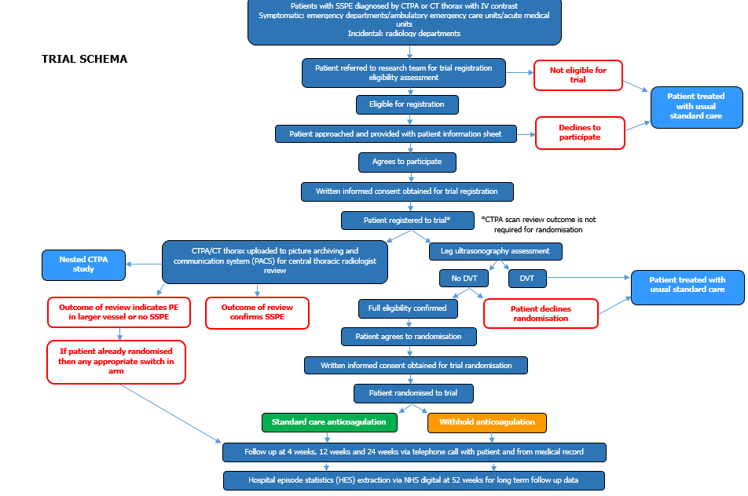

Schedule of Assessments
 | Screening | Baseline | Telephone Call 1 | Telephone Call 2 | Telephone Call 3 | HES data extraction
 |  |  | 4 weeks (± 1 week) | 12 weeks (± 2 weeks) | 24 weeks (± 2 weeks) | 52 weeks
Consent | X | X
Eligibility check | X | X
Registration | X
Randomisation |  | X
CTPA/CT thorax with contract | X
Medical history | X
Concomitant medications |  | X
Ethnicity |  | X
Risk factors for bleeding |  | X
VTE symptoms and recurrence risk factors |  | X
Routine blood tests |  | X
Modified MRC Dyspnoea score |  | X |  | X | X
Pregnancy test | X
Physical exam | X
Vital signs | X
CTPA/CT Thorax upload to PACS |  | X
Leg venous ultrasound | X
EQ-5D-5L |  | X |  | X | X
Anticoagulant medication check |  |  | X | X | X
VTE Recurrence |  |  | X | X | X | X
Bleeding events (major bleeding and clinically relevant non major bleeding) |  |  |  | X | X | X
NHS usage for VTE related events/bleeding events |  |  |  | X | X | X
SAE check |  |  | X | X | X
Survival check |  |  | X | X | X | X

