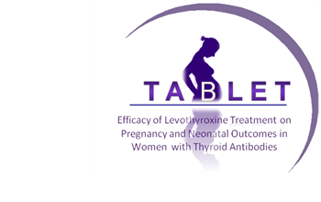
Summary of testing stage
Patient Screening Information
Thyroid AntiBodies and LEvoThyroxine Study

- There is evidence that thyroid antibodies can influence important clinical outcomes such as the chance of completing a successful pregnancy.
- We would like to invite you to have a blood test to find out if you have thyroid antibodies. The blood test will also measure your thyroid hormone levels.
- It is believed that taking thyroid hormone tablets may counteract the influence of thyroid antibodies.
- If the results of the blood tests show you do have thyroid antibodies, you will be invited to take part in a study of a thyroid hormone supplement – levothyroxine - that might reduce the risk of miscarriage. The study is called TABLET.
- The results of the blood tests may show you have unusual thyroid hormone levels, but this is rare. If this is the case, you will be given an appointment to see a doctor to discuss treatment. You will not be eligible for the TABLET study.
- You will not be asked to decide whether you want take part in the study until the test results are available. We expect less than 1 in 5 women to have thyroid antibodies.
- Your anonymised test results and other basic information e.g. age may be used by researchers to look at thyroid hormone levels in pregnant women in general. This information will be anonymised and you will not be identified to the researchers.
- Please take as much time as you feel you need to make the decision whether or not to have this test.
- Taking the blood sample may be a little painful and may result in short-lived bruising.
If you think you might be interested in the study, you will need to have the thyroid antibody test If you decide not to have the test, you may be able to have it at a later date. Your care will not be affected by your decision.
You decide to have thyroid antibody test
Thyroid antibodies present
No thyroid antibodies
Other thyroid problem
You will be given an appointment to see a GP/relevant specialist for follow-up You are not eligible for TABLET study
A nurse or midwife will contact you. You are not eligible for TABLET study and will not need to see a doctor or nurse.
You will be sent more information about the TABLET study and will be invited to see a doctor or nurse at a clinic to discuss participation.
What happens next?
For further information about the blood test or the study please contact:

Name:- Tel:-

