To be printed on hospital headed paper

PARTICIPANT INFORMATION SHEET
8-12 YEARS OF AGE

rEECur

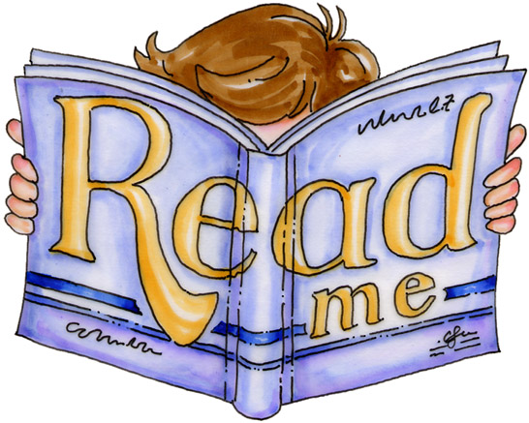

Dear …………………………………………………………………………..

We would like to ask you to take part in a research study. Research helps us to find out answers to questions.
You have an illness which gives you lumps called Ewing sarcoma. Your illness is treated by strong medicines called chemo. There are different types of chemo that can be used to treat Ewing sarcoma. We want to find out which one is best at making your lump go away.
This is some information about the research study. When you have read it, or listened to it being read to you, you can ask as many questions as you like. You and your parents can then decide whether or not you should take part.

Why have I been asked to take part?
We are asking lots of children like you who have your type of lump, from all around the world, to take part in this research study.

What will happen if I take part?
Before the treatment starts you will have some tests done, some of which you will have had before. The results will be looked at by your doctor. If you want to know more about these tests, please ask your doctor or your family.

If you take part in this research study, a special computer program will decide which type of chemo you are given.
You will be asked to fill in some forms which ask how you are feeling.

When you have finished your treatment, we will do some more tests to see how you are getting on. You will continue to have check-ups and scans so we can monitor how you are.

Do I have to take part?
No, you do not have to take part. It is up to you and your family to decide whether or not you want to take part. If you decide to take part, you can change your mind at any time, even after treatment has started. Your doctor will not mind if you do not want to take part.

Are there any other choices?
Your doctor is very happy to talk to you about any other choices. Please ask any questions that you have and take time to make up your mind.

Will the medicines make me unwell?
Medicines can make you better but they can also make you feel unwell. When medicines make you feel unwell it is called a “side-effect”. When you are having your treatment, some of the medicines will make you feel sick, but we can give you other medicines to help stop this. You may also find that you bruise more easily if you hurt yourself, and you might get coughs, colds and temperatures more easily. Sometimes you will have to go into hospital to help these to go away.
Many side effects go away soon after you stop treatment. You should talk to your doctor or nurse about any side effects that you have. If you want to know more about possible side effects that you may have, talk to your doctor.

Will joining in help me?
The information that we get from this research study will help us to give the best treatment to other children with Ewing sarcoma in the future. We are not sure which treatment is the best at the moment.

What if something goes wrong?
It is possible that something may go wrong and you may have side effects we did not think you would have. You will be watched closely for any side effects and the study treatment may be stopped if you get too sick or if they are not helping you. Your family have been told what to do and who to speak to if something goes wrong.

What could be good about taking part?
The aim of this study is to help improve how we treat your type of lump. We hope that this treatment will help you, but we cannot promise that it will. The information we gain from this study will help us treat other children like you in the future.

What happens when the research stops?
When the research stops your doctor will carry on seeing you at the hospital and we would still like to hear about how you are.

What if new information becomes available?
It is possible that the doctors will find out more information about the medicines whilst you are taking them. Your doctor will then talk to you and your family about whether you should still carry on taking them or whether you should try another type of treatment. If you decide to carry on with the study, you and your family may be asked to sign a new consent form.
What if I don’t want to do the research anymore?
If at any time you don‘t want to do the research anymore, just tell your family, doctor or nurse. They will not be cross with you. Your doctor will help you decide which treatments are best to have afterwards.

Will anyone else know that I am doing this?
The only people who will know that you are taking part in this study will be the doctors, nurses and researchers looking after you, and your GP (family doctor).

All of the information about you will only be shared with people involved in the research.

Who has checked the study is okay to do?
This study has been checked and approved by a group of people called a Research Ethics Committee. They have read all about the research and looked at all the good and bad points about taking part; they do not allow research to go ahead if they believe it is not safe.

What if I have any questions?
Talk to your family about the question we have asked you. They will be able to help you decide. You can also talk to the doctors and nurses who are looking after you. We are all here to help you.

Thank you for reading this information sheet

