EMPLOYEE NAME:
MANAGER:
DATE:
DISCUSSION TOOL
WORKING PREFERENCES
INSERT
COMPANY
LOGO
USING THE WORKING PREFERENCES
DISCUSSION TOOL

The Working Preferences Tool is designed to facilitate a discussion between manager and employee about appropriate working arrangements after COVID 19 working restrictions come to an end and to inform future working arrangements.
The Working Preferences Discussion does not guarantee flexible working opportunities, but it does signify a willingness by all to explore options which could work for everyone.
It is assumed that those involved are working within parameters set by employment law along with any existing company policies. Recording agreements does not make them formal, or contractual entitlements. All arrangements will be subject to business requirements, which may change over time, or in different roles, different contexts or due to different operating needs. This discussion should be repeated periodically to account for any changes in employee preferences and business needs.
It is recognised that working preferences for employees may be highly personal, and an employee need not disclose detailed information about personal circumstances if they do not wish to (however an open and frank discussion where possible can lead to outcomes that fit the needs of the employees and the business more closely).
Section A of this tool should be completed prior to a face to face meeting between manager and employee and section B during the meeting.

This work is licensed under a Creative Commons Attribution-NonCommercial-NoDerivatives 4.0 International License.

SECTION A
(to be completed jointly by the manager and employee prior to the meeting)
EMPLOYEE PROFILE
NAME:

DATE OF FIRST CONVERSATION:
LINE MANAGER:
ROLE IN ORGANISATION:

CURRENT ROLE AND CIRCUMSTANCES
(give details of your current role and any circumstances for example work/life balance or job requirements you would like to discuss)

EXPERIENCES OF WORKING DURING COVID-19 (include notes of what worked well, what did not and what this means for how you would like to do the job in the future)

DESIRED WAYS OF WORKING POST COVID-19 (outline your preferences below. Include things like working from home and flexible working in this section. If you are considering working from home include how many days a week)

IF YOU ARE REQUESTING FLEXIBLE WORKING OR HYBRID WORKING WHAT MIGHT WE NEED TO MAKE IT WORK? (for example, IT support, communication, office access, altered targets, HR support, equipment etc)

WHAT OTHER ISSUES NEED TO BE DISCUSSED?
WHAT ELSE COULD HELP?

SECTION B
(to be completed jointly by the manager and employee during the meeting, managers should consider employment law and company policies in advance)

FLEXIBLE WORKING AT [COMPANY]
DISCUSS [COMPANY] APPROACH TO WORKING POST COVID-19, FLEXIBLE WORKING AND RELEVANT COMPANY POLICIES.
For example, any (relevant) policies including:
- Working from home
- Job sharing
- Part time working
- Compressed hours
- Flexitime
- Annualised hours
- Staggered hours
- Phased retirement
- Unpaid Parental Leave
Possible questions:
• What worked well during lockdown and would you be interested in continuing with some of the ways of working your utilised during the COVID-19 Pandemic (or at another time)?
• Are there any policies in place that could be made use of?
• Is there anything you would like to know more about?
• Is there anything else the company should be considering in this area?

The employee should then discuss their preferences, with reference to working practices during COVID-19 (if applicable), particularly what worked and what did not work and start a discussion to see what arrangements could be mutually beneficial in light of their preferences stated above and the company approach and policies.
Managers need to consider H & S, company policies, contractual arangements and employment law, being careful not to ask questions related to childcare which could be seen as discriminatory and take into account government guidelines in respect to COVID-19. The organisation also may want to offer a tick box for potential working scenarios so that this information can be easily analysed for all staff for planning purposes.
DOCUMENT DISCUSSION AND ANY AGREED ACTIONS HERE:

DISCUSSION CHECKLIST:
Checklist of Actions | Date to be completed by | Relevant Y/N | Complete  Y/N
Discuss COVID-19 working experiences from employee and manager perspectives.
Manager explain the organisation’s approach post CODID-19 and company policies.
Employee explain working preferences.
Agreement reached.
Support agreed.
Date to begin.
Discuss any HR or contractual implications.

WHAT HAPPENS NEXT?
NEXT STEPS FOR THE MANAGER:
(What can be done? What can’t and why? Can anything else be done? What are the next steps for the line manager to follow / escalate? Would any changes need to be contractual? Does HR need to be consulted?)

NEXT STEPS FOR THE EMPLOYEE

CONSENT AND STAYING IN TOUCH
In the event that the organisation needs to access and record information provided in this document, consent from the employee is necessary.

☐ I am happy for my line manager / HR to keep a copy of this documentation and/or use it for planning purposes
☐ I am not happy for my line manager / HR to keep a copy of this documentation and/or use it for planning purposes*

If your organisation would like to use this information for workplace planning you can add the following question (delete if not to be included):
Ideally how many days a week would you like to spend in the office? (tick)
- 1 day a week in the office
- 2 days a week in office
- 3 days a week in office
- 4 days a week in office
- 5 days a week in office

NAME OF EMPLOYEE:
SIGNATURE:

NAME OF LINE MANAGER:
SIGNATURE:

DATE:
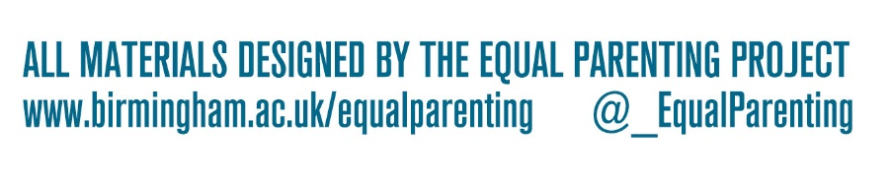
*If not shared with HR this information will not be passed to any new line manager.

