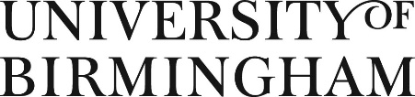

Department of Political Science and International Studies
MA Politics Fee-only Bursary Application

POLSIS is pleased to be able to offer a small number of fee-only full and partial bursaries for the academic year 2021/2022 for students applying for the M.A. Politics programme. These will be awarded on a competitive basis based on academic merit.

Please complete the form below and send it by email to the Director of Postgraduate Studies, polsisma.bursaries@contacts.bham.ac.uk by Friday 4th June 2021.

Please indicate which bursary you are applying for:

- Home/EU student
- Overseas student

Candidate Details

Candidate Family Name:
Candidate First name(S)

Application ID (if known) or date of application (all applicants for the bursary must also have applied for the M.A. in Politics

Qualification Details

University
Degree Subject and
Classification (or equivalent)
Awards or Prizes

Supporting Statement

Please provide a personal statement to address the following: Why are you interested in the subject matter, your knowledge of the programme and any relevant experience you may have. Please also outline your academic performance to date, and any other factors which you believe should be taken into account in assessing your application for an MA bursary (e.g. welfare).

Signed: |  | Date:

Please note: The bursaries will be competitively allocated. In submitting the application, applicants agree that no correspondence will be entered into regarding the outcome of the application after the final result has been announced. Bursary holders may be asked to agree to participate in promotions advertising the scheme or MA programme.

