Financial Inclusion:

Annual Monitoring Report 2020




Contents
Executive summary iii
Key findings iii
The economy iv
The labour market iv
Incomes v
Subjective financial wellbeing vi
Bank accounts vi
Savings vii
Pensions vii
Borrowing vii
Problem debt viii
Insurance ix
Introduction 1
Towards a financially-inclusive society 1
The policy context 3
Detailed findings 7
1. The economy 7
2. The labour market 12
3. Incomes 22
4. Subjective financial wellbeing 32
5. Bank accounts 37
6. Savings 42
7. Pensions 47
8. Borrowing 51
9. Problem debt 60
10. Insurance 68
Conclusions 69
Appendix: Data sources and research methods 71
Stakeholder engagement 71
Secondary analysis of existing data sources 71
Administrative data 71
Survey data 72

Acknowledgements
We would like to thank the Friends Provident Foundation and Barrow Cadbury Trust for funding this work. Danielle Walker-Palmour and Clare Payne have been particularly helpful and supportive, as always.
We also wish to thank the UK Data Service for supplying the datasets used in this research project – and thank the funders and data collectors of these surveys.
Naturally, none of these individuals or organisations has any responsibility for the analysis conducted or conclusions drawn.
Authors
Stephen McKay, Distinguished Professor in Social Research, University of Lincoln.
Karen Rowlingson, Professor of Social Policy, University of Birmingham.

October 2020.

Executive summary

Key findings
- COVID-19 has had, and will continue to have, a devastating impact on household finances in the UK and globally. But our report shows that household finances, and the UK’s economy more generally, was already faltering in many ways, prior to the pandemic, possibly as a result of Brexit-related uncertainties during 2019.
- In the second quarter of 2019, economic growth was negative and in the fourth quarter of 2019 it was zero. Furthermore, unemployment, under-employment and zero hours contracts had all increased in 2019 while wages had started to fall in real terms towards the end of that year and into early 2020.
- Subjective financial wellbeing was also in decline prior to COVID-19 with an increase in the proportion of people saying they were ‘just about getting by’ or ‘finding things difficult’ in 2017/18 – the first time this figure had increased since 2009/10.
- So, there were clear signs of actual and potential strains on family budgets during 2019, prior to COVID-19. The impact of the pandemic on top of this situation looks set to be monumental. From just March to May 2020, between one quarter and one third of jobs were furloughed and from March to April that year there were 2 million more claims for Universal Credit than there had been in the same period in 2019. By the end of May 2020, 28 per cent of the population said that COVID-19 had had a direct negative effect on their income.
- The Job Retention (furlough) Scheme and the boost to Universal Credit have been incredibly important interventions to support people’s incomes. Those on ‘legacy’ benefits, however, are not seeing the same level of income protection, leading to a two-tier benefit system. And despite all this support, the Trussell Trust saw a doubling of emergency food parcels going to children in April 2020 compared with April 2019 and other charities report increasing levels of debt and fear of eviction among their clients.
- There is slightly more positive news in relation to financial inclusion with the number of people ‘unbanked’ reaching an all-time low in 2018/19. But there is growing concern about access to cash as bank branch closures escalate and free cash machines continue to disappear from local high streets.
- There is also some good news with increasing levels of occupational pension membership but, here again, there are concerns that contribution levels are too low to provide a sufficient level of income on retirement.
- These are extremely difficult times for the country and many within it. A significant minority of the population, however, are unaffected, financially, by COVID-19 or, indeed, are seeing their savings increase as their income remains the same and their spending has reduced. Thus, inequality is likely to rise further.

The economy
- After 2015, GDP started trending downwards and, indeed, was recorded as negative in the second quarter of 2019 and zero in the fourth quarter, even before the COVID-19 crisis. In the first two quarters of 2020, GDP was recorded as dropping by one-fifth, an unprecedented reduction.
- Inflation has been trending down in the last two years from a recent peak of 3.1 per cent in November 2017 to 0.5 per cent (CPIH) in August 2020. The most recent falls in prices were mainly due to the lower cost of motor fuels (due to a price war between Russia and Saudi Arabia) and to falls in the price of recreational and cultural goods in the wake of the COVID-19 crisis.
- In an attempt to support borrowing and demand, the Bank of England Base Interest Rate was reduced in March 2020 to the lowest it has ever been in the Bank of England’s 325-year history: 0.1 per cent.

The labour market
- Unemployment had started to increase even before the COVID-19 crisis, possibly due to Brexit-related uncertainties. Underemployment was similarly trending slightly upwards again to 2.5 million in December 2019. And the number of zero-hour contracts also began increasing again in 2019 to a record high of 974,000.
- Employment levels appeared to stall in 2019 and wages had still not reached their pre-Global Financial Crisis levels by the end of 2019. Indeed, wages started to fall slightly by February 2020, before the COVID-19 crisis.
- The COVID-19 crisis has led to a considerable increase in unemployment though the Job Retention (furlough) Scheme has prevented it from reaching even higher levels. From March to May 2020, between a quarter and a third of jobs had been furloughed. The furlough scheme is due to end on 31st October 2020, albeit with new schemes being lined up for some groups.
- During March and April 2020 alone, there were nearly 2.5 million claims for University Credit, 2 million more than in the same period in 2019.

Incomes
- Around 14 million people were living in poverty in the UK (more than one in five of the population) in 2017/18, made up of 8 million working-age adults, 4 million children and 2 million pensioners.
- Over the last five years, poverty rates have risen for children and pensioners. And around 56 per cent of people in poverty were in a working family, compared with 39 per cent 20 years ago. Poverty rates were highest in London, the North of England, Midlands and Wales, and lowest in the South (excluding London), Scotland and Northern Ireland.
- By the end of May 2020, more than one quarter, 28 per cent of adults, or 14 million people, had experienced a direct negative effect on their income due to COVID-19, affecting people throughout the income distribution though affecting those at the bottom and middle most of all.
- According to the Resolution Foundation, the emergency boost to Universal Credit (UC), tax credits and housing support on 20th March increased the incomes of families in the poorest quarter by 5 per cent on average and so strengthened the safety net. The Job Retention Scheme (JRS) also provided much greater income protection with the median fall in disposable income if furloughed being just 9 per cent compared with 47 per cent if people lost their jobs and turned to UC.
- The adequacy of means-tested, out-of-work benefits (of all kinds) had been declining over the past few years prior to COVID-19 and we now see a difference emerge between those on ‘legacy’ benefits (income support, employment support allowance, jobseeker’s allowance) and those on UC who are on higher levels of benefit, according to the Loughborough University.
- Means-tested pensioner benefits (e.g. Pension Credit) also dropped massively in adequacy levels between 2009 and 2019 and have only increased marginally in the last year. They do, however, continue to provide incomes much closer to the Minimum Income Standard level than for other groups.
- As many as 1.9 million emergency food parcels given out from 1st April 2019 to end of March 2020 (ie pre-COVID-19) by the Trussell Trust (up from 1.6 million the previous year). And the Trust then reported an 89 per cent increase in need for emergency food parcels during April 2020 compared to the same month in 2019, including a 107 per cent rise in food parcels for children.

Subjective financial wellbeing
- Prior to COVID-19 there was an increase in the number of people reporting that they were ‘just getting by or finding it difficult’ to do so in 2017/18 – and this was the first time there had been an increase in this indicator since 2009/10. Some minority ethnic groups were the most likely to report his.
- COVID-19 has had a massive impact on anxiety levels generally and worries about money in particular. Just under 1 in 4 adults (23 per cent) said that the pandemic was affecting their household finances in March/April 2020.
- The most common concern among these adults continued to be a reduced income (70 per cent), with increasing proportions, 30 per cent, saying they had needed to use savings to cover living costs, and 16 per cent saying they had to borrow money or use credit.

Bank accounts
- There has been a steady decline in the numbers of unbanked adults from 2.85m in 2005/6 to a record low of just below 1 million in 2018-19. The number of adults living in households without access to a relevant account has also fallen to a record low of just under half a million.
- While the number of unbanked has continued to fall, access to cash may be increasing as a problem. Bank branches and free-to-use cash machines are continuing to be removed as more people do banking online. But not everyone is able to use, or confident in using, digital banking. Such banking also suffers from security and technical problems. At the March 2020 Budget, the Chancellor announced that the Government will bring forward legislation to protect access to cash.

Savings
- The household savings ratio spiked at 28% in the second quarter of 2020, the highest it has reached by some margin in the last 20 years, no doubt due to some households maintaining their incomes but reducing their spending very significantly during lockdown.
- The latest findings, for 2016/17, show that about two in five (43 per cent) of the population were putting something away ‘now and then’ with an average of £304 saved per month by savers. Those with higher earnings were much more likely to save and were saving much higher amounts.
- According to the Resolution Foundation, the COVID-19 crisis has meant that for those on low incomes – and for those who have experienced a drop in income – savings have fallen but some on middle or higher incomes have been able to save more as a result of reduced spending on leisure, holidays, eating out and so on leading to greater inequalities of wealth.

Pensions
- Private sector pension schemes had been on the decline since the late 1960s but the mandatory introduction, in 2012, of auto enrolled workplace pensions has seen a massive increase so that, in 2018, 11 million people had such pensions. This is far higher than the number of people with public sector pensions, but this figure has also increased since 2012, albeit at a much slower rate to 6.3 million.
- While the numbers with a pension look promising in relation to financial inclusion, there are a couple of important points to bear in mind. First of all, figures from NEST (who are a key provider of workplace pensions) show that, as at March 2017, only 60 per cent of their workplace pension members were truly ‘active’ (i.e. paying into their pension). And even among those who are actively contributing, the amounts paid into these pensions (particularly by employers) may be insufficient to provide a decent standard of living in later life.

Borrowing
- The annual rate of growth in credit card lending has fallen since 2018 probably due to uncertainty around Brexit and, most recently, the COVID-19 crisis. Indeed, during March 2020, the growth rate was actually negative at -0.3 per cent, with changes exceeding -10 per cent in the subsequent months (up until August 2020)..
- Mortgage lending plateaued somewhat from 2015 to 2019 but the global pandemic crisis has, again, seen an abrupt fall in such lending in March 2020 – albeit now mostly back in line with past trends
- The value of outstanding student loans at the end of March 2019 reached £121 billion. The Government forecasts the value of outstanding loans to reach around £450 billion (2018-19 prices) by the middle of this century.
- Over 2.1 million people (including young people) were members of credit unions in the UK with the vast majority (1.9 million) being adults. This represents a 4.5 per cent increase in adult members over the previous year but a drop of 2.3 per cent of young members (those aged under 16).

Problem debt
- Prior to the COVID-19 crisis, nearly 2 million families (6 per cent) said that they could not keep up with bills and regular debt payments according to 2018/19 data. Levels of problem debt were highest among renters, particularly council and housing association renters.
- Council tax debt was the most common type of debt in 2018/19, followed by water rates (or rates in Northern Ireland) then electricity and then rent.
- Data from the Insolvency Service shows that the total number of insolvencies peaked at the end of 2018 before falling in 2019, but in that year nearly 122,000 insolvencies were still recorded. Quarter 1 of 2020 recorded nearly 29,000.
- There has been an increase in the last year from 1,590 mortgage possessions in the third quarter of 2018 to 2,130 in the third quarter of 2019. In terms of evictions from rented properties, there were 3,374 evictions in the third quarter of 2019, suggesting that there would have been a further fall in the numbers of evictions in 2019 as a whole compared with 2018.
- COVID-19 has increased debt problems still further. Research by Stepchange Debt Charity reported that, at the end of May 2020, 4.6 million people had accumulated £6.1 billion of arrears and debt, averaging £1,076 in arrears and £997 in debt per adult affected. The report also found that, as of late May, 2.7 million people had accessed payment holidays on mortgage and credit products.
- The position for many in 2020 looks bleak. Research by Shelter, published in July 2020, estimated that 227,000 adult private renters (three per cent) had fallen into arrears since the start of the pandemic, meaning they could lose their homes when the evictions ban ends (originally 23 August, extended to 20 September, and longer for commercial tenants) in addition to those already in arrears.

Insurance
- The proportion of working adults who had home contents insurance dropped from 65 per cent in 2008/9 to 60 per cent in 2018/19.

Introduction

Towards a financially-inclusive society
This report is the eighth in a series of ten planned annual monitoring reports commissioned by the Friends Provident Foundation and Barrow Cadbury Trust to monitor progress towards, or indeed, away from financial inclusion in Britain. In order to provide a comprehensive picture, this report takes the same framework as the previous reports and updates figures, where available, to give the most recent data and trends.
According to Kempson and Collard, a financially inclusive society would be one in which everyone had the ability to:
- manage day-to-day financial transactions (e.g. through appropriate bank accounts)
- meet one-off expenses (both predictable expenses through savings, and unpredictable expenses also through savings and/or appropriate credit and insurance products)
- manage a loss of earned income (e.g. through savings, including pension savings)
- avoid/reduce problem debt
In this series of reports, we argue that people need three key components in order to achieve financial inclusion as follows:
- A secure income which meets a minimum standard. The Minimum Income Standards Team define a minimum income standard as covering ‘more than just food, clothes and shelter. It is about having what you need in order to have the opportunities and choices necessary to participate in society.’
- Access to appropriate and well-regulated financial services, particularly transactional bank accounts, savings accounts, affordable credit, pensions and insurance products.
- Access to free and appropriate advice and education, particularly for those with debt problems.
Much of the official focus on financial inclusion surrounds the second of these – access to financial services and in their Financial Inclusion Report 2018/19, HM Treasury and the Department for Work and Pensions stated that ‘‘Financial inclusion’ means that individuals, regardless of their background or income, have access to useful and affordable financial products and services.’ This begs the question of which products and services are ‘useful’ rather than ‘harmful’ and which are ‘affordable’ rather than ‘unaffordable’. It also begs the question of barriers to access which the FCA in 2016 used three metaphors to describe: the void - physical and digital barriers to access; the maze - complex bureaucratic procedures; and the fog - lack of transparent and simple information which hampered understanding.
Alongside much empirical and policy-focused research on financial inclusion there is also an increasingly lively debate, in academic circles, about the nature of financial inclusion and whether it serves as a progressive response to financialisation or serves to advance the process of financialisation. In these debates, financialisation is seen as the increasing role and power of the financial sector in both the economy in general and people’s lives in particular. Financialisation is also generally seen as part of the shift in responsibility from the (welfare) state to the individual.
We briefly review the policy context to financial inclusion in this chapter. The remainder of the report presents data on a range of indicators from a number of sources (see the Appendix for further details). The choice of indicators relates to Kempson and Collard’s framework and the three key components to achieving financial inclusion outlined above. Where possible, we have shown data from previous years to consider trends in these indicators.

The policy context
Financial inclusion first emerged on the policy scene in the UK under the New Labour government from 1997 onwards. Key policy milestones under New Labour included:
- 1999: the Social Exclusion Unit set up Policy Action Team 14 to look at financial exclusion.
- 2003: Basic Bank Accounts were introduced.
- 2004: HM Treasury published ‘Promoting Financial Inclusion’.
- 2005: the Financial Inclusion Taskforce was established.
The Financial Inclusion Taskforce was set up to advise HM Treasury with a mission to: increase access to banking; improve access to affordable credit, savings and insurance; and improve access to appropriate money advice
The Coalition Government (2010-2015) retained an interest in this issue but had no overall strategy. The Financial Inclusion Taskforce was formally wound up, as originally planned, in March 2011 and the term ‘financial inclusion’ was rarely mentioned in government policy despite some relevant reforms in this area (for example, in relation to Credit Unions and reform of the regulation of high-cost, short-term credit via the Financial Conduct Authority (FCA)). Mortgage lenders also had to change their practices to conform to tighter regulation of affordability checks in the wake of the financial crash. The government also made changes to ISAs, allowing people to save more in such tax-free accounts. And the introduction of auto enrolment in workplace pensions was a significant change in pensions policy alongside the extra freedom given to people to access the whole of their Defined Contribution pension pot on retirement.
Alongside these reforms, the government also made considerable cuts to benefits which made it more difficult for people (both in and out of work) to make ends meet. The Social Fund was also reformed and cut, reducing alternatives to high cost lenders. And while the government certainly supported the principle of encouraging savings and self-reliance, one of its first acts was to abandon the introduction of the Saving Gateway, a policy specifically designed to help those on low incomes to save.
While the Coalition government rarely used the term ‘financial inclusion’, it was nevertheless revived in 2015 through two key (non-government) initiatives. The first was a major conference held in January 2015 in London, sponsored by HSBC and Lloyds Banking Group. The second key initiative was the formation of a Financial Inclusion Commission, a non-partisan, cross-party commission supported by Mastercard but independent, chaired by Sir Sherard Cowper-Coles. The Commission produced a report in March 2015 which argued, among other things, for a senior minister in government on financial inclusion and capability, with the title of ‘Minister for Financial Health’.
These two initiatives placed financial inclusion back on the public agenda but the election of a Conservative government in May 2015 did not initially see a particular policy focus on financial inclusion. Austerity policies remained in terms of further cuts to benefits and tax credits causing hardship for some. Government policy was also active in other fields, not least: basic bank accounts; workplace pensions; new savings schemes; and local welfare assistance.
In a report published by the FCA (2016: 18) on access to financial services, the authors echoed the Financial Inclusion Commission's call for a stronger strategic lead from government and more joined-up action on this issue. This call was reinforced in the recommendations of the report from the House of Lords Select Committee on Financial Exclusion in 2017. And following on from this, in June 2017, the government established two ministerial roles with responsibility for financial inclusion: the Parliamentary Under Secretary of State (Minister for Pensions and Financial Inclusion) in the Department for Work and Pensions and the Economic Secretary to the Treasury, with the two departments producing the first of what was intended to be an annual report on financial inclusion in 2019. They also established the Financial Inclusion Policy Forum. A series of other reforms and changes in regulation have taken place since then.
For example, the FCA introduced a cap on the cost of rent-to-own products from July 2019 and a package of reforms relating to overdrafts culminating in a change from April 2020 such that banks could only charge a simple annual interest rate for overdraft users – without additional fees and charges. The FCA have also acted in relation to a growing form of high-cost credit, Buy Now Pay Later (BNPL) offers. From the end of 2019, providers were obliged to give clearer information to customers and to prevent interest payments being backdated.
HM Treasury has also been active in this space, with the Help to Save scheme launched in September 2018, to support people on low incomes to build up a savings buffer. A pilot of a new Prize-linked Savings Scheme is planned. HM Treasury released a feasibility study on a No Interest Loans Scheme, with London Economics, in March 2020. In terms of access to affordable credit, Fair4All Finance is the independent body set up to distribute dormant assets towards financial inclusion.
Despite all this activity on the policy and regulatory fronts, the last year or so has been dominated by Brexit-related politics culminating in the December 2019 General Election. And in 2020, of course, the response to the COVID-19 crisis has come to the forefront, with major impacts for people’s finances, as we shall see in this report.
Relevant policies to financial inclusion, since the COVID-19 crisis began, include asking lenders to provide mortgages payment holidays and similar holidays for other loans where borrowers are struggling to make payments. Renters have received some temporary protection from eviction but there are no holidays from rent payments. There has also been an unprecedented response to supporting those in and out or work e.g. the Job Retention scheme which has furloughed around 6 million workers, enabling them to keep their jobs and the majority, if not all, of their income. There has also been support for the self-employed and small businesses which has been very generous for some but with many left out: including the newly self-employed, those with less than 50 per cent of their earnings from self-employment and those earning more than £50,000. Adjustments to the social security safety net have also been made including a £1,000 per annum Universal Credit supplement, a re-alignment of Housing Benefit with 30th percentile local rents to increase support for rent payments, and a relaxation of the sick pay rules.
While this report focuses on updating our usual statistics on financial inclusion we have also highlighted data relating to the current Coronavirus disease 2019 (COVID-19) crisis.

Detailed findings

The economy
As highlighted in our previous monitoring reports, the fundamental cornerstone of financial inclusion is for people to have a sufficient level of income to meet basic needs. The source of income is also important as those in stable employment generally have better access to appropriate financial products, such as affordable credit, than those out of work or in insecure jobs.
A key indicator of the state of an economy is GDP (Gross Domestic Product) which is the amount an economy produces each year. Figure 1.1 starts in 2006 and shows that over the course of 2008-9, GDP fell massively (as it seemed at the time, pre-COVID) as a result of the Global Financial Crisis by 7 percentage points in total. From then until 2012, there was a slow recovery, and from 2012, GDP has grown more steadily and in 2015 reached above the pre-crash level of 2008 (typically experiencing 2 per cent rise in GDP per year). However, since 2015, GDP has been trending downwards and, indeed, was recorded as negative in the second quarter of 2019 and 0 in the fourth quarter, even before the global pandemic crisis. First signs of the impact of the crisis can be seen in the figure for the first quarter of 2020 (January to March) when GDP fell by 2.5 per cent. This was, however, dwarfed by the 19.8 per cent drop in the following quarter (April to June), a reduction unprecedented in modern times.

Figure 1.1. Gross Domestic Product: Quarter on Quarter growth. Source: ONS
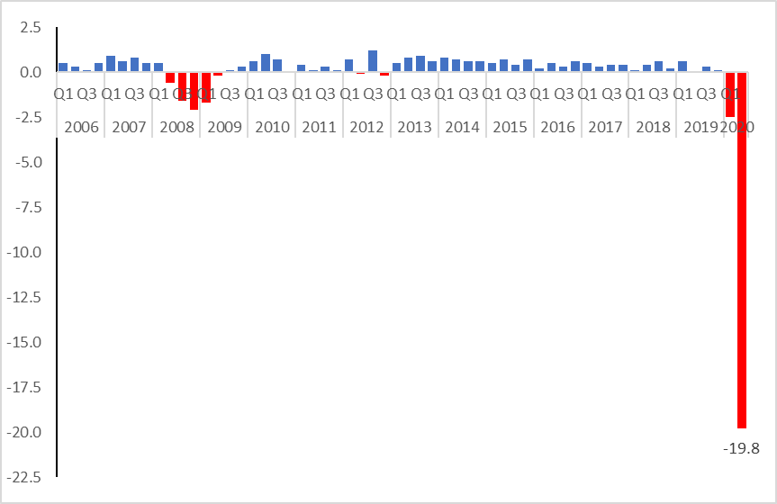
Last updated 30 September 2020.

ONS also produces a monthly series for the level of GDP, and this enables a finer-grained view of the effect of the pandemic and lockdown on economic activity. As we show in figure 1.2, monthly GDP saw a huge fall between February and May 2020.
Figure 1.2. Gross Domestic Product: Monthly Series. Source: ONS
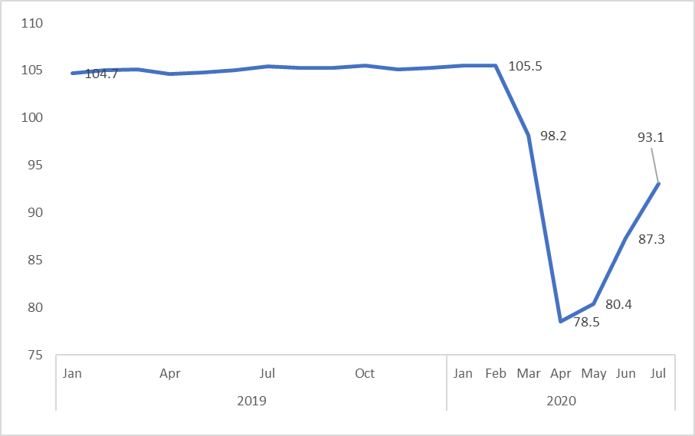
Last updated 11 September 2020.

Inflation is another useful economic indicator to monitor in relation to financial inclusion. When inflation is high, people face higher costs and so may struggle to manage money unless their incomes also rise. As we see in figure 1.3, inflation has been trending down in the last two years from a recent peak of 3.1 per cent in November 2017 to 1.0 per cent (Consumer Price Index including Housing costs of owner-occupiers) in August 2020 (see figure 1.3).
Figure 1.3. Consumer Price Inflation (CPI) and CPIH (including owner occupiers’ housing costs). Source: ONS
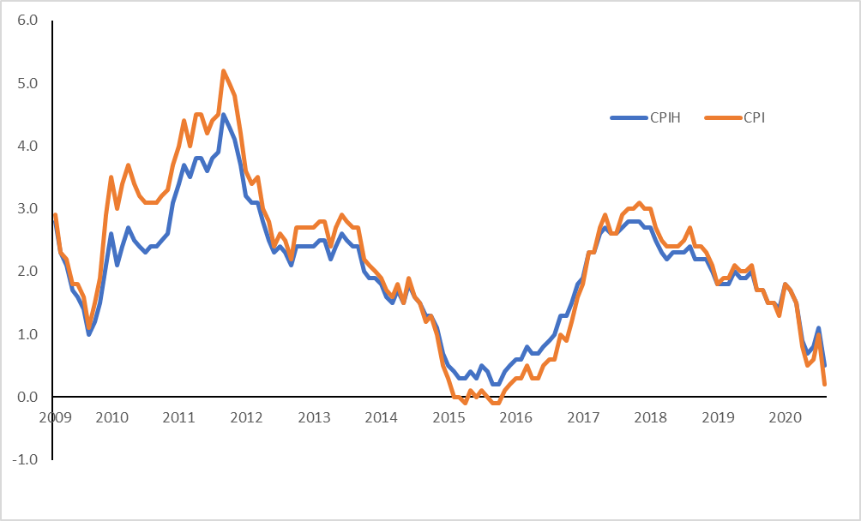
Last updated 16 September 2020.

The third economic indicator considered here is the Bank of England Base Interest Rate which affects the cost of borrowing. Interest rates have been at historic lows since the Global Financial Crisis of 2008/9 (at 0.5 per cent). But in 2017, the Bank of England Base Rate rose, albeit very slightly, for the first time in nearly a decade. A further slight increase took place in 2018 and the Base Rate reached 0.75 per cent. But, in response to the global pandemic, the rate was reduced again in March 2020 to the lowest it has ever been in the Bank of England’s 325 years: 0.1 per cent.
Figure 1.4. Bank of England Base Rate. Source: Bank of England
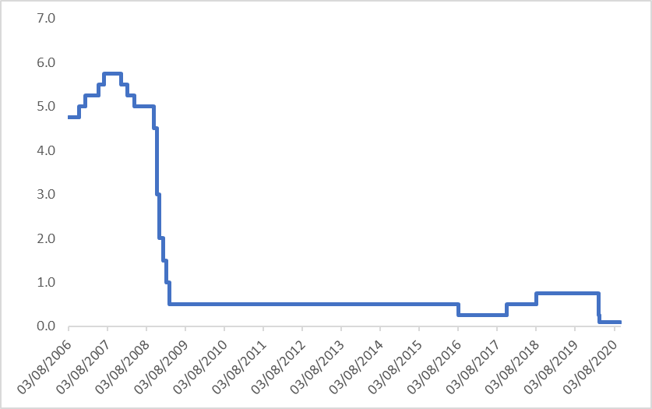
Updated 30 September 2020.

THE LABOUR MARKET

As we have also seen in previous reports, the Global Financial Crisis and ensuing recession of 2008/9 had a major impact on the labour market. Most recent data, for December 2019 to February 2020, shows that unemployment was at 1.36 million on the eve of the COVID-19 pandemic (see figure 2.1). This is far lower than at the height of the Global Financial Crisis when it reached 2.5 million. However, the previous six months had seen the first increase in unemployment since the Global Financial Crisis from the low of 1.28 million unemployed in August 2019. So there are signs that unemployment may have been starting to increase before the COVID-19 crisis, possibly in response to Brexit-related developments. By the end of 2019, long-term unemployment had also dropped on previous years - to just under 0.3 million, back again to pre-2008 levels. There is still, however, a slightly higher rate of unemployment for those who have been out of work for more than 2 years, compared to the rate before the Global Financial Crisis.

Figure 2.1. Unemployment levels started to increase slightly even before the COVID-19 crisis. Source: ONS Labour Force Survey

Underemployment also dropped between 2014 and 2018 from 3.1 million to 2.4 million workers ‘underemployed’ (see figure 2.2). But this was still more than the 1.9 million underemployed before the 2008/9 recession and the figures were trending slightly upwards again to 2.5 million by December 2019. Nevertheless, more workers considered themselves ‘overemployed’ (in other words they wanted to work fewer hours and would be willing to take a commensurate cut in pay) – nearly 3.5 million - at the end of 2019.
Figure 2.2. Underemployment began to increase slightly at the end of 2019. Source: Labour Force Survey

Underemployment is linked to part-time jobs and self-employment, both of which grew steadily from 2008 onwards while full-time employment dropped dramatically. Figure 2.3 shows the increase in part-time employment and self-employment (both full and part-time) from 2007 onwards. But it also shows that the level of full-time employment has increased even more dramatically since 2012 and was still increasing in 2019 though perhaps at a slower rate than before. These trends help explain some of the trends in underemployment.
Figure 2.3. Full-time employment continued to grow (taking 2006 as a baseline). Source ONS Labour Force Survey

Alongside ‘underemployment’ and the growth in part-time and self-employment, we have also seen a growth in zero hours contracts. Once again, definitions and measurements of such contracts (also referred to as ‘contracts with no guaranteed minimum number of hours’ – NGCHs) varies over time but the Office for National Statistics (ONS) has estimated, from a survey of individuals (the Labour Force Survey), that the number of people with a zero hours contracts rose to 907,000 or 2.8 per cent of workers at the end of 2016 – see figure 2.4. The numbers then fell by 2018 to 781,000 or 2.4 per cent of the labour force before picking up again in 2019 to a record high of 974,000 or 3 per cent. It is worth noting that these numbers are lower than those estimates based on data of the number of ‘actual’ zero hours contracts due to people not necessarily being aware that they have a ‘zero hours’ contract when asked about it in the survey. Also, it is quite possible that some people have more than one zero hours contract. Crucially, we still seem to have little data on how the hours worked on zero hours contracts actually vary from week to week.
Figure 2.4. Percentage and number of workers on "zero hours contracts" reached record high at the end of 2019. Source: ONS

It is often assumed that zero hours contracts are most commonly taken by younger people and it is indeed true that workers aged 16-24 are more likely to have a zero hours contract than any other age group (9.1 per cent) but the second age group most likely to have such a contract are those aged 65 or more (5.7 per cent). However, that represents only 74,000 people aged 65+ compared with 350,000 people aged 16-24. Women are slightly more likely than men to have such contracts (3.6 versus 2.4 per cent) – see figure 2.5. These patterns may partly reflect the groups most likely to find the flexibility of “zero-hours contracts” an advantage, for example, young people who combine flexible working with their studies, and those who have retired from their main occupation but are continuing with some work.
Figure 2.5. Zero hours contracts are most common among 16-24 year olds and those aged 65 and over, October-December 2019. Source: ONS Labour Force Survey

In terms of the particular impact of COVID-19 on the labour market, ONS data has revealed that, from 23 March to 5 April 2020, 27 per cent of the workforce had been furloughed across 6,150 businesses that responded to the Business Impact of Coronavirus (COVID-19) Survey (BICS) and were still trading or had temporarily paused trading. According to the Resolution Foundation, at the end of May, 8.4 million jobs had been furloughed – one-third of all private sector employees.
Further data, released by the Office for National Statistics in September 2020, showed that the number of people who were estimated to be temporarily away from work (including furloughed workers) had fallen, but it was still more than 5 million in July 2020, with over 2.5 million of these being away for three months or more. And the unemployment rate as measured by the ‘Claimant Count’ reached 2.7 million in August 2020, an increase of 120.8% since March 2020. The furlough scheme is due to end on 31st October 2020.
The COVID-19 pandemic, and the resulting lockdown has, very clearly, severely disrupted work patterns leading to an extraordinary increase in new claims for Universal Credit from people whose incomes had dropped (see figures 2.6 and 2.7). During March and April 2020 alone, there were nearly 2.5 million claims for University Credit, 2 million more than in the same period in 2019. At its peak, in late March to early April 2020, more than half a million Universal Credit applications were made each week, almost ten times the level of the previous year.
It is a testament to DWP that it was able to handle this volume of claims and keep the systems running. Indeed a study by the Resolution Foundation found that most UC payments were paid in full and on time with 74 per cent of new UC claimants reporting that they were satisfied with the way DWP handled their claim. UC is now supporting those in work and on low earnings, as well as the newly unemployed, and self-employed people awaiting grants or on reduced earnings.
These figures are for the population as a whole but, of course, some groups will be more affected than others. Research by the Centre for Economic Performance at the LSE has found that the people most likely to be negatively affected by the current recession were: young, low-paid, Black, in self-employment, with low education levels and living in large families.

Figure 2.6. Applications for Universal Credit each week from March to early July 2020 compared with the same figures in 2019. Source: Government Statistics
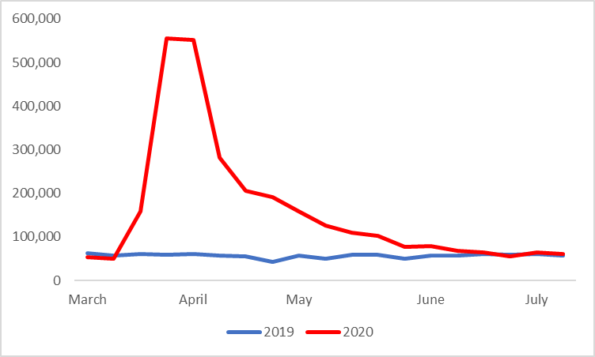
Figure 2.7. Applications for Universal Credit each week from March to early July 2020, compared with the same figures for 2019. Source: Government Statistics
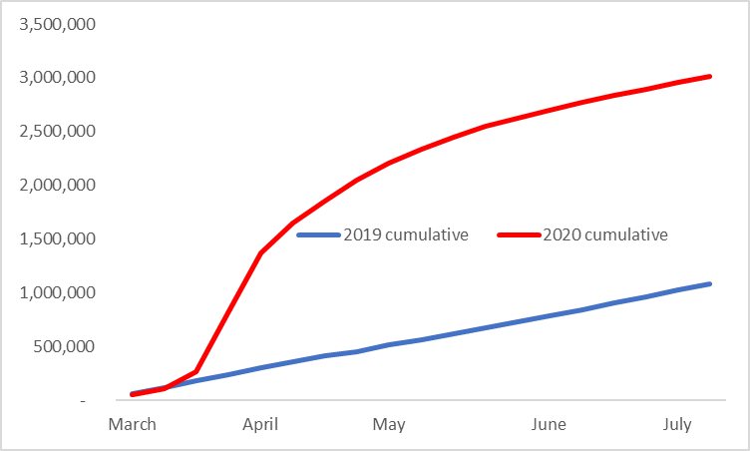

The Government acted to retain jobs, and much of people’s incomes, through various schemes. This included the ‘furloughing’ of employment. At its peak the Coronavirus Job Retention Scheme was supporting close to nine million employments – see figure 2.8.
Figure 2.8. Employments furloughed (number). Source: Government Statistics
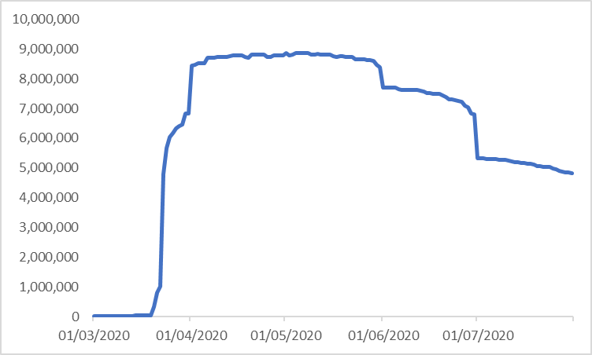
Last updated 18 September 2020.

The proportion of employees being moved on to furlough was not evenly distributed throughout the land. As shown in figure 2.9, younger people were particularly likely to have been on furlough, including a majority of teenaged employees. Older workers also had a higher than average chance of being put on furlough.

Figure 2.9. Employments furloughed. Source: Government Statistics
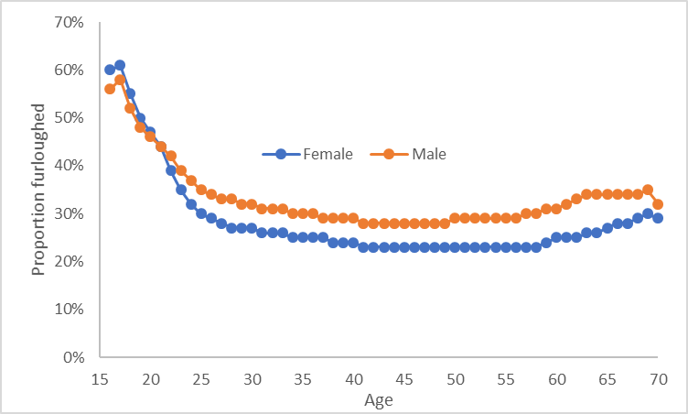
Taken from July 2020 data.

Incomes

Trends in relation to employment were broadly positive after 2008 though progress appeared to be stalling in 2019 and then crashing in 2020 due to COVID-19. The situation in relation to pay, however, had not been so positive prior to COVID-19. Average real weekly wages had started to increase in 2014-2015 but were still lower than prior to the 2008/9 recession. Rising inflation as a result of the Brexit vote’s impact on the value of the pound has further reduced levels of real pay at the end of 2016/early 2017 and this is reflected in the fact that the annual rate of change at the end of 2016 plummeted with a further drop in real wages in 2017. The following year, 2018, saw a recovery which continued for 2019. But at the end of 2019 real wages had still not reached their pre-Global Financial Crisis levels and wages started to fall slightly by February 2020, even before the COVID-19 crisis.
Figure 3.1. Levels of real pay rose in 2018 and 2019 but fell slightly by February 2020 (adjusted by inflation – Consumer Prices Index). Source: ONS

As figure 3.2 shows, there was a rise in poverty levels from 2010/11 to 2015/16 but there has been relatively little change since then. According to the Joseph Rowntree Foundation, poverty (after housing costs) has fallen slightly in the last year because of three housing-related factors: social sector rents in England were reduced by one per cent; the proportion of homes being bought with a mortgage (which often have lower housing costs than renting) increased slightly, while the proportion being privately rented fell; and actual private rents fell in some areas.
Figure 3.2. Relative poverty levels changed little since 2015/16 after rising from 2010/11 (incomes below 60 per cent median AHC). Source: IFS

The trends therefore show little change in the proportion of people experiencing poverty between 2017/18 and 2018/19 but the absolute numbers are still stark. According to the Joseph Rowntree Foundation, around 14 million people were in poverty in the UK (more than one in five of the population) in 2017/18, made up of 8 million working-age adults, 4 million children and 2 million pensioners. Over the last five years, poverty rates have risen for children and pensioners. In-work poverty has also risen, because workers’ pay, hours, or both, are not enough to avoid poverty. Around 56 per cent of people in poverty were in a working family, compared with 39 per cent 20 years ago. Poverty rates were highest in London, the North of England, Midlands and Wales, and lowest in the South (excluding London), Scotland and Northern Ireland.
This data predates COVID-19 by two years so cannot tell us about poverty levels now. However, the government’s lockdown policy has clearly had a major impact on the economy and household finances. At the same time, the government has also introduced a series of unprecedented measures to protect incomes and businesses. However, these schemes have not protected all households against economic shock and many households are now facing a very challenging financial situation.
According to a national survey by StepChange Debt Charity carried out at the end of May 2020, two months after the lockdown period began, 28 per cent of adults, or 14 million people, had experienced a direct negative effect on their income. We might expect that the vast majority of these people would be in the lowest income groups but the Resolution Foundation’s research has found that people have been affected throughout the income distribution by relatively similar amounts. For example, 37 per cent of adults in the bottom 40 per cent of working-age incomes reported income falls since the outbreak began, compared to 35 per cent of adults in the top 40 per cent of incomes.
The fact that the difference between these two groups is not as large as we might expect could be explained by the fact that lower earning individuals are actually quite spread across household income quintiles (as low-earners may be living with higher earners); that many on the lowest incomes were not actually in work when the crisis began and so not exposed to the labour market shock; and that the social security system has played an important role in cushioning job loss and earnings falls at the bottom. And while there has been an impact across the incomes distribution, those on lower incomes have less to lose, of course so a drop in income for this group may be much harder to manage than for those on higher household incomes.
While the picture in terms of income is perhaps a little unexpected, changes in spending reflect a much stronger distributional gradient. For example, 57 per cent of adults in the top quintile of working-age family incomes have experienced falling outgoings, compared with 30 per cent in the bottom quintile. This is likely to mean that those at the top will be able to save as a result of lockdown restrictions on non-essential spending. And the Resolution Foundation indeed reported that respondents in the top quintile were as likely to say that their personal financial situation has improved as worsened (23 per cent compared to 22 per cent). Those in the bottom quintile much more likely to say their financial situation has worsened (36 per cent) than improved (10 per cent)
Another study by the Resolution Foundation on housing costs found that while all tenure groups had seen similar falls in earnings, renters were more likely than owner-occupiers to have fallen behind with their housing payments. This is probably because owner-occupiers entered the crisis with lower average housing costs and more disposable income/savings than renters. Families have tended to manage housing costs by cutting back spending on other items but a majority of renters who have done so are also at risk of material deprivation. The study also shows that a small group of (especially younger) people had moved to another home, presumably their parents, and this is likely to be more of an option where parents are both willing and able to provide accommodation. The broad conclusion from the study was that housing is usually a family’s largest single regular cost which is difficult to flex with ease; and can lead to serious consequences if families cannot keep up with payments.
And a third study by the Resolution Foundation on Universal Credit made the point that the emergency boost to UC, tax credits and housing support on 20 March boosted the incomes of families in the poorest quarter by 5 per cent on average and strengthened the safety net, increasing the median replacement rate from 50 to 53 per cent. The amount of income protection provided under the Job Retention (furlough) Scheme (JRS), was however, far greater than that provided under social security benefits. The median fall in disposable income if furloughed was just 9 per cent, but that figure was 47 per cent if people lose their jobs and turn to UC. This means that workers who are made redundant as the JRS phases out may face large falls in income (the scheme is due to end on 31st October 2020). It also highlights the role that UC will play in supporting family finances during the long road back to normal times.
As mentioned above, a vital source of income for many people out of work (as well as in work) is the social security system. Figure 3.3 focuses on people of working-age and shows that, in the decade from 2009 to 2019, there was a massive drop in the adequacy of means-tested benefits to provide a minimum income. For example, a single person of working age only had 42 per cent of a minimum income standard in 2009 but this dropped still further to 32 per cent in 2019. Other working-age families saw similar drops in adequacy levels over this period though from different initial points (see figure 3.3). For 2020, the picture becomes more complex because of policy changes linked to COVID-19. For example, if we take the level of all means-tested, out-of-work benefits in 2020 prior to COVID-19 we can see in figure 3.3 that the adequacy of means-tested, out-of-work benefits (of all kinds) dropped still further for single people of working age (to 31 per cent). Couples of working age without children saw no change (remaining at 30 per cent adequacy). Lone parents with two children saw a slight increase in adequacy levels from 58 to 60 per cent and couples with two children also saw a very slight increase in adequacy levels from 56 to 57 per cent.
The final two bars for each family type in figure 3.3 illustrate the changes to adequacy levels as a result of the COVID-19 benefit reforms. Here, we see a difference emerge between those on ‘legacy’ benefits (income support, employment support allowance, jobseeker’s allowance) and those on Universal Credit. For example, those without children on legacy benefits have seen a small increase in adequacy levels. Those with children on these benefits have seen no change. But the big difference is for all groups on Universal Credit where single working-age people return to adequacy levels last seen in 2009 (though still very far from providing a minimum income standard) at 43 per cent. Families with children on universal credit have also seen a significant increase in adequacy of benefits though, again, still only reaching 65 per cent of lone parents with two children and 61 per cent for couples with two children.
Figure 3.3. Means-tested, out-of-work benefits as a percentage of Minimum Income Standards. Source: CRSP, Loughborough University

As far as pensioners go, we can see in figure 3.4 that means-tested pensioner benefits (e.g. Pension Credit) also dropped massively in adequacy levels between 2009 and 2019 and have only increased marginally in the last year. They do, however, continue to provide incomes much closer to the Minimum Income Standard level than for other groups. For example, single pensioners, if claiming all they are entitled to, will reach 94 per cent of the level they need for a minimum income standard and pensioner couples reach 92 per cent in 2020.
Figure 3.4. Means-tested benefits for pensioners as a percentage of Minimum Income Standards
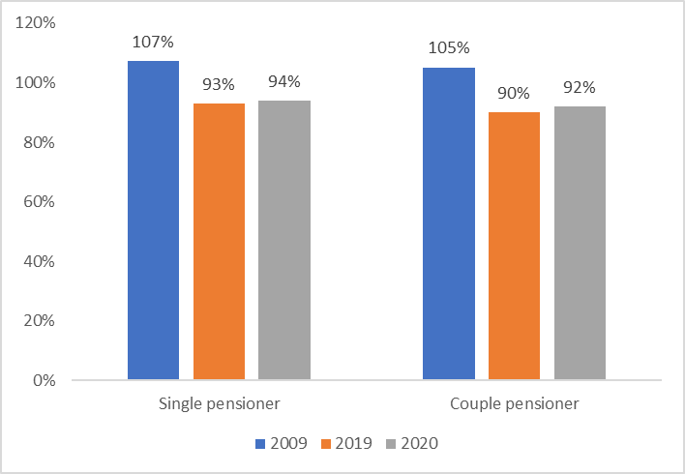
Levels of poverty have remained relatively stable over the past few years as measured in relation to average (median) incomes. But it is clear that some groups are suffering particularly severe levels of poverty and thus turning to emergency sources of help, such as foodbanks. Figures from the Trussell Trust, for example, show a dramatic increase in the number of 3-days emergency food parcels given out over the past few years with an increase from just over 61,000 in 2010/11 to nearly 1.9 million from 1st April 2019 to end of March 2020, that is, largely before the COVID-19 lockdown (see figure 3.5). The primary reason for use of food banks was, according to the Trussell Trust: low income; benefit delays; and benefit changes (including sanctions).

Figure 3.5. Number of people given 3-days emergency food and support by the Trussell Trust increases to 1.9 million
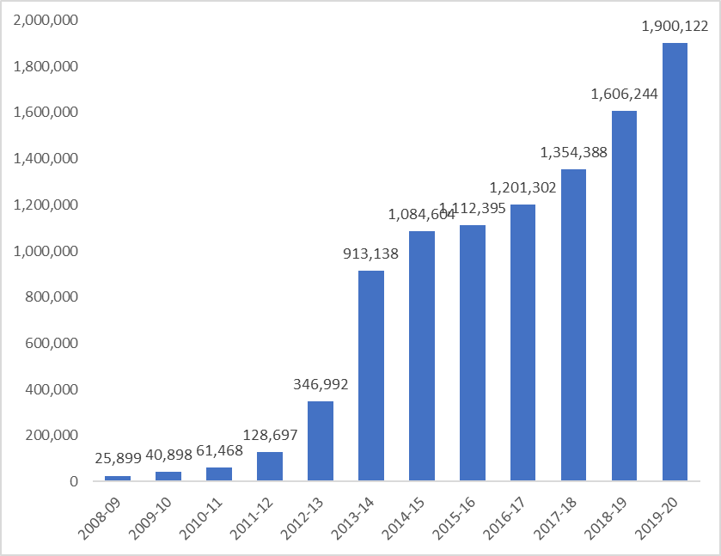
Following lockdown, in June 2020, The Trussell Trust reported an 89 per cent increase in need for emergency food parcels during April 2020 compared to the same month in the 2019, including a 107 per cent rise in parcels given to children. The number of families with children receiving parcels had almost doubled compared to the same period in 2019. The Trust also reported that food banks in the Independent Food Aid Network (IFAN) had seen a 175 per cent increase in need for the same period.
According to a YouGov survey for the Standard Life Foundation’s Coronavirus financial tracker, by the end of July 2020, a third (34 per cent) of households reported a fall in income as a direct consequence of the pandemic – that is a total of 9.7 million households across the UK. The effects of the lockdown on household finances were therefore still widespread even though about a third of those furloughed had returned to work, the.

Subjective financial wellbeing
So far in this report we have looked at objective measures of income and employment and shown increasing pressures on families to manage their finances. But how are they feeling about all of this? The Understanding Society survey asks people about how they are managing, financially, and according to our most up-to-date figures, 7.5 per cent of households in 2017/18 were finding it either very or quite difficult to manage financially and a further 21 per cent were ‘just about getting by’ – a combined total of 28.5 per cent (see figure 4.1).
Figure 4.1. Means tested benefits remain below what is needed for an inclusive lifestyle among those of working age.. Source: Understanding Society

If we look at trends over time with these figures, we see, in figure 4.2, that from 2007/8 to 2009/10 there was a major increase in the number of people just getting by or finding it difficult to do so. The following 7 years saw a decline in these figures but in the last year for which we have data (2017/18) we have seen a reversal of the trend here, with more people now saying that they are just getting by or finding it difficult to do so compared with the previous year (see figure 4.2).
Figure 4.2. Trends in subjective financial wellbeing, Understanding Society

Of course, some groups are struggling more than others and we see in figure 4.4 that around 45 per cent of those on the lowest incomes (those in the bottom 20 per cent of the income distribution) were finding it very or quite difficult to manage, financially, or were just about getting by in 2017/18.
Figure 4.3. Subjective financial wellbeing by income quintile, Understanding Society

Those who identified as ‘British’ (or identities naming their country within the UK) tended to report lower levels of difficulties than those with other identities (see figure 4.4). Levels of difficulty were particularly high for those describing themselves as ‘African’, ‘Caribbean’ or ‘Arab’, from the list of options with which they were presented. Similarly, respondents who identified as ’Pakistani’ or ‘Bangladeshi’ also had rather high levels of deprivation.
Figure 4.4. Subjective financial wellbeing by ‘ethnic group’: Understanding Society
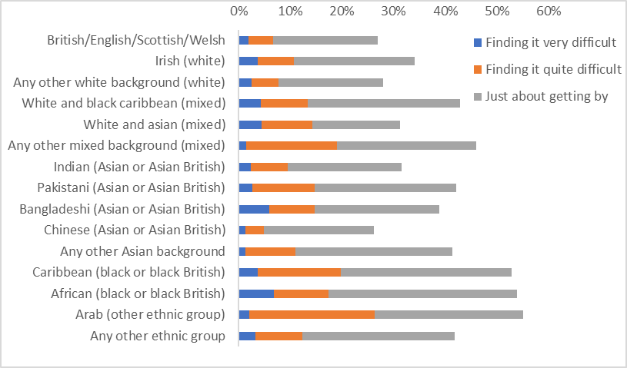
Note: groups with <50 cases are excluded.

These statistics are from 2017/18 and so cannot tell us about financial wellbeing during the current COVID-19 crisis. Given the great need to know about the situation now, the Office for National Statistics have run various surveys to measure public reactions to the pandemic. They have found that almost half (49.6 per cent) of people reported high anxiety (rating it between 6 and 10 out of 10) during the period 20 to 30 March (lockdown was announced on 23rd March). Average anxiety levels were 5.18 out of 10 and remained broadly at this level for the next couple of weeks. For reference, the average anxiety level was 2.97 out of 10 between October and December 2019.
In May 2020, people's most common concerns related to their well-being, their work, and their finances; those who thought they would not be able to save money in the next year reported anxiety 33 per cent higher on average compared with those who thought they would. People who had already been impacted financially were also reporting lower well-being; and people who had experienced a reduction in household finances because of COVID-19 reported 16 per cent higher anxiety on average. In the same May 2020 survey, people who were renting and the self-employed were more likely to have had their household finances and their jobs negatively impacted due to COVID-19, through reduced income, using savings to cover living costs, reduced working hours, and the inability to save for the future. And just under 1 in 4 adults (23 per cent) said the pandemic was affecting their household finances, similar to the previous week (24 per cent). The most common concern among these adults continued to be a reduced income (70 per cent), with increasing proportions, 30 per cent, saying they had needed to use savings to cover living costs, and 16 per cent saying they had to borrow money or use credit.
According to the Standard Life Foundation’s July 2020 Coronavirus finances tracker, 47 per cent of households said ‘thinking about my financial situation makes me anxious’.

Bank accounts
Access to a bank account is a core part of financial inclusion as it enables people to manage day-to-day financial transactions and this means having access to an appropriate:
- account or equivalent product into which income can be paid, held securely and accessed easily;
- method of paying and spreading the cost of household bills and regular commitments;
- method of paying for goods and services, including making remote purchases by telephone and on the internet.
The number of adults without access to an account of any kind is relatively small as a proportion of the population. The Family Resources Survey collects a great deal of detail about accounts, but the opening question seeks to identify whether any accounts are either currently held, or have been held in the last 12 months. In Table 5.1 we extend the series of estimates of the unbanked previously produced by the Financial Inclusion Taskforce (set up by HM Treasury) to the latest data for 2018/19.
The first column shows the number of adults without a current or basic bank account. This figure also includes people who ‘did not state’ whether they had an account or not. Previous research suggests these are more likely to be without an account but some of these people will have one. The figures in table 5.1 (see also figure 5.1) show that there has been a steady decline in the numbers of unbanked adults according to this measure from 2.85m in 2005/6 to a low of 1.5m in 2012-13. However, the figure then increased before falling the last few years to fall just below 1 million (996,000) in 2018-19 (higher of the two lines in figure 5.1).
Some adults may not have a bank account themselves but they may live in a household where someone else has an account. And if that person (partner, parent, adult child) shares the benefits of doing so with them, the lack of an account may be less of a concern. The final column of table 5.1 (and the lower line figure 5.1) therefore shows the number of adults living in households without access to a relevant account. It also excludes those who ‘did not state’ whether or not they have an account, focusing only on those who positively stated that they did not have an account. This group is the most severely excluded. The trend for this group has also been downward over the period of study from 2005/6 to 2018/19 but not at the same rate and there are still half a million adults living in households who positively state that they do not have access to a transactional form of banking.
Figure 5.1. Trends in numbers of people without bank accounts (million people)

Table 5.1: Households and adults without access to a current or basic bank account, or savings account, Family Resources Survey,
Year | Adults without current or basic bank account (including 'did not state') | Adults living in households without access to a current or basic bank account, or savings account (including 'did not state') | Adults living in households without access to a current or basic bank account, or savings account – Positively affirmed no account
2018-19 | 0.996m | 0.68m | 0.48m
2017-18 | 1.03m | 0.77m | 0.57m
2016-17 | 1.23m | 0.87m | 0.68m
2015-16 | 1.52m | 0.88m | 0.71m
2014-15 | 1.64m | 0.89m | 0.64m
2013-14 | 1.71m | 1.02m | 0.73m
2012-13 | 1.50m | 1.00m | 0.66m
2011-12 | 1.87m | 1.37m | 0.70m
2010-11 | 1.97m | 1.51m | 0.78m
2009-10 | 2.36m | 1.78m | 0.87m
2008-09 | 2.54m | 1.85m | 0.87m
2007/08 | 2.71m | 1.85m | 0.89m
2006/07 | 3.00m | 2.09m | 1.01m
2005/06 | 2.85m | 1.97m | 1.00m
2002-03 | 4.38m | 2.83m | 2.02m
Figures are not available for 2003/04 and 2004/05. In those years the FRS did not distinguish between basic bank accounts and post office card accounts (which have generally not been counted as a relevant account in past monitoring figures).

Another issue in relation to access to bank accounts is branch closures which have been increasing dramatically over the last few years – over 1,000 branches closed between 2015-2016, just over 10 per cent of the network. While the banks claim, quite rightly, that online banking has increased and so fewer branches are needed, digital exclusion remains a problem and so branch closures are adversely affecting those customers who cannot (easily) access online banking.
The importance of maintaining access to cash was stressed in Access to Cash Review which reported that cash is used to make three in 10 transactions, down from six in 10 a decade ago. This has since been updated by UK Finance’s latest Payments Market Review, which puts the figure at 23 per cent. But it could fall as low as one in 10 in the coming two decades. At the same time, around 8 million adults have reported that they would be unable to manage in a cashless society. Moreover, Positive Money found that 77 per cent of people regarded cash as essential to their daily lives.
More recently, Which? research published in November 2019 found that more than a third of bank and building society branches have closed in less than five years. While this may not be a problem for the most digital savvy consumers, a survey by Which? found that a fifth of the public – equivalent to 11 million adults – would not even be confident checking their balance online via a website or app. Previous Which? research had also revealed that some 5,334 free machines were either closed or converted to fee-paying between January 2018 and May 2019. And in their survey, nine out of 10 people said that cash was an important backup which is important given that figures from the FCA reported that banks had experienced 265 IT glitches in the last year. These included 133 incidents involving internet banking and 111 mobile banking failures.
In the budget in March 2020, the government announced that it would introduce new laws to protect access to cash. And HM Treasury is engaging closely with stakeholders including the Bank of England, the Financial Conduct Authority (FCA) and Payment Systems Regulator (PSR) to ensure that regulators have the right responsibilities and powers so that industry continues to meet the needs of cash users across the UK. The role of the Post Office may also be important here.

Savings

Savings are important in relation to financial inclusion because they can help people meet one-off expenses (both anticipated and unanticipated expenses). They can also help people to manage a drop in income and avoid taking out high-cost credit and/or experiencing problem debt. However, as we shall see, levels of saving are low in Britain, particularly among people on low incomes who need them most. This is largely due to a lack of income to save (see earlier in this report) but attitudes to spending and saving are also important. 'Incentives' to save are also important and this links to interest rates and other potential ways to encourage people to save.
There are many ways to measure actual and potential saving. One approach is the household saving ratio as measured in the National Accounts by subtracting household spending – on goods and services, housing and financial services – from household income, which includes post-tax earnings from employment, benefits and net interest received, as well as imputed sources of income. A lower saving ratio may arise either because of a fall in households’ income, a rise in their expenditure or a combination of the two. As shown in figure 6.1, the saving ratio was 13.2 per cent, at the beginning of 1997 and this fell to a low of 4.8 per cent just before the economic crash. The fall in the savings ratio over this period was due to strong consumer confidence and the rise in house prices which led many households to increase their spending and take on more debt. The savings ratio then grew sharply as a result of the Global Financial Crisis as households became more cautious and tended to pay off their debts and cut back on spending. Unemployment and lower incomes would also have reduced discretionary spending. The savings ratio reached its lowest since the turn of the century at 4.0 in Q1 of 2017. Since then, it has recovered slightly to 8.4 in Q1 of 2020, with a huge spike (which may well be temporary) during Q2 of 2020, when opportunities for spending were rather curtailed.
Figure 6.1. The Household Savings Ratio has increased since the recent low of 2017, with a lockdown spike. Source: Office for National Statistics
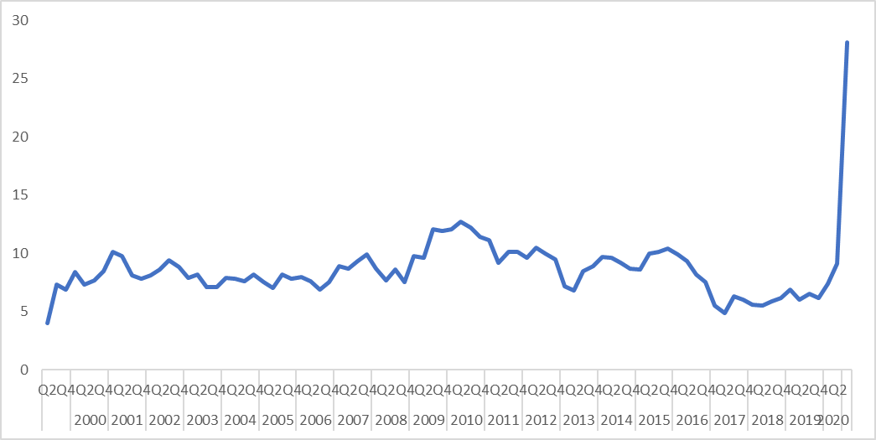
Last updated 30 September 2020.

Every few years the British Household Panel Survey/Understanding Society survey asks people about their saving behaviour – both whether they save ‘now and then’ and, if so, how much. The latest findings, for 2016/17 show that 43 per cent of the population say they save something but this varies considerably by earnings level. Those with earnings in the top fifth of the distribution are twice as likely to save compared with those who have no earnings (65 per cent compared with 31 per cent). Nevertheless, it is interesting to see that almost one third of those without earnings still save something.
Figure 6.2. Levels of Saving in 2016/17 are highest for those on the highest earnings. Source: Understanding Society

Figure 6.3 is based on those who do save something ‘now and then’ and it shows that the average (mean) amount saved per month by savers was £304 in 2016/17. But savers in the top fifth of the earnings distribution were saving three times as much as those in the bottom fifth (£586 compared with £194).
Figure 6.3. Amount saved per month (mean) among those who save something ‘now and then’ are highest for those on the highest earnings. Source: Understanding Society

Levels of saving are not just related to level of disposable income, of course, but also to attitudes to spending/saving which can be influenced by a range of factors, not least the 'incentives' to save, including those related to the interest rate on savings. But, in this regard, there has been very little incentive to save in recent years given that interest rates have been negligible since 2009 (see Figure 1.3 above).
In 2018, the government introduced Help to Save accounts to encourage and reward saving among those entitled to Working Tax Credit or receiving Universal Credit. These savers receive, in general terms, a bonus of 50p for every £1 they save over 4 years. Under the scheme, individuals can save up to £50 per month with the 50 per cent bonus payable at the end of the second and fourth years.
According to data from HM Treasury, the total number of accounts in July 2020 was 222,000 and around 162,000 individuals had made a deposit into their Help to Save account. For those individuals making deposits, the average deposit per person per month was £48. However, there were 60,500 accounts that had not received any deposit at all so far. In total, more than £70m had been saved by people on low incomes but take-up of Help to Save is estimated to be well below 10 per cent as there are around 3 million people eligible.
For those whose incomes have been affected by the impact of COVID-19, any savings are likely to be drawn on quite quickly and the Resolution Foundation have estimated that one-third of those in the second income quintile have reduced the amount they save (and 22 per cent have cut their saving by more than 10 per cent) as a result of the crisis. But they have also estimated that over one-third of the richest fifth of the population have seen their savings increase in the first months of the crisis.

Pensions

Pensions are rarely included in discussions about financial inclusion, but they are clearly important in relation to financial security and inclusion in later life. Figure 7.1 provides data on the number of active members of occupational pension schemes – with separate figures for those in the private sector and those in the public sector. Private sector schemes had been on the decline since the late 1960s but the mandatory introduction, in 2012, of auto enrolled workplace pensions has seen a massive increase so that, in 2018, 11 million people had such pensions. This is far higher than the number of people with public sector pensions, but this figure has also increased since 2012, albeit at a much slower rate to 6.3 million (see figure 7.1).
Figure 7.1. Active membership of occupational pension schemes by sector increases dramatically from 2012 to 2018 after long decline. Source: Office for National Statistics Occupational Pension Schemes Survey

The newly-introduced workplace pensions from 2012 onwards are almost certainly all defined contribution (DC) schemes – hence the increase in such schemes shown in figure 7.2. DC schemes are typically much less secure and generous than defined benefit (DB) schemes. With DC schemes, the contributions paid in by the member and their employer are invested. From age 55 the member can then access the proceeds in one of four ways: to take a lump sum for the full amount of the pot, to purchase a drawdown product and access their money over several years, to purchase an annuity (regular income for life), or to take an uncrystallised pension fund lump sum (UFPLS) for a proportion of their pot and leave the remainder invested. The amount that will be available is very uncertain compared to DB schemes where the employer is obliged to pay a set amount (e.g. half the final salary or career average if someone contributes for 40 years).
Figure 7.2. Active membership of defined contribution occupational pensions now exceeds the numbers for defined benefit schemes (percentage of employees with workplace pension). Source: Office for National Statistics Occupational Pension Schemes Survey

While the numbers with an active pension look promising in relation to financial inclusion, there are a couple of important points to bear in mind. First of all, figures from NEST (who are a key provider of workplace pensions, show that, as at March 2017, only 60 per cent of their workplace pension members were truly ‘active’. And even among those who were actively contributing, the amounts paid into these pensions may also be insufficient (at around five per cent of earnings, in recent data) to provide a decent standard of living in later life. Employers also seem to be paying much less into DC schemes compared with DB schemes (see figure 7.3). The difference between the contributions of employers to the different schemes also reflects differences in the public/private sector split with DB schemes much more likely to be within the public sector where employers are more generous.
Figure 7.3. Member and employer average contribution rates in defined contribution schemes now lower than those in defined benefit schemes

Borrowing

As we have stressed in previous reports, some forms of borrowing/debt may be very positive in some circumstances, for example, in enabling people to buy a home or invest in education. Borrowing can also help people to smooth income and expenditure and meet one-off expenses where they do not have savings (see above). However, those on the lowest incomes are often charged the highest rates for borrowing and may also be borrowing to pay for essentials due to low income. This section highlights key data on borrowing.
Before doing so, however, it is again important to note that different terms and definitions are used here. Some data sources refer to all ‘borrowing’ as ‘debt’ while others refer to ‘credit’ and still others to ‘indebtedness’. Furthermore, how different activities are labelled is open to question. For example, someone may have a credit card but never use it or just use it as a payment mechanism, clearing the full balance every month. Should this count as ‘borrowing’ or not? And there are also different datasets which ask questions of different samples in different ways leading to different answers. It is therefore important to bear all of this in mind when interpreting the data.
Our data on borrowing comes from different sources, using different definitions and methods of data collection. It is therefore difficult to get a consistent picture of trends over time and some of the most useful data sets have not been updated since 2008/9 and so cannot show the impact of the recession/recovery on borrowing. A new national survey of ‘credit and debt’ is urgently needed.
The Resolution Foundation, drawing on data from the Bank of England, report that the total stock of secured debt (mostly mortgages) rose from £363bn in 1997 to £1.4tn in 2018, while the stock of consumer (mostly unsecured) debt rose from £58bn to £203bn over the same period. These figures are striking but they also report that while the total value of household secured debt relative to disposable income today (97 per cent) is higher than in 1994 (62 per cent) it is below levels reached during the financial crisis (110 per cent). Furthermore, the value of unsecured (mostly consumer and excluding student loan) debt is, at 15 per cent of income, 4 percentage points lower than levels reached immediately before the financial crisis. In other words, household debt remains below Global Financial Crisis levels.
Our analysis similarly shows that the annual rate of growth in credit card lending reached a particular low in 2012/13 but then increased to a peak in June 2018 (see figure 8.1) no doubt due to an increase in loan limits as banks have been given ‘funding for lending’ to stimulate borrowing and spending. The rate of growth has fallen since then, however, probably due to uncertainty around Brexit and, most recently, the global pandemic crisis. Indeed, from March 2020, the growth rate has been actually negative. In May, June, July and August of 2020, credit card lending was more than 10 percentage points lower than the same point last year.
Figure 8.1. Monthly 12-month growth rate of total sterling net credit card lending to individuals fells dramatically from March 2020 onwards. Source: Bank of England
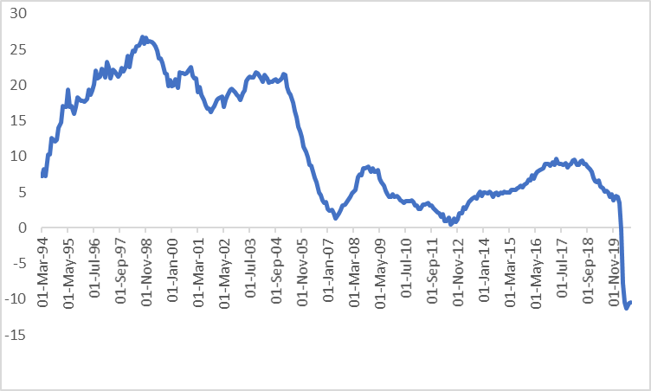
The reduction is clearer, during the lockdown, if we just look at the period from January to August 2020. Lending dived from a 5% growth rate at the end of January to a negative growth rate of -10% by the end of April. It stayed roughly at this level into July, indicating that lending was 10% lower in July 2020 than it had been in July 2019.
If we look at similar figures for consumer credit which exclude credit cards (and student loans), we also see a massive increase in lending since 2010. Much of this increase is probably accounted for by car finance. But the trend has also been downward since 2017 and, indeed, the very latest figures for 2020 suggest that this growth in lending is now falling rapidly (see figure 8.2), with actual falls in June, July and August 2020.
Figure 8.2. Monthly 12-month growth rate of total (excluding the Student Loans Company and credit card) sterling net consumer credit lending to individuals (in percent) falls from March 2020. Source: Bank of England
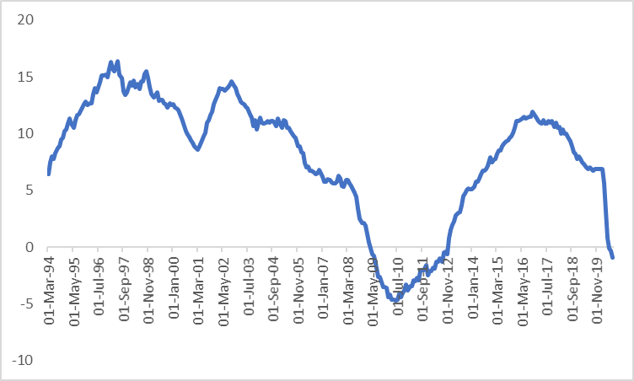
Turning now to mortgage lending, figure 8.3 shows the massive drop in mortgage lending in 2007/8 followed by a slow but steady increase which plateaued from 2015 to 2019. The global pandemic crisis, again, saw an abrupt fall in mortgage lending in March 2020, but this has now fully recovered to pre-lockdown levels.
Figure 8.3. Monthly number of total sterling approvals for house purchase to individuals seasonally adjusted, Source: Bank of England
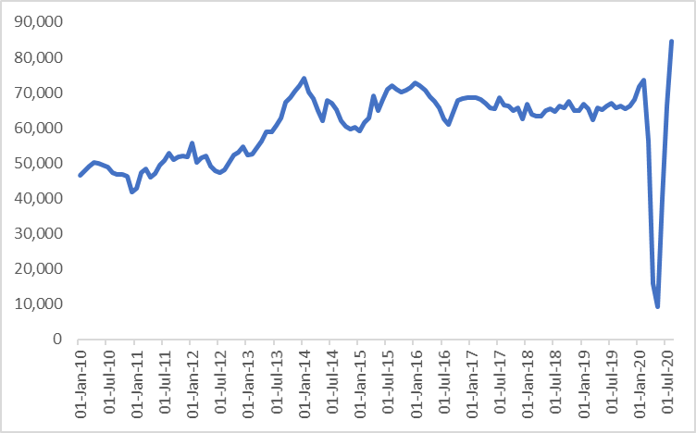
The recovery is very clear if we focus on the last year, from September 2019 until August 2020. Numbers in April-June were well down on trend, but there seems to be a return to pre-lockdown levels in July and August. Indeed, numbers are higher, which may represent some catching up of lost business.
The latest figures from the Wealth and Assets Survey are from 2016/2018 and so do not provide information about the current situation but they do allow us to break down the figures by different groups. Figure 8.4 therefore shows that those with the least wealth (bottom 10 per cent) were most likely to have taken out unsecured (mon-mortgage) credit with 61 per cent of households having done so in 2016/18 compared with 33 per cent of those in the highest wealth households (top 10 per cent). But those in the lowest wealth households were least likely to have taken out borrowing linked to a property (mortgage borrowing) This was highest among those with average amounts of wealth, presumably because the wealthiest households had already paid off their mortgages and so their high level of wealth was partly linked to being outright home owners.
Figure 8.4. Non-mortgage borrowing is most common among those on the lowest 10 per cent of incomes, Source: Wealth and Assets Survey 2016/18

Figures from the Wealth and Assets Survey also show that total non-mortgage borrowing (also referred to as financial debt) had also risen, from £107 billion in 2014/16 to £119 billion in 2016/18, an increase of £12 billion (11 per cent). As with property debt, the increase in total household financial debt in the latest period was driven by a combination of both an increase in the number of households with financial debt and increasing levels of financial debt. The number of households with financial debt increased over this period from 12.4 million to 12.7 million. Median household financial debt (for households with financial debt) was £4,000 in2014/16, after adjusting for inflation and this rose to £4,500 in the latest period, 2016/18, an increase of 12 per cent. In time, we will see just how many more both households with financial debt, and with increasingly levels of debt, have been generated by the policy responses to the coronavirus crisis, despite payment holidays.
A rather different form of borrowing is student loans. These are only paid back once the borrower earns over a certain threshold. Nevertheless, it is worth reflecting on the amount borrowed. According to a House of Commons Briefing Paper in 2019 there was currently more than £17 billion loaned to around 1.3 million higher education students in England each year. The value of outstanding loans at the end of March 2019 reached £121 billion (see figure 8.5). The Government forecasts the value of outstanding loans to reach around £450 billion (2018-19 prices) by the middle of this century.
Figure 8.5. Total amount outstanding at the end of the financial year, including loans not yet due for repayment. Source: Student Loans Company and House of Commons

The average Loan Balance for those who finished their courses in 2018 was £34,800 (see figure 8.6). But the Government expects that (only) 30 per cent of current full-time undergraduates who take out loans will repay them in full. Full time students entering HE in 2012/13 who completed three years of study are included in this average, but the average balance is diluted by other borrower types in the same repayment cohort.
Figure 8.6. The average Loan Balance for those entering into repayment. Source: Student Loans Company

High-cost credit is a particular concern in relation to financial inclusion as the poorest tend to pay the most to borrow money - sometimes for necessities. But reliable and timely data on this is difficult to find. According to the FCA’s 2017 Financial Lives Survey a third of the 52 million personal current account users in the UK used arranged overdrafts, and a quarter used unarranged overdrafts, while more than 3m consumers used the other forms of high-cost credit (equivalent to one in twenty – or 6 per cent UK adults). Some groups were more likely to use particular types of high-cost credit than others. For example, payday loans, short‑term instalment loans and pawnbroking were more likely to be used by younger adults (18‑34 year olds) and single people. Hire purchase and logbook loans were more commonly used by older adults and couples. Women were more likely than men to be customers of home collected credit while men were more likely than women to use payday loans.
In terms of overdraft use, the Financial Lives survey also found that, in 2017, 12.9 million people, or a quarter (25 per cent) of all UK adults, had been overdrawn at some point in the last 12 months. One in ten (9 per cent) UK adults were overdrawn at the time of the survey in 2017. Credit cards, however, were the most widely held credit product with three fifths (62 per cent) of all UK adults, or 31.6 million people, having a credit card, but only one fifth (19 per cent), or 9.6 million people, using the card for credit purposes, that is, revolving a balance. Most credit card holders paid their bill off in full every month if they used their card at all.
Financial inclusion policies generally aim to increase access to affordable credit, including credit unions and over 2.1 million people (including young people) were members of credit unions in the UK with the vast majority (1.9 million) being adults. There has been a 4.5 per cent increase in adult members over the previous year but a drop of 2.3 per cent of young members (under 16). While most members are based in England (see figure 8.7) the percentage of the English population who are credit union members is actually very small (about 2 per cent). The percentage of Northern Irish population who are members is much greater at about one in three (32 per cent) see figure 8.8.

Figure 8.7. Total number of members of credit unions in the UK (including 'Juvenile Depositors') in 2019. Source: Bank of England Data

Figure 8.8. Percentage of population in country who are members of credit unions in the UK (including 'Juvenile Depositors') in 2019. Source: Bank of England Data

Problem debt

We saw, in the previous section, levels of borrowing. This chapter reviews data on the difficulties people may have in repaying this debt. It also reviews difficulties paying utility and other bills. As is the case with data on ‘borrowing’, there are also issues in relation to data on ‘problem debt’. Once again, definitions vary, and the way data is collected over time also varies. Also, while data on debts is collected on some routine surveys (such as the Wealth and Assets Survey and Family Resources Survey) the detail provided by these datasets is limited and it takes several years for the data to become openly available. The Bank of England/NMG data provides some additional data which is released more quickly but we still lack a comprehensive picture of problem debt and the last time that we had such a survey was in 2008/9 when the Department for Trade and Industry/Business Innovation and Skills carried out a series of surveys. We therefore suggest, again this year, that the government should take action to ensure the collection of better evidence on problem debt.
In the Family Resources Survey 2018/19, we see that six per cent of the population said that they could not keep up with bills and regular debt payments. Figure 9.1 breaks these figures down in relation to different types of problem debt, with council tax debt being the most common type, followed by water rates (or rates in Northern Ireland) then electricity and then rent. Arrears on Council Tax were also the largest in 2017/18.

Figure 9.1. Problem debt in 2018/19

Another sign of potential problem debt is where people are paying a large percentage of their income on consumer credit repayments. The IFS has found that, in 2016-18, well before the COVID-19 pandemic, more than one in five individuals lived in a household where more than 10 per cent of their income was spent on unsecured debt repayments. A further one in ten lived in households that spent over 20 per cent of income on debt repayments and a further one in twenty lived in households that spent over 30 per cent of income on debt repayments. Figure 9.2 shows that those on middle incomes – who have the potential to see significant income falls as a result of the crisis – were most likely to have significant levels of debt repayments: almost one in four of those in the 7th income decile spent more than 10 per cent of their income on debt repayments, and 12 per cent of those in the 4th income decile spend over 20 per cent of their income on debt repayments. As Figure 9.2 also shows, debt repayments were most likely to take up very high shares of income (of over 30 per cent) at the very bottom of the income distribution.

Figure 9.2. Percentage of income spent on unsecured debt repayments by income decile. Source IFS using 2016/18 Wealth and Assets Survey

Research by StepChange Debt Charity published in June 2020 reported that, at the end of May 2020, two months after lockdown began, almost half (45 per cent) of those in severe problem debt before the outbreak had been negatively affected financially by the pandemic compared to 25 per cent of those not in financial difficulty. They estimated that the 4.6 million people negatively affected had accumulated £6.1 billion of arrears and debt, averaging £1,076 in arrears and £997 in debt per adult affected. Furthermore, from March to May 2020, 2.8 million people had fallen into arrears: most frequently utilities (1.2 million people), council tax (820,000 people) and rent (590,000 people). Some people (4.2 million in total) were using credit to make ends meet, most often using a credit card (1.7 million), an overdraft (1.6 million) or a high cost credit product.
According to the Standard Life Foundation’s Coronavirus financial tracker, between May and July 2020, the proportion of households that currently owed money in missed payments (including agreed ‘payment holidays’) had increased from 16 to 18 per cent. And among the 16 per cent of households who were struggling to make ends meet, the figure was much higher, with 37 per cent having missed payments on one or more of their commitments (including payment holidays).
If people are not able to keep on top of their debts there can, of course be serious consequences. Linked to this, another indicator of serious problem debt is the rate of insolvency. Individual insolvency procedures include bankruptcy, debt relief orders (with effect from 6 April 2009) and individual voluntary arrangements:
- Bankruptcy: a form of debt relief available for anyone who is unable to pay the debts they owe. Any assets owned will vest in a trustee in bankruptcy who will sell them and distribute the proceeds to creditors in accordance with the order laid down by statute.
- Debt relief order: a form of debt relief available to those who owe £15,000 or less and have little by way of assets or income. There is no distribution to creditors, and discharge from debts takes place 12 months after the DRO is granted.
- Individual Voluntary Arrangements – a voluntary means of repaying creditors some or all of what they are owed. Once approved by the majority of creditors, the arrangement is binding on all. Such arrangements are supervised by a licensed Insolvency Practitioner.
Quarterly data from the Insolvency Service shows that the total numbers of individual insolvencies fell to around 19,000 in the second quarter (April to June) 2015 but then rose to just over 34, 000 in the last quarter (October to December) 2018 before falling again. Nevertheless, the total number of insolvencies during the whole of 2019 was just short of 122,000. And the first quarter of 2020 recorded nearly 29,000 (see figure 9.3).
Figure 9.3. individual insolvencies in UK, quarterly data. Source: Insolvency Service

Another, quite extreme, indicator of problem debt is the number of properties taken into possession over time. Figure 9.4 shows this trend both for mortgage repossessions and landlord possessions with a considerable difference in the trend. Mortgage repossessions declined steadily from 2009 to 2015 before reaching a plateau of around 7,000 per year. But there has been an increase in the last year from 1,590 mortgage possessions in the third quarter of 2018 to 2,130 in the third quarter of 2019. Landlord repossessions, by contrast, peaked at 10,785 in the first quarter of 2014. For that year as a whole, over 40,000 evictions took place. In 2018, that annual figure had fallen to 27,000. The latest quarter we have data for was the third quarter of 2019 when there were 3,374 evictions, suggesting that there would have been a further fall in the numbers of evictions in 2019 as a whole compared with 2018 if the trend had continued and, in particular, if the COVID-19 crisis had not hit.
Figure 9.4. Mortgage repossessions and landlord possessions 2009-2019. Source: Government Statistics

Figure 9.5 shows quarterly claims for possession broken down by different kinds of procedure/landlord. This shows that the major decline in evictions has been in terms of the accelerated procedures and with social landlords. Indeed, over the last couple of years there has been an increase in evictions by private landlords from just under 6,000 in the whole of 2015 to just over 8,000 in 2016.
Figure 9.5. Quarterly claims for possession in England Wales by type of procedure and landlord, 2009 - 2019, Q3. Source: Government statistics

This decline in repossessions might seem surprising given the extent of the recession and austerity in the UK but it appears to be the result of actions taken by government, regulators and other key actors. Low interest rates have certainly helped along with increased help with mortgage payments when people lose their jobs. The government also introduced new protocols to ensure that lenders exercised greater forbearance when borrowers found themselves in arrears. Moreover, the Bank of England notes that “UK households entered the Covid-19 shock in a stronger financial position than before the global financial crisis, in part due to financial policies that have guarded against an increase in the number of highly indebted households”. Despite this, reports on credit conditions show some early signs of concerns about increased defaults on loans. Projected increases in unemployment-related indebtedness show increases, but not necessarily to the high levels experienced during the Global Financial Crisis.
Research by Shelter, published in July 2020, estimated that 227,000 adult private renters (3 per cent) had fallen into arrears since the start of the pandemic, in addition to those already in arrears. Shelter also point out that under the current court system, anyone who has accrued rent arrears of eight weeks or more can be automatically evicted, in addition to the risk of being subjected to a Section 21 ‘no fault’ eviction.
There have, of course, been recent actions to reduce possessions and evictions as a result of COVID-19 with lenders providing the facility for mortgage payment ‘holidays’ and the government putting a halt to evictions (extended until 20th September 2020) and providing some more resource towards the cost of rent for some groups. However, as these provisions end, possessions and evictions are likely to increase substantially unless there is a very rapid economic recovery or additional government support and forbearance from landlords and lenders.

Insurance
When budgets are tight, as they have increasingly become in the last few years, home contents insurance may seem like an expensive luxury. In particular, people on the lowest incomes may have relatively few possessions to insure and may find that the products available are designed for those with more. There have therefore been a number of attempts to increase the proportion of households covered by home contents insurance, not least by investigating ways of involving the third sector and making the products more appropriate to low-income households in terms of the minimum amount that needs to be covered. But there appears to have been a continuing slow decline in the proportion of households with home contents insurance. Figures from the Family Resources Survey suggest the proportion of working adults who had home contents insurance in 2008/9 and 2018/19 dropped from 65 per cent to 60 per cent (see figure 10.1). The table excludes those who did not answer the question, saying that it was ‘not applicable’ (about 13 per cent in 2018/19)
Figure 10.1. Home contents insurance for working-age adults 2008/9 to 2018/19. Source: Family Resources Surveys

Conclusions

COVID-19 has had, and is likely to continue for some time to have, a devastating impact on household finances in the UK and globally. But before we review what our data tell us about this, it is important to note that, even prior to the pandemic, family budgets and the UK’s economy more generally were already faltering in many ways, possibly as a result of Brexit-related uncertainties during 2019.
Prior to COVID-19, economic growth was negative in the second quarter of 2019 and zero in the fourth quarter. Unemployment, under-employment and zero hours contracts had all increased in 2019 while wages had started to fall in real terms towards the end of that year and into early 2020. Around 14 million people were living in poverty in the UK in 2018/19 made up of 8 million working-age adults, 4 million children and 2 million pensioners. Linked to this, the adequacy levels of benefits (how they compare to people’s needs) were falling. Subjective financial wellbeing was also decreasing prior to COVID-19 with an increase in the proportion of the population saying they were ‘just about getting by’ or ‘finding things difficult’ in 2017/18 – the first time this figure had increased since 2009/10.
On a more positive note for financial inclusion, the number of people ‘unbanked’ has continued to fall to a record low of less than 1 million adults in 2018/19. And fewer than half a million people lived in households where no-one had access to a bank account. We may also find some hope for the future in terms of pensions with increasing levels of occupational pension membership but there are concerns that people are not putting enough, if anything, into their pensions and so will nevertheless lack a sufficient level of income on retirement.
In terms of borrowing, the rate of increase in credit card lending was starting to slow prior to COVID-19 while mortgage borrowing was holding steady. Insolvencies had dropped from their peak in 2018 but remained high at 122,000 in 2019. Landlord possessions had declined but were still at 27,000 in 2018 and there was some sign of an increase in mortgage possessions in 2019. So there were clear signs of strains on family budgets during 2019 prior to COVID-19. And the UK now looks set to enter its worst recession since at least the 1930s. From March to May 2020, between one quarter and one third of jobs were furloughed and from March to April that year there were 2 million more claims for Universal Credit than there had been in the same period in 2019. By the end of May 2020, 28 per cent of the population said that COVID-19 had had a direct negative effect on their income.
The Job Retention (furlough) Scheme and the boost to Universal Credit have been incredibly important interventions to support people’s incomes. Those on ‘legacy’ benefits, however, are not seeing the same level of income protection, leading to a two-tier benefit system. Moreover, the retention of the benefit cap may have reduced the helpfulness of the increase made to Universal Credit. And despite all this support, the Trussell Trust have seen a doubling of emergency food parcels going to families with children in April 2020 compared with April 2019.
COVID-19 has led to an increase in already high levels of anxiety about finances with an estimated 4.6 million people now in arrears on household commitments totalling around £6 billion. StepChange Debt Charity estimate that 2.7 million people have accessed ‘payment holidays’ on mortgage and credit products which will come to an end. And Shelter estimate that around 230,000 adult private renters had fallen into arrears since the start of the pandemic, meaning they could lose their homes when the evictions ban is due to end on 20th September. These are extremely difficult times for the country and many within it. Some statistics reveal, however, that a significant minority of the population is unaffected, financially, by COVID-19 or, indeed, are somewhat better off financially as their incomes remain the same but their expenditure drops. Inequality is therefore likely to rise still further.

Appendix: Data sources and research methods

This research, funded by the Friends Provident Foundation and Barrow Cadbury Trust, began with stakeholder engagement to help refine the scope of the research. The research then draws on analysis of a range of existing data sources as outlined below. We also review key research studies, and statistics produced, by other organisations as appropriate.

Stakeholder engagement
The research began with discussions with key stakeholders about the approach the research might take. Stephen McKay led a workshop at the 2012 Centre for Responsible Credit conference and then the project team held an event in London in January 2013 to specifically discuss to consider the scope of the research (in particular, how wide or narrow a definition of financial inclusion we should use), the type of indicators we might monitor and the data sources we should consult. Stakeholders engaged included Brian Pomeroy, former Chair of the Financial Inclusion Taskforce alongside representatives from: Fair Banking Foundation; Centre for Responsible Credit; Financial Services Authority; DWP Finance Change, Credit Union Expansion project; Which?; ABCUL ; Resolution Foundation; IPPR; and Transact.

Secondary analysis of existing data sources
A number of data sources were analysed as part of this research. The two key sources were administrative systems of various kinds, and sample surveys available to the academic community:

Administrative data
Aggregated data is available from, in particular, the Office for National Statistics (ONS), the Bank of England and various government departments.
ONS data includes summary data from certain surveys, such as the Labour Force Survey and Wealth and Assets Survey (see below) and from administrative systems including numbers receiving benefits of various kinds. They are also responsible for price indices, such as the CPI.
The Bank of England provides data on credit and mortgages.
Various government departments provide data on their area of competence. So, the Department for Work and Pensions (DWP) provides data on numbers receiving benefits, such as universal credit.

Survey data
Sample surveys are conducted within government on a regular basis, and by some academic bodies. Many of these surveys may be accessed at the UK Data Service, subject to certain conditions. Below we list the main surveys used in this report.
  - Wealth and Assets Survey (WAS)
This is a panel survey of people’s assets and general wealth, including pensions, financial assets, property and savings. Six waves/rounds have been produced, covering 2006-08, 2008-10, 2010-12, 2012-14, 2014-16 and 2016-18. Each wave of the survey includes around 20,000 households, or more.. These data are Crown Copyright.
  - Family Resources Survey (FRS)
This is a long-running annual cross-sectional survey of over 24,000 households. It is used by government and others to describe the income distribution and numbers of households below various income lines. It also collects details about bank accounts held, and those in arrears on particular household commitments. These data are Crown Copyright.
  - Labour Force Survey (LFS)
Each quarter around 120,000 individuals are included in the LFS. The emphasis is on collecting labour market data, including those who are unemployed. These data are Crown Copyright.
  - Understanding Society
This is a very large household panel study, including over 40,000 households each wave. It follows on from a similar panel survey (the British Household Panel Survey).
  - Older surveys
There are a number of sources of data on credit and debt using different methodologies, making trends over time difficult to measure. Many of these sources are also considerably out of date. The Department of Trade and Industry/Business Innovation and Skills carried out a series of studies on over-indebtedness beginning with a detailed survey by MORI in 2002, which involved 1,647 face-to-face interviews with the head of household or their spouse/partner. A second survey was also carried out in 2004 by MORI (the Financial Services Survey, or MFS) which collected data from almost 10,000 individuals. Results for 2006 were based on unweighted ONS data collected for 7,443 households interviewed between July and December 2006. In particular, the results for the MFS in 2004 are not directly comparable with the other results available, as they are based on responses for individuals rather than households or family units. BIS then published a report on over-indebtedness in Britain based on data from the YouGov DebtTrack survey, a series of on-line surveys carried out between July 2008 and July 2009 with a sample size of around 3,000. Another source of data here is the NMG survey for the Bank of England, carried out in 2012-2016,
.

Kempson, E and Collard, S (2012) Developing a vision for financial inclusion, London: Friends Provident Foundation.
The MIS team works at the Centre for Research into Social Policy at Loughborough University, see http://www.minimumincomestandard.org/index.htm
Rowe, B., De Ionno, D., Peters, D. and Wright, H. (2016) Mind the gap. Consumer research exploring experiences of financial exclusion across the UK. London: ESRO/FCA. Available at: https://www.fca.org.uk/static/documents/research/vulnerability-exposed-research.pdf.
See, for example: Berry, C (2014) ‘Citizenship in a financialised society: financial inclusion and the state before and after the crash’ Policy & Politics, 1-17; Finlayson, A (2009) ‘Financialisation, financial literacy and asset-based welfare, British Journal of Politics and International Relations, 11, 3, 400-21; Leyshon, A and Thrift, N (2009) ‘The capitalisation of almost everything: the future of finance and capitalism, Theory, Culture and Society, 24, (7-8), 97-115
See Rowlingson, K and McKay, S (2014) Financial inclusion annual monitoring report 2014, Birmingham: University of Birmingham
See Appleyard, L (2015) Financial inclusion: review of Coalition Government policies 2010-2015, Birmingham: University of Birmingham
See Gardner, J and Rowlingson, K (2015) ‘High cost credit and welfare reform’, In Defence of Welfare II http://www.social-policy.org.uk/wordpress/wp-content/uploads/2015/04/08_gardner1.pdf
Financial Inclusion Commission (2015) Financial inclusion: improving the financial health of the nation
McKay, S. and Rowlingson, K. (2015) Social security under the coalition and Conservatives: shredding the system for people of working age; privileging pensioners in Bochel, H. and Powell, M. (eds) The Coalition government and social policy, Bristol: The Policy Press.
Collard, S, Coppack, M, Lowe, J and Sarkar, S (2016) Access to financial services in the UK. London: FCA, http://www.fca.org.uk/static/documents/occasional-papers/occasional-paper-17.pdf
https://www.parliament.uk/financial-exclusion
HM Treasury (2019) Financial Inclusion Report 2018-19 https://www.gov.uk/government/publications/financial-inclusion-report-2018-to-2019
https://londoneconomics.co.uk/blog/publication/feasibility-study-into-the-viability-of-establishing-a-no-interest-loans-scheme-nils-in-the-uk-march-2020/
https://www.ons.gov.uk/economy/grossdomesticproductgdp/timeseries/ihyq/qna
https://www.ons.gov.uk/economy/grossdomesticproductgdp/bulletins/gdpmonthlyestimateuk/july2020
https://www.ons.gov.uk/economy/inflationandpriceindices/bulletins/consumerpriceinflation/august2020
https://www.bankofengland.co.uk/monetary-policy/the-interest-rate-bank-rate
https://www.ons.gov.uk/employmentandlabourmarket/peopleinwork/employmentandemployeetypes/datasets/employmentunemploymentandeconomicinactivitybyagegroupseasonallyadjusteda05sa
The definition and measurement of underemployment has changed recently and so the precise figures for previous years are different from last year’s report but the broad concept and underlying trends are the same. Basically, underemployed workers are those who are employed but who either wish to work more hours in their current role or who are looking for an additional job or for a replacement job which offers more hours. They must be able to start working extra hours within the next two weeks to be categorized as ‘underemployed’.
https://www.ons.gov.uk/employmentandlabourmarket/peopleinwork/employmentandemployeetypes/datasets/underemploymentandoveremploymentemp16
https://www.ons.gov.uk/employmentandlabourmarket/peopleinwork/employmentandemployeetypes/bulletins/employmentintheuk/latest#data
https://www.ons.gov.uk/employmentandlabourmarket/peopleinwork/employmentandemployeetypes/datasets/emp17peopleinemploymentonzerohourscontracts
https://www.ons.gov.uk/employmentandlabourmarket/peopleinwork/employmentandemployeetypes/datasets/emp17peopleinemploymentonzerohourscontracts
https://www.ons.gov.uk/employmentandlabourmarket/peopleinwork/employmentandemployeetypes/articles/furloughingofworkersacrossukbusinesses/23march2020to5april2020
https://www.resolutionfoundation.org/comment/three-big-decisions-for-the-chancellor-on-the-future-of-the-job-retention-scheme/
https://www.ons.gov.uk/employmentandlabourmarket/peopleinwork/employmentandemployeetypes/bulletins/uklabourmarket/september2020
Brewer, M. and Handscomb, K. (2020) This time is different – Universal Credit’s first recession: Assessing the welfare system and its effect on living standards during the coronavirus epidemic. London: Resolution Foundation. https://www.resolutionfoundation.org/publications/this-time-is-different-universal-credits-first-recession/
Brian Bell, Mihai Codreanu and Stephen Machin (2020) What can previous recessions tell us about the Covid-19 downturn?, A CEP Covid-19 analysis, Paper No.007, http://cep.lse.ac.uk/pubs/download/cepcovid-19-007.pdf
Source: DWP Stat-Xplore system.
Source: DWP Stat-Xplore system.
https://www.gov.uk/government/statistics/coronavirus-job-retention-scheme-statistics-september-2020
https://www.gov.uk/government/statistics/coronavirus-job-retention-scheme-statistics-july-2020
https://www.ons.gov.uk/employmentandlabourmarket/peopleinwork/earningsandworkinghours/timeseries/a2fc/lms?referrer=search&searchTerm=a2fc
https://www.jrf.org.uk/report/uk-poverty-2019-20
https://www.ifs.org.uk/tools_and_resources/incomes_in_uk
https://www.jrf.org.uk/report/uk-poverty-2019-20
StepChange (2020) Coronavirus and personal debt: a financial recovery strategy for households June 2020: https://www.stepchange.org/Portals/0/assets/pdf/coronavirus-policy-briefing-stepchange.pdf
Brewer. M. & Gardiner, L. (2020) Return to spender: Findings on family incomes and spending from the Resolution Foundation’s coronavirus survey. London: Resolution Foundation. https://www.resolutionfoundation.org/publications/return-to-spender/
ibid
Judge, L. (2020) Coping with housing costs during the coronavirus crisis: Flash findings from the Resolution Foundation’s coronavirus survey. London: Resolution Foundation. https://www.resolutionfoundation.org/publications/coping-with-housing-costs-during-the-coronavirus-crisis/
Brewer, M. and Handscomb, K.(2020) This time is different – Universal Credit’s first recession: Assessing the welfare system and its effect on living standards during the coronavirus epidemic. London: Resolution Foundation https://www.resolutionfoundation.org/publications/this-time-is-different-universal-credits-first-recession/
Figures for previous years and methodology can be found here https://www.jrf.org.uk/sites/default/files/jrf/migrated/files/MIS-2015-full.pdf
Data sent by email from Donald Hirsch on 1st June 2020. MIS reports can be found here: https://www.lboro.ac.uk/research/crsp/mis/reports/
Data sent by email from Donald Hirsch on 1st June 2020. MIS reports can be found here: https://www.lboro.ac.uk/research/crsp/mis/reports/
https://www.trusselltrust.org/news-and-blog/latest-stats/end-year-stats/
https://www.trusselltrust.org/2020/06/03/food-banks-busiest-month/
Elaine Kempson, David Collings, Christian Poppe and Jamie Evans (2020) Emerging from lockdown: Key Findings from the 3rd Coronavirus Financial Impact Tracker Survey, Standard Life Foundation
https://www.understandingsociety.ac.uk/
https://www.understandingsociety.ac.uk/
https://www.understandingsociety.ac.uk/
https://www.ons.gov.uk/peoplepopulationandcommunity/healthandsocialcare/conditionsanddiseases/articles/coronaviruscovid19roundup/2020-03-26#wellbeing
https://www.ons.gov.uk/peoplepopulationandcommunity/wellbeing/bulletins/personalandeconomicwellbeingintheuk/may2020
Elaine Kempson, David Collings, Christian Poppe and Jamie Evans (2020) Emerging from lockdown: Key Findings from the 3rd Coronavirus Financial Impact Tracker Survey, Standard Life Foundation
See Kempson, E and Collard, S (2012) Developing a vision for financial inclusion, London: Friends Provident Foundation
HM Treasury, March 2007, Financial Inclusion: The Way Forward.
Source: own analysis of Family Resources Survey for 2008-09 onwards based on previous methodology from HM Treasury which drew data from different questions on account-holding in the FRS. Published HMT figures for 2002-03 (http://www.hm-reasury.gov.uk/d/stats_briefing_101210.pdf).
Some waves of data have been re-released with new information on weights, so estimates vary slightly from those previously published.
House of Commons Library briefing note, 385 (2016) Bank Branch Closures, file://cssfs15/home2/rowlingk/rowlingk%20Documents/Admin/College%20DoR/SN00385.pdf
https://www.accesstocash.org.uk/media/1087/final-report-final-web.pdf
https://www.ukfinance.org.uk/system/files/UK-Payment-Markets-Report-2020-SUMMARY.pdf
https://positivemoney.org/2019/12/all-the-latest-on-our-campaign-to-protect-free-access-to-cash/
https://www.which.co.uk/news/2019/11/bank-branch-closures-risk-leaving-millions-of-people-behind/
https://www.which.co.uk/news/2019/11/uk-banks-suffer-five-it-shutdowns-every-week-how-does-yours-rank/
http://www.ons.gov.uk/economy/nationalaccounts/uksectoraccounts/articles/nationalaccountsarticles/2015-07-01#the-saving-ratio-is-on-a-downward-trend. The Non-Profit Institutions Serving Households sector is currently measured alongside households, and comprises of institutions such as charities and trade unions. For the purposes of the data in this report, any mention of the household sector includes NPISH.
https://www.ons.gov.uk/economy/grossdomesticproductgdp/timeseries/nrjs/ukea
More specifically, the year 4 bonus will be 50 per cent of the difference between the highest balance saved in the first 2 years and the highest balance saved in the last 2 years.
https://assets.publishing.service.gov.uk/government/uploads/system/uploads/attachment_data/file/912379/Help_to_Save_August_2020.pdf
https://www.thisismoney.co.uk/money/saving/article-7411637/More-40-000-signed-Help-Save-six-months-say-HMRC.html
https://www.resolutionfoundation.org/app/uploads/2020/06/Rainy-Days.pdf
In these ONS figures, ‘active members are current employees who would normally contribute to the pension scheme (or have contributions made on their behalf)’.
https://www.ons.gov.uk/peoplepopulationandcommunity/personalandhouseholdfinances/pensionssavingsandinvestments/bulletins/occupationalpensionschemessurvey/uk2017
http://www.nestpensions.org.uk/schemeweb/NestWeb/includes/public/docs/NEST-in-numbers_April_2017,PDF.pdf
https://www.resolutionfoundation.org/app/uploads/2020/01/An-outstanding-balance.pdf
https://www.ons.gov.uk/peoplepopulationandcommunity/personalandhouseholdfinances/incomeandwealth/bulletins/householddebtingreatbritain/latest
https://commonslibrary.parliament.uk/research-briefings/sn01079/
https://www.slc.co.uk/official-statistics/student-loans-debt-and-repayment/england.aspx, https://commonslibrary.parliament.uk/research-briefings/sn01079/
https://commonslibrary.parliament.uk/research-briefings/sn01079/
https://www.slc.co.uk/official-statistics/student-loans-debt-and-repayment/england.aspx
FCA (2017) Understanding the financial lives of UK adults: Findings from the FCA’s Financial Lives Survey 2017 https://www.fca.org.uk/publication/research/financial-lives-survey-2017.pdf
defined in terms of payday loans, short‑term instalment loans, home collected loans, pawnbroking, hire purchase (other than for a motor vehicle) and logbook loans.
https://www.bankofengland.co.uk/statistics/credit-union/2019/2019-q4
https://www.bankofengland.co.uk/statistics/credit-union/2019/2019-q4
https://www.ifs.org.uk/publications/14820
https://www.ifs.org.uk/publications/14820
StepChange Debt Charity (2020) Coronavirus and personal debt: a financial recovery strategy for households June 2020 https://www.stepchange.org/Portals/0/assets/pdf/coronavirus-policy-briefing-stepchange.pdf
Elaine Kempson, David Collings, Christian Poppe and Jamie Evans (2020) Emerging from lockdown: Key Findings from the 3rd Coronavirus Financial Impact Tracker Survey, Standard Life Foundation
See the Insolvency Service website: http://www.bis.gov.uk/insolvency
https://www.gov.uk/government/statistics/individual-insolvency-statistics-january-to-march-2019
https://www.gov.uk/government/statistics/mortgage-and-landlord-possession-statistics-october-to-december-2019
https://www.gov.uk/government/statistics/mortgage-and-landlord-possession-statistics-october-to-december-2019
Kempson, E. (2016) What explains the low impact of the financial crisis on levels of arrears among UK households? in Ferretti, F (ed) Comparative Perspectives of Consumer Over-Indebtedness. A View from the UK, Germany, Greece, and Italy. Eleven International Publishing
Page 13 of https://www.bankofengland.co.uk/-/media/boe/files/financial-stability-report/2020/august-2020.pdf.
https://www.bankofengland.co.uk/credit-conditions-survey/2020/2020-q2
E.g. Chart B1 https://www.bankofengland.co.uk/-/media/boe/files/financial-stability-report/2020/august-2020.pdf
https://england.shelter.org.uk/media/press_releases/articles/230,000_renters_at_risk_of_covid-eviction_when_the_government_ban_lifts
Dayson, K, Vik, P and Ward, A (2009) Developing models for delivering insurance through CDFIs – opportunities and risks, Community Finance Solutions
https://cpag.org.uk/news-blogs/news-listings/covid-capped
https://www.ukdataservice.ac.uk/.
https://www.ons.gov.uk/releases/wealthingreatbritainwave62016to2018.
Department for Work and Pensions, National Centre for Social Research and Office for National Statistics. Social and Vital Statistics Division, Family Resources Survey, 2010-2011 [computer file]. Colchester, Essex: UK Data Archive [distributor], October 2012. SN: 7085 , http://dx.doi.org/10.5255/UKDA-SN-7085-1
Office for National Statistics. Social Survey Division and Northern Ireland Statistics and Research Agency. Central Survey Unit, Quarterly Labour Force Survey, July - September, 2012 [computer file]. Colchester, Essex: UK Data Archive [distributor], November 2012. SN: 7174 , http://dx.doi.org/10.5255/UKDA-SN-7174-1
https://www.understandingsociety.ac.uk/.
BIS (2010) Over-indebtedness in Britain: second follow-up report, http://www.bis.gov.uk/assets/BISCore/consumer-issues/docs/10-830-over-indebtedness-second-report.pdf
Between 12 and 30 September 2013, NMG Consulting carried out an online survey of around 6,000 UK households on behalf of the Bank and asked them a range of questions about their finances. See: http://www.bankofengland.co.uk/publications/Documents/quarterlybulletin/2013/qb130406.pdf
http://www.bankofengland.co.uk/research/Pages/onebank/datasets.aspx#2

