Sustainability Engagement Strategy for Staff and Students 2023
The University of Birmingham has made a strategic and policy commitment to Sustainability, being one of six pillars within our 2030 Strategic Framework. This recognises that as a research-intensive University founded on social responsibility, we have the expertise and partnerships to play a significant role in tackling global sustainability challenges. We have also committed to embed Sustainability in all our activities, seeking to change society and the environment positively through our research and education, using the 17 United Nations Sustainable Development Goals.
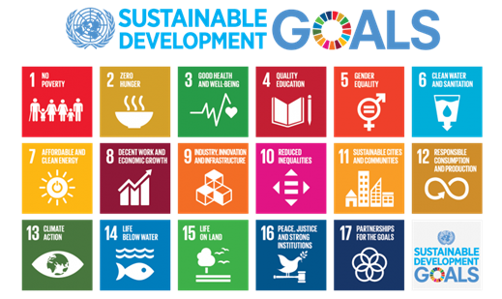

Objectives for the Engagement Strategy:
The following strategic objectives are used when designing and delivering Engagement activities:
- We will support staff and students to be knowledgeable about issues of sustainability and how to integrate sustainability into everyday actions, behaviours, and business practices. This will support the delivery of the University’s ambitious Net Zero Carbon targets and contribute to socially responsible activities. The areas of focus typically includes a focus on one or more areas:
- Biodiversity
- Carbon
- Energy
- Procurement
- Resource use
- Travel
- Waste
- Water
- We will create ongoing opportunities for the University’s community to engage and address the biggest impacts within their working environment through a range of interventions.
- We will engender a more sustainable culture, enriched and informed by regular events and communications. This will empower greater ownership of actions and achievement of goals.
- We will equip our students to be knowledgeable practitioners of sustainability, ensuring our courses address sustainability in the context of each subject. We will enable our graduates to be global citizens, insightful leaders, and contributors to a more sustainable future in their chosen career and their lives. It should be noted, that although the Guild of Students and the student societies provide numerous opportunities throughout any academic year, we will work with closely with them, and collaborate on events.
- We will draw on our academic expertise to develop programmes on climate change and sustainable solutions, from natural to social capital. The full list of academic courses available can be found here.
- We will use the UN Sustainable Development Goals to increase engagement, understanding and alignment in everything we do. In addition, we will be developing educational material for each discipline to further this work.

Monitoring and Measuring
As a Measure of Success or strategic KPI, progress in Sustainability is being monitored, measured, and subsequently reported, through the applied governance structure, up to University Council. We are in the process of developing the measures to monitor progress against our priorities relating to community engagement and will finalise this during 2023/24.
As part of the University’s planning activities, we will develop and deliver a yearly Engagement Campaign for both staff and students, to increase interest and effect engagement in more sustainable practices.

Communication
This will be provided to colleagues, students and the wider community, wherever appropriate, through targeted and measured activities. Tactics may include email, social media, PR, events, and partnerships.
Where appropriate, case studies or news item will be posted on the website to recognise and celebrate achievements.
Best practice will be shared across partnerships and external fora, as appropriate.
An indicative summary of events that have been provided for staff and students, is set out within the Appendix. This includes the name of the event, the audience, the objective, the attendance, and the impact.

Responsibility
The Head of Sustainability is responsible for coordinating and publishing the yearly Engagement Campaign of activities, in collaboration with the following:
- The Deputy PVC Sustainability
- The Director of Sustainability Education
- The Director of Campus Services and Team
- The Director of Estates and Team
- The University of Birmingham Guild of Students

Appendix: A Sample of Sustainability Engagement Events (2022/23)

Date | Name of Event/Activity | Audience | Approx Reach
Summer-autumn 2022 | Numerous Sustainable Travel presentations | Staff | 500+
Academic Year 2022-23 | Development of Life and Natural Sciences Garden | Students and Staff | ~400
Academic Year 2022-23 | BIFoR Volunteer Scheme | Students | -
Academic Year 2022-23 | ARLI (Alternative Raw Material with Low Impact) supporting sustainable student start ups | Students | 5 projects
Sep-22 | Welcome Fair | Students | 3,283
Sep-22 | Travel fair | Students | 200
Oct-22 | Sustainable Travel Survey | Students and staff | 6,035
Oct-22 | Staff benefits fair | Staff | 700
Dec-22 | Sustainability Town Hall | Students and Staff | 80
Jan-23 | Cost of Living Fair | Staff | 600
Mar-23 | Wellbeing and Sustainability in Easter edition of the Campus Services newsletter | Staff | 970
Mar-23 | Great British Spring Clean | Staff and Students | 18
April-23 | Green Impact introductory webinar | Staff | 168
April/May-23 | Visits to BIFoR | Students | 60
May-23 | Green Impact training and auditing | Students | 45
Jun-23 | Sustainability Open Forum and Green Impact Awards | Staff & Students | 268
Jun-23 | Apprentices - Sustainability Workshop | Staff | 25
Jun-23 | Junkbusters | Students/ residents of Selly Oak Campus | -
Summer - 23 | Summer Sustainability Internships | Students | 20

