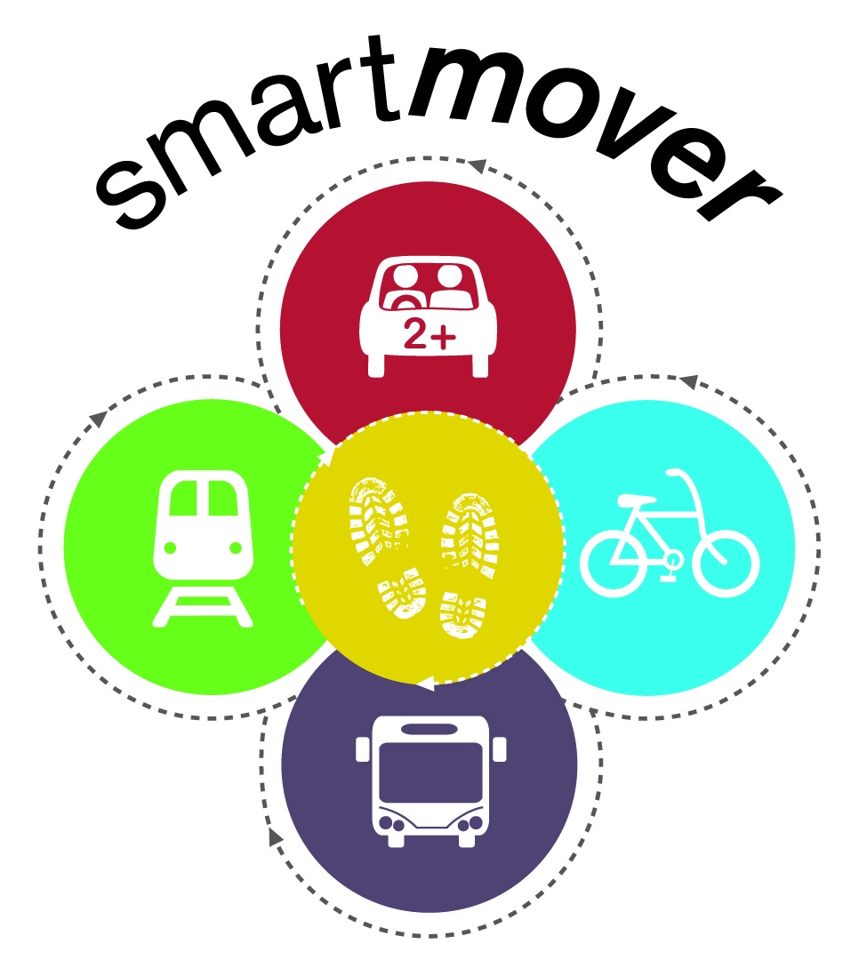
Action Plan
University of Birmingham
Sustainable Travel
Action Plan
2010 – 2015
Updated August 2015

9.1 The following Action Plan sets out the proposed Travel Plan targets accompanied by the University’s existing sustainable travel initiatives and proposed measures that could be considered to aid their achievement and the approximate cost of the measures.

9.2 The Action Plan sets out the resources that have been identified to date to enable implementation of the Plan.

Key to Action Plan

STPSG - Sustainable Travel Plan Steering Group
STG – Sustainable Task Group
STC - Sustainable Travel Coordinator
SEA - Sustainability and Environmental Advisor
HAS – Hospitality and Accommodation Services
HR – Human Resources
BUBUG – Birmingham University Bicycle Users Group
BCC – Birmingham City Council
CSTG – Campus Safe Transport Group
EDF – Estates Development Framework

Travel Plan updated August 2015
(Sustainable Travel Co-ordinator)

Area | Objective | Action | Means | Ownership | Status | Timescale/  deadline
Commuting | Identify current modes of travel for comparison with targets and baselines to assist in further informing and developing the Travel Plan.  Analyse the carbon footprint for Scope 3 reporting purposes | Travel survey of both staff and students | Undertake an online travel survey of both staff and students.  Employ a Travel Survey Officer to assist in the marketing, promotion and statistical analysis of the survey.  Liaise with University Hospitals Birmingham (UHB) and Women’s Hospital to comprise a jointly compatible travel survey.  Exchange and compare information on key findings from the survey with Birmingham City Council and Centro and link into LSTF. | STC & UHB | Survey held between 18th Feb and 31st March  Reports completed June 2013  Currently assisting UHB with a further survey Summer 2014 | Communications ongoing
 | Identify staff commuting routes | Map and analyse current routes travelled by commuters and cross reference with local travel services | Map staff and student postcodes via GIS and share information with UHB, National Express and Centro. | STPSG | Staff postcodes collected and GIS expertise sourced from academic dept.  Public transport maps obtained from Centro | Completed  June 2013
Marketing and Communication  Marketing and Communication  (cont.)  Marketing and Communication  (cont.) | Raise awareness and promote Travel Plan initiatives  Raise awareness and promote Travel Plan initiatives  (cont.)  Raise awareness and promote Travel Plan initiatives  (cont.) | Sustainable Travel Publicity Campaign | Implement a new publicity campaign to promote sustainable travel initiatives to both staff and students.  Revise pocket Travel Guide for  circulation to all staff and students.  Revise Smartmover logo  Promote initiatives and discounts, via induction sessions, Wellbeing Days, departmental newsletters  Link real time travel information into University main web portals.  Post messages on staff and student portals.  Staff magazine (BUZZ) and online monthly newsletter (BUZZ Bitesize) | STC | Developed in conjunction with Design and Publications plus Marketing and Communication Depts. | Ongoing –  Pocket Guide and new logo measures completed
 |  | Travel Champions | Establish a network of travel champions to help communicate and promote a broad range of travel issues and initiatives relating to cycling, public transport, walking, car parking, car share and salary sacrifice schemes. | STC | Travel champions have been nominated for Corporate Services and the majority of Colleges  Working with the Colleges and remaining Corporate Services to fill the gaps | Bi-monthly meetings ongoing
 |  | University Environment Day / Go Green Week events | Invite key external travel partners including Centro, Birmingham City Council, Sustrans and NXWM to actively participate and promote joint travel initiatives at these events. | STC | Annually at the start of each academic year | Format and date of the next University wide Environment Day is under review.
 |  | Student accommodation information | Review and revise information supplied to new students within accommodation literature on travel options. | STC & HAS Accommodation Manager | Under review | Completed August 2013
 |  | Social networking sites | Promote initiatives via the University of Birmingham Facebook page  Potential for a Sustainable Travel Twitter account | STC | Started June 2012 | Ongoing
 |  | Promote safe travel on campus | Establish a Campus Safe Transport Group to assess and improve safety on the University’s road network, cycling and pedestrian routes.  Initiate a safe travel campaign to sit under the Smart mover branding to be launched in conjunction with the sustainable travel campaign to include production of web page and a UB Safe Travel video for cyclists, pedestrians & drivers ‘Travel Around Safe and Sound’ to promote advantages of ‘shared’ spaces where no one has preference. | CSTG/Security | Completed  Completed | March 2012  Group meetings ongoing  UB Safe Campaign ongoing
 |  | University website | Improve navigation and search tools, assess feasibility of a link on the front page.  Amend directions and Google maps to show locations of facilities such as cycle lockers and regularly update to reflect changes | STC | Discuss with IT Services | Ongoing
 |  | Travel website | Revise and update content plus transfer pages to new UoB Intranet site and retain same address i.e. www.bham.ac.uk/travel as an alias | STC | Revision started June 2012 | Ongoing
 |  | Academic Colleges | Liaise with colleges and their environmental groups to encourage the adoption of sustainable travel as a regular agenda item. | STC | Establishment of a group of Travel Champions. | Ongoing
 |  | Staff/student inductions | Participate at central staff induction courses /sessions and include travel literature in induction packs. | STC & SEA | Monthly | Ongoing
 |  | Welcome Week | Attend the Welcome Week sessions for new students. | STC | Annually | Ongoing
 |  | Wellbeing days | Attend individual academic colleges and Corporate Services Wellbeing days. | STC | Held throughout the year | Ongoing
 |  | Open days | Promote to prospective students the travel benefits of the University e.g. own train station and regular local bus services | STC | Approved | September 2012 onwards
Reducing the need to travel | Reduce the need to travel | Video- conferencing & tele-conferencing | Promote the new fixed 6-seater video-conference suite which is equipped with large monitors. Up to 4 remote venues can be connected to simultaneously. | Learning Resources and Accommodation Team (LRAT) | Include in campaigns and on travel webpages | Ongoing
 |  | Flexible working & working from home policy | Review policy following outcome of travel survey | HR | Discussion needed with HR based on travel survey results | Ongoing
Walking to the University | Increase the number of people walking to the University for sustainable or health benefits | Introduce and monitor a range of initiatives to encourage people to walk | Initiatives and inducements include:  - Improved network of signed, well lit pedestrian pathways  - Provision of free personal alarms  - Pocket sized walking maps highlighting routes around campus and the local area  - Participation in Walk to Work Week events  - Work with the Security team and West Midlands Police to improve perceptions of campus safety  - In line with the Estates Development Framework where possible new pedestrian routes will be formed to strengthen links between the University and surrounding areas.  - Liaise with Sport’s Thrive Team for advice on University organised walks, exercise, health and fitness | STC, Estates,  WM Police,  CSTG &  Sports | Raised at induction sessions and via Travel webpages | Ongoing
 |  | Develop a programme of themed walking trails around campus | University of Birmingham App to integrate with Walking.com | STC, STPSG | Under development with various colleagues around the University inc. IT Innovation Centre | On-going
Cycling to the University  Cycling to the University  (cont.) | Increase the proportion of staff and students cycling to the University  Increase the proportion of staff and students cycling to the University  (cont.) | Consider options for introducing more local cycle routes | Liaise with Birmingham City Council through the Cycle Revolution | STC/Estates/  BCC | Improvements made to canal towpath | On-going
 |  | Active bicycle users group (BUBUG) | Website & forum promoted at events, bike roadshows, inductions etc. | BUBUG | Established | On-going
 |  | Regular Dr Bike Cycling Roadshows | Urban Cycles are on campus 4 days per week providing Dr Bike services to all staff and students – cycle check and basic parts free of charge. Also the sale of accessories and second hand bikes subject to availability. | STC | Varying frequency, Urban Cycles on campus 4 days a week | On-going
 |  | Cycling Lessons and Bike Maintenance Classes | Delivered to University staff and students free of charge by BikeRight as part of the LSTF Centro Smarter Choices Smarter Network project. | STC | On-going every Monday evening until demand ceases | Available until April 2016
 |  | Events | Bike to Work Week | STC | Next event cycle to work day in September 2015 | Annually
 |  | Good coverage of cycle parking facilities | Additional cycle parking facilities installed. Approximately 320 new spaces since 2009. Includes a secure 40 space compound, 21 cycle lockers plus the majority of new spaces are sheltered | STC & Estates | 26% increase in cycle parking places since 2009.  More new facilities including cycle lockers to be installed – funded by charging for existing lockers. | On-going
 |  | Free shower and changing facilities | Improved and additional shower and changing facilities. Facilities are incorporated during refurbishments where possible. Free access to shower facilities at Munrow Sports Centre | STC & Estates | 13 new shower facilities have been introduced in the last 2/3 years | On-going
 |  | Cycle repair kits | Assess feasibility of installing cycle pumps and repair kits at several locations on the main campus | STC & HAS | Assessing options | Discussions on-going
 |  | Salary sacrifice scheme Cyclescheme | Allows staff to save money on the purchase cost of a new bike | HR | 659 staff applications to date | On-going
 |  | Maps travel related facilities | Electronic ‘google’ map highlighting cycle parking on campus, shower and changing facilities and cycle routes around campus and the local area | STC | Google map available May 2012 | Completed January 2013
 |  | Cycle hire scheme | Student bike hire scheme to commence in September 2014 in partnership with Urban Cycles – funded via a grant from Cento (18 bikes available initially – expand if successful and funding available) | STC, Urban Cycles | 16 bikes hired | Ongoing
 |  | Pool bikes | Explore the potential to provide departments with pool bikes. | STC | First pool bike has been allocated. | Ongoing
 |  | Sale of safety/security equipment | Sales of subsidised d-locks and lights may be purchased from Security Reception Monday to Friday 9am to 5pm | STC, BUBUG & Security | Ongoing | Ongoing
Motorcycling | Support those who travel to the University by motorcycle | Free parking | Establish a motorcycle users group  Provide a dedicated web page  Provision of free motorcycle parking spaces | STC, HAS & Estates | Webpage established | Launched  March 2013
Public Transport  Public Transport  (cont.)  Public Transport  (cont.) | Increase the number of people travelling to the University by public transport  Increase the number of people travelling to the University by public transport  (cont.)  Increase the number of people travelling to the University by public transport (cont.) | Live travel information | Provide link from main web portals | STC & Centro | Completed | Completed June 2013
 |  | Promote initiatives to encourage staff to try public transport instead of their car | Car swap challenge schemes (e.g. Network West Midlands) that also provide goody bags on receipt of feedback form | Centro, BBC + STC | x20 people applied July 2012 | Ongoing
 |  | Promotional material | National Express West Midlands to provide free bus travel leaflets | NXWM + STC | NXWM travelling to UoB leaflet produced September 2012 | NXWM leaflet revised June 2015
 |  | Improve bus coverage in the local area | Liaise with National Express West Midlands on potential improvements to local bus service/s, for getting to and from the University plus signage/branding on new bus service (99) to University of Birmingham.  Undertake a review of University and UHB staff postcodes and work with local transport operators in particular working with National Express West Midlands to identify whether services/routes can be improved. | STC, STPSG & UHB | 2 new bus services introduced (98 + 99) in 2012 which serve Halls of Residence plus Edgbaston and Selly Oak Campus | 99 bus service branded as serving University of Birmingham
 |  | Interest free loans for public transport season tickets | In partnership with National Express West Midlands the University offers a 25% discount on annual bus passes to all staff | STC & Finance | Completed and uptake being monitored | April 2012 onwards  (good take up to date)
 |  | Swiftcard | Liaise with Centro regarding the feasibility of using the SWIFT smart card on local public transport. For example loading points for business travel. | STC & Centro | Under discussion | Ongoing
 |  | Introduce specific route bus passes | Review feasibility with NXWM | STC & MXWM | Reviewed March 2013 | Not currently a viable option, review ongoing
 |  | Reduce the cost of student public transport season tickets | Work in partnership with NXWM to assess options for further reducing the cost of student season tickets | HAS & NXWM | Under discussion | Ongoing
 |  | Promote benefits of personal journey planners | Provide links to journey planners covering West Midlands area travel e.g. http://www.networkwestmidlands.com/journeyPlanner/journeyPlanner_home.aspx | STC + Marketing & Communication | Updating publicity material | Ongoing
 |  | Provision of shuttle buses | A free shuttle bus service operates between the Edgbaston and Selly Oak campus. | HAS & STC | Monitor and review effectiveness of services | Ongoing
 |  | Develop good working relationships with local partners | Close links with Birmingham City Council, Centro, London Midland and National Express | STC | Established | Ongoing
 |  | Introduce quicker systems to obtain tickets | Assess options for Smart/Oyster cards  New Centro funded train ticket machine to be installed at University Centre. Further ticket machine to be installed at Medical School as part of the Station refurbishment. | STC, HAS & Centro  STC, Estates & Centro | Assessing options with local transport providers  Station works begin 2016 | Ongoing  2016
 |  | Improve University Station facilities – Expansion to University Station | Centro and London Midland have received funding to expand the Station | STC, Estates, Centro & London Midland | Negotiations re University land currently underway | Work begins 2016
Car Sharing | Increase the number of people car sharing to the University | Join a new carshare scheme and introduce incentives. | Establish a new University branded car share scheme with a national company – UB Liftshare | STPSG & HAS | Scheme launched in February 2014 (135 members) | Limited number of sharers, needs further publicising
Business Travel  Business Travel | Reduce the carbon footprint generated from business activities | Increase the number of fuel efficient vehicles in its fleet (hydrogen & electric) and available to hire | Undertake an assessment of current fleet and recommend options for replacing with more fuel efficient options and introduce a Vehicle Selection Strategy | STC & Transport | Fleet vehicles reduced from 116 to 98 (2008-15) | Ongoing
 |  | Hire vehicles | Reduce the number of cars hired annually for business purposes | Transport | 2,000 reduction: from 3,500 to 1,500 (2008-15) | Ongoing
 |  | Provide fuel efficient driving training course for University employed drivers | Organised by University Transport Manager | Transport | Undertaken | Ongoing
 |  | Promote alternative modes of travel for business use | Travel Plan + guide, events, campaigns, newsletters, websites etc. | STC & Transport |  | Ongoing
 |  | Salary sacrifice schemes | Implement a Fuel Efficient Salary Lease Scheme | STC, Transport & Finance | Scheme launched October 2014 | Discussions ongoing
Partnership Working | Establish good links with the University’s partners and key stakeholders | Develop close working relationships and engage on a regular basis | - Environmental Association of Universities and Colleges (EAUC)  - Birmingham TravelWise membership University campus maps on Travel wise website  - Local universities working group  - University Hospital NHS Foundation Trust  - Guild of Students  - Finance  - University Conferencing and Events Office  University environmental task groups  . | STC, SEA  & Guild | Good working relationships developed | Ongoing improvement
General Measures  General Measures | Maximise success of the Travel Plan | Make safety improvements to the campus  Other | Improve CCTV coverage around campus.  CCTV provision under review for potential upgrading following an assessment of a camera by camera operational requirement. | STC & Security | Assessments September 2015 | Long term migration to new system 2015/2017
 |  |  | Explore the potential to enhance the use of the canal towpath for walking & cycling | STC, Sustrans & British Waterways | On-going discussions | Long term (1-2 years)
 |  |  | Personalised journey planning | STC & TravelWise | Promoting Network West Midlands journey planner | On-going promotion
 |  |  | Consolidation of suppliers deliveries | STC, Finance & suppliers | Procurement under discussion e.g. with stationery suppliers | On-going
Car Parking  Car Parking | Reduce the number of people driving to the University | Improve the management and control of car parking facilities | Maintain a daily pay-as-you-go option | STPSG, STC, HAS, Estates and BCC | Daily rate encourages adoption of alternative more sustainable modes of travel where possible | On-going
 |  |  | Introduce Electric Charging Bays | STPSG/HAS | 3 parking bays | Review December 2015
 |  |  | Improve lines, signage, lighting and surfaces | STC & Estates | Improvements undertaken  2009-12 | On-going review
 |  |  | Stricter enforcement of car parks including the employment of x4 University Security Traffic Control Officers (TCOs), financial penalties are now levied on offenders if they contravene the University’s Traffic Regulations. | STPSG, STC, HAS | Completed | September 2011  onwards
 |  |  | Implement charging on the peripheral areas of car parking Pritchatts Pk and Vale residences and Selly Oak campus | STPSG, HAS | Implementing | September 2015
 |  |  | Constrain Estates Development Framework to current level of car parking spaces | STPSG | On-going | On-going
 |  |  | Enforce and manage a ‘Short-stay’ Car Park on the forthcoming Sports Centre | HAS | On-going | Due Sept 2016

