Sustainable Travel Action Plan
2023

Survey Results 2022
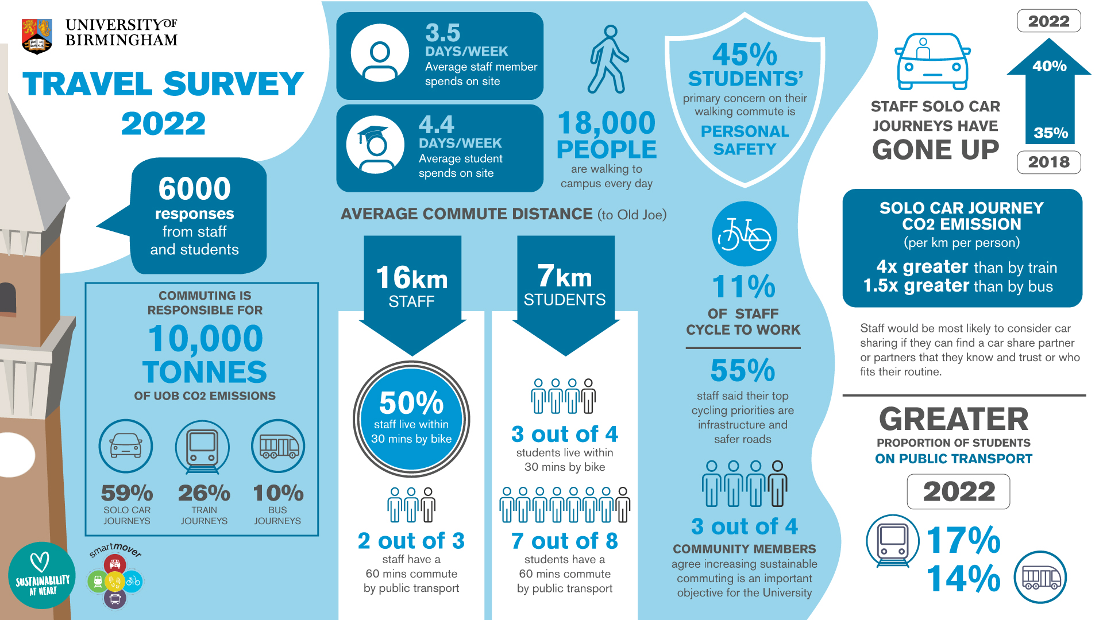

Action Plan

- The University of Birmingham is seeking to reduce the number of single occupancy commutes by car.
- The University of Birmingham is targeting net zero for scope 1 and 2 carbon emissions by 2035, and net zero for scope 3 carbon emissions by 2045, which includes commuting. These targets will be reached by three changes
- Reduction in the volume of travel
- Changing from more polluting modes of transport to less polluting modes
- Upgrading to zero-emission technologies and renewable energy
- The university can take steps to bring about these changes. Partnerships are essential in the endeavour, as are local and national policymaking and supply chain adaptation. For example, the university provides an attractive bus season ticket scheme for staff, but bus companies are responsible for upgrading to low and zero-emission buses and national energy planners must switch over to renewable electricity, for full decarbonisation of bus travel. This travel plan aims therefore to do everything feasible to enable and encourage behaviour change, by making sure that:
  - campus facilities are excellent and support sustainable choices;
  - sustainable travel incentives are available and operate optimally;
  - staff and students know about the facilities and schemes available to them;
  - barriers to uptake of sustainable travel modes are addressed;
  - the university makes best use of its local, sectoral and national influence to effect positive changes for sustainable travellers.
- This document sets out the actions and resources required to reduce carbon emissions from commuting. That means reducing solo car driving and increasing the uptake of active travel and public transport modes: namely walking, cycling, scooting, bus travel, train travel and carpooling.

Commuting Needs and Barriers to Sustainable Travel Choices

- Transport choices are dictated by practical questions of feasibility, cost, time-efficiency, flexibility, safety, security, convenience, agreeableness, and wellbeing. Increasingly UoB commuters are aware of the environmental impact of their actions, and cite it as a commuting need. A commute is viable if it meets the needs of a given individual. There are certain barriers to sustainable travel choices. The pre-eminent barrier to all sustainable modes is habit: changing from a routine that ‘works’—even if it is not perfect—to a new commute takes a bit of thought, effort, and planning, and potentially some costs and some new skills (particularly in the case of cycling).

Walking
- Walking can be time efficient for short journeys of up to 1-2 miles and 30 minutes. At these distances, walking commutes are convenient and flexible as it is a door-to-door journey and the commuter can leave at any time. Public transport users are likely to combine their commute by bus or train with walking. This form of active commuting is to be actively encouraged. Walking can be safe, agreeable and health-promoting if and only if there are good routes. Walking costs nothing more than a new pair of shoes every now and again and a good raincoat Beyond 1-2 miles, walking commutes can be matched less flexibly with other daily commitments, leisure and errands and the time and effort taken becomes a barrier for many.
- Assuming a feasible and time efficient distance, the main barriers then are 1) road safety and 2) personal safety. These factors rise and fall in their prominence depending on the time of year. Personal safety is of greater concern during the dark winter months.

Cycling
- Cycling commutes can be some of the most time efficient in Birmingham, as cyclists can avoid queueing cars and buses and are not beholden to timetables. Again, a commute of around five miles or 30 minutes is feasible for most, and the rise of e-bikes is making longer commutes possible for more and more people. Cycling commutes are flexible and can combine well with individual commitments, errands and leisure activities. It costs to keep a bike on the road year round, and most keen cycle commuters choose to upgrade their kit over time, but cycling remains very good value. Commuting by bike raises fitness levels.
- Assuming that cycling is viable for a member of staff/student (she lives close enough to campus and is fit and able to cycle), the main barriers to cycling are: 1) security of bikes on campus, 2) safety of route to campus, 3) being able to shower, change, and organise cycling kit to start the day, and 4) starting out. The cost of cycling is not a particularly great barrier, but it is something that the university can help with, particularly at the stage of trying out cycling.

Train travel
- UoB is served by a University station, so the proximity and accessibility of the local station decide whether a train commute is time-efficient and convenient. Once aboard, trains are generally an efficient way to travel. Flexibility is dictated by the frequency of the services. Currently there are four trains per hour on the cross-city line, and long distance trains serve University station in addition. This is lower than the six trains per hour pre-pandemic, and therefore makes the train commute less flexible and convenient. On the other hand, capacity on the cross-city line has increased to six carriages on all services. Greater capacity on trains is more agreeable for commuters.
- Colleagues wanting to travel by train are impeded by 1) cost of tickets, particularly for long distance commutes and 2) capacity on cross-city line to University station.

Bus travel
- Some bus journeys are time efficient, particularly where there are good bus lanes on the route, but, compared to a car journey, commuters must factor in getting to the bus stop in time. The more frequent the buses on a route, the more flexible the commute. While many of our local routes have good frequency, some services from key areas are too infrequent, reducing convenience and flexibility. The 48 from Bearwood/Harborne is half hourly and the direct 41 service from Acocks Green and Moseley is hourly. Birmingham’s bus system has a broadly radial design, meaning that many bus journeys require changing bus, often in the city centre. The cost of Birmingham bus travel improved significantly in 2022 when National Express West Midlands reduced prices of many tickets, but the cost is still high compared to other options.
- Colleagues wanting to travel by bus are impeded by 1) cost of tickets. 2) frequency of services, and 3) agreeableness of the experience on the bus.

Car pooling
- Car sharing saves money and can offer some social benefits. However, sharing a car journey is not standard practice currently because it reduces some of the attractiveness of solo car journeys. It requires coordinating arrival and departure with someone else so the pick up and drop off will likely add a little extra time. Carpooling is likely to be less time efficient, convenient and flexible, unless steps are taken in mitigation, like closer, more convenient car parking on arrival, or, on a municipal level, priority lanes on large roads. Many colleagues would not consider sharing their car as they consider their personal space. Others would only consider carpooling with someone they already know and may be concerned by personal safety if sharing with strangers.
Travel Plan updated April 2023

Area | Strategic Objective | Action | Detail | Ownership | Status | Rating | Next action | Action timescale
Measurement, Performance and Insight | Undertstand how staff and students commute to the university | Survey staff and students | Large scale survey every 2-3 years; smaller surveys every year | STO | Project |  | Communicate results of survey | 2023-24
 | Estimate carbon emissions from commuting and business travel | Evaluate and report emissions | HESA reporting yearly; carbon accounting undertaken by consultants | STO, MG | Project |  | Support Hoare Lea reporting | Late 2023
 | Measure how staff travel for funded business trips | Combine Clarity and expenses data | Reports to allow comparison of booking across university and within colleges | STO, MG | Project |  | Finalise reporting methodology and present to SSG; create expenses report | Jul-23
 | Identify and record KPIs for sustainable travel at UoB | Create spreadsheet and identify data sources | See further detail in five-year plan | STO | Project |  | Consult on appropriate KPIs with Strategic Change | Dec-23
Communications | Promote importance and benefits of sustainable travel | Deliver communications plan | Presentations, internal comms, events, intranet | STO | Project |  | Plan events and presentaions for 2023-24 | Aug-23
 | Explain how the university supports sustainable travel choices | Deliver communications plan | Presentations, internal comms, events, intranet, social media | STO | Project |  | Plan events and presentaions for 2023-24 | Aug-23
Alternatives to Travel | Enable staff and students to avoid long distance travel by remote study and work | Provide remote working software and hardware to staff and students | Teams, Zoom, laptops | IT Services | Service |  |  | Ongoing
 |  | Support working from home where operationally possible | Hybrid working strategy | HR and line managers | Policy |  |  | Ongoing
Commuting on Foot | Make walking to campus safer | Improve campus roads, pavements and pedestrian areas | Map areas that require attention and highlight areas to prioritise | STO/CSTG | Project |  | Deliver improvements to South Gate, West Gate and Selly Oak campus | Aug-23
 |  | Advocate for improvements to local roads, pavements | Focus on South Gate and Somerset Rd/Edgbaston Park Road | STO | Project |  | Monitor South Gate crossing; write letter to local councillor | Oct-23
Commuting by Bicycle | Make cycling to campus safer | Raise skills and confidence of campus cyclists | Cycling skills training classes and group rides through Green Heart Riders community | STO | Service |  | Schedule classes for 2023-24 | Aug-23
 |  | Advocate for improvements to local roads | Focus on South Gate and North Gate | STO | Project |  | Press council to add push button at South Gate | Ongoing
 |  | Improve campus roads and cycle paths | Map areas that require attention and highlight areas to prioritise | STO/CSTG | Project |  | Widen South Gate contraflow | Sep-23
 | Combat bike theft on campus | Provide D-locks for staff and students | Free locls available from Security/ hireable locks from Sustainable Travel | Security/STO | Service |  | Launch lock hire scheme | Onoing
 |  | Remove abandoned bikes from campus bike racks | Quarterly | STO/Security | Project |  | Establish new tagging system | Sep-23
 |  | Patrol campus and educate cyclists | As part of daily operations | Security, STO | Service |  |  | Ongoing
 | Provide excellent facilities on campus for cyclists | Increase the number of secure cycle shelters on campus | Deliver new facilities on an annual basis | STO, Estates | Projects |  | Identify new locations; completion and snagging of minor works | Oct-23
 |  | Support the operation of a successful independent bike repair shop on campus | Shop managed by social enterprise Gear Up | Gear Up, STO | Service
 |  | Map where there are cycle racks/shelters and showers for commuters on campus. | Audit and update yearly | STO | Project |  | Set plan to audit campus by zone | Oct-23
 | Ensure that cycling to work is good value for money | Provide and administer Cycle-to-Work scheme | Scheme provied by Cycle Solutions | Payroll and STO | Service
 |  | Provide and administer staff bike loan scheme | 4-6 week free trials for staff to see if cycling is for them | STO | Service |  | Commission new e-bike | Ongoing
Commuting by Train | Ensure that staff and student rail travellers get the best available value for money | Provide and administer interest free loan for staff annual season tickets | Through TfWM’s corporate Swift scheme | Payroll and STO | Service
 |  | Inform staff and students of other ticket options and how to get value for money | In particular, Flexi Season tickets, point-to-point season tickets, evening and group fares | STO | Service
 | Support the redevelopment of University station | Attend steering meetings and support project managers as required | MG to attend regular meetings | Director of Facility Services and Estates | Partnership
 | Advocate for improved rail services to University station: more frequent, more reliable, and higher capacity | Develop closer partnership with West Midlands Railway |  | STO, Director of Facility Services | Project |  | Scrutinise response to scheduling query | May-22
Commuting by Bus | Ensure that staff and student bus travellers get the best available value for money | Support and part-fund discounted staff monthly bus passes | Through National Express West Midlands' portal | Payroll and STO | Service |  | Establish auditing process | Oct-23
 |  | Advocate that NX retain a £1 fare for university staff and students | Key contacts at NX: Richard Cawton and Stacey Pollard; | STO | Partnership
 |  | Inform staff and students of other ticket options and how to get value for money | In particular, contactless, weekly and monthly fares, group tickets, £1 hop, flexible bundles and other bundles | STO | Service
 | Advocate for improved bus services to campus: more frequent, more reliable, and with excellent user experience | Ensure The Hop! fare remains available on m-Tickets app; |  | STO | Partnership
Commuting by Car | Enable and encourage staff to drive lower-emitting vehicles | Provide and administer a ULEV car lease scheme for staff | Delivered by Tusker | STO, Procurement, Payroll | Service |  | Improve eligibility approval process | Dec-23
 |  | Provide EV charging on campus, review and improve provision |  | Car Parking | Service
 | Ensure car drivers on campus comply with parking regulations | Administer and enforce permit system | Car parking dept of manager, administrator and 4 traffic officers | Car Parking | Policy
 | Provide car sharing/ride pooling service | Recruit new provider of service and relaunch |  | STO, Car Parking Manager, Director of Facility Services | Project |  | Review options for delivery | Aug-23
Commuting by Light Motor Vehicles | Support the excellent operation of the scooter trial on campus | Monitor and make improvements to parking and riding zones of campus | Scooter rental delivered by Beryl, work in partnership to make changes | STO | Partnership |  | Finalise agreement with Beryl | Aug-23
 |  | Promote safe use of e-scooters |  | STO | Partnership
 | Provide motorcycle parking spaces on campus | Map where motorcycle spaces are available |  | STO | Project |  | Schedule work for apprenctice | Jan-24

