
Sustainable Travel Action Plan
2025

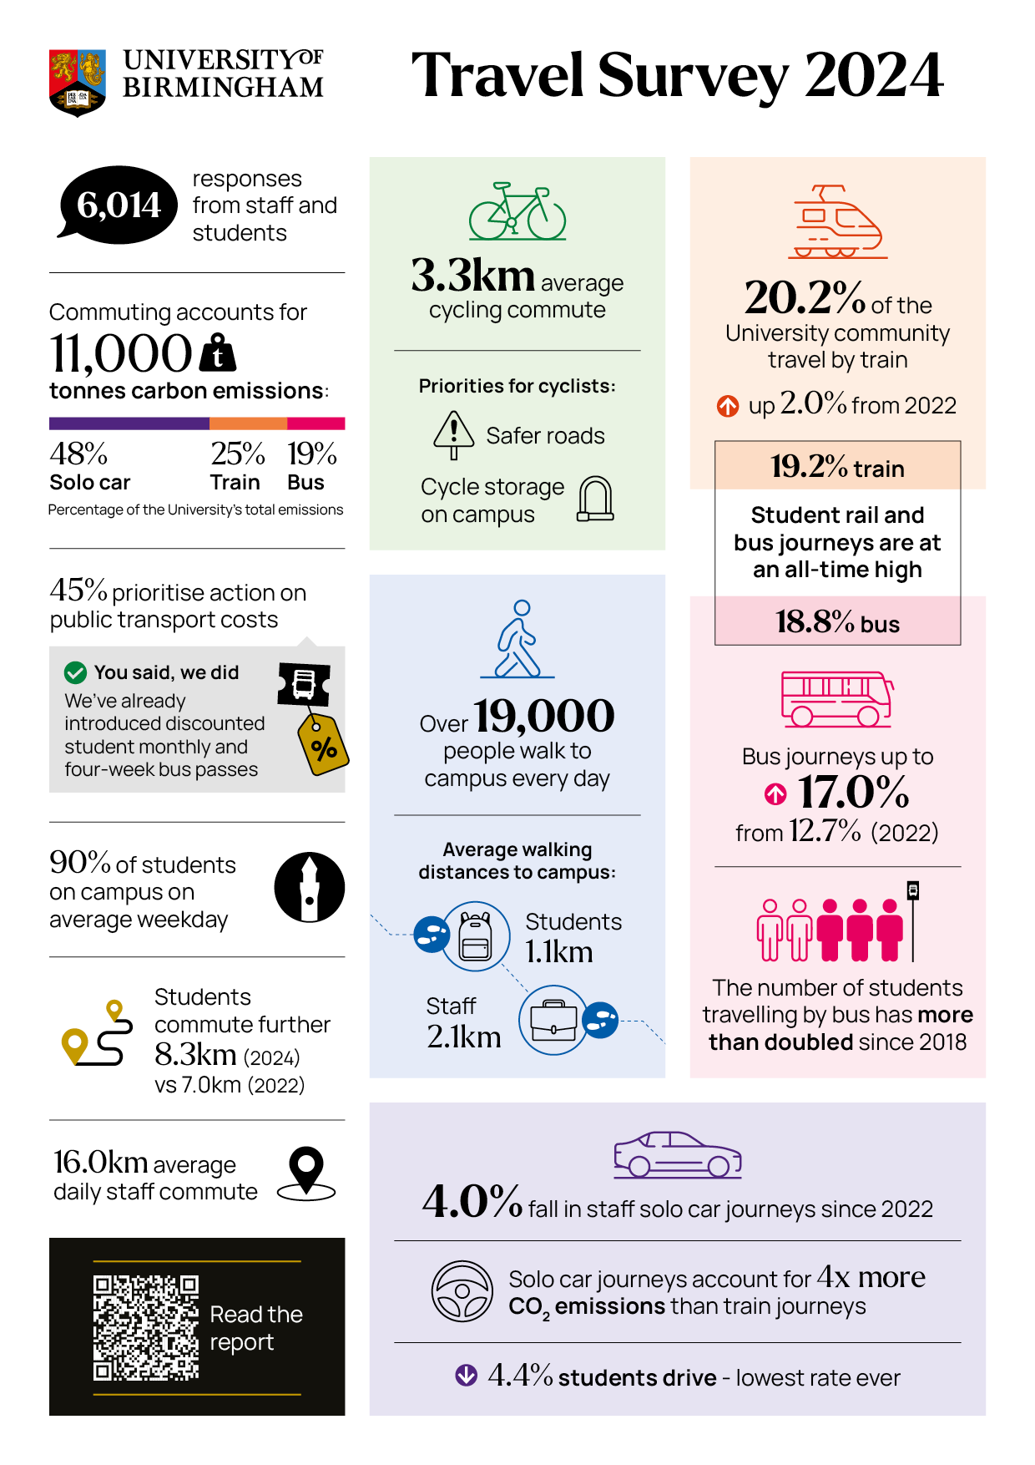
Survey Results 2024

Action Plan

- The University of Birmingham is targeting net zero for scope 1 and 2 carbon emissions by 2035, and net zero for scope 3 carbon emissions by 2045, which includes commuting. These targets will be reached by three changes
- Reduction in the volume of travel
- Changing from more polluting modes of transport to less polluting modes
- Upgrading to zero-emission technologies and renewable energy
- On the road to net zero, this sustainable travel plan aimed for one percentage-point reduction in solo car commutes in the 2024 survey, and a three percentage-point reduction by 2026, compared to 2022 levels. The 2024 target was exceeded, with solo car commutes dropping 2.2% overall (12.7 to 10.5%), including staff dropping from a 40% to a 36% share, and students hitting the lowest ever level of 4.4%.

- The University can take steps to bring about these changes, which this plan outlines. Partnerships, with internal and external stakeholders, are essential in the endeavour, as are local and national policymaking and supply chain adaptation. For full decarbonisation of bus travel, for example, the University provides an attractive bus season ticket scheme for staff, bus companies are responsible for upgrading to low and zero-emission buses, and national energy planners must switch over to renewable electricity. This travel plan aims therefore to do everything feasible to enable and encourage behaviour change, by making sure that:
  - Campus facilities are excellent and support sustainable choices;
  - Sustainable travel incentives are available and operate optimally;
  - Staff and students know about the facilities and schemes available to them;
  - Barriers to uptake of sustainable travel modes are addressed;
  - University of Birmingham makes best use of its local, sectoral and national influence to effect positive changes for sustainable travellers.
- This document sets out the actions and resources required to reduce carbon emissions from commuting. That means reducing solo car driving and increasing the uptake of active travel and public transport modes: namely walking, cycling, scooting, bus travel, train travel and carpooling.
- Beyond carbon emissions, sustainable travel has numerous other benefits, including reduced congestion, improved air quality, more liveable neighbourhoods, stronger communities and better public health.

Commuting Needs and Barriers to Sustainable Travel Choices

Transport choices are shaped by practical considerations such as feasibility, cost, time-efficiency, flexibility, safety, security, convenience, comfort, and overall wellbeing. Increasingly, University of Birmingham commuters also factor in the environmental impact of their travel, recognizing sustainability as a key commuting need. A commute is considered viable when it aligns with an individual's specific requirements. However, there are notable barriers to adopting sustainable travel options, which are explored in the following sections.Walking
- Walking can be time efficient for short journeys of up to 1-2 miles and 30 minutes. At these distances, walking commutes are convenient and flexible as it is a door-to-door journey and the commuter is not beholden to a timetable. Public transport users are likely to combine their commute by bus or train with walking. This form of active commuting is to be actively encouraged. Walking can be safe, agreeable and health-promoting if and only if there are safe, agreeable routes. Walking incurs minimal costs, primarily for appropriate footwear and outerwear. Beyond 1-2 miles, walking commutes can be matched less flexibly with other daily commitments, leisure and errands and the time and effort taken becomes a barrier for many.
- Assuming a feasible and time efficient distance, the main barriers then are 1) road safety and 2) personal safety. These factors rise and fall in their prominence depending on the time of year. Personal safety is of greater concern during the dark winter months.

Cycling
- Cycling commutes can be some of the most time efficient in Birmingham, as cyclists can avoid queueing cars and buses and are not beholden to timetables. Again, a commute of around five miles or 30 minutes is feasible for most, and the rise of e-bikes is making longer commutes possible for more and more people. Cycling commutes are flexible and can combine well with individual commitments, errands and leisure activities. It costs to keep a bike on the road year round, and most keen cycle commuters choose to upgrade their kit over time, but cycling remains very good value. Commuting by bike raises fitness levels and boosts wellbeing.
- Assuming that cycling is viable for a member of staff/student (she lives close enough to campus and is able to cycle), the main barriers to cycling are: 1) security of bikes on campus, 2) safety of route to campus, 3) being able to shower, change, and organise cycling kit to start the day, and 4) starting out. The cost of cycling is not a particularly great barrier, but it is something that the university can help with, particularly at the stage of trying out cycling.

Train travel
- UoB is well served by University station, so the accessibility of the local station to home decides whether a train commute is time-efficient and convenient. Once aboard, trains are generally an efficient way to travel. Flexibility is dictated by the frequency of the services. Currently there are four trains per hour on the cross-city line, and long distance trains serve University station in addition. This is lower than the six trains per hour pre-pandemic, and therefore makes the train commute less flexible and convenient. On the other hand, capacity on the cross-city line has increased to six carriages on all services. Greater capacity on trains is more agreeable for commuters.
- Colleagues wanting to travel by train are impeded by 1) cost of tickets, particularly for long distance commutes and 2) capacity on cross-city line to University station.

Bus travel
- Some bus journeys are time efficient, particularly where there are good bus lanes on the route, but, compared to a car journey, commuters must factor in getting to the bus stop in time. The more frequent the buses on a route, the more flexible the commute. While many of our local routes have good frequency, some services from key areas are too infrequent, reducing convenience and flexibility. The 48 from Bearwood/Harborne is half hourly and the direct 41 service from Acocks Green and Moseley is hourly. Birmingham’s bus system has a broadly radial design, meaning that many bus journeys require changing bus, often in the city centre. The cost is high compared to other options, and headline measure in this plan is a special subsidy of monthly bus tickets.
- Colleagues wanting to travel by bus are impeded by 1) cost of tickets. 2) frequency of services, 3) the routes and connections available in the bus network, and 4) agreeableness of the experience on the bus.

Car pooling
- Car sharing saves money and can offer some social benefits. However, sharing a car journey is not standard practice currently because it reduces some of the attractiveness of solo car journeys. It requires coordinating arrival and departure with someone else so the pick up and drop off will likely add a little extra time. And that’s assuming that there is actually a colleague with compatible routine living nearby. Carpooling is likely to be less time efficient, convenient and flexible, unless steps are taken in mitigation, like closer, more convenient car parking on arrival, or, on a municipal level, priority lanes on large roads. Many colleagues would not consider sharing their car as they consider their personal space. Others would only consider carpooling with someone they already know and may be concerned by personal safety if sharing with strangers. The barriers to carpooling are: 1) finding colleagues to form a carpool; 2) extra time taken over the journey; 3) loss of flexibility and convenience, and extra admin such as arranging petrol contributions; 4) the need to find an alternative route home if the carpool partner is not available.
Theme | Strategic Objective | Q1 2025 Summary | Responsible | KPI: 2024
Measurement, Performance and Insight | Understand how staff and students commute to the university | Survey staff and students commuting habits every 2 years | Sustainable Travel Dept | 6014 responses; Staff solo car: 36%, student 4.4%; overall 10.5%, down 2.2% vs 2022
Measurement, Performance and Insight | Estimate carbon emissions from commuting and business travel | Evaluate and report emissions to HESA and internal carbon accounting exercises | Sustainable Travel Dept | 11,000 tonnes CO2e
Measurement, Performance and Insight | Identify and record KPIs for sustainable travel at UoB | Record measures of action plan item performance | Sustainable Travel Dept | Data recorded here
Engagement | Share advice and expertise on commuter transport | At events, presentations on intranet, via email and appointments, including tickets, route planning, cycling to work etc. | Sustainable Travel Dept | 1600 emails and interactions
Engagement | Promote sustainable travel benefits and schemes to UoB community | Deliver engagement plan of presentations, fairs and events, supported by internal comms via email and Teams | Sustainable Travel Dept | 47 events
Commuting on Foot | Make walking to campus safer | Work through Campus Safe Travel Group to identify, prioritise and deliver pedestrian safety projects for campus | Sustainable Travel Dept | Projects delivered: new signs at Staff House and Green Heart
Commuting on Foot | Make walking to campus safer | Advocate for improvements to local roads, pavements, focusing on South Gate and Somerset Rd/Edgbaston Park Road | Sustainable Travel Dept | Submission to Cross-City Bus Consultation;  Exploring feasibility of upgrading three areas on campus roads
Commuting by Bicycle | Make cycling to campus safer | Raise skills and confidence of campus cyclists through a programme of skills classes | Sustainable Travel Dept | 276 participation hours; 5-star rating
Commuting by Bicycle | Make cycling to campus safer | Advocate for improvements to local roads, | Sustainable Travel Dept | Submission to Cross-City Bus Consultation
Commuting by Bicycle | Make cycling to campus safer | Work through Campus Safe Travel Group to identify, prioritise and deliver cycling safety projects for campus | Sustainable Travel Dept | Exploring feasibility of upgrading three areas on campus roads
Commuting by Bicycle | Provide excellent facilities on campus for cyclists | Increase the number of secure cycle shelters on campus | Sustainable Travel Dept | 344 spaces on campus; 368 at accommodation; 6 new shelters to be delivered
Commuting by Bicycle | Provide excellent facilities on campus for cyclists | Support the operation of a successful independent bike repair shop on campus | Sustainable Travel Dept | 230 days open; 1715 'core' services
Commuting by Bicycle | Provide excellent facilities on campus for cyclists | Audit and update yearly; check key cycle storage and shower facilities monthly | Sustainable Travel Dept | Yearly audit completed April '24
Commuting by Bicycle | Ensure that cycling to work is good value for money | Support operation of Cycle-to-Work scheme | Sustainable Travel Dept & Payroll | 2024: 126 orders; av. staff saving £344
Commuting by Bicycle | Ensure that cycling to work is good value for money | Provide and administer staff bike loan scheme of free 4-6 week trial; students hire bike scheme and bike sale | Sustainable Travel Dept | 83 loans/hires; 1 student bike sale; 5-star rating
Commuting by Public Transport | Advocate for improved rail services to University station: more frequent, more reliable, and higher capacity | Develop closer partnership with West Midlands Railway; focus on platform management and capacity of cross city lines | Sustainable Travel Dept | Engagement on student 50% discount
Commuting by Public Transport | Ensure that staff and student bus travellers get the best available value for money | Support and part-fund discounted staff and student monthly bus passes; ad-hoc discounts through TfWM | Sustainable Travel Dept | 300+ staff per month; 700+ students per month; 4950 staff and students benefitted from free four-week bus pass
Commuting by Public Transport | Advocate for improved bus services to campus: more frequent, more reliable, and with excellent user experience | Initiate dialogiue with NX and TfWM, and council partners focusing on X21/22 frequency; 76 service; North Gate bus shelter | Sustainable Travel Dept | Meeting with Kings Heath Councillor; submission to X-city bus
Commuting by Car | Enable and encourage staff to drive lower-emitting vehicles | Provide and administer a ULEV car lease scheme for staff | Sustainable Travel Dept & Payroll/HR | 114 staff on scheme
Commuting by Car | Provide car sharing/ride pooling service | Recruit new provider of service and relaunch | Sustainable Travel Dept | Project relaunched
Micromobility | Support the safe and orderly operation of the scooter and hire bike schemes on campus | Scooter rental delivered by Beryl, work in partnership to make changes | Sustainable Travel Dept | 20 parking locations on campus

In addition, a number of partner services around the University are responsible for important tasks to support sustainable travel, they are recorded here.

Area | Strategic Objective | Action | Responsible Division
Alternatives to Travel | Enable staff and students to avoid long distance travel by remote study and work | Provide remote working software and hardware to staff and students | IT Services
Alternatives to Travel |  | Support working from home where operationally possible | HR and line managers
Commuting by Bicycle |  | Provide D-locks for staff and students | Security
Commuting by Bicycle | Combat bike theft on campus | Remove abandoned bikes from campus bike racks | Security
Commuting by Bicycle |  | Patrol campus and educate cyclists | Security
Commuting by Train | Ensure that staff and student rail travellers get the best available value for money | Provide and administer interest free loan for staff annual season tickets | Payroll
Commuting by Car | Enable and encourage staff to drive lower-emitting vehicles | Provide EV charging on campus, review and improve provision | Car Parking
Commuting by Car | Ensure car drivers on campus comply with parking regulations | Administer and enforce permit system | Car Parking
Commuting by Light Motor Vehicles | Provide motorcycle parking spaces on campus | Map where motorcycle spaces are available | Car Parking

