Student Instructions using New Quizzes

- When logged into Canvas select the relevant module.

- In Course Navigation, click the Quizzes Link.

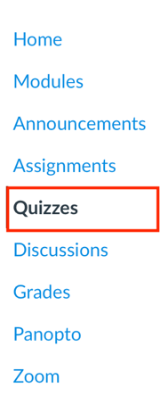
- Select the relevant quiz from the list, the number of quizzes will vary depending on how many have been set up in the module.
Hint: You may require an access code which your tutor will provide.

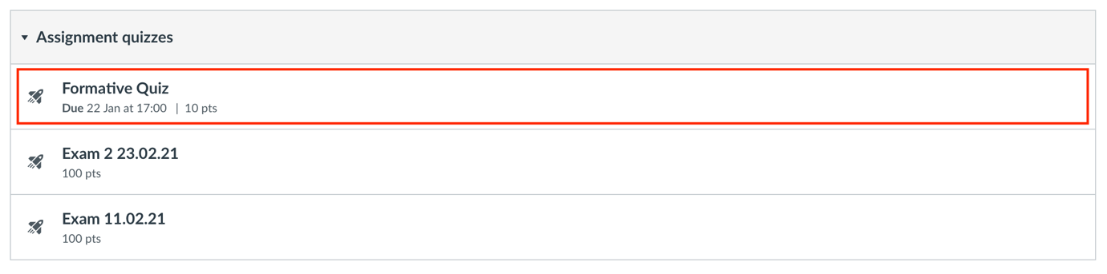

- From the assessment page, you can view the title [1], introduction [2], time limit [3], and due date [4]. You can also view the number of attempts allowed [5]. Click the begin button to start the assessment [6].

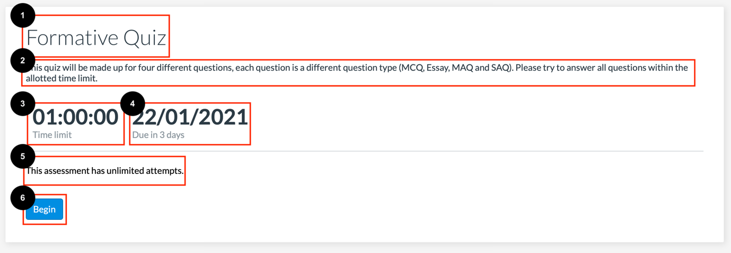

- When in the assessment, on the left-hand side you will see the question navigator, to open the navigator click the expand icon.

- The Question Navigator allows you to easily view all questions included in an assessment. All pinned questions will display in the Pinned Questions section [1]. To view a pinned question, click the name of the question. To jump to a specific question, click the question in the Question Navigator [2]. To pin a question to review later, click the Pin icon [3].
Hint: The quiz may be set so that you can only view one question at a time.

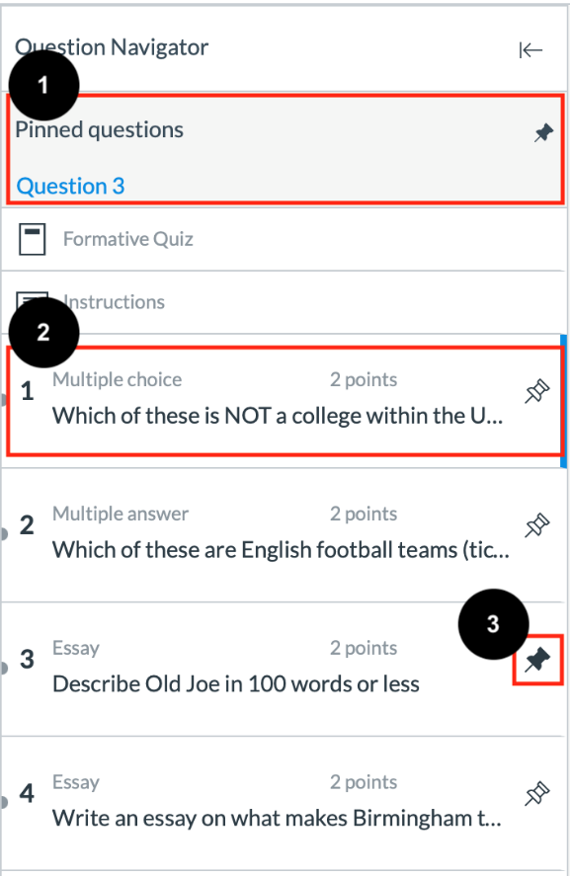

- If your assessment has a time limit, a countdown will appear on your screen [1]. To hide the time limit, click the Hide button [2].

- When viewing the questions, you will see the question number and question [1] and the pin button which you can use to review a question later [2]. In essay style questions, you will see the content editor [3]. Underneath the content editor you can see if a word count has been applied to the question, and how many words you have currently written [4]. You will also see the previous [5] and next [6] buttons allowing you to navigate the quiz.

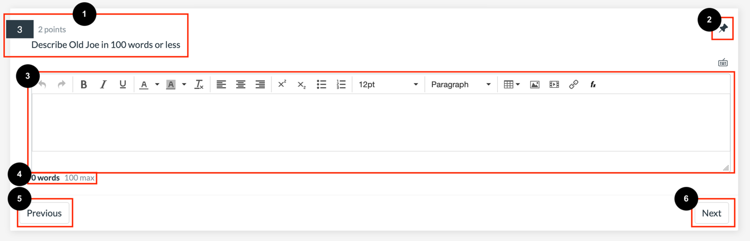
Hint: There are various types of question you may encounter in a quiz:

- Categorization
- Essay
- File Upload
- Fill in the Blank
- Formula
- Hot Spot
- Matching
- Multiple Answer
- Multiple Choice (MCQ)
- Numeric
- Ordering
- True or False

Hint: Your instructor may allow you to use an on-screen calculator for the entire assessment or only for certain questions. To open the on-screen calculator, click the Calculator icon.
Note: If the Calculator icon doesn't display on the question, your instructor has not enabled calculators.

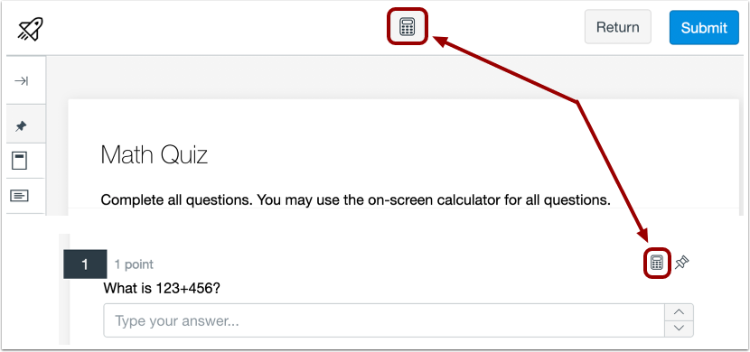

- To submit your assessment, click the submit button, this will take the place of the next button upon reaching the final question.

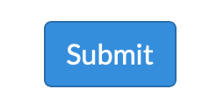

- Upon clicking submit, if you haven’t answered all of the questions you will see a prompt, highlighting that there are unanswered questions. You can still submit. Alternatively, if all questions have been answered a confirm submission will appear, allowing you to submit.

Hint: Upon submission you will not be able to change your answers.

