Online Exams using New Quizzes

Introduction
This document gives the following information:
- How to use Canvas New Quizzes
- How to set up both a summative and formative exam.
- A guide on the marking of Short Answer Questions (SAQs) within SpeedGrader
- Approaches on how multiple markers can mark the same exam.

Considerations
Some things to consider when deciding whether to use New Quizzes for an online exam.
Pros
- Anonymous marking possible
- Part-mark questions possible
- Greater variety of question types than Classic Quizzes
- Clear layout of questions with large amounts of text/images (using Stimulus)
Cons
- Cannot use annotations when marking file upload questions in Speedgrader
- File upload answers cannot be bulk downloaded or re-uploaded
- Essay questions have no Turnitin integration
- Unable to export a CSV with a breakdown of the quiz answers and results
- Item banks belong to the individual who has created the quiz

Setting up the exam
This guidance will cover how to set up an online exam using Canvas New quizzes and will cover the set-up of short answer (SAQs) and multiple-choice questions (MCQs).
- To start with, click on + Quiz (1) in the Quizzes area accessed from the left-hand navigation menu. In the Choose a Quiz Engine box, select ‘New Quizzes’ (2) and ‘Submit’.
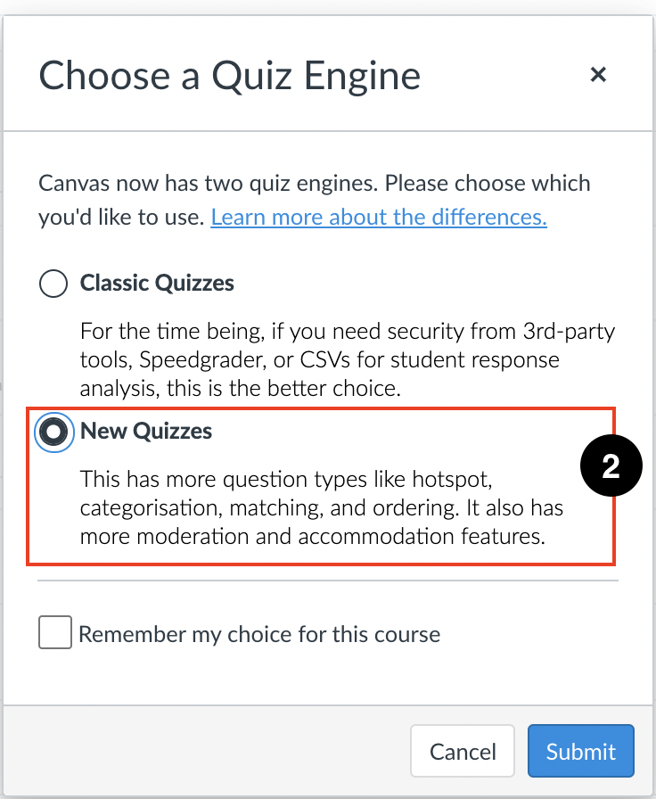
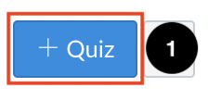

- Once you click submit, the system takes you to the settings page. Add the Quiz Exam Title (3), the total number of marks/points available (4) and display grade as percentage or points (5). The Submission type will be automatically populated, and anonymous grading can be activated by checking ‘Graders cannot view student names’ (6).
N.B – Submissions Attempts must be set within the Quiz itself rather than in this Settings page, so this can be left as ‘Unlimited’.
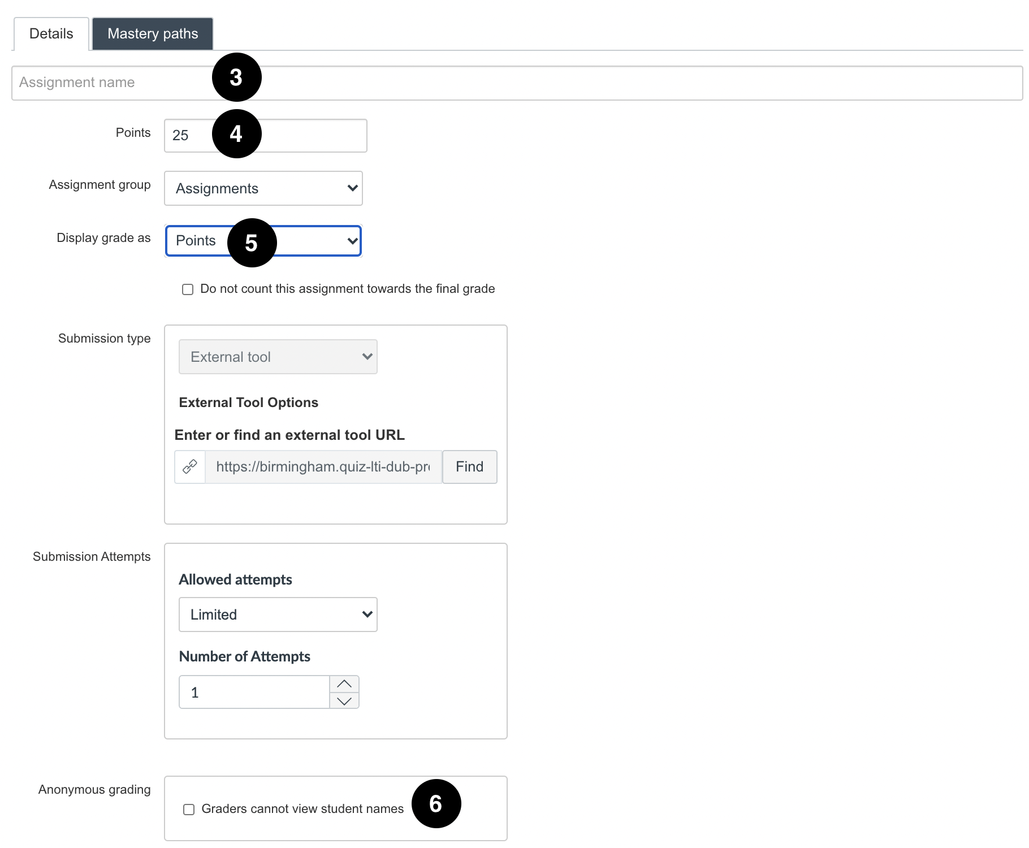

- By default, the quiz will be assigned to all students within the module, but you can allocate to specific Sections (7). For large cohorts of students, we recommend allocating students in sections to allow multiple markers to mark a set number of students. You will need to set up sections before setting up the quiz. Please follow the sections set up process guidance before setting up your quiz.
You can also set a due date (8) and an availability window (9) for the Quiz.
The + Add tab (10) enables you to add RAPs (Reasonable Adjustment Plans) for students, and allocate extensions for specific students/sections. For further information on RAPs and allocating extra time in New Quizzes, please refer to the HEFi Guide on Adding Time adjustments in New Quizzes e.g (Reasonable Adjustment Plans).
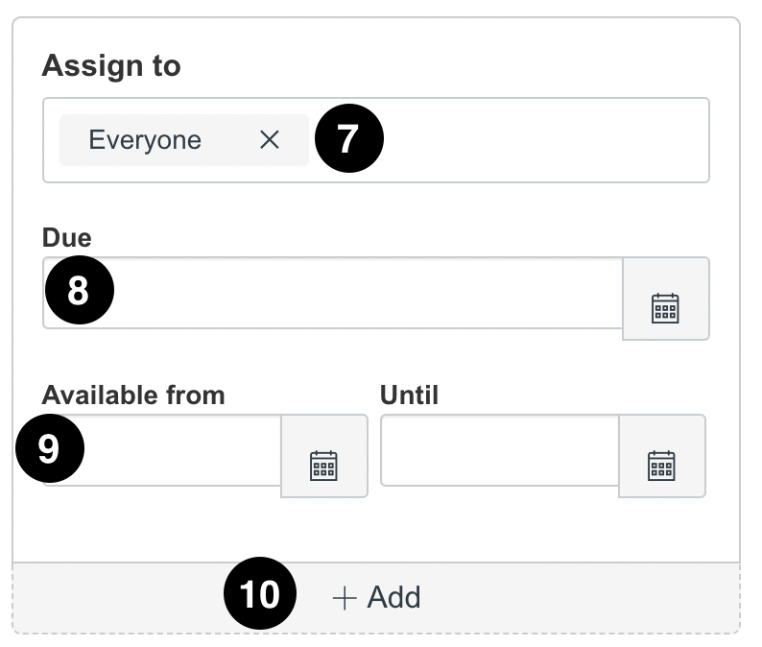

- Once you have finished setting up the quiz you can click on either Save (11) or Build (12) at the bottom of the page. The Save button saves the content in the existing page and returns you to the area where the quiz was accessed. The Build button saves the existing page and launches the New Quiz editor.
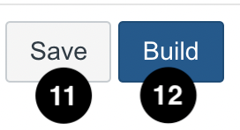

Building a Quiz

- On the Build page you can edit the title and description of your quiz by clicking on the pencil symbol (1). Provide clear instructions to the students. To add content to your assessment, click the + Add button (2).
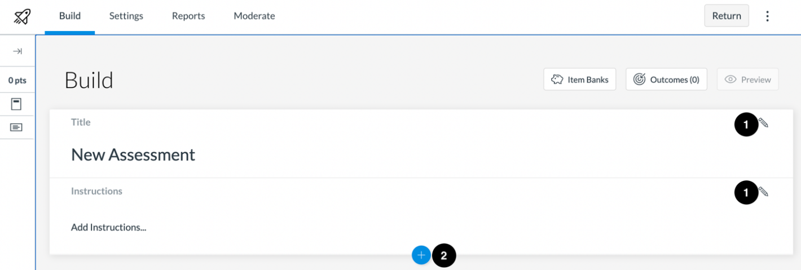
- To create a new question, click the button for the desired question type (3).
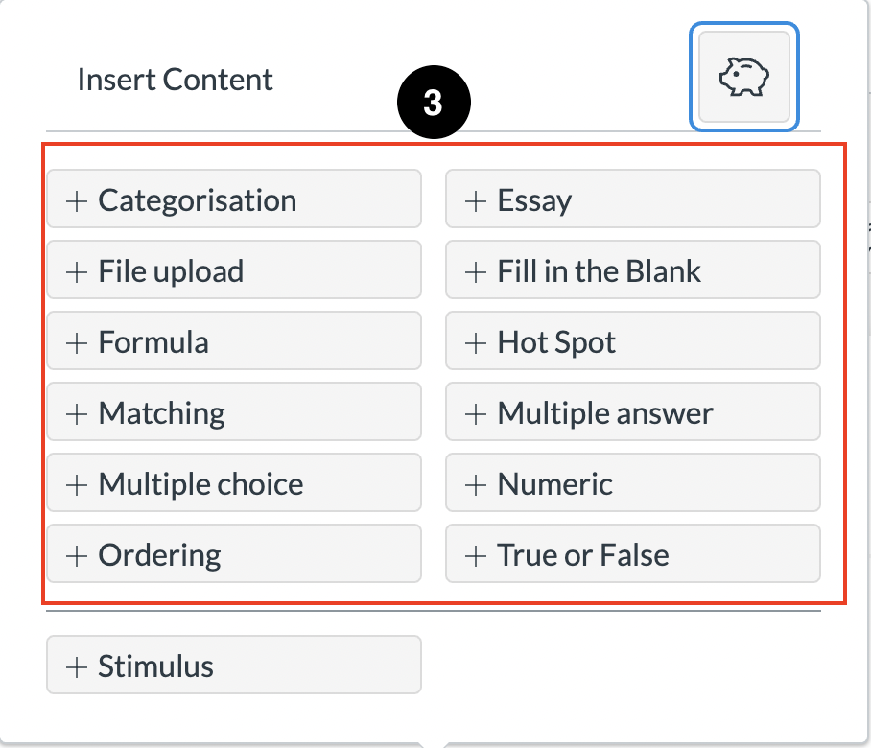
The following question types are available in New Quizzes:
- Categorization
- Essay
- File Upload
- Fill in the Blank
- Formula
- Hot Spot
- Matching
- Multiple Answer
- Multiple Choice
- Numeric
- Ordering
- True or False

Building Multiple Choice Questions (MCQs)
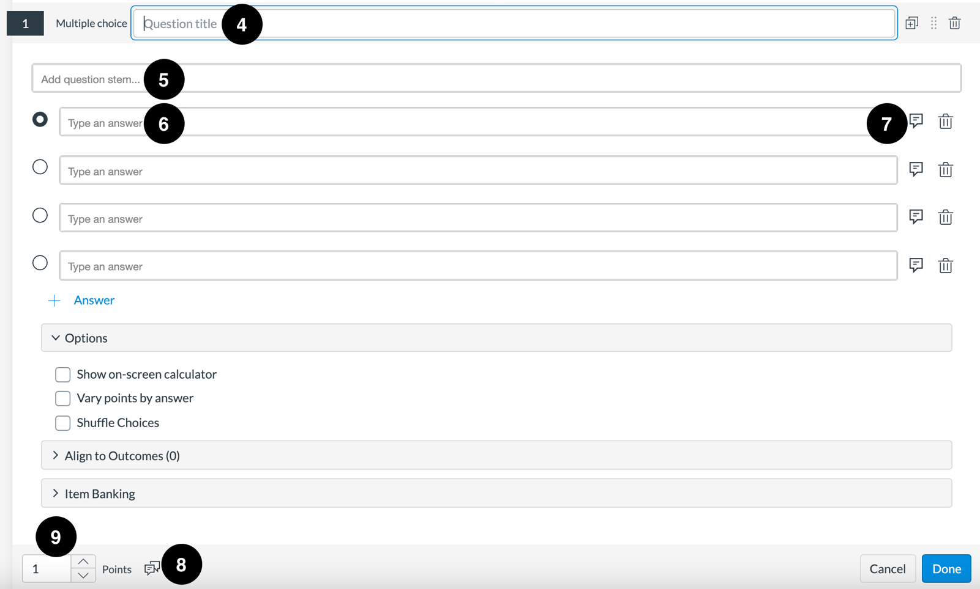
- For each question, you can enter a question title (4) and a question stem (5) and answers (6). You can add feedback for each individual answer (7) or general student feedback for the whole question (8) using the Feedback icon. In the Points field (9), adjust the point value for the question by entering a number or clicking the arrow buttons.
- Under the ‘Options’ dropdown box, you can choose to ‘Show on-screen calculator’, ‘Vary Points by Answer’ and ‘Shuffle Choices’
  - Vary Points by Answer will allow you set specific point totals for each answer option.
  - Shuffle Choices will shuffle the answer choices for each student. You will also have the option to lock an answer in its location by clicking the Lock icon next to an answer.
- To save the question, click the Done button.

Building Short Answer Questions (SAQs)
- To build an SAQ, choose the ‘Essay’ type question.
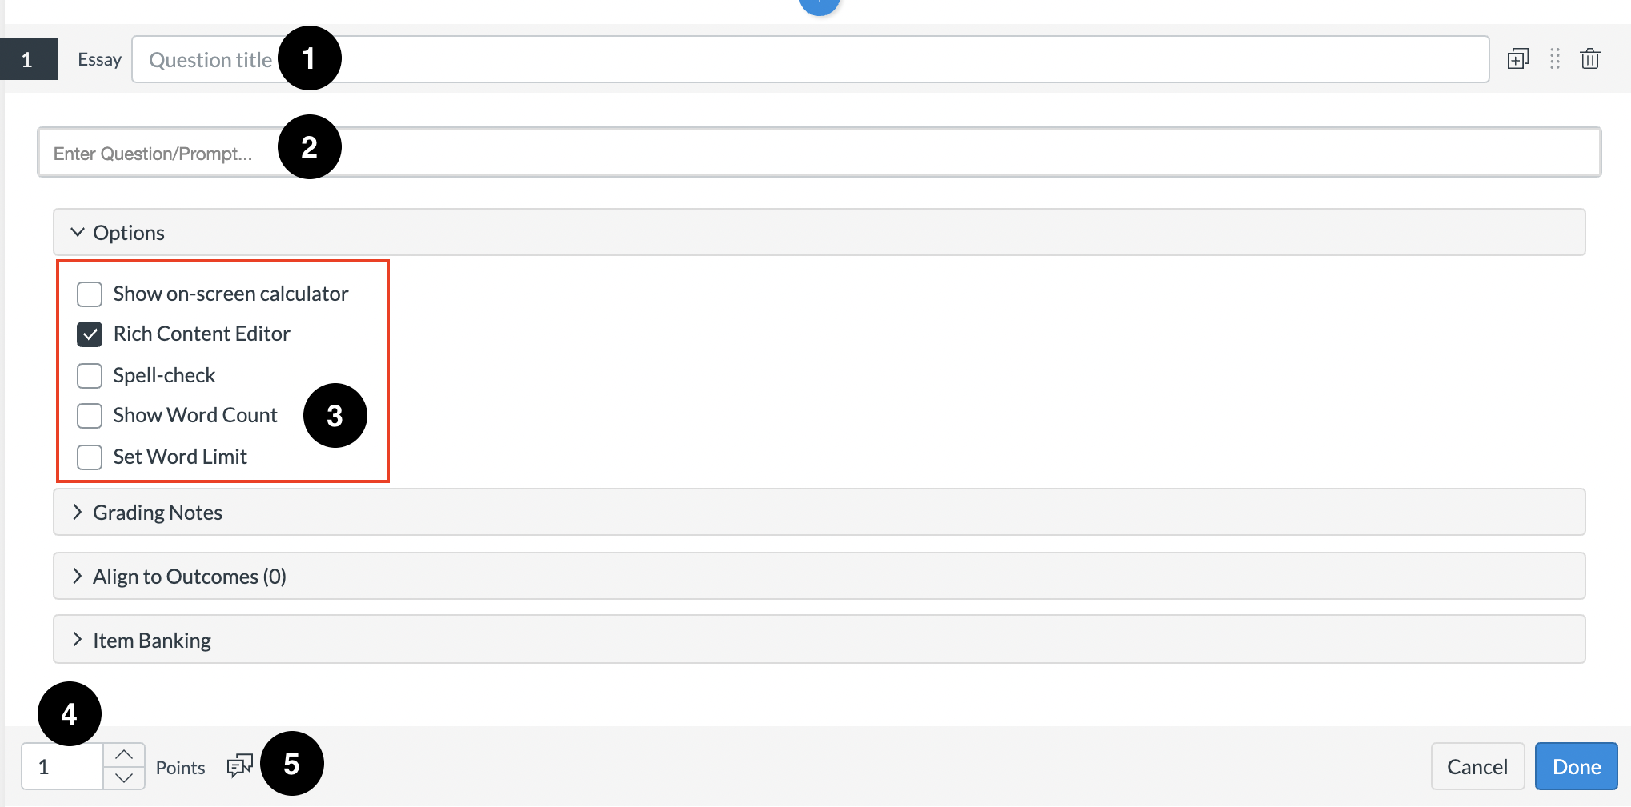
- Add the topic to the Essay Title (1) and add the question under ‘Enter Question/Prompt’ (2). Under the ‘Options’ dropdown, you can choose to ‘Show Word Count’ which can be useful for students to view the number of words (3). You can also set a Word Limit. In the Points field (4), adjust the point value for the question by entering a number or clicking the arrow buttons, and general question feedback can be added for the question via the Feedback icon (5).
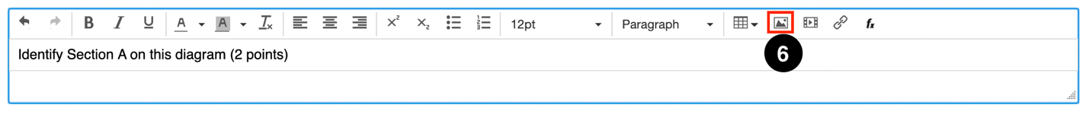
- To add an image, click the ‘Upload Media’ icon (6), and select the file to embed by dragging your image or browsing to the file location, followed by ‘Import’.
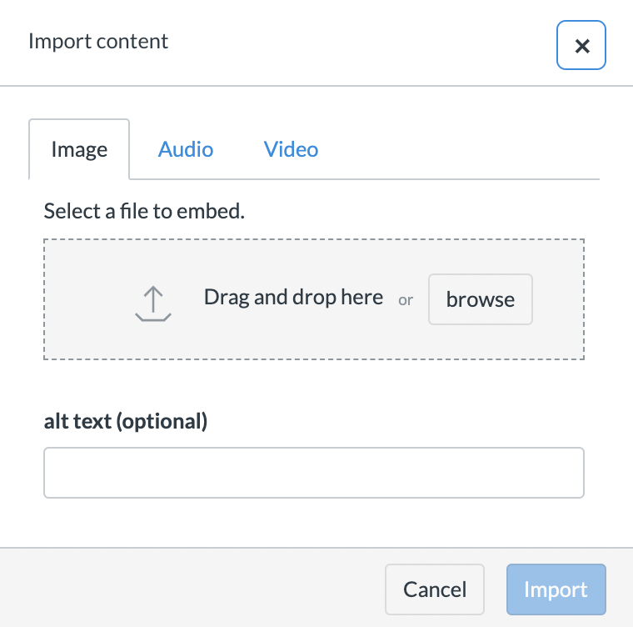
- When complete, click ‘Done’ to save the question.

Quiz Settings
- The settings for New Quizzes are found in the Settings tab within the Quiz.
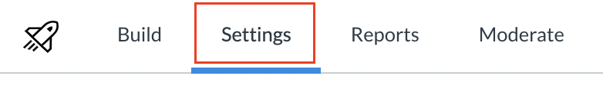
- Within Settings, there are a number of settings to adjust the way assessment is delivered to students. Questions and Answers for the whole quiz can be shuffled (1) so that questions and/or answers are presented to students in a different order. ‘One question at a time’ is especially useful for SAQs so that questions are not presented all at once (2). Allowing backtracking will allow students to go back to previous questions and change their answer before submitting. To add a time limit, check the ‘Time limit’ option and stipulate the duration of the exam (3) – this will end the exam for students after the stated time has elapsed.
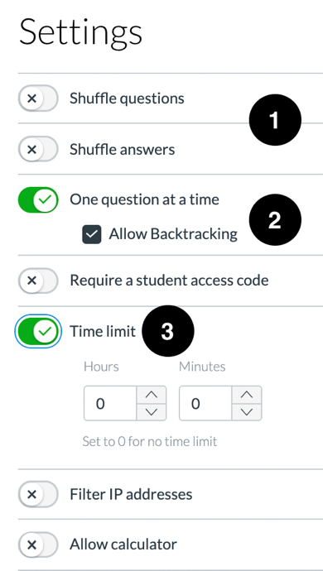

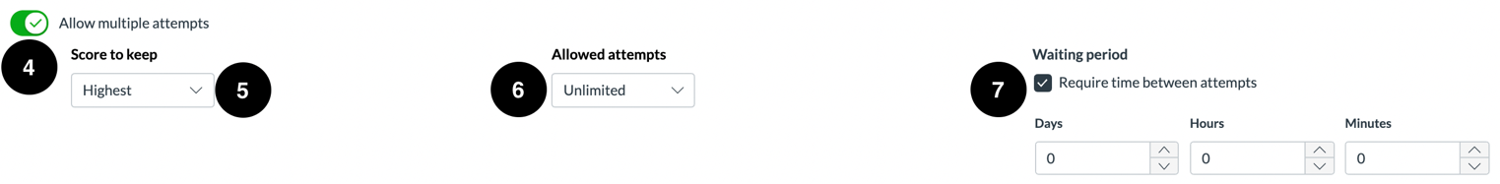
- By default, New Quizzes will be limited to 1 attempt. Check the ‘Allow Multiple Attempts’ option (4) to add extra attempts. You can choose how many attempts are allowed (5), which score to keep (6), and whether a time period must elapse before students can complete another attempt (7).

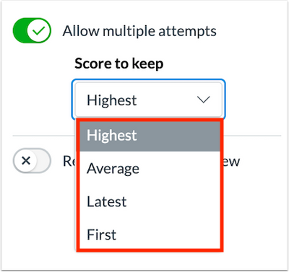
The Score to keep option allows you to choose which score is kept as the final grade, if there are multiple attempts on the quiz.
The options are:
- Highest – The highest score is kept as the final grade.
- Average – The average score is kept as the final grade.
- Latest – The latest attempt is kept as the final grade.
- First – The first attempt is kept as the final grade even if the quiz is retaken at a later date.

- By default, students can view all results for their assessment attempts. To hide assessment results from students, click the ‘Restrict student result view’ button. When this option is enabled, instructors can manage what is displayed to students in their assessment results page. This includes answer choices, feedback, and scores.

N.B – If you want Students to only see their assessment grades in the Gradebook, do not check any of the boxes when the ‘Restrict student result view’ option is enabled. To hide grades from students in the Gradebook, you will need to enable the Manual Grade Posting policy in the Gradebook (see below).

- To display the points awarded for the overall assessment and individual questions in the assessment results page, click the ‘Show points awarded’ checkbox. To display the points possible for the overall assessment and individual questions in the assessment results page, click the ‘Show points possible’ checkbox.
To display assessment items and questions in the assessment results page, click the ‘Show items and questions’ checkbox. If the Show items and questions option is enabled, you can also manage the option to display student responses and item feedback:
  - To display student responses in the assessment results page, click the ‘Show student response’ checkbox. To display item feedback in the assessment results page, click the ‘Show item feedback’ checkbox.
  - To display to students if their response was correct or incorrect, click the ‘Indicate response as correct/incorrect’ checkbox.
  - If the Indicate response as correct/incorrect option is enabled, you can indicate correct answers when incorrect responses were selected by clicking the ‘Show correct answer with incorrect response’ checkbox.
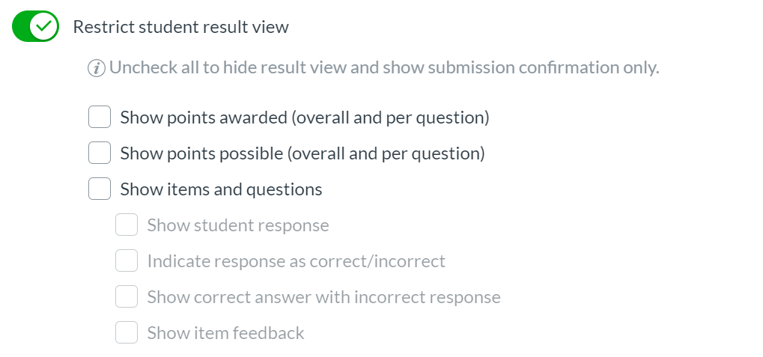

Editing a quiz
If you want to go back and edit your quiz questions or the settings, click on the quiz title (1) and then scroll down and click ‘Save’ at the bottom of the page (2).

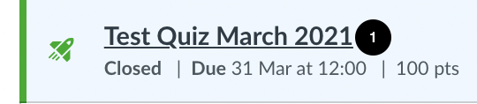

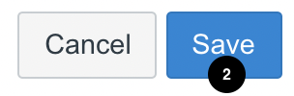

Set Grade Posting Policy to ‘Manual’ within the Gradebook
Once you’ve created your exam, you need to ensure that the Grade Posting Policy is set to ‘Manual’. This is accessed from ‘Grades’ in the Course Navigation menu.
- From the Grades select the 'Settings Cog' (1)
- A new window will open, select the 'Grade Posting Policy' tab (2) to view the options.
- 'Automatically Post Grades' (3) means students will see grades as soon as they are posted. This should not be used for an online exam.
- 'Manually Post Grades' (4) requires the grades to be posted before students can see them. Grades should not be posted for an online exam until determined by your School/Programme.
Gateway Resource setting a Grade Posting Policy
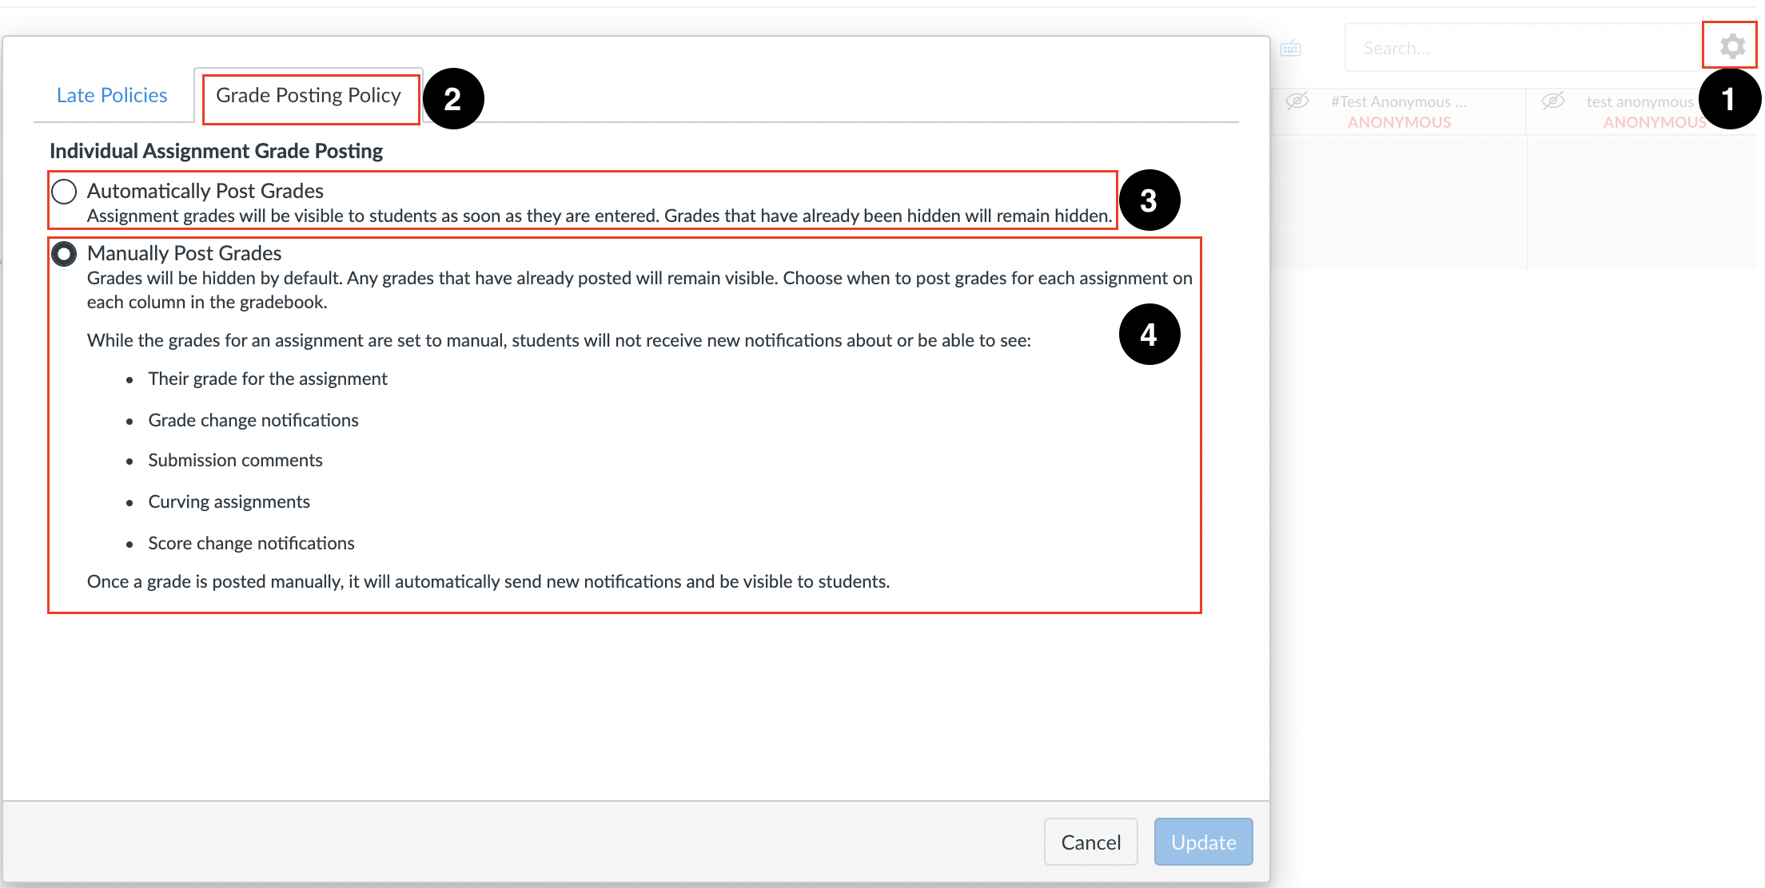

Marking an Online Exam using New Quizzes (SAQs)

Simultaneous marking with two or more markers
Within SpeedGrader two or more markers cannot actively mark the same exam script at the same time. This is because SpeedGrader only saves the comments/grades of one marker.

Below are two possible solutions. We also recommend a separate spreadsheet to record marks in case they are not entered due to multiple markers being active on the same exam.

Solution 1
- Academics will arrange amongst themselves a time where only they will go in and do the marking. They will mark all of their questions during this period.

Solution 2
- Academics will arrange amongst themselves to mark a block of students starting at different points.
- After this set of marking is finished, they will need to communicate with each other and arrange when to mark the next section.
- Finally, after the second set of marking is completed, the academics should arrange to mark the final section.

Marking in SpeedGrader
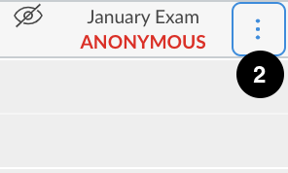
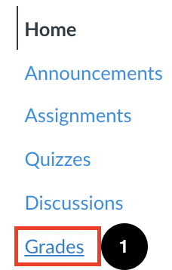
- Go to Grades (1) within the Global Navigation. Once in Grades search for the column with the Exam Title, hover over the title and click the three dots icon (2). In the menu, choose the SpeedGrader (3) option to open the quiz submissions in SpeedGrader.
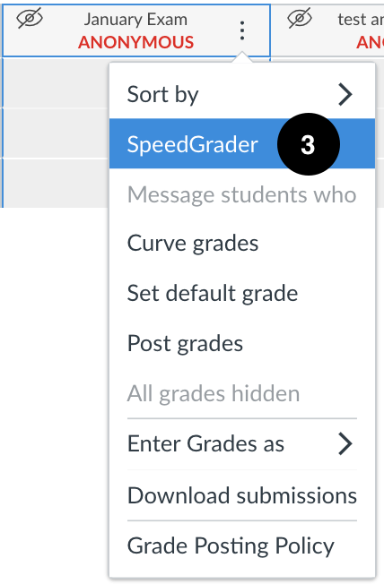
- Students will be listed in the drop-down box at the top right-hand side of the page. If the exam is set to anonymous, students are listed as Student 1, Student 2 etc. If you are using sections to mark you will need to click the drop down and select the relevant section you are marking.
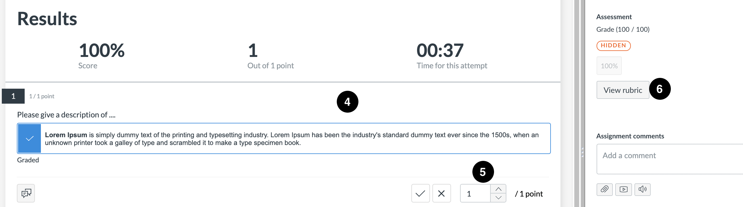
- You will see the selected student’s quiz responses on the left-hand side of SpeedGrader (4). You can either mark questions within the quiz (5) or using a rubric by clicking ‘View rubric’ (6).
N.B - If you are using a Rubric for the exam, it is recommended to only use the Rubric to mark.

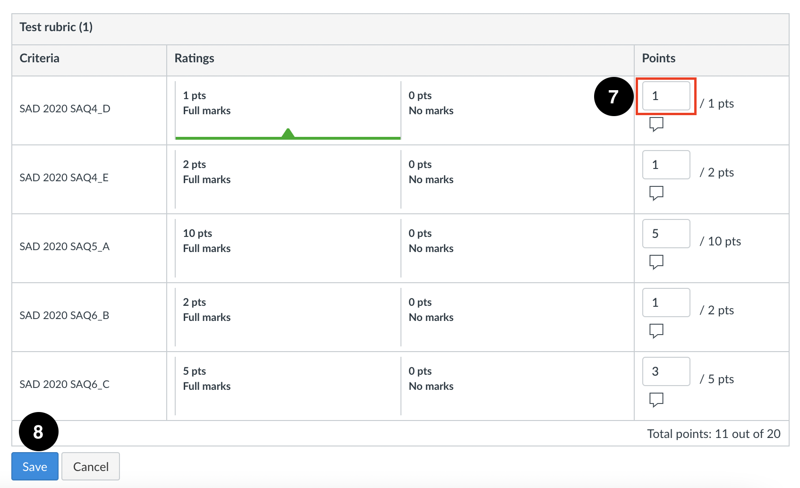
- If you are using a Rubric, whilst marking you will see the exam questions and the student responses on the left hand-side and the Rubric on the right-hand-side. This will have been set-up prior to marking.
Mark your relevant questions by adding the points within the Rubric (7). Once you have added your points to your rubric, for your individual question Click ‘Save’ (8).
- Each time you save after marking a question, you will see the mark reflected within the grey box (9) (this is faint, and automatically applied by Canvas). To access the next student, click onto the Drop-down arrow (10).
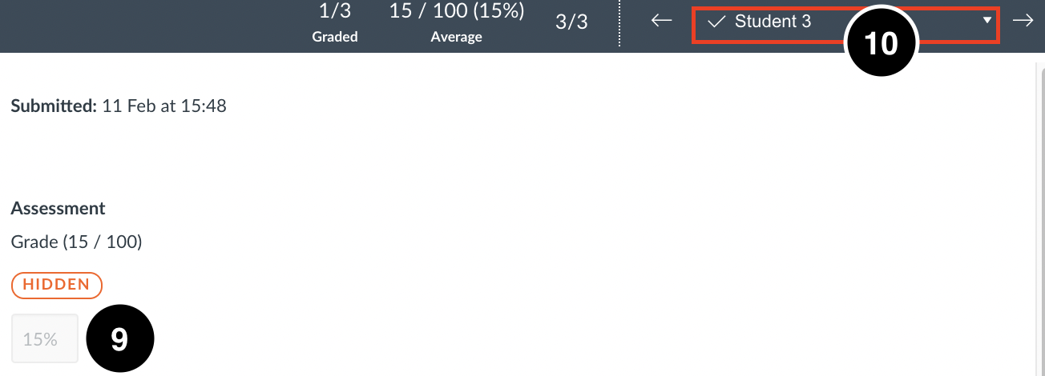

Canvas Admin
You can download an excel spreadsheet of your Online Exam marks from Canvas Admin. This is useful if you do not want to change your Grade Posting Policy but require marks for BIRMS.

Please see the full instructions on the Online Administrator Training Canvas course.

