Professional Services Guidance – New Quizzes

Introduction
This guidance will cover the following:
- A checklist of new quiz set-up points to check have been completed prior to a quiz been published.
- How to give students additional time and retakes in new quizzes.
- Setting up of Sections (marking for large cohorts of students)
- Setting the Grade Posting Policy and Grade Release
- Exporting reports from new quizzes

New Quizzes Checklist
The following is a series of checks that should be carried out to ensure a quiz is ready for release to students

On the quiz set-up page check the following variables have been entered:
- There is a logical title for the quiz which includes a clear date/time and subject.
- Check the point value for the quiz has been set
- Set what format the grade will display in Canvas.
- Check anonymous grading has been selected (if using).
- Ensure the Available from and Until dates have been set for the quiz which include additional time for students with reasonable adjustment plans (RAPS). See further guidance in this document on how to set up additional time in new quizzes.
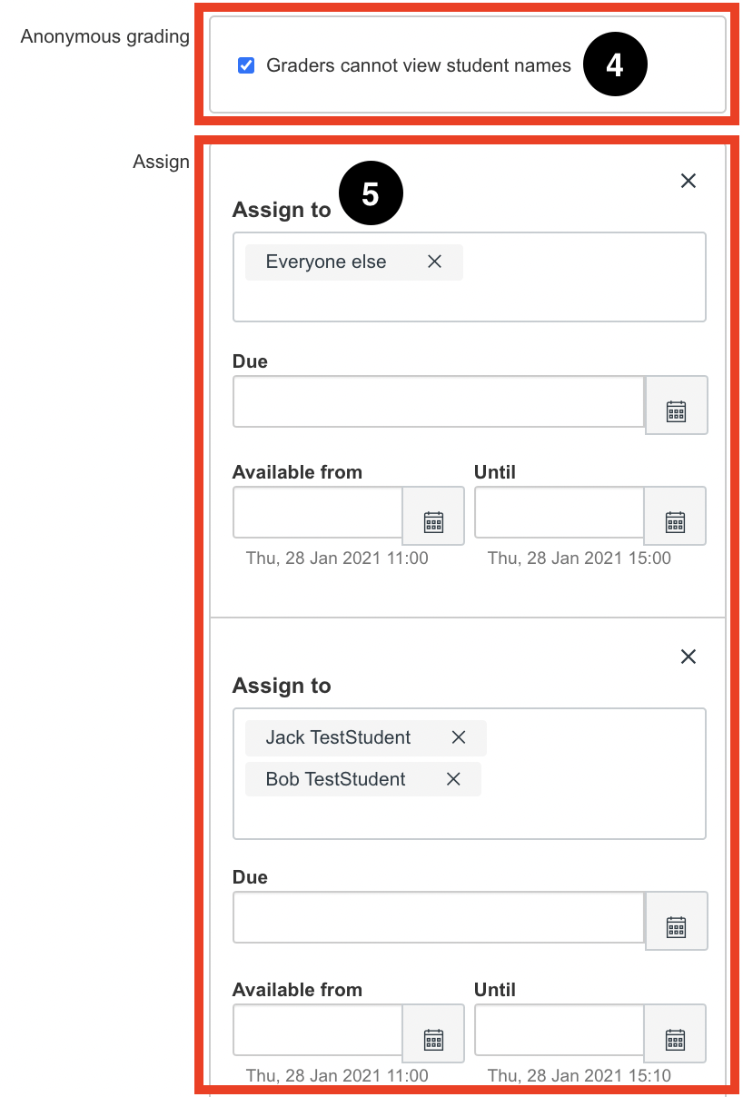

- Once you have finished setting up the quiz you can click on either Save (6) or Build (7) at the bottom of the page. The Save button saves the content in the existing page and returns you to the area where the quiz was accessed. The Build button saves the existing page and launches the New Quiz editor.
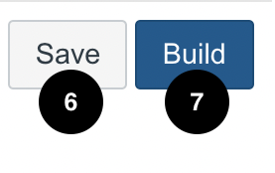

On the New Quizzes settings tab check the correct variables have been entered:
- If using ‘Shuffle questions’ make sure this is switched on.
- If using the ‘One question at a time option’ select this.
- Set the time limit for the quiz
- There are also options for multiple attempts which may be used for formative assessment.
- Ensure that restrict student result view is selected if this is a summative assessment.
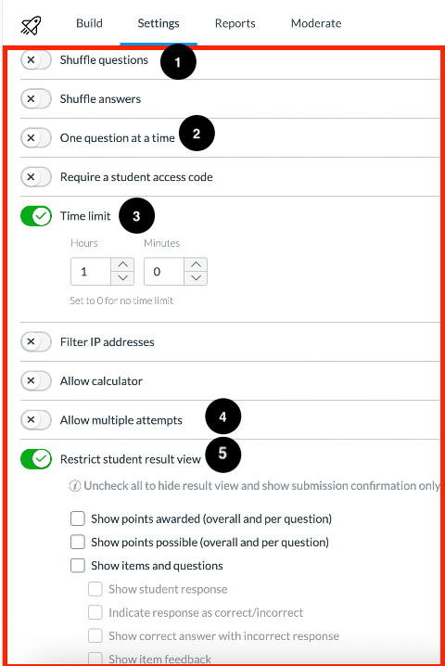
- Check that reasonable adjustments have been applied for students with RAPs. This must be done before the quiz has started and cannot be set up once the quiz has started. See step by step guidance below on how to add additional time in new quizzes.
- Ensure the Grade Posting Policy is set to ‘Manual’. The quiz needs to be published before the grade posting policy settings can be applied. Please see the guidance on how to set the grade posting policy which can be found in this document.

Adding additional time (E.g.: Reasonable Adjustment Plans)

Please note: You can only apply time adjustments in new quizzes to students before they have commenced the quiz. No time adjustments can be applied whilst the student(s) are undertaking the exam. Quiz availability dates still apply to a quiz with additional time. If the until date passes before a student completes a quiz with additional time, any in-progress attempts will auto-submit and the quiz will close.

Setting availability dates and times
- To assign students additional time navigate to ‘quizzes’ from the left hand menu, select the dots icon at the far right of the quiz.

- Then select on ‘Edit’ from the drop down menu.
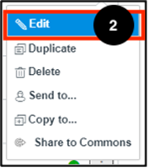
- Click on the ‘Add’ button below the ‘assign to everyone’ group to add a new grouping.
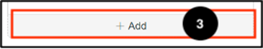
- Assign the students who need additional time by typing in the name(s). Please note: You can only group students together if they have the same time adjustment. Students with separate time requirements will need to be added to a separate grouping, by repeating step 3.
- Assign the ‘available from’ date and time and then add the additional time to the ‘available until’ time and click Save.
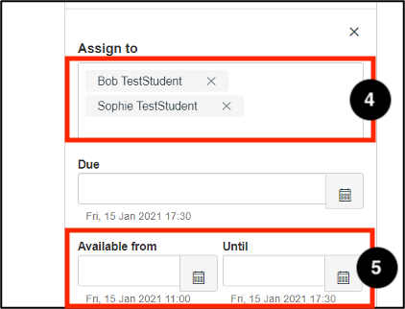

Assigning the additional time
- After assigning available from and until dates, select the quiz and click on ‘Moderate’ from the top menu.
- Find the student(s) who need time adjustments, click on either the pencil icon under Accommodations and the additional time.
- Or the ‘moderate’ button on the far right. Either of these options will apply the time adjustment.

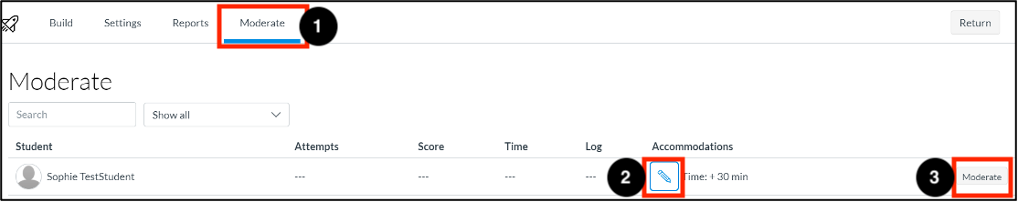

- Under the Time adjustments drop down menu select ‘Give additional time’.
- Add the hours / minutes of extra time that the student requires.

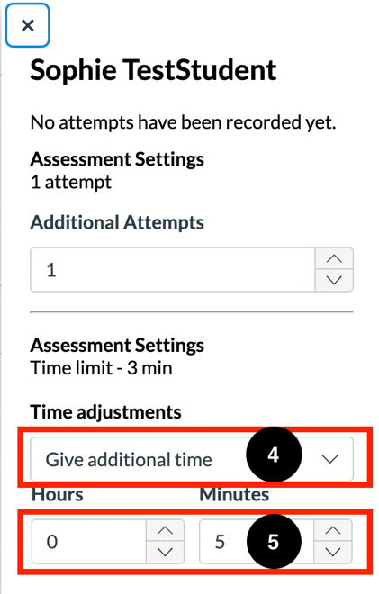

Adding additional attempts
Please note: Quiz availability dates still apply for a student who has been given an extra attempt(s). If the Until date passes before a student completes an extra attempt, any in-progress quizzes with automatically submit.

- Go into the quiz and select ‘Moderate’ from the top menu.
- Then next to the student name click on the ‘Moderate’ button.
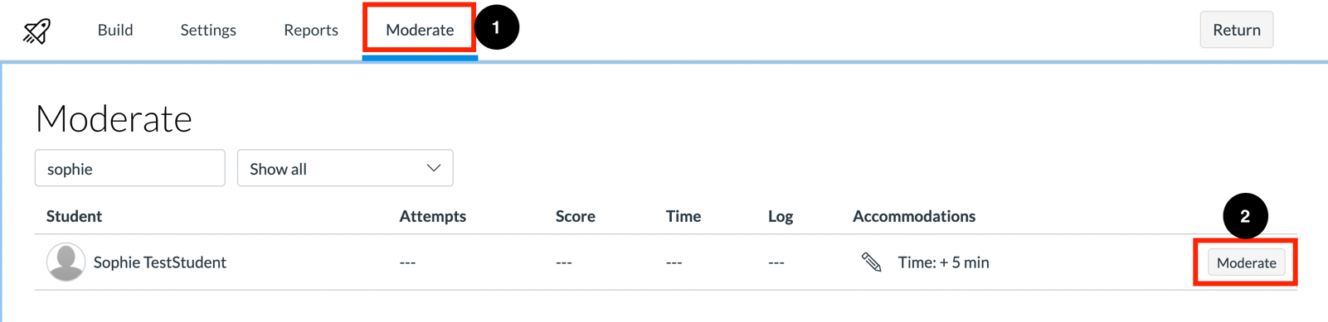

- Under the ‘Additional Attempts’ field select the number of additional attempts to give the student.
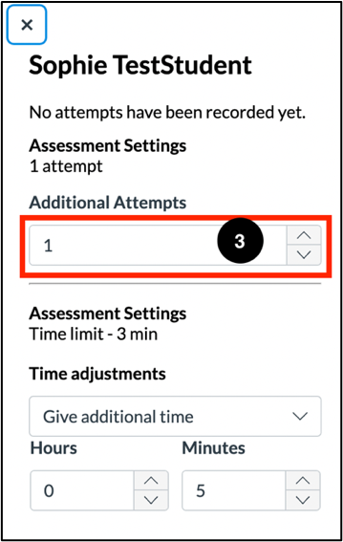

Multiple Attempts for all students
By default, New Quizzes will be limited to 1 attempt. Within the in-quiz settings check the ‘Allow Multiple Attempts’ option(1) to add extra attempts for all students in the quiz. You can choose which score to keep (2) how many attempts are allowed (3) and whether a time period must elapse before students can complete another attempt (4).
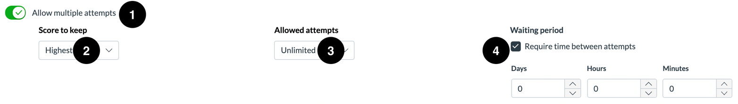

The Score to keep option (2) allows you to choose which score is kept as the final grade, if there are multiple attempts on the quiz.
The options are:
- Highest – The highest score is kept as the final grade.
- Average – The average score is kept as the final grade.
- Latest – The latest attempt is kept as the final grade.
- First – The first attempt is kept as the final grade even if the quiz is retaken at a later date.

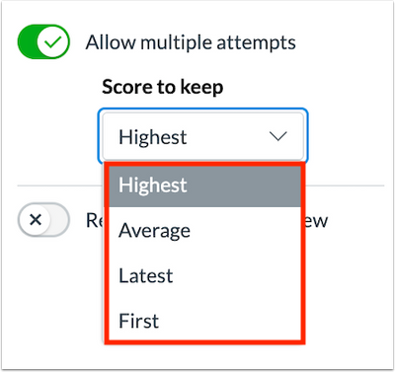

Setting up Sections
When marking in new quizzes, short answer or essay style questions need to be marked manually in Speedgrader. For large cohorts of students it can be easier to arrange the students into sections so that they can be assigned to the marker(s). This is also useful when using the anonymous grading in new quizzes. Please see the following guidance on how to set up sections in Canvas.

Editing a quiz

If you want to go back and edit your quiz questions or the settings, click on the quiz title (1) and then scroll down and click ‘Save’ at the bottom of the page (2).
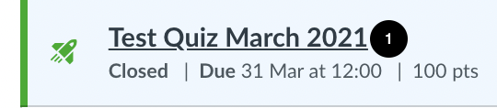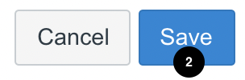

Setting the Grade Posting Policy
The grade posting policy should be set to 'Manual’ within the Grades within Canvas. This will ensure students will not receive their feedback until this is ready to be released.
- Click ‘Grades’ from the left hand menu.
- Select the dots icon next to the quiz title and then select ‘Grade Posting Policy’.
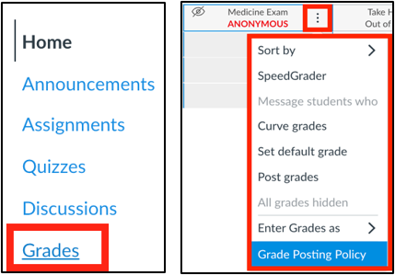
- Select the Manually release grades option and then ‘Save’.
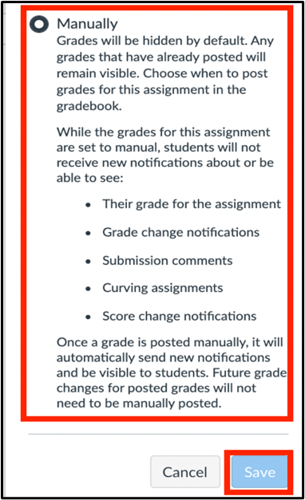

Release of Grades
- To release the grades to the students through Canvas go to ‘Grades’ from the left hand menu and then navigate to the quiz and click the three dots icon.
- Then click the ‘Post grades’ option.
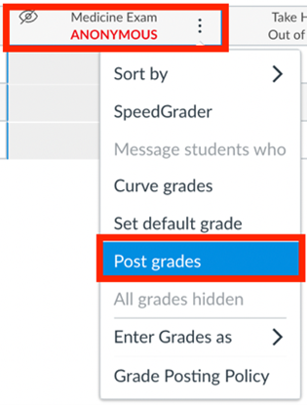
- Click the option to post for ‘Everyone’ or all the students who are ‘Graded’, then select ‘Save’. Please note that anonymous assignments will post grades for everyone in the course.
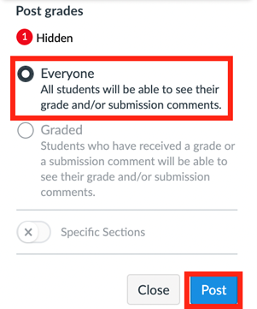

Exporting Reports
You can download an excel spreadsheet of your Online Exam marks from Canvas Admin. This is useful if you do not want to change your Grade Posting Policy but require marks for BIRMS.

Please see the full instructions on the Online Administrator Training Canvas course.

