Ed-Xchange

European International Exchange Programme

Birmingham, Dortmund, Groningen, Oslo, Trondheim

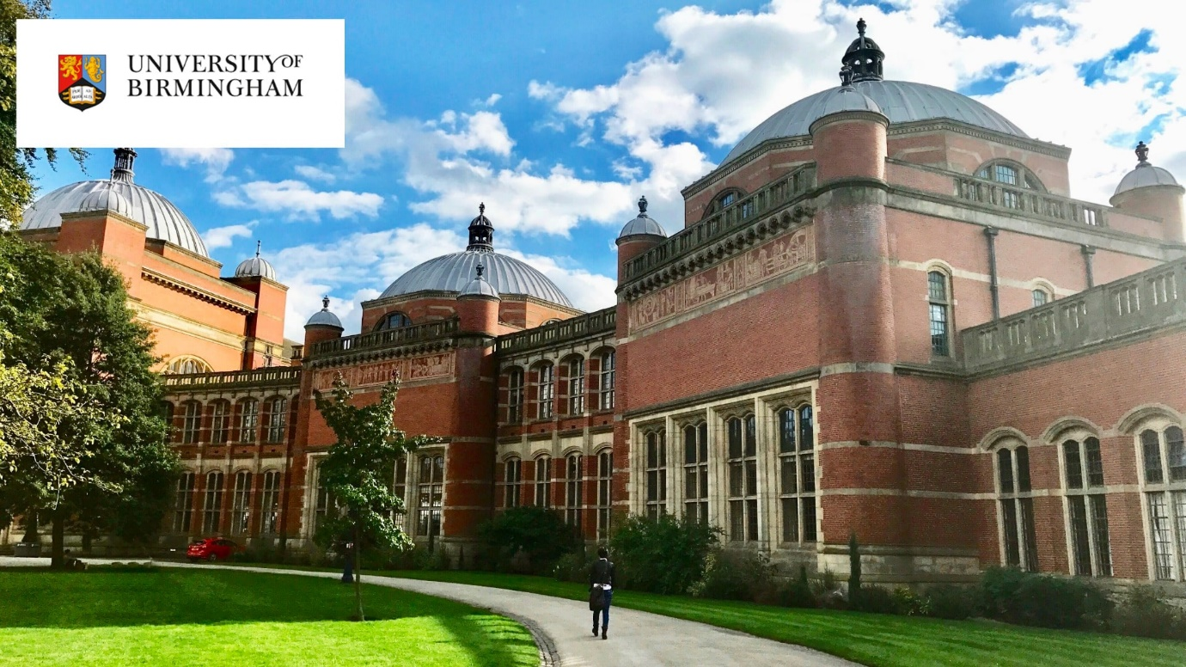

University of Birmingham, UK

Information for ‘Inbound’ Students 2023 - 2024
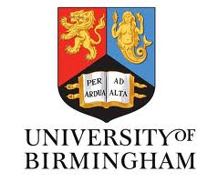

Head of School: Professor Karen Guldberg

For routine and administrative queries please contact:
ug-education@contacts.bham.ac.uk

For specifically academic queries please contact:

Dr Jawiria Naseem
j.naseem@bham.ac.uk
School of Education
University of Birmingham
Edgbaston, Birmingham
B15 2TT, United Kingdom

Follow us on Twitter: @esj_bham

Key information

University of Birmingham:
https://www.birmingham.ac.uk

School of Education:
http://www.birmingham.ac.uk/schools/education/index.aspx

Department of Education and Social Justice: http://www.birmingham.ac.uk/schools/education/departments/education-social-justice/index.aspx

BA (Hons) Education Programme: https://www.birmingham.ac.uk/undergraduate/courses/edu/ba-education.aspx

English Pre-sessional Programmes: http://www.birmingham.ac.uk/International/bia/presessional/index.aspx

University of Birmingham Study Abroad: http://www.birmingham.ac.uk/international/study-abroad.aspx

Explore: Birmingham: https://www.birmingham.ac.uk/study/birmingham/city/index.aspx

Accommodation at the University of Birmingham http://www.birmingham.ac.uk/study/accommodation/index.aspx

University of Birmingham YouTube Channel: http://www.youtube.com/user/unibirmingham

The University of Birmingham
The University of Birmingham has been challenging and developing great minds for more than a century. Characterised by a tradition of innovation, research at the University has broken new ground, pushed forward the boundaries of knowledge and made an impact on people’s lives.
We continue this tradition today and have ambitions for a future that will embed our work and recognition of the Birmingham name on the international stage. Universities are never complete. They develop as new challenges and opportunities occur. At Birmingham we innovate, we push the frontiers of understanding; we ask new research questions, we turn theory through experiment into practice – because that’s what great universities do.
The University grew out of the radical vision of our first Chancellor, Joseph Chamberlain. Founded in 1900, Birmingham represented a new model for higher education. This was England’s first civic university, where students from all religions and backgrounds were accepted on an equal basis.
Birmingham has continued to be a university unafraid to do things a little differently, and in response to the challenges of the day. It was a founder member of the National Union of Students and the first university in the country to:
- be built on a campus model;
- establish a faculty of commerce;
- incorporate a medical school;
- offer degrees in dentistry;
- create a women’s hall of residence;
- have a purpose-built students’ union building.
The University of Birmingham was established by Queen Victoria by Royal Charter in 1900 and was the UK’s first civic or 'redbrick' university. The first phase of building work on the campus was completed in 1909 under the auspices of the esteemed architect Sir Aston Webb. We celebrated the centenary of those buildings in July 2009.

The University of Birmingham’s Global Profile
The University of Birmingham has welcomed international students since 1900. Today we have one of the largest international student communities in the UK with over 4,000 students from more than 150 countries worldwide currently studying with us.
In addition, 27% of our academic staff are from outside the UK, demonstrating that Birmingham is seeking to attract the brightest talent to its academic community from around the globe.

Birmingham
With more students than any UK city outside London, Birmingham is a fantastic place to study and live. A £9 billion regeneration programme has transformed the city into a vibrant centre, with great shopping, theatres and night life.
The main Edgbaston Campus is located only 3 miles from Birmingham city centre, and close to the shopping areas of Edgbaston, Selly Oak, Harborne, and Selly Park.
To find out more about what the city of Birmingham has to offer, visit the official tourism pages: http://visitbirmingham.com.

School of Education
The original Department of Education was founded in 1896 and became the School of Education in 1947. It has a long-standing reputation as a centre of excellence for teaching and research in a wide range of areas of educational practice and policy:
- we are using our world class expertise to research issues which lie at the heart of excellence in education;
- our teaching draws on the research and professional expertise of high calibre academics;
- we work in close partnership with schools and educational organisations across the UK and internationally to support school and educational improvement.
The School of Education is one of four schools within the College of Social Sciences at the University of Birmingham, which brings together academics and administrative staff across a wide range of disciplinary and interdisciplinary fields in social sciences.

Department of Education and Social Justice
As an undergraduate student at the University of Birmingham, you will belong to the BA (Hons) Education Programme. Education is the main Undergraduate Programme offered by the School of Education and the Programme sits in the Education and Social Justice Department.
http://www.birmingham.ac.uk/schools/education/departments/education-social-justice/index.aspx
The Department of Education and Social Justice (ESJ) comprises researchers who share a common interest in researching the inequalities that persist in society and understanding the role that education plays in improving social justice.
All members of the Department are actively involved in research, and this informs teaching on all our courses, which include the BA Education, as well as postgraduate taught courses in MA Education and MSc TESOL Education. In addition, the Department also has dedicated Research Centres – CREE (Centre for Research in Race and Education), DOMUS, which is a collaborative cluster of historians who concentrate on researching the social, political and cultural histories of schooling, education and childhood
Our research has an international as well as national focus, and our interests extend from early childhood education through to adult learning, spanning from the historic to contemporary issues. Our research activity can be grouped into five broad sub areas:
- Education Policy and Effectiveness;
- Histories of Education and Childhood;
- International Education and Global Justice;
- Post-compulsory and Informal Education and Training;
- Sociology of Educational Inequalities.

BA (Hons) Education Programme
https://www.birmingham.ac.uk/undergraduate/courses/edu/ba-education.aspx
The BA (Hons) Education is one of the most prestigious education programmes in the UK. The programme is interdisciplinary and combines ideas and research from areas such as education, psychology, sociology, philosophy, social policy and history. It is designed for both national and international students who have career aspirations and/or academic interests in the fields of childhood and education. The BA (Hons) Education combines the academic study of childhood and education with a practical focus on career development in related areas in the United Kingdom, Europe and beyond.

Programme Overview
The BA (Hons) Education Programme aims to equip students with the academic knowledge, as well as relevant practical skills and experiences, which aid progression to professional training and to careers working with children and young people in a diverse range of settings and geographical locations.
All our modules explore how people, and especially children, develop and learn in cultures around the world. We identify and evaluate different ways of knowing about and understanding children and young people and their behaviour; with how educational policy can promote, or frustrate, attempts to develop justice; and with the skills and competencies necessary to develop graduate careers in the UK, Europe and beyond. There are four curriculum strands.

Psychology
The psychology strand introduces you to the theory and research that underpin our ideas of human learning and development. These are the basis to explore child development from early years through adolescence and into adulthood, through themes such as perception, language and thinking, attachment and social relationships.

Sociology
In the sociology strand you will learn about how people’s thoughts, feeling and actions shape and are shaped by their social, cultural and economic contexts. Using sociological theory from a range of traditions we will look at how policy and politics shapes educational institutions and practice. We will examine the contribution education can make to reducing social inequalities, and how education varies around the world to address different challenges. We will look at what it means to be young today, and the challenges young people face from employment to mental health.

History
In the history strand you will examine the emergence of the institutions that dominate our experience of education, that shape our ideas of what it is to learn, and what it means to be educated. Ranging across centuries and continents, and formal and informal learning contexts, you’ll critically examine how education has been used to shape character, mould behaviour, and strengthen social groups. We will look at the purposes of schooling, and the role it plays in individual and national development. We will explore how the story of education is bound up with social science’s changing ideas about the capacities of humans, their differences and their limitations.

Philosophy
Through philosophy you are introduced to work by major Western philosophers (Plato, Aristotle, Kant, Hume, Rousseau, Dewey) as well as figures specialising in the philosophy of education. Through philosophy you will examine the core concepts that define education and learn to debate fundamental questions. What does it really mean to learn and to teach? What is knowledge? The different kinds of education we undertake implies there is a value to teaching knowledge, or a vocation, or character. How important are each of these things? Our aims for education are often bound up with hopes of greater prosperity, personal fulfilment, and equality and social justice. What does equality mean? Is there a conflict between individual freedom and equality? Should education be for prosperity? Does the existence of private education make the system more or less fair?

Research in Education
The Research in Education strand applies academic knowledge to real world settings and it will help you develop those skills and competencies characteristic of a University of Birmingham graduate. With modules in Special Educational Needs, Autistic Spectrum Disorders and Teaching and Learning in Schools, we’ll help you become critical thinkers, effective communicators and educational leaders.

Module Choices
As an Ed-Exchange student, you will be able to study modules we offer as part of our Undergraduate Programme. The modules currently on offer are listed below, but please note that there may be changes to the modules we will be able to deliver. In some cases, you may be limited by timetabling restrictions or availability on the module. We advise you to select some ‘reserve’ modules in the event that we are not able to register you on your preferred choices. When you arrive at Birmingham, we will work with you to ensure that you are registered for modules that are compatible with modules you have studied at your home institution and your learning interests.
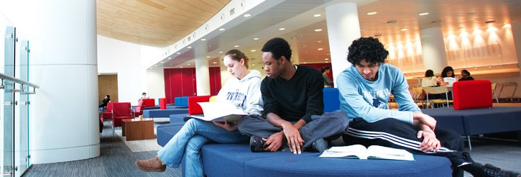

Level C Undergraduate Year 1
Level I Undergraduate Year 2
Level H Undergraduate Year 3

The availability of modules, content and assessment method can all be subject to alteration.

Code: 11 34016
Title: LC Contemporary Issues in Education: Learning Communities in Higher Education
Semester: 1
Credits: 10 (5 ECTS)

Objective: This module enables students to develop the relationships, skills, and critical dispositions that support their overall achievement. It is designed introduce students to different kinds of educational research while also equipping them with key skills in academic reading, writing and discussion (both listening and speaking). A key aspect of the module is the practical recognition it gives to the importance of relationships and community in developing a sense of belonging and facilitating academic success.

Assessment: Participation in group tutorials (20%), 800 word reflection (40%) and 800 word reflection (40%)

Coordinator: Dr Jawiria Naseem

Code: 11 34023
Title: LC Introduction to Developmental Psychology – Part 1
Semester: 1
Credits: 10 (5 ECTS)

Objective: Key themes and issues in developmental psychology will be discussed, including continuous and discontinuous development, stability and change and the nature/nurture debate. It also considers how research and theories of these issues are applied to children’s development and education.

Assessment: Group oral presentation of a research project with accompanying individual 1000 word script (100%)

Coordinator: Dr Catherine Darnell

Code: 11 27408
Title: LI Changing Behaviours
Semester: 1
Credits: 20 (10 ECTS)

Objective: This module identifies, explores and evaluates the production and application of scientific knowledge about human behaviour in the period 1760-2000. It explores the ways in which state and imperial formations conditioned the emergence of modern scientific disciplines and it traces the influence of new technologies for understanding and changing human behaviour. A particular focus is on the emergence of psychology, both developmental and social, and its applications in therapeutic and both formal and informal educational settings.

Assessment: 2500 word essay (63%), 1500 word blog (37%)

Coordinator: Prof Kevin Myers

Code: 11 34289
Title: LH Reclaiming Education: Past, Present and Futures
Semester: 1
Credits: 20 (10 ECTS)

Objective: This module offers students the opportunity to examine and discuss neglected traditions of thought and practice in the field of education. These traditions are geographically, politically and ideationally diverse but their shared aspiration was, and is, to challenge dominant educational ideas and practices. For the actors who led and participated in these movements, the primary purpose of education was empowerment and, for at least some of them, social transformation. The module begins by identifying and examining alternative educational theories and critiques. It then explores alternative educational practices through a series of historical and contemporary case studies. Each case study will examine the concepts and practices of alternative education and students will be asked to reflect on their relevance for today. The module is completed by imagining the ways in which education can be reclaimed for the purposes of empowerment and social justice.

Assessment: 3000 word essay (75%), 1000 word blog (25%)

Coordinator: Dr Sian Roberts

Code: 11 34019
Title: LC Contemporary Issues in Education: Engaging with Research
Semester: 2
Credits: 10 (5 ECTS)

Objective: This module enables students to develop the relationships, skills, and critical dispositions that support their overall achievement. It is designed to introduce students to different kinds of educational research while also equipping them with key skills in academic reading, writing and discussion (both listening and speaking). A key aspect of the module is the practical recognition it gives to the importance of relationships and community in developing a sense of belonging and facilitating academic success.

Assessment: Participation in group tutorials (20%), 800 word reflection (40%) and 800 word reflection (40%)

Coordinator: Dr Jawiria Naseem

Code: 11 34024
Title: LC Introduction to Developmental Psychology – Part 2
Semester: 2
Credits: 10 (5 ECTS)

Objective: Key paradigms in developmental psychology will be presented. Developmental psychology research models and their underlying assumptions will be studied in reference to key areas of development. Ethical principles and research limitations will also be considered.

Assessment: 2000 word research proposal (100%)

Coordinator: Dr Catherine Darnell

Title: 11 26290 LC Young People and Social Change
Semester: 2
Credits: 20 (10 ECTS)

Objective: This module introduces and examines sociological perspectives on young people and social change. In the first part of the module students are introduced to a series of contemporary debates on the alleged crises facing young people today. The module locates these crises in sociological debates about social change and the changing influence of social structure. Students are introduced to key sociological tools that can be applied to these debates and explores the ways in which sociologists can best understand the ways in which young people are affected by social change. Throughout the module, there is an emphasis on developing critical and analytic skills in acdemic work.

Assessment: 500 word essay (formative); 1500 word essay (33%) and 2500 word essay (67%)

Coordinator: Dr Ian McGimpsey

Code: 11 19247
Title: LC Equality and Diversity: Children, Families and Society
Semester: 2
Credits: 20 (10 ECTS)

Objective: This module will explore relationships between cultural identity, social policy and issues of equality and diversity in Britain. The module will explore popular and state responses, both national and local, to issues of equality, diversity and social justice. It will examine patterns of inequality in selected areas of social policy and provision. While the focus of the module will be on the British experience, some international comparative data will be used

Assessment: 2000 word essay (50%) and 2 hour unseen examination (50%)

Coordinator: Dr Valentina Migliarini

Code: 11 38947
Title: LI Primary and Early Years Education Theory and Practice
Semester: 2
Credits: 20 (10 ECTS)

Objective: This module enables participants to study systematically, critically and in-depth, aspects of educating Primary and Early Years children (UK and International perspectives). It provides a practitioner perspective on curriculum approaches for Primary and Early Years Children, and enables participants to understand the contribution of curriculum subjects to children’s learning and development. As well as lecture content, the module uses a series of weekly tasks to explore the relations of educational theory, teaching practice, curriculum and child development and learning. These tasks are undertaken by students independently, including weekly guided independent study sessions, and contribute to the creation of an assessed online portfolio.

Assessment: 2500 word essay (60%) and an online portfolio based on a series of weekly tasks (equivalent to 1500 words) (40%)

Coordinator: Victoria Saunders and Celia Greenway

Code: 11 19038
Title: LH Children as Citizens
Semester: 2
Credits: 20 (10 ECTS)

Objective: The module examines the development of Citizenship as a concept and a curriculum subject. Student will develop their knowledge of the debates surrounding citizenship through an evaluation of research, government publications and other writings in this area. Students will identify challenges to the teacher’s role through an exploration of classroom conflict, multiculturalism and educational aims. Consideration will be given to related concepts of Political Systems, Human Rights and Global Citizenship.

Assessment: 2000 word essay (50%) and live blog on a theme from the module using a digital platform (equivalent to 2000 words) (50%)

Coordinator: Dr Saba Hussein

