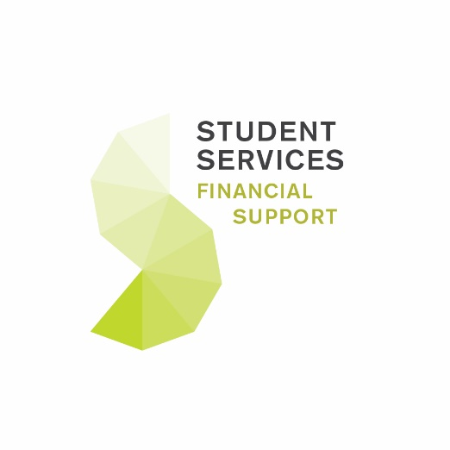

Music Scholarship Guidance Notes 2021/22

- Am I eligible?

In order to apply for a Music Scholarship, you must meet the following eligibility criteria:

- You must be classed as a “home” student (i.e. been normally resident in the UK for three years prior to the start of your course);
- You must have selected Birmingham as your “firm” choice following an offer of a place on a full-time undergraduate programme (other than a programme offered by the Department of Music) commencing in September 2021;
- You must be performing at a Grade 8 standard in instrumental or vocal studies and supply evidence of your performance standard (see section 4).

N.B. For Jazz scholarships, a supporting letter from your instrumental or vocal tutor can be accepted in lieu of standard grading certificates, if required (e.g. ABRSM, Trinity Guildhall, RSL Awards).

- What is the scholarship worth?

Each scholarship will offer approximately 17 hours of musical tuition per year for three years and will be administered by the UoB Department of Music; tuition may be delivered by tutors employed by the UoB Department of Music or at Birmingham Conservatoire. This musical tuition will have a cash value of £1,000 per year, or £3,000 over the lifetime of the award.

In order to continue receiving the Music Scholarship in subsequent years, each Music Scholar must make academic progression at a 2:1 standard in their studies and commit to playing in at least one ensemble organised by University Music. If you do not meet the academic standard and musical obligations upon moving into your second year, your award will be suspended. However, you will have the opportunity to reclaim the award in subsequent years if your academic progress improves and you reach a 2:1 standard.

- How many scholarships are available?

15 new Music Scholarships will be available for the 2021/22 academic year.

- How do I apply?

To apply, please complete and submit an online Music Scholarship application form. You will have the opportunity to save your progress on the online form and return to it later if necessary.

Orchestral and Choral Scholarships:
In addition to submitting your application, you are required to include:

- A copy of your grade 8 or diploma certificate/mark sheet (if you have not passed a grade 8 examination, we will accept a letter from your instrumental/vocal tutor attesting that you are performing at a Grade 8 standard or above).
- Video evidence of your performing standard. This takes the form of two contrasting works taken from a recognised examination syllabus at either Grade 8 or Diploma level. We request videos are uploaded and submitted via YouTube.
- A copy of the sheet music from pieces that you have chosen to perform for your application.

Jazz Scholarships
In addition to submitting your application, you are required to include:

- A letter of reference from your instrumental or vocal tutor (or similar) outlining why you would be a worthy recipient of a scholarship.
- Video evidence of your performing standard. This takes the form of two contrasting jazz standards (see below), each of around 2-3 minutes in length.
- The first submission should feature a ‘head-solos-head’ arrangement with an improvised solo. This can be performed with a band accompaniment or a backing track.
- The second submission should feature a transcription of a recorded solo, using the original recording as a backing track.
- A copy of the notated transcription featured in the second video submission. This can be produced by hand or using music notation software.
- We request videos are uploaded and submitted via YouTube.

Repertoire List:
- Any tune from the ‘jazz standard’ repertoire. “Real Books”, or similar lead sheet compilation volumes, are a recommended source for this material.

Backing Tracks:
- iReal Pro is a recommended app-based resource for chord sequences and backing tracks. Other backing tracks, e.g. from the “Learn Jazz Standards” YouTube channel are also acceptable.

Submitting your documentary evidence:

The online form will enable you to upload and attach your supporting documentation (Grade 8 mark sheet or letter, sheet music etc.) and submit it along with your application. All attachments must not total more than 20MB in size. We would recommend that you submit these documents via the online form if possible, however if you are unable to do this you may submit the evidence by logging an online enquiry to the Funding, Graduation & Awards Office at www.studenthelp.bham.ac.uk and attaching your supporting documents to that submission.

Submitting your video evidence:

If you choose to submit your recorded performance via YouTube, you can include a link to the video on the form. Alternatively, you can submit through a ‘wetransfer’ link. If you have any difficulty with this, please write to Eoin Funnell, as Solo Performance Administrator (E.Funnell@bham.ac.uk).

Please remember that this must be a solo performance.

Due to the uncertainty surrounding national COVID restrictions, we appreciate that applicants may be unable to meet with their accompanists to record and submit videos before submitting their application. If you feel that this applies to you, please instead submit an alternative unaccompanied piece (e.g. a complete work, study, or etude) that reflects your current performing standard, noting the reasons for this in your application.

- When is the deadline?

Completed applications together with supporting evidence must be submitted by 11:59pm on Friday 7th May 2021.

- How will the scholarship be selected?

Following the deadline, all completed applications will be collated with documentary and video evidence and forwarded to a selection panel composed of various members of academic staff from the Department of Music. Selection of successful candidates will be based on academic standard (e.g. your A Level results) and your musical performing standard and experience as evidenced by your video, documentary evidence and personal statement.

- When will I be notified of the outcome?

Applicants will be informed of the outcome following the release of A Level qualifications in August.

If you have any queries about the application form, please log an enquiry at www.studenthelp.bham.ac.uk.

Any music scholar undertaking a 5 year medical/dental degree will have the option to apportion their tuition over 5 years rather than 3, meaning you will receive approximately 10 hours of musical tuition each year.

