CARBON EMISSIONS

REPORT 2020/21

FOREWORD

EMPOWERING SUSTAINABILITY
Climate change is the most serious threat facing our planet today; there is an urgent need to cut emissions if we are to limit global warming to 1.5°C.

We are already beginning to see the consequences of inaction. The
Sixth Assessment Report from the Intergovernmental Panel on Climate
Change reiterates that the evidence for global warming is clear and the time
for action is now.

The University of Birmingham has the expertise and partnerships to play a
significant role in tackling global sustainability challenges. Our pioneering
research and teaching addresses the realities of climate change through
transforming health, environment and society. However, we also have a
responsibility to ensure that we lead by example, reducing the impact of
our own operations. We are committed to going beyond business as usual,
embedding good sustainable practices across all our activities.

With goals of achieving net zero carbon for Scopes 1 & 2 by 2035 and Scope
3 by 2045, the University has committed to developing sustainable campuses
and ways of working; our global strategic collaboration with Siemens is
testament to this. We are ensuring our community of staff, students and
visitors are knowledgeable about sustainability, so they are empowered to
make sustainable changes.

On the 16th June 2022 we joined many others in declaring a climate
emergency. We recognise that more needs to be done and more quickly to
keep the increase in global temperature below 1.5 degrees, thereby reducing
the worst impacts of climate change. Our membership of the United Nations
(UN) ‘Race to Zero’ campaign demonstrates the value we place on rallying
leadership and support from businesses, cities, regions, and investors for a
healthy, resilient, zero carbon recovery that prevents future threats, creates
decent jobs, and unlocks inclusive, sustainable growth.

Achieving net zero carbon for all scopes is one of our three goals within the
sustainability pillar of our 2030 strategy, alongside using our research and
education to make a major global contribution to the UN Sustainable
Development Goals and collaborating with Birmingham, Dubai, and their
wider regions to tackle sustainability.

Measuring our emissions according to best practice is an important step
to enhance our approach to meet our net zero ambition and decarbonise
our operations. Ensuring we have a robust process in place to measure
our progress will allow us to make increasingly informed decisions about
where best to target emissions reduction within the University’s practices
and programmes.

The path to reaching zero emissions is multi-faceted, requiring technical
intervention, behavioural change and community empowerment. It is also
challenging, but as a university, we have always understood that a
commitment to society and the environment go hand-in-hand. This
commitment is evident in our approach to sustainability across our research,
our student experience, and through our innovative campus management
and development.

This report is part of our commitment to transparency as we develop our
decarbonisation strategy. There is a significant challenge ahead of us
given the plans for the University’s estate expansion and growth in student
numbers, however, I feel confident that we can continue to reduce our impact
whilst improving our experience for students and staff, allowing us to continue
to have a positive global impact with our research.

Professor David Hannah, Institutional Lead for Sustainability

INTRODUCTION

MEETING OUR NET ZERO AMBITIONS

This report introduces a vital step toward meeting our net zero ambitions. We have undergone an extensive process to understand our greenhousegas (GHG) emissions, within the limits of data availability and quality, for the academic year of August 2020 to July 2021.

This represents the beginning of an annual process which will allow us to monitor and adjust our pathway to net zero with increasing accuracy.

GHG emissions are typically categorised into three scopes so that responsibility for them can be accurately allocated (Figure 1). Typically, an organisation will have a greater level of influence over their Scope 1 and 2 emissions, however, Scope 3 emissions can often represent the greatest carbon impact.

The University has committed to the ambitious targets of being net zero carbon for Scope 1 and 2 by 2035, and Scope 3 by 2045. A comprehensive understanding of our carbon footprint is an essential step to establishing a net zero carbon pathway.

Following a review of applicable methodologies, we have adopted the World Resource Institute’s GHG Protocol1 to assess our emissions. This international standard is recognised as the best practice approach to reporting and is widely
adopted. Following standardised approaches and principles to measuring our emissions will allow us to:

- Prepare a GHG inventory that represents a true and fair account of our emissions.
- Provide us with information that can be used to build an effective strategy to manage and reduce GHG emissions.
- Increase consistency and transparency in GHG accounting and reporting in UK Higher Education (HE).
Enhancing our existing sustainability governance structures will be central to achieving robust, permanent and managed emissions reductions. Our governance strategy will involve external auditing of our carbon accounting, increasing engagement, assigning responsibility, and embedding net zero in our current practices. This report provides a baseline to measure our decarbonisation year on year. We intend to take a transparent reporting approach, holding ourselves
accountable to our net zero commitments.

DIRECT
Scope 1: Emissions resulting from activities under the direct control of the University,
such as combustion of gas and oil in boilers, fleet vehicles, and on-site refrigerant leakage

INDIRECT
Scope 2: Emissions arising from energy purchased by the University for its operations such as power or district heating.

SECONDARY INDIRECT
Scope 3: Emissions arising from associated activities not directly controlled by the University such as procurement of equipment, staff and employee commuting, water use and waste management.

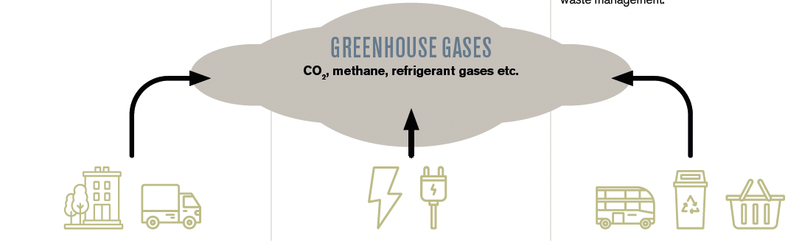

ACCOUNTING FOR OUR CARBON EMISSIONS

All our Scope 1 and 2 emissions are accounted for in this report. With regards to our Scope 3 emissions, we have prioritised those where we have robust information and data. These tend to be upstream in the University’s value chain (the products and services we buy).

[Figure 2 shows the University’s Scope 1, 2 and 3 emission sources.]

Those emissions currently out of scope will not necessarily remain so, and will
be regularly evaluated as we continue to bolster the quality and breadth of
data we collect.

As well as emissions sources, the organisational boundary has also been
defined in terms of the assets and activities to be included. We have applied
the financial control approach as defined by the GHG Protocol. This control
approach effectively says that if you have financial control of the emissions
sources, it is reasonable that you should be responsible for those emissions.2
By using the financial control approach, we intend to closely align our carbon
reporting with our financial reporting each year.

Future scope
The emissions accounted for and measured in this report are those related
to our UK activities and do not currently extend to our international Dubai
campus. We are working towards including this campus in future
emissions reporting.

It’s also important to note that there is not an exact science to reporting emissions. Estimates and assumptions are required. As it’s our first year of reporting our emissions in this detail, there may be imperfections in our emissions boundary or calculation methodologies that we need to address in the future, following the principle of continuous improvement. We will establish a Base Year Recalculation Policy to guide work in future years should enhancements in data availability, quality, or other improvements make it appropriate to recalculate. Understanding and reducing our carbon emissions is too urgent to prioritise perfection today — as guidance and technology evolve, so will our reporting. Additions and adjustments made to our footprint as a result of emergent information or clarification will be
clearly signposted and highlighted in future annual reports to ensure that adjustments are called out and explained as part of a transparent reporting approach.

SCOPE 1
- Natural gas
- Gas oil
- University vehicle fleet
- Grounds maintenance fuel
- Fugitive emissions

SCOPE 2
- Grid electricity
- Purchased heat

SCOPE 3
- Business travel
- Waste
- Water and wastewater
- Employee and student commuting
- Purchased goods and services
- Capital goods
- Fuel and energy procurement emissions
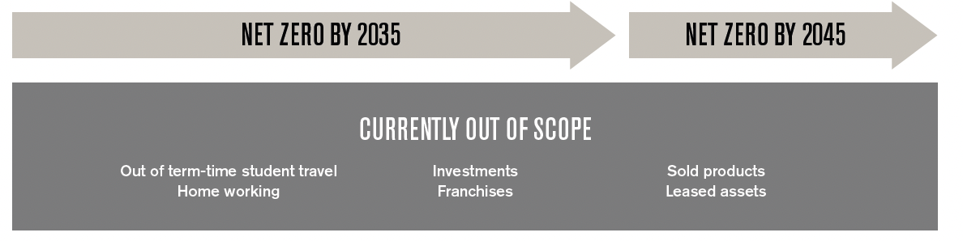

THE UNIVERSITY’S CARBON FOOTPRINT

The University’s carbon footprint for the academic year 2020/21 is 280,504 tCO2e.
Table 1 categorises those emissions according to our operational boundary and Figure 3 shows that the majority of them result from our indirect Scope 3 emissions, making up 83% of the total.

Of those Scope 3 emissions, the majority are due to the purchase of goods and services; this covers catering services, IT equipment, scientific supplies and other things that allow for the day-to-day operation of the University.

The second largest emissions source is gas at 16%, driven by the Energy Centre, which supplies heat and electricity to the Edgbaston Campus. It is explored in more detail later in this report.

Throughout this carbon accounting project, we have captured the lessons learned from gathering and processing data in this, our first year of reporting, to improve the processes in future years. As we gain more and better data covering the sources in Figure 3, our emissions may go up or down but this exercise of refinement is absolutely necessary to establish a robust and verifiable net zero carbon position.

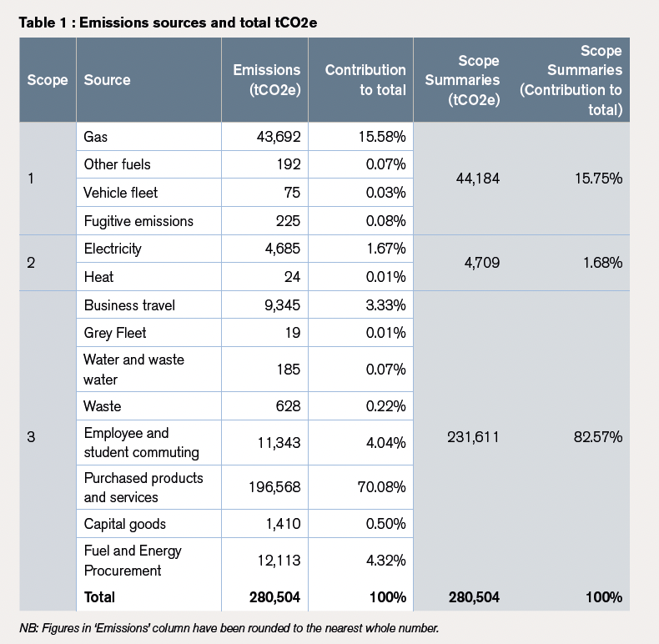

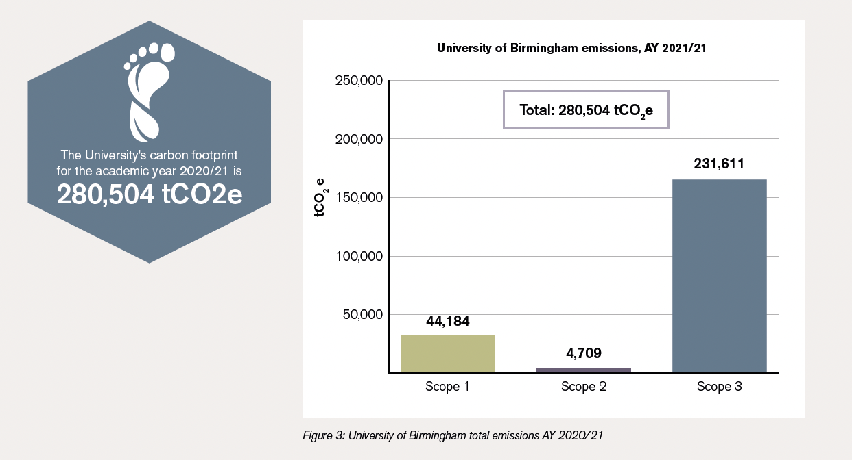

SCOPE 1 & 2 EMISSIONS

Scope 1 covers the emissions we generate directly, which are from burning fossil fuels to heat our buildings or the leakage of refrigerants we use to cool them3. Conversely, Scope 2 covers the emissions we generate indirectly, like from
the electricity we buy. As we directly control our activities leading to emissions from these sources, they tend to be easier to quantify and ultimately reduce.

As mentioned earlier, our total Scope 1 and 2 emissions are dominated by gas rather than electricity, which is an unusual finding for a university. This isn’t necessarily because our buildings consume less electricity than the average, but because of how we source it. Our Energy Centre burns gas via combined heat and power (CHP) units to generate both heat and electricity, which are distributed across our
Edgbaston campus. As a consequence, we only import electricity where we cannot generate it ourselves.

Historically, electricity was the most carbon intense source of energy for buildings, greater than gas and coal. Therefore, gas-fired CHP engines offered a lower carbon solution to servicing buildings. However, the national grid has rapidly decarbonised over the last eight years, resulting in much cleaner electricity, which means
in turn that CHP engines produce higher carbon emissions per unit of energy than electrically powered systems.

As the national grid continues to decarbonise and the generation of electricity becomes ever cleaner, the University will need to move away from gas-fired
to electrically-powered heating systems to reduce emissions. We are already working with partners such as Siemens and Equans to develop solutions to decarbonise.

The remaining electricity we use is imported from the national grid via a ‘Pure Green’ certified tariff. This means that the energy supplied is associated with certificates (known as REGOs) which are contractual instruments created for each
unit of renewable energy generated. Although this is a ‘green tariff’ there are still emissions reported under electricity as the GHG protocol requires the use of a ‘location-based’ method of reporting which reflects the national average
carbon intensity of the grid and recognises the interconnected nature of the supply network.

Our Scope 2 emissions include the fuel required for the University’s own vehicle fleet. The University operates one of the most sustainable fleets in the country and has been recognised nationally. Electric vehicles (EVs) are used for a range of services in and around campus including postal delivery and by the Estates team, and now make up 53% of the University fleet. There are plans for this to increase to 80% by 2030.

Recommendations to improve reporting
The majority of buildings connect to our heat network and private wire electricity distribution. Data from fiscal meters is used to ensure calculation of an accurate carbon footprint.
In future, greater focus will be placed on using data from electricity and heat sub-meters to identify opportunities to reduce carbon emissions by improving building performance, including on site generation.

Fugitive emissions makes up a small percentage of the total. Data gathering currently excludes refrigerant leakage from cold rooms due to lack of available data. Establishing consistent records for refrigeration systems maintenance would help to address this gap.

SCOPE 1 & 2 EMISSIONS
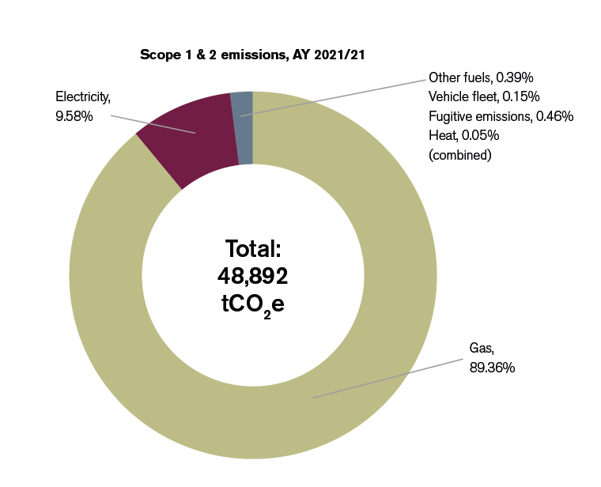

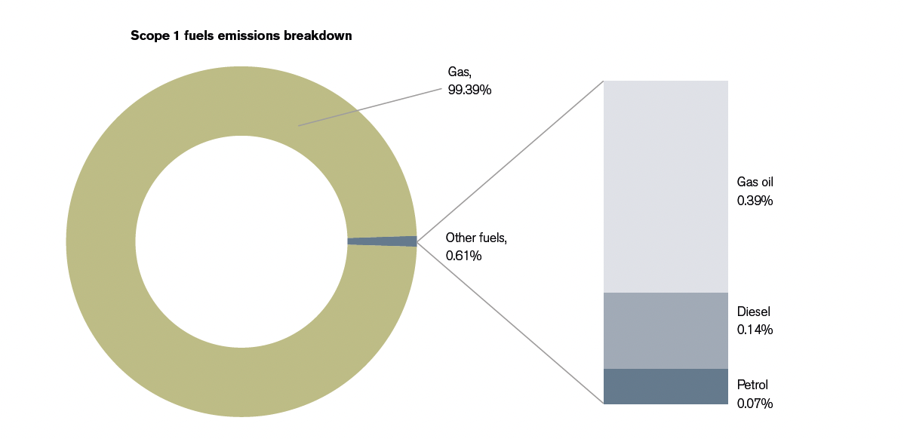

SCOPE 3 EMISSIONS

Our Scope 3 emissions make up 83% of our total footprint: these are all the other emissions we are indirectly responsible for such as fuel used in public transport, emissions from the processing and provision of water, and emissions from the processing of waste. Unlike Scope 1 and 2, where we often have primary source data, for example, direct consumption of gas and electricity measured in kWh, Scope 3 emissions are harder to track and often rely on less certain data, such as financial spend. One of the challenges in future years will be to improve how we measure, record and monitor our Scope 3 emissions; this will involve collaborating with our suppliers and other HE institutions.

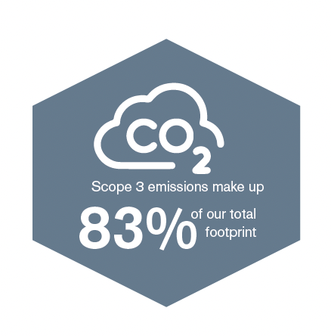

SCOPE 3 EMISSIONS BREAKDOWN AY 2020/21
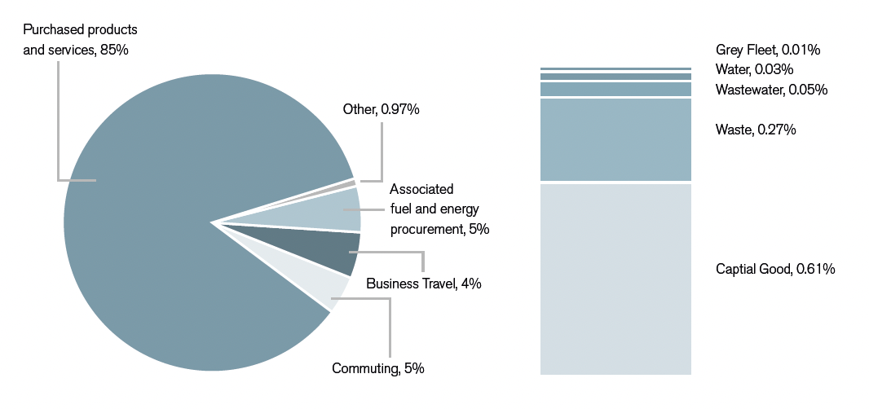

WASTE

Waste accounts for 0.2% of the University’s total emissions. The calculations for our waste emissions comes from a combination of data from our main waste contractor and other spend data. During the reporting period we changed our main waste contractor and now have access to a more detailed breakdown of different waste
types. In Figure 7, we have presented the data from our new waste contractor both in tonnage and associated emissions between January and August 2021. It is indicative of the wider picture as the University collects significantly varying quantities of waste across different systems, ranging from paper recycling to hazardous chemicals. Despite all mixed municipal waste being incinerated to produce energy and avoiding landfill, it is still the highest emitter and represents
the greatest tonnage for the University. It is also important to note, that due to the impact of the Covid-19 pandemic, the University was closed to staff and students for extended periods of time, therefore, it is likely that this reporting year is
atypical in terms of waste consumption.

Reducing the amount of waste produced in the first instance and increasing recycling rates will have a positive impact on the emissions. This will require engagement from a range of stakeholders (individuals, estate teams and suppliers) to reduce this very visible symbol of environmental harm.

Over 60% of total UK waste comes from construction and demolition activity.4 As there is a significant amount of redevelopment planned across the estate, it is likely that waste emissions on campuses where development is ongoing will be dominated by construction waste impact.

Recommendations to improve reporting
Waste data has been collected through a combination of our main waste contractor
and spend data. It was not always possible to disaggregate waste types and therefore emissions had to be calculated using a generic spend factor. For example, our medical waste is currently reported as generic waste, however, it is less emitting
and therefore not a true representation.

Being able to disaggregate the data further in future years will give us a more accurate understanding of where our greatest emission sources are. We are already working with our suppliers to ensure the data is collected to allow for this.

Waste reduction targets will be set for each major project at both the design and construction stages.
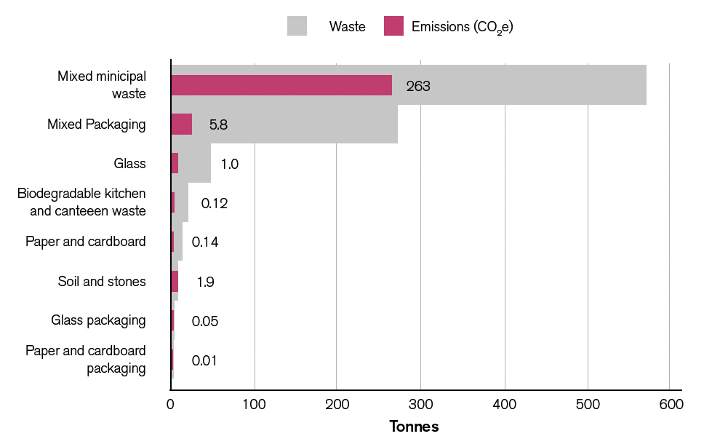
4 https://assets.publishing.service.gov.uk/government/uploads/system/uploads/attachment_data/file/1002246/UK_stats_on_waste_statistical_notice_July2021_accessible_FINAL.pdf

ASSOCIATED FUEL AND ENERGY PROCUREMENT

Associated fuel and energy procurement accounts for 4.3% of our total footprint
and refers to all the indirect emissions associated with our energy consumption:
the extraction, production, and transportation of fuels and the transmission and distribution of electricity. There is limited influence the University can
have on these emissions other than reducing our energy consumption.

WATER AND WASTEWATER

The emissions from water consumption and the treatment of wastewater are relatively low in comparison to other Scope 3 emissions. The emissions associated with wastewater are higher than that of water consumption due to the pumping and treatment processes. This means that although there is a lesser amount of wastewater processed, the overall emissions are higher.

Recommendations to improve reporting
Metering of both means good accuracy in data quality. Metering increases accuracies in data quality. There are some data gaps where manual recordings are required. An improvement to the sub-metering infrastructure would enhance proactive consumption management.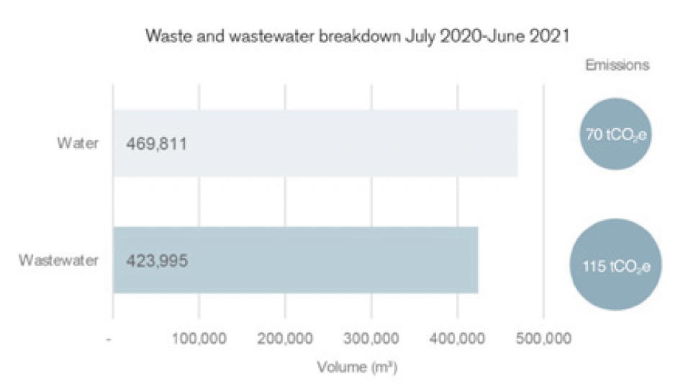

BUSINESS TRAVEL

Business Travel accounts for around 3% of total emissions. The emissions for our business travel are calculated through a combination of data from our travel management company and other spend data. Figure 9 shows the breakdown of data from our travel management company. Grey fleet refers to personal vehicles used for business use. Air travel is the greatest emitter by a large margin. It is also
important to note, that due to the impact of the Covid-19 pandemic, air travel was probably lower than in a typical year and so the data are not an accurate reflection of travel patterns. Covid demonstrated that some meetings can be held virtually and the University is reviewing the amount and type of business travel and revising its travel policy in light of Covid and sustainability.

Recommendations to improve reporting

The majority of the emissions reported in business travel relied on spend data.

This limited our ability to categorise data into different travel modes and calculate

emissions with a higher level of accuracy. Introducing a business travel policy to ensure that bookings are made through our Travel Management Company, combined with changes to expenses procedures, would allow for more accurate data collection and therefore, emission calculations.

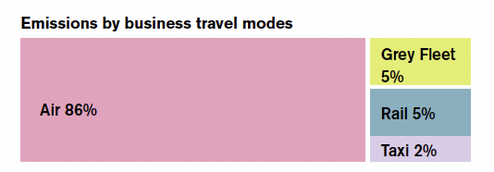

STUDENT AND STAFF COMMUTING

For the reporting period 2018, the total population of the University comprised 8,253 staff and 36,335 students. We only consider term time travel in this report. Student and staff travel outside term time is currently out of scope.

14% of those commuting do so through sustainable travel modes (biking, walking, or sharing a lift). This was largely driven by the student population, who in most cases are travelling shorter distances.

23% travel alone by car and, whilst the shift towards EVs will limit the impact of this mode of commuting in the years to come, choosing public transport remains the best option for cutting emissions; those travelling by train account for twice the distance as cars, but less than half the emissions.

Understanding and mitigating barriers to public transport will be key to reducing emissions. We will do this in partnership with Birmingham City Council, whose Birmingham Transport Plan sets out the infrastructure and behavioural changes needed for the city.
Recommendations to improve reporting
The data for student and staff commuting is based on a Travel Survey from 2018 and it may not accurately reflect current travel modes, especially given the likely impact of Covid on long-term commuting preferences and homeworking.

A more recent Travel Survey was carried out in October 2022, from which data will be used in the next report.

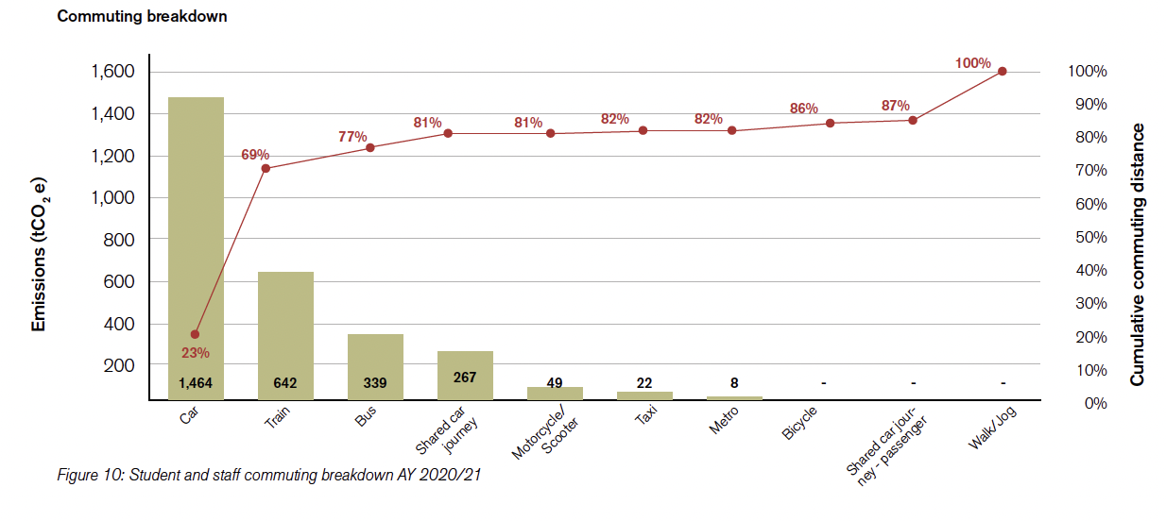
PURCHASED GOODS AND SERVICES

As discussed earlier, the procurement of purchased goods and services constitutes the majority of our emissions.

We used financial spend data to inform emissions calculations, using the Higher Education Supply Chain Emissions Tool (HESCET). For the Academic Year 2020/21, the total money spent against each of the HE procurement codes was
mapped to a defined list of DEFRA categories for which conversion factors (unit: kgCO2e/£) are available and last updated in 2021. There are three primary emissions sources:

- Business services
- Information and communication technologies
- Medical and precision instruments

This methodology is a blunt tool for calculating emissions and whilst it comes with a high degree of uncertainty, the HESCET is the best of what is available today where value of spend is the only data we have to work with. As purchased goods and services represent such a large proportion of our total emissions, it will be vital for us to improve how this is calculated in future. Some recommendations are listed below.
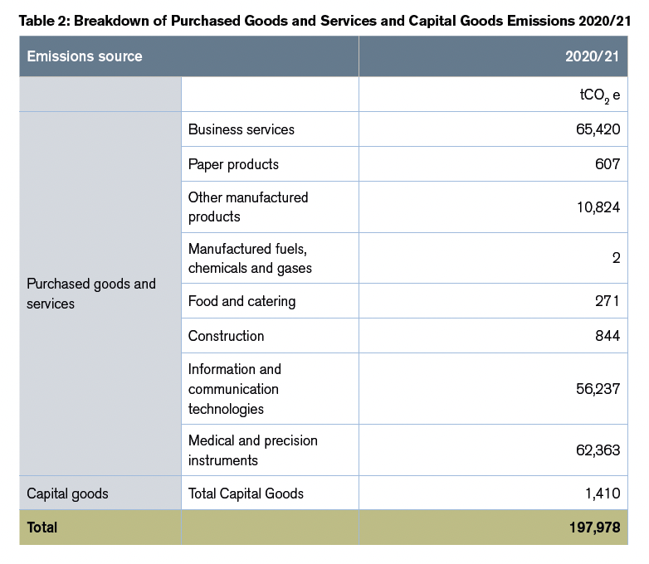
CAPITAL GOODS

Capital Goods are classed differently from Purchased Goods and Services in
carbon accounting. Specifically, they include the emissions from the extraction,
production, and transportation of fixed assets that we purchased or acquired to
provide our products and services (e.g. vehicles, buildings, and equipment). For
the University of Birmingham, a large proportion of our Capital Goods emissions
are embodied carbon from the construction of our buildings.

This is distinct from the energy they use, which is captured under Scope 1
and 2. Therefore, the capital goods emissions will increase in the years that
our estate expands. Some goods and services used for very small-scale
construction projects have been classified as Purchased Goods and Services
rather than Capital Goods, as seen in Table 2.

The purchase of construction goods varies year on year, directly related to the
expansion and refurbishment of the University estate. The University has outlined
several new capital projects between 2022–2026. The emissions associated
with these projects are twofold; firstly, through the purchase of construction
materials and secondly, through the operational emissions associated with the
new-building footprint. Developing our estate in line with best practice building
principles will be essential to limiting the increase in emissions as far as possible.

We have currently excluded upstream and downstream leased assets5 due to
data availability; however, it is likely that this is a significant source of emissions
for the University and is expected to rise as more student residences are
leased. Including upstream and downstream leased assets is a priority for our
future reporting.

Recommendations to improve reporting
As discussed, we used spend data to inform our calculations of purchased goods & services and capital goods. In the future, we hope to work with suppliers to better understand the emission sources and propagate GHG reporting throughout the supply chain. Once we have transparency on our supply chain emissions we can be more targeted in our approach to making savings. We will also be encouraging our supply chain to set science based
targets for reducing their own emissions.

5 Upstream leased assets = assets that uob lease from someone else and operate. Downstream leased assets - assets that uob own and Lease out to others to operate.
SETTING A NET ZERO STRATEGY

Understanding the sources of our emissions is the first step in setting a path to net zero. We have already begun to identify and appraise decarbonisation initiatives, some of which have already been implemented and are reducing our impact; however, this report will allow us to take a more targeted approach to yield greater emissions savings as well as track and record progress
against our reductions target.

We have set ambitious targets of being net zero carbon for Scope 1 and 2 by 2035, and Scope 3 by 2045. We will align our targets with climate science, which is focusing on limiting global warming by 1.5°C, with the aim of reducing our
absolute emissions as far as practicable before any remaining emissions are offset.

We intend to publish our net zero strategy, establishing our long-term vision and committing ourselves to tangible actions. This challenge comes with a huge opportunity to transform the way we operate as a university and ensure we are
leading the way for the HE sector. Through this process we intend to:

Disseminate knowledge and engage
We want to use this report as an opportunity to raise awareness of the climate crisis and share knowledge on how we are tackling it. We will ensure that students and staff have a voice in the development and implementation of the decarbonisation strategy.

The University as a living lab
Where there are opportunities to test emerging technologies and practices, the University can act as a ‘living-lab’, drawing on our extensive research and development capabilities to drive innovation and accelerate emissions reduction.

Establish effective and lasting partnerships
The University of Birmingham cannot tackle the climate emergency in isolation. It is essential that we continue to collaborate with local stakeholders such as Birmingham City Council, NHS, local community and other HE institutions.

Build capacity for effective procurement
Over two thirds of our reported emissions come from the procurement of goods and services. An internal review of our procurement policies will look for opportunities to reduce the need for purchases where possible. We also intend to work with our partners along the entire value chain, encouraging and requiring them where possible, to take active steps in reducing their emissions.

GOVERNANCE AND IMPLEMENTATION

The successful delivery of the decarbonisation strategy requires active engagement across all of the University and our wider stakeholders. Our strategy to create accountability, whilst simultaneously socialising the decarbonisation agenda, is being developed. This will involve embedding our strategy in both our policies and
behaviours and ensuring that those with the most influence over carbon emissions have the right information, responsibility and tools to reduce it. Our Sustainability Steering Group (SSG) has oversight of the direction and implementation of the strategy which will be reviewed yearly alongside the yearly carbon emissions report.
The annual carbon emissions report will be produced to allow us to monitor the success of our decarbonisation strategy and make revisions where appropriate and following advice from the SSG. Our data collection and calculation methodologies will be externally verified by a third-party auditor, to a certified international
standard. By being transparent in our reporting, we will contribute to consistent emissions reporting across the HE sector.

MEASURING AND REPORTING EMISSIONS: CONTINUOUS IMPROVEMENT

The calculation of emissions is an iterative process. In our first year of emissions reporting our Scope 3 emissions, we were limited by data availability and quality. Over time we will seek to improve, incorporating more robust data as it
becomes available.

The GHG protocol makes a suggestion that we recalculate base year emissions when changes occur that have a significant impact on the inventory. The below scenarios may trigger a recalculation of our base year:

- Changes in the University structure, such as mergers, acquisitions, divestments, outsourcing, and insourcing; if there are any changes to the University structure it may impact our boundaries of reporting. We will therefore review this annually to ensure we are capturing any changes in our reporting boundary.

- Changes in calculation methodologies, improvements in data accuracy, or discovery of significant errors; we might report the same sources of GHG emissions as in previous years, but measure or calculate them differently over time. This report provides recommendations on improving the accuracy of our emissions. As we change our methodology for reporting our emissions we will be required to re-baseline.

- Changes in the categories or activities included in the Scope 3 inventory; we plan to expand our reporting of Scope 3 emissions to understand our impact more fully.

However, the base year will not necessarily be recalculated for every event that might alter emissions – a threshold over which the effect of a single change, or cumulative effect of several changes, would trigger recalculation will be determined. We will develop and adopt a recalculation policy based on thresholds which could be quantitative and / or qualitative, but must be specific to our stakeholders who will make decisions based on reported emissions data. An external auditor can determine if we are complying with the recalculation policy and confirm adherence as part of their verification activity.

University of Birmingham | Edgbaston, Birmingham, B15 2TT, United Kingdom.

