University of Birmingham Edgbaston, Birmingham, B15 2TT, United Kingdom

University of Birmingham Dubai
Dubai International Academic City
P.O. Box 341799, Dubai

Letter of commitment to the priorities of the Concordat for the Environmental Sustainability of Research and Innovation Practice

I, Professor Adam Tickell on behalf of University of Birmingham, confirm our commitment to the priority areas outlined in the Concordat for the Environmental Sustainability of Research and Innovation Practice.

University of Birmingham fully supports the priority areas outlined in the concordat and recognise our responsibilities as a signatory, as set out in the concordat.

By signing this concordat, we recognise the need to develop how we conduct research and innovation, taking steps to reduce our own environmental impact where feasible and practical, as well as promote wider solutions around environmental sustainability.

As a University founded on social responsibility, we have the expertise and partnerships to play a significant role in tackling global sustainability and climate challenges. Aligned with our aspirations as a leading global University, we will tackle the biggest challenges facing people and the planet as expressed by the UN Sustainable Development Goals (SDGs). Our ambition is to deliver sustainability through pioneering research, our practices, processes and behaviours and our engagement with our local, national and global partners and communities; we are committed to the continuous improvement ethos woven through the concordat.

Yours sincerely,



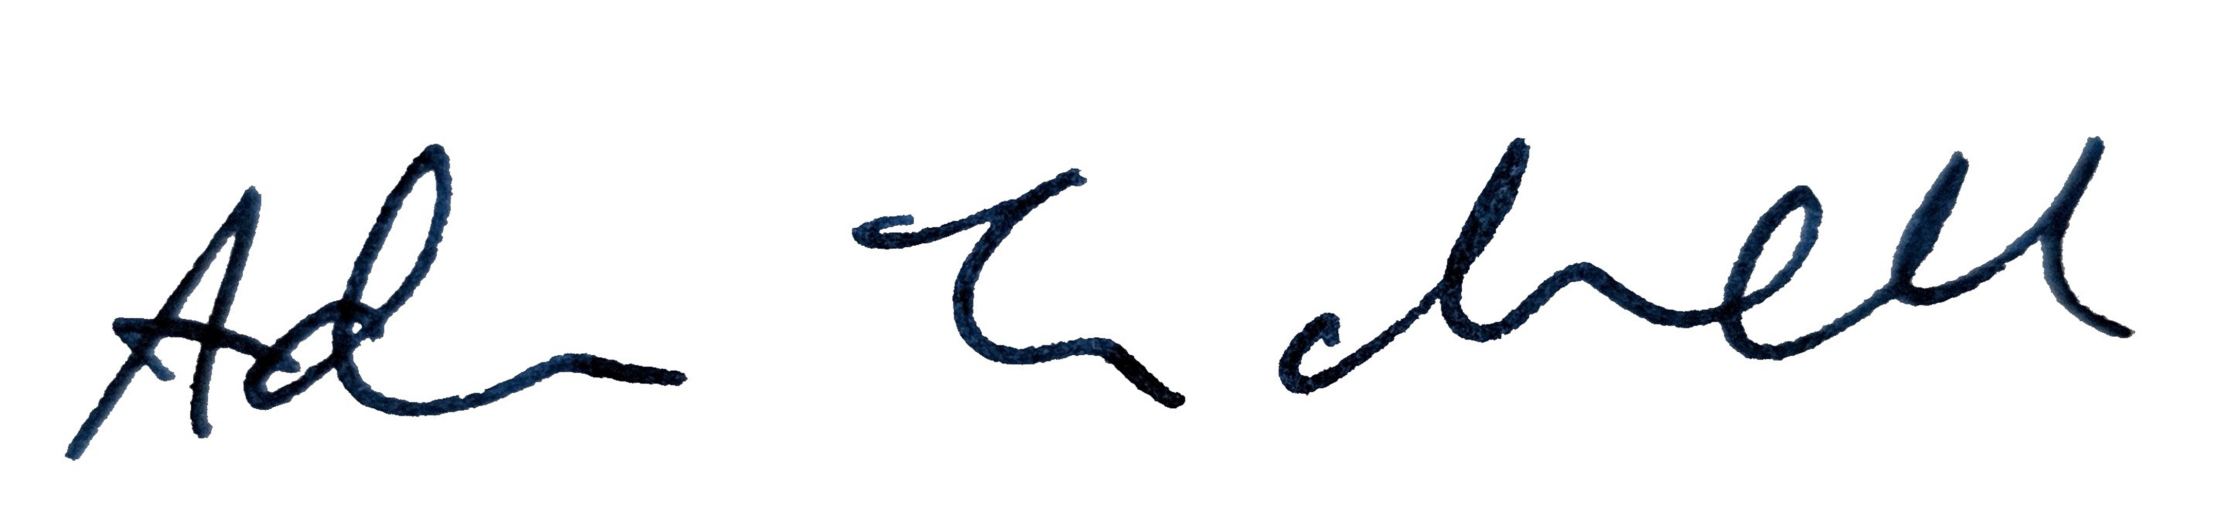

Professor Adam Tickell
Vice-Chancellor and Principal
University of Birmingham
21st May 2025

