Parliamentary

Briefing

Welcome to the University of Birmingham Parliamentary
Briefing

The University of Birmingham (UoB) is a global institution working within a diverse and vibrant city. We’re the UK’s first civic University and we see
this as being a force for good to the communities we serve, here in Birmingham but also across the world. For nearly 125 years we’ve remained firmly
committed to our foundations in the highly diverse communities, people, and economy of the city of Birmingham and the West Midlands.
We are a leading member of the Russell Group, a founding member of the Universitas 21 global network of research universities and, for more
than a century, have been pursuing and sharing knowledge through outstanding teaching and world-leading research.
With more than 8,000 staff, 37,000 students and 300,000 alumni across the globe, we think, recruit, and compete worldwide. We count ten Nobel Laureates among our staff and alumni and been integral to some of the greatest scientific discoveries of recent times, such as the Higgs Boson and Gravitational Waves.
More recently, we were the first university to establish a fully comprehensive secondary school, and we opened our new campus in Dubai in 2018, becoming the first Russell Group and Global Top 100 University
to do so. Our 2030 strategy will see us further enhance our research expertise and establish ourselves in the top 50 universities globally. We’ll also build on the substantial progress we’ve made in the quality, ambition and impact of our research in different areas over the last decade.

Research focus
and impact
Our research expertise focusses on vital issues and tangible solutions centred on our communities, our country, and our world.
We are advancing new approaches to tackling some of the biggest global challenges facing society, from antibiotic resistance and maternal health to clean energy and transport and access to education.

Life-Changing Technologies
As pioneers in advanced manufacturing, quantum sensors, critical materials, and healthcare technologies, our researchers are transforming lives and livelihoods.
From helping to deliver on the nation’s 2050 net- zero goals by accelerating the decarbonisation of manufacturing, creating novel solutions to age-old problems such as dementia and public infrastructure, and leveraging our expertise
in science, economics, and law to answer the challenges posed by society’s need for strategic critical materials, we are leading advances in technology and accelerating their impact on human progress.

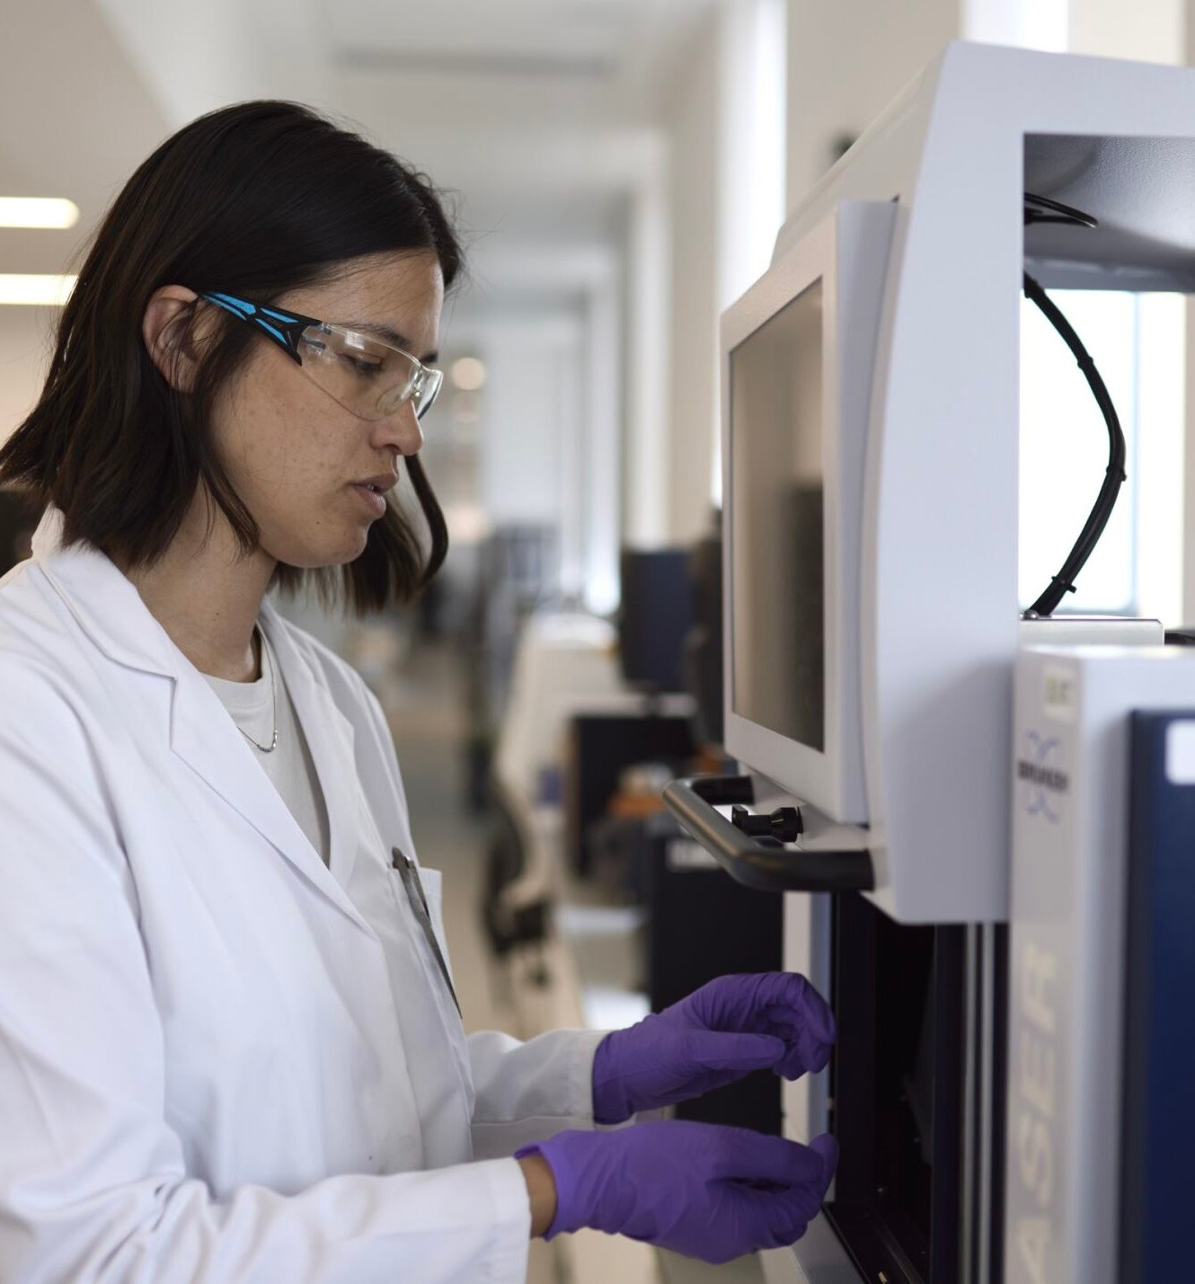

Thriving Planet
We’re at the forefront of developing scalable clean technologies needed to ensure a sustainable future for people, the planet and our communities.
Whether this is addressing the urgent threat to the air and water, fostering practical solutions to protect the world’s precious biodiversity,
or creating clean energy for households and transportation in both developed and developing regions, we are applying our understanding in practical ways to improve lives worldwide.

Global Health
Through the application of advanced analytics, the development of personalised treatments and the delivery of early interventions, we’re having an enormous impact in improving the health and well-being of people across the world.
We are collaborating with the public sector, patients and industry to improve outcomes and care for people with mental health problems.

And we are working to end preventable death and illness in mothers, and by collaborating with key-partners like the World Health Organisation, our research findings are changing guidelines that better protect pregnant women and mothers, saving many lives.

Fairer World
Our research is contributing to efforts to provide everyone with the chance of a fairer future by tackling inequalities and regional disparities in all aspects of economy and society.
We are seeking to understand the enduring presence of gender inequalities across all areas of society and by determining how and why gender inequality persists we are helping to empower organisations, governments and individuals in their pursuit of equality and inclusivity.
We are helping to advance the economic and social development of cities and regions worldwide by delivering the intelligence and
insight needed to shape policy and drive action, and our research into progressive education is helping to ensure that all students, including those with special educational needs, are given the chance to thrive in an equitable learning environment.

Cultural Connections
Our aim is to understand how different cultures shape the world, so that people and
communities can enjoy fulfilling, rewarding lives.
We are connecting people with culture regionally and around the world by investigating the buildings, objects, traditions and customs
that have bound populations for hundreds of generations.
We are bringing together experts who study various aspects of identity, focusing on how different identities intersect and influence one another and the stories we tell individually and in society and exploring how art, music and language shape our communities, today and over the centuries, bridging the bond between modern society and historical culture.
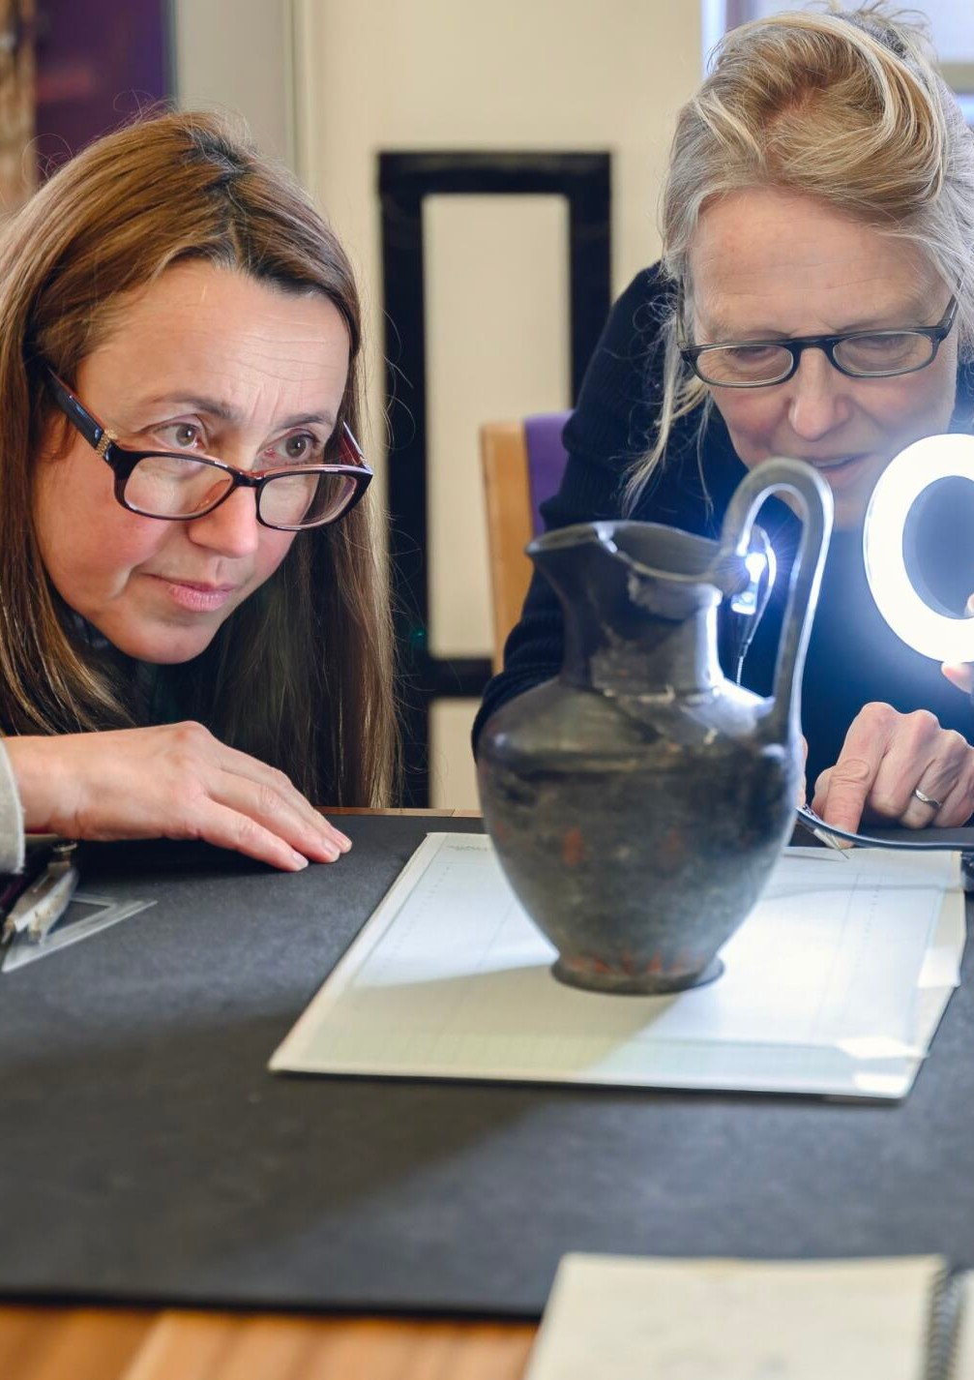
And our researchers are making the creative arts more accessible to deprived groups, removing barriers so that no one is excluded.

Driving innovation
UoB is the key driver for some innovation assets across the West Midlands.

Tysley Energy Park
Located in East Birmingham, Tyseley Energy Park (TEP) is on a mission to transform clean energy innovation in Birmingham and the West Midlands by stimulating and demonstrating new technologies and turning them in to fully commercially viable energy systems that will contribute to Birmingham’s commitments to reduce CO2 emissions by 2030.

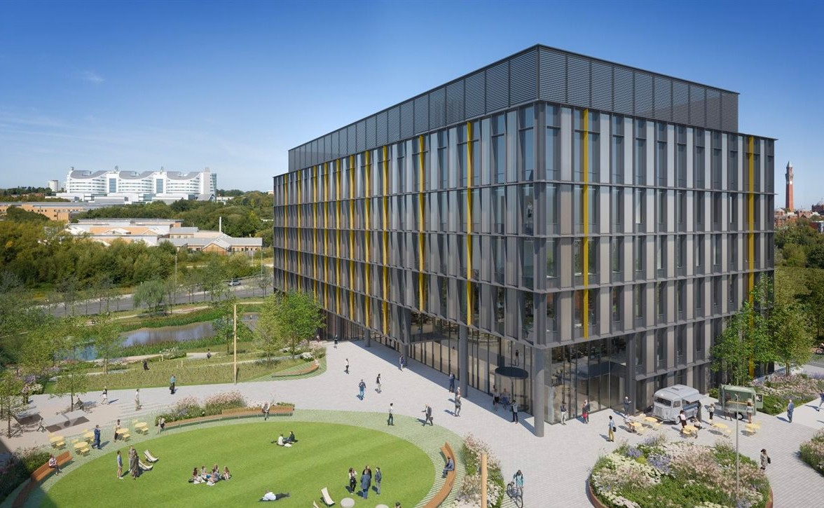

Birmingham Health Innovation Campus
Located in Selly Oak, Birmingham Health Innovation Campus (BHIC) is set to become a world leading healthcare technologies hub.
The first phase of the development, No.1 BHIC, which is due to open in 2024, will harness world-leading academic and clinical strengths while bringing new commercial power to the region to accelerate life sciences research, taking innovative new healthcare treatments and technologies from early development to real life application.

Policy engagement

COP28
From 30 November to 12 December 2023, COP28 will be held in Dubai where the University of Birmingham is uniquely placed to use our local, in-country, convening power to drive national and international policy development around climate change.
To mark COP28, our campuses in Dubai and Birmingham will host a programme of events, discussions, and projects which will highlight the research we are leading to help tackle the climate crisis.
We have developed four policy briefings on the thematic areas of food security, global finances, health and environment and adaptation which contain ‘manifesto- ready’ recommendations at a national and international level on key areas.
The content from the policy briefs has been used to create a ‘Building Resilience in a Changing World’ Report which is supported by Anna Nsubuga, Ambassador and Permanent Delegate to UNESCO. The report will be formally launched at the start of COP28 by our Chancellor, Lord Bilimoria at an event which will be attended by high-level stakeholders.

Join the launch of our new report for COP28
COP28 report launch Adaptation and building resilience in a changing world
Invitation to panel discussion & reception - Wednesday 29 November 2023
https://www.birmingham.ac.uk/dubai/ events/2023/cop28/adaptation-and-resilience. aspx
All welcome in person in Dubai or online.

Artificial Intelligence
UoB has begun a programme of work looking at Artificial Intelligence and grasping
some of the key issues its rapid development is creating.

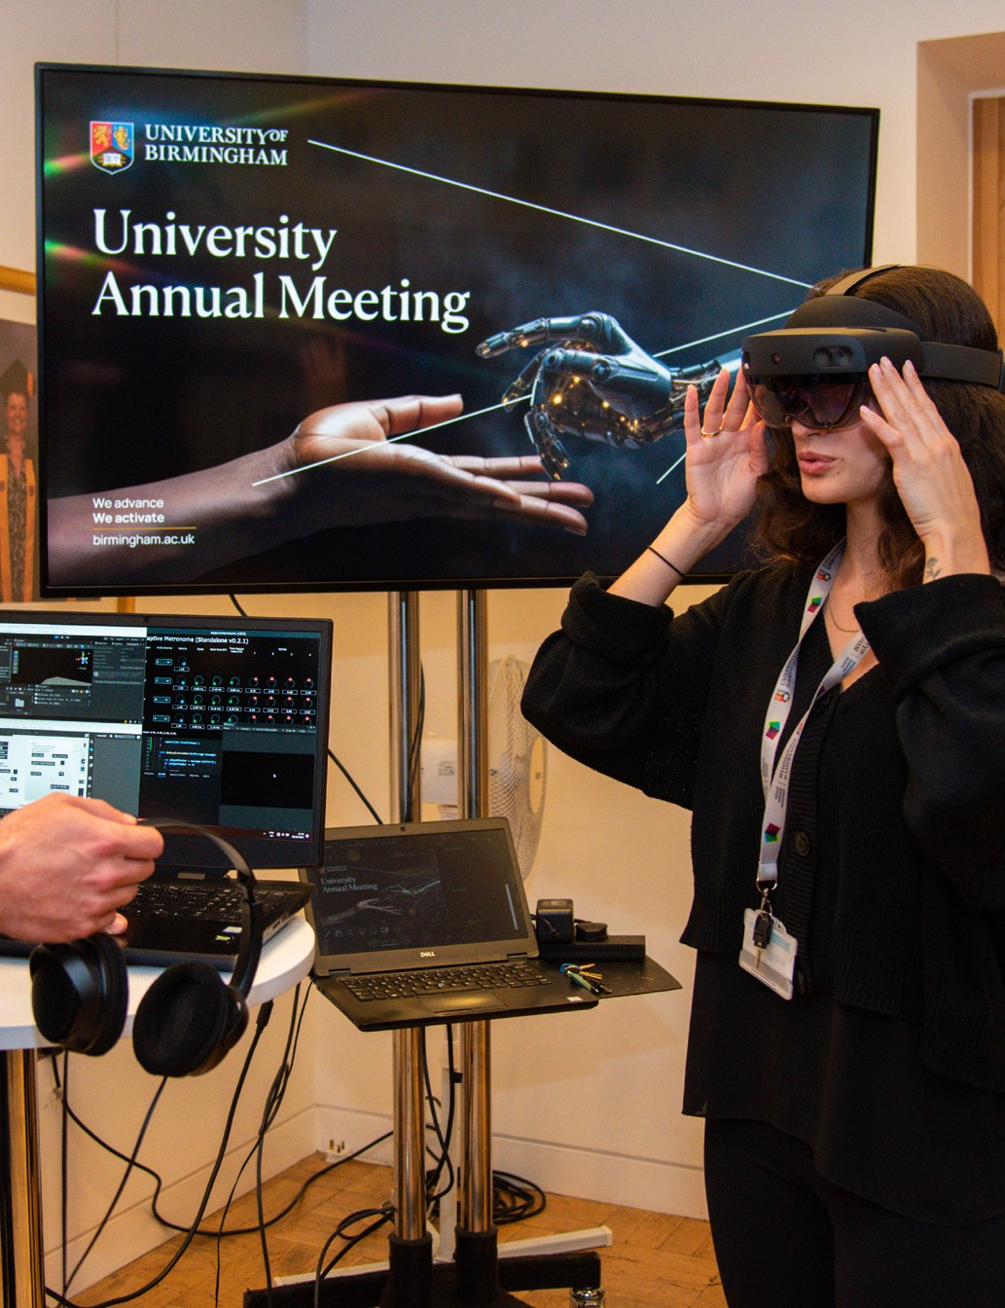

University Annual Meeting (UAM)
Our UAM was held in October where the theme was “Artificial Intelligence and Our World”. With AI and advanced technologies poised to impact
every element of our lives, we channelled a panel of thought-leaders as they debated the role
and risks of AI in society, government, business, health, education and the arts.

Our panel included:
- Melanie Garson – Cyber Policy and Technology Geopolitics Lead at the Tony Blair Institute
- Sarah Ellis – Director of Digital Development at the Royal Shakespeare Company
- Jonathan Chamberlain – Employment, Labour and Equality Partner at Gowling WLG,
- Professor Slava Jankin - Professor of Data Science and Government and Director of the Centre for Artificial Intelligence at the University of Birmingham
- Professor Karen Yeung – Interdisciplinary Professorial Fellow in Law, Ethics and Informatics at the University of Birmingham

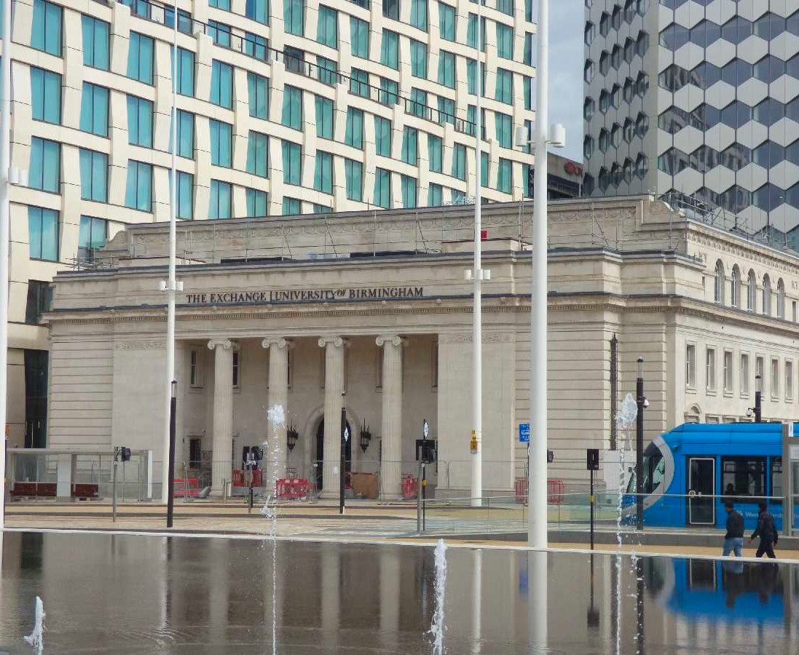

The Exchange
Based in the historic old municipal bank located in Centenary Square in Birmingham City Centre, The Exchange is a place for communities to shape ideas and solutions together, to make our cities and regions better places to live, work and learn.
From February to November 2024, we will be holding a programme of exhibitions and events on AI in which we’ll explore vital questions through the lens of university research including: Can AI create things or is it just copying? Should we be scared? And what will the future look like?

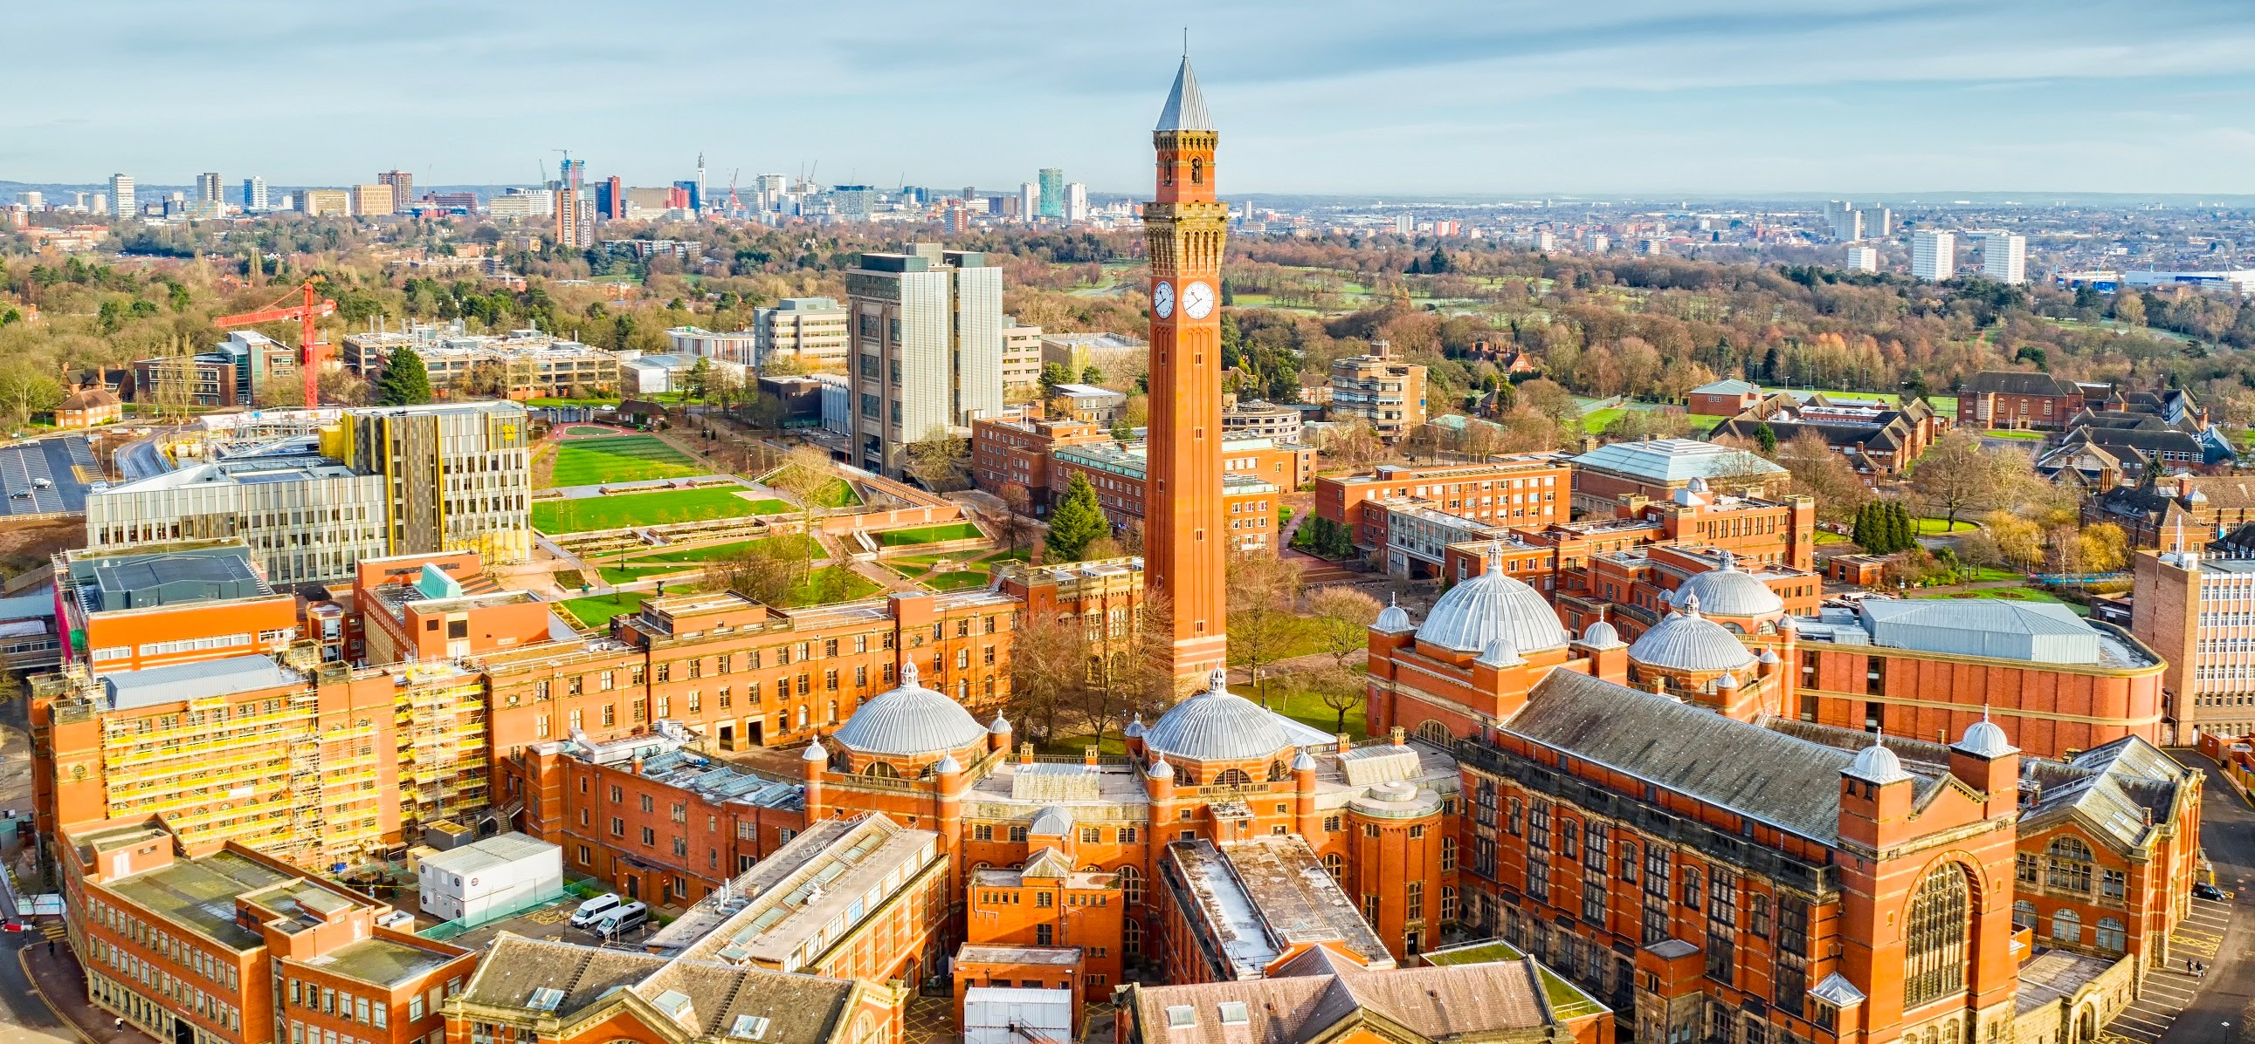

Our commitment to our region
The University of Birmingham has a major impact on the city and region as an employer, research leader and international gateway. We are an anchor institution, a driver of economic growth, and a catalyst for cultural development in Birmingham, the West Midlands and beyond. In the current landscape, this is more important than ever.

As one of the region’s largest employers, the University makes a significant contribution to the economies of Birmingham and the West Midlands, creating prosperity and driving growth both locally and nationally. The impact of the University’s spending and that of our students
is worth £678.8 million per year to Birmingham’s economy and £951.8 million per year to the West Midlands. Our teaching contributes £1.34 billion to the economy, and we are a net importer of talent; 24 per cent of our students come from the West Midlands and almost 48 per cent of our students stay in the region after graduation.
We see the contribution we can make economically, socially, and culturally, to our locality as core to our purpose. From our commitment to widening access, boosting social mobility, and supporting the NHS through our training of vital health workers, we are passionate about effecting positive change in our region.

Working with you

We are very keen to support you with your parliamentary activities, and also to highlight some of the key issues and themes our university is focussed on. Please do let us know if you would be interested in:
- Meeting or hearing from our key academics on research or policy issues
- Tabling Written Parliamentary Questions on the research or policy issues in this briefing
- Writing to Ministers or speaking in debates on these policy issues
- Visiting our campus in Birmingham to see our research in action
- Touring our innovation assets
- Attending our events
We would be very happy to draft any materials to support your
parliamentary work, so please do get in touch with our Head of Public Affairs and Stakeholder Relations,
Ross Matthewman, at
r.matthewman@bham.ac.uk

