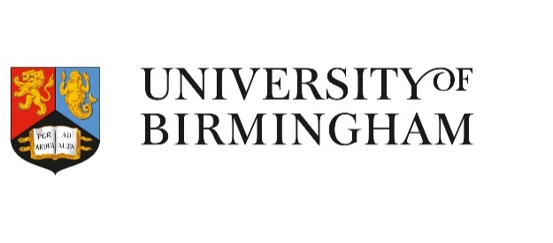
The Smart Campus

A platform for innovation

Strategic Context
Universities are by their very nature complex. First and foremost, they are educational institutions, where undergraduate and postgraduate students learn and where faculty teach and conduct research.
In addition, they function as small cities, complete with facilities teams, energy plants, sports facilities, and other civic attractions.
Finally, they are major local employers and act as an important catalyst within local and regional economies.
These unique characteristics mean that universities have a large number of stakeholders with which to communicate, and often have highly complex revenue models.
Due to this complexity, Universities are uniquely and acutely impacted by the current pandemic, the response to which poses significant challenge.
Before Covid-19 struck, the Higher Education sector was already undergoing significant change. Concerns over funding and revenue, increased competition and globalisation were all factors influencing university strategies.
The Covid-19 pandemic has further emphasised and accelerated the pace at which Universities need to adapt in the fast-changing Higher Education market.
As universities, schools and colleges closed across the world in 2020, researchers, teachers and students scrambled to adopt a whole host of new pedagogical tools, communication techniques, learning methods and teaching styles almost overnight. For some faculties, the adjustment was seamless, with lectures and projects conducted online with little or no change at all. Others understandably struggled with having to relinquish the physical, peer-to-peer learning environment of the classroom, the dynamic interaction of the campus, or the personal contact of the seminar debate.
In responding to the challenges of Covid-19, cross-institutional teams at the University of Birmingham have worked collaboratively to adapt at pace and deploy solutions rapidly. This response has ranged from establishing new digital tools to facilitate widespread remote teaching and learning, to modifying buildings in line with social distancing guidelines, and modelling the potential impact of the likely deficit in international students, all with a renewed focus on new ways of working and staff well-being.

What is the Best Path to the Next Normal?

As we plan for a post-Covid-19 future, it is important that we find the right balance between stabilising core operations, and pioneering new ways of enabling physical and digital interactions.

To transition, with sustainability in mind, from a method of ‘surviving’ to ‘thriving’, this means radically rethinking the way our universities operate, the service we provide, and the overall experience for our students, academics and visitors.

Covid-19 is accelerating some trends that were already happening, but what we all have to realise is that these changes will not be temporary.

One thing is for certain; Covid-19 will have a lasting impact. Those that adapt quickly, will emerge stronger.

The Future Landscape

Learning from the experiences of the Covid-19 Emergency

Post-Covid-19 will see the true advent of the ‘Clicks and Mortar’ campus; one that embraces digital and remote working and learning, and more sustainable transport options.

Short-term physical space will be at a premium, as will the digital tools that help us work both individually and collaboratively.

Long-term strict social distancing measures could result in physical space being severely underutilised, presenting new challenges around operational efficiency and carbon reduction.

Universities will need to use the experience and evidence generated during the campus’s restricted mode of operation to capture success stories and lessons learned when developing the format of the post-pandemic and future state university campus.

Student Experience
By 2026, the students enrolling at the University of Birmingham will be younger than the smartphone. These are students that have only ever lived with technology and the constant connectivity it brings.
They have grown accustomed to a frictionless experience; one that is personalised, immediate, efficient, reliable, responsive, and at their fingertips. They will want this quality of experience from their universities.

Staff Experience
Staff and academics will be empowered to choose the most effective location and workspace for the task at hand, balancing this with the needs of the institution and the relevant teams.
Universities will need to trust their people to deliver, regardless of location, and stay in regular contact to thrive in this new environment, focusing on outputs and delivery.
Staff will be mindful to avoid an ‘always on’ culture, and flexibility will be the default position, leading to an improved work-life balance for staff, as well as delivering greater productivity and efficiency for the institution.
This future landscape raises an important question for our academics, staff and the University as a whole; how will we adapt to meet these expectations?
“In this fast-paced environment, it is vital that our universities are able to pivot and adapt to change, but we must remember that the changes that we make must always complement the academic mission of our institution.”
- Professor Tim Jones, Provost and Vice-Principal

Structuring our Approach
As university leaders, we should consider three viewpoints:
- Inspired – How has the lockdown inspired new and exciting ways of working and influenced what it means to be productive? How will we work differently now as a result?
- Desired – What do people miss most from business as usual and how could this be incorporated into new ways of working?
- Not Required – On reflection what did not work pre-Covid-19 and what legacy behaviours and processes can now be dropped?
“As we emerge from stabilisation and begin to orchestrate a safe return to campus, our attention must shift from ‘surviving’ to thriving.”
- Dan Lawrence, Director of IT Services
Thrive
Embrace collaboration and accelerate change to thrive in the next normal.
Reopen
Plan and orchestrate the safe reopening of University Campus. Leverage partners for competitive advantage.
Stabilise
Mitigate short-term risks and stabilise operations.

From surviving to thriving
The Covid-19 pandemic has brought – and will continue to bring - far-reaching changes to the global Higher Education sector.
As our thoughts turn to the realities of post-Covid life, it is important that we begin to make preparations that enable the University to pivot and adapt to embrace future change. This will ultimately enable us to emerge stronger.
A key component for the next wave of reform is the Smart Campus initiative.
“At the University of Birmingham, we believe that the Smart Campus initiative will serve as a platform that fosters the innovation needed to deliver an excellent University experience to future generations.”
- Trevor Payne, Director of Estates

A University of Birmingham Perspective

Our Smart Campus initiative is an integrated vision set to transform the way people experience the University of Birmingham. It will enhance the physical and digital foundations of our University, whilst protecting our cultural and physical heritage, and realising cost savings.

By embedding emerging technologies across our physical estate, we will create a campus capable of adapting to advances in technology together with the changing needs of our people.

The use of such technologies will unlock data and information that will be harnessed for valuable insight, facilitating living lab opportunities that will enable world-leading research, teaching and learning.

Our Mission
To deliver an enriched, personalised experience for students, staff, academics and visitors.
To bring together our people, processes and services to become a fully connected, global campus.
“It is our collective responsibility to guide and educate our people on how best to utilise technology to deliver an enhanced teaching and learning experience, as well as word-class research. With a renewed focus on education and experience, we will embrace modern practice through pedagogy along with enhancements to physical and digital learning environments.”
- Dr Emma Robinson, Academic Registrar

Thematic Areas

Digital Transformation
Focussing on a series of coordinated technology shifts that enable new educational and operating models and transform an institution’s operations, strategic directions, and value proposition.

New ways of working
Empowering our people; supporting a method of working that enables it to take place at the most effective locations and at the most effective times, so that flexibility becomes the norm. Helping to improve work-life balance for staff, as well as delivering greater productivity and efficiency for the institution.

The Smart Estate
Embedding Internet of Things (IoT) devices into our physical estate to gather real-time data, information and feedback about the things that matter most. The use of such technologies will enable the estate to flex and respond to the changing needs of our people.
“These three thematic areas are the foundations on which we can imagine a campus that supports the changing needs of our people.”
- Dan Lawrence, Director of IT Services

Our Objectives

Transition safely and sustainably from a method of surviving to thriving
Maintaining our duty of care to students, staff and visitors, and offering a positive and valuable learning experience as we emerge from the pandemic.

Deliver greater workplace efficiency
Delivering efficiency and enhanced collaboration through agile workplace optimisation and utilisation.

Deliver an enhanced experience
Creating extraordinary physical and digital experiences for students, staff, academics and visitors.

Improve environmental sustainability
Embracing sustainable practices to ensure delivery of a modern campus that will adapt to changes in technology, learning and climate whilst also protecting both cultural and physical heritage, and realising cost savings.

Covid-19: The Next Normal

Transition safely and sustainably from a method of surviving to thriving. Maintaining our duty of care to students, staff and visitors, and offering a positive and valuable learning experience as we settle in to the next normal. Future innovations might include:

Contactless Environment

Voice, facial recognition and other biometric technology minimises the need for contact to reduce disease transmission. Anything from accessing buildings and spaces, using the lift, getting library books or ordering a coffee can be done using this technology or from a smart phone.

Campus Analytics

Real-time occupancy data and people flow analysis enables effective track/trace and also evidence if social distancing is being observed and is working.

Campus analytics inform interventions such as one-way flows, cleaning protocols, building ventilation and the positioning of hand sanitiser stations.

Agile Working for Business Continuity

Innovative technologies and robust infrastructure enable staff and academics to work and teach unencumbered by location. The virtual learning environment begins to replicate the on-campus experience.

Security in Emergency

Beacon technology, security management software and mobile apps provide a means to prepare for emergency scenarios, including lockdowns of buildings or spaces, communication with those on campus, and simulations for training exercises.

The Online Community Platform

Creating a connected student experience and sense of belonging is critical. For many students the value of their experience is often shaped by the vibrancy of campus life. In lieu of physical space, an online community platform offers a central, virtual space for open discussions and debate, events, wellness classes and other activities to take place. It is a place to foster relationships, connecting students with one another together with staff and alumni.

Efficiency

Focusing on delivering efficiency and enhanced collaboration through smart workplace optimisation and utilisation. Future innovations might include:

Room DNA

Data on historical room occupancy, teaching and technology requirements, and room profiles are analysed to optimise space allocation for academic timetabling and room bookings, with the ability to intelligently relocate sessions in real-time when the situation requires it.

Connectivity
Bulletproof, high-speed connectivity regardless of device and location.

The Digital Twin

The Digital Twin realises the campus in 3D, using Building Information Modelling and the Internet of Things for real-time analysis, monitoring, testing and responding to challenges, all within a virtual environment. The digital twin is used to mimic scenarios, modelling cause and effect of decision-making in the virtual world to improve responses to ‘real-world’ incidents.

New Ways of Working

People choose the most effective location and workspace for the task at hand; technology utilises room booking information to automatically set up the space for its scheduled purpose, with no time-wasting technical issues before or during the session.

Experience
Focusing on delivering a world-class physical and digital experience through implementation of the latest technology and Internet of Things (IoT) devices. Future innovations might include:
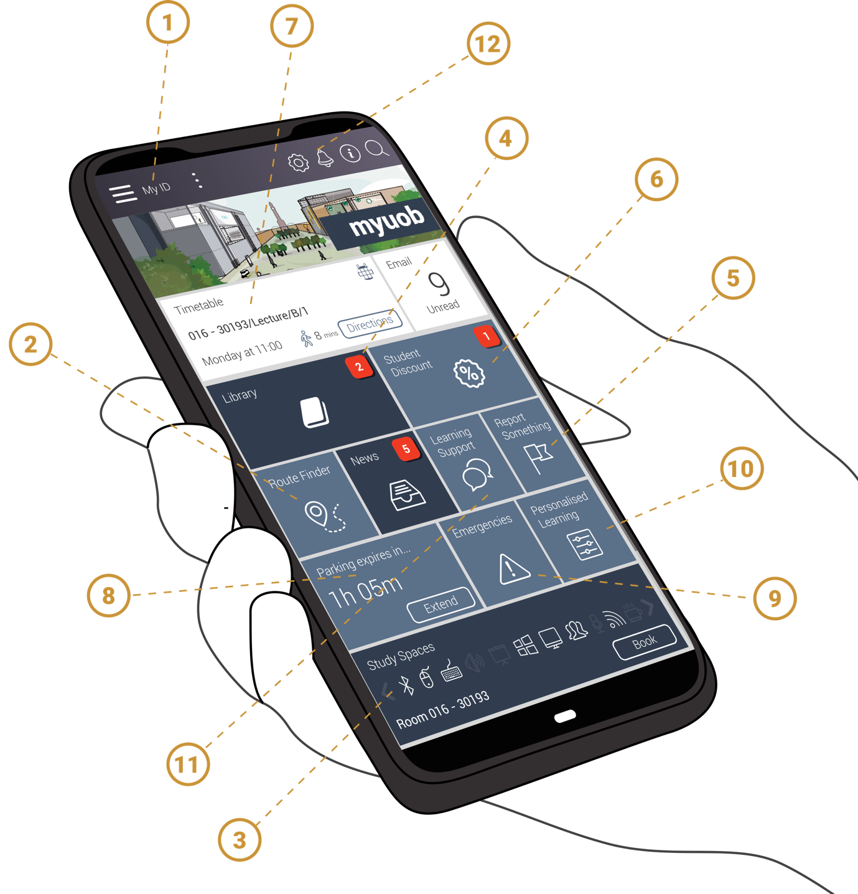
- User ID offers frictionless access to appropriate spaces, buildings and learning materials.
- Personalised route-finding features in-building and accessible options for navigation, with live data for trains, buses, walking and cycling paths to help people move around campus safely and efficiently.
- Study space is automatically booked en route to campus during exam period, with suggested breaks scheduled in.
- Notifications not to forget overdue library books appear before students leave for campus.
- A “flag an issue” portal offers users one simple method to report things that matter to them - be it a leaking tap to a maintenance officer, or a problem submitting an online assessment.
- Promos are made available based on students achieving personal targets such as step counts, online learning completion or timely return of learning materials.
- Timetables intelligently group lectures based on proximity, and notifications pop up around required reading before seminars, to minimise disruption and maximise preparedness.
- Seamless visitor experiences become the standard, with automated parking, navigation guidance to get to the end location, minimal waiting times, and notifications to your host.
- Immediate response for first aid, emergencies, security concerns or personal support, with help only the click of a button away.
- Adaptive learning technologies offer personalised, real-time support to students so that they address gaps in knowledge before they cause anxiety.
- An enriched experience for students with disabilities, mental health or learning support needs that adapts to their personal circumstances, such as world-class remote learning, augmented reality sign-language/subtitles, intelligent audio description, and prioritised home delivery from on campus.
- Complete control and transparency over how personal data is used, and when notifications are provided.

Environmental Sustainability
Embracing sustainable practices to ensure delivery of a modern campus that will adapt to changes in technology, learning and climate whilst also protecting both cultural and physical heritage, and realising cost savings. Future innovations might include:

Energy Management
IoT sensors respond to changes throughout the day to optimise in-room lighting, Heating, Ventilation and Air Conditioning, and air quality to ensure no energy is wasted when supporting the use of spaces and buildings.
Movement across campus and natural light are converted into substantial sources of kinetic and solar energy, to be stored or intelligently deployed.

Smart Travel
Connected facilities support active travel and low emission vehicle use, such as secure cycle racks, showers and lockers, as well as Ultra Low Emission Vehicles charging infrastructure. This enhances staff and student wellbeing and supports the transition to zero carbon.

Estate Development
Data and information about the physical estate is harnessed for valuable insight, facilitating living lab opportunities that enable world-leading research, teaching and learning.
Machine learning processes all energy and facilities data throughout the year to suggest improvements for the future.
Building performance data including condition, carbon emissions, water use and utilisation statistics are harnessed to inform the design of future spaces and ensure that the business cases for future programmes are further evidence-based and cost-effective.

Smart Waste Management
IoT sensors within waste bins monitor their weight and capacity. This allows waste collections to be optimised to locations on an as-needed basis.

Progress to Date
The last 24 months has seen the University make significant progress towards preparing for a Smart Campus. We have:
- Piloted several technologies to learn quickly what could be scaled up to deliver greatest value to users
- Appointed an independent consultancy to help formulate strategy
- Engaged within and, importantly, outside of sector, to share lessons, knowledge and opportunities for innovation.

Siemens Partnership
The University of Birmingham, in partnership with Siemens, will transform its infrastructure using cutting edge technologies to make its campus one of the smartest and most sustainable in the world. To deliver the campus of the future, Siemens will evaluate a vast range of technologies in the fields of Energy, IoT and Data, Smart Transport and Smart Building Technologies, ultimately leading to the development of a Living Lab and Net Zero Carbon campus. This will result in enhanced student and visitor experience, research and teaching, industry engagement and carbon and operational cost reduction.

Next Steps
Our aim is to identify, create and deliver innovative initiatives that enable us to meet the future needs of our people. Much of our journey lays ahead of us.
Our next steps are listed in the following 5-point plan:

Understand
Build on the operational insights from existing campus data.

Tell the story
Map the user journeys from beginning to end, focusing on user experience.

Benchmark
Seek to establish a Higher Education sector benchmark for measuring Smart Campus readiness.

Build the Team
Strengthen the partnerships needed to deliver our Smart Campus.

Create the Roadmap
Establish the key initiatives that will deliver high impact solutions and long-term benefits.

Thoughts for the Sector
The Smart Campus will mean different things to different institutions, however, common questions that continue to arise within the sector are:

Access and Inclusivity
With a rise in remote teaching and learning, how do we tackle issues related to equal access to education and technology?

Digital Skills
How will we ensure that our staff and students learn how to embrace the changes to their campus experience?

KPIs
How do we define success, and ensure that we realise the benefits?

Building the Smart Estate
How do we implement IoT technology and deliver smart buildings within a complex estate made up of old and new?

Innovation
How do we acquire knowledge about the trends influencing the way people learn, teach and conduct research?
“Higher Education has never been as dynamic and open to new ideas as it is right now. The next decade provides a unique opportunity for us all to rethink everything, especially the things we take for granted. Let’s embrace the change. Let’s innovate. Together, let’s make important things happen.”
- Trevor Payne, Director of Estates
Let us take a deep breath, and adapt.
This document is not a strategy.
Rather, it is an attempt to illustrate the vision for a University of Birmingham campus that is prepared with the necessary physical and digital technologies to support the ever-changing needs of our people.
The document acknowledges some of the challenges presented by Covid-19 and offers a pragmatic approach, explaining how the University of Birmingham plans to transition from simply
‘surviving’ towards a University ‘thriving’ in the fast-paced environment that is Higher Education.

University of Birmingham | Edgbaston, Birmingham, B15 2TT, United Kingdom.

Susan Grajek and Betsy Reinitz, 2019

