Archive resources relevant to the study of First World War

Last updated May 2022



ARCHIVAL RESOURCES FOR
THE FIRST WORLD WAR

The following listing highlights a range of materials in our collections relevant to the study of the First World War which include political archives, institutional archives and personal and family collections.

This is by no means a comprehensive listing but aims to give examples of some of the archive material we hold that may help with your research. Further material can be found by searching our archive catalogue or our book catalogue, or email us for specific advice.

Archives of the YMCA
Material specifically relating to the First World War include several sequences of papers: c4,000 photographs of war emergency work at home and abroad (Finding No: YMCA/K); printed reports, pamphlets, cuttings and some manuscript correspondence and notes about war work (organised by place or subject); and compilation volumes of typescript records relating to the YMCAs war work including lists of workers.

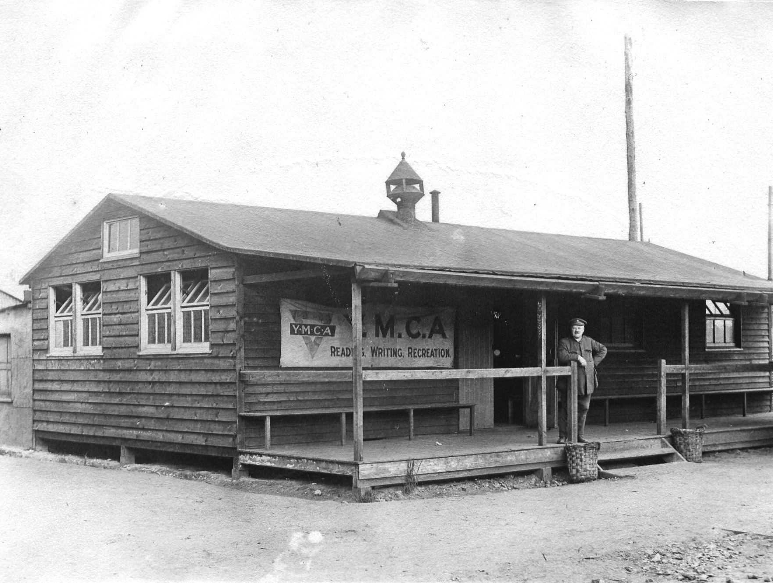

Other material relating to the war period include sets of YMCA journals and magazines; the minute books of the National Council of YMCAs, including those of its War Emergency Committee and of its Women’s Auxiliary; records of local associations including both printed and manuscript materials; minutes and publications of the International Hospitality League/ Red Triangle Hospitality League.

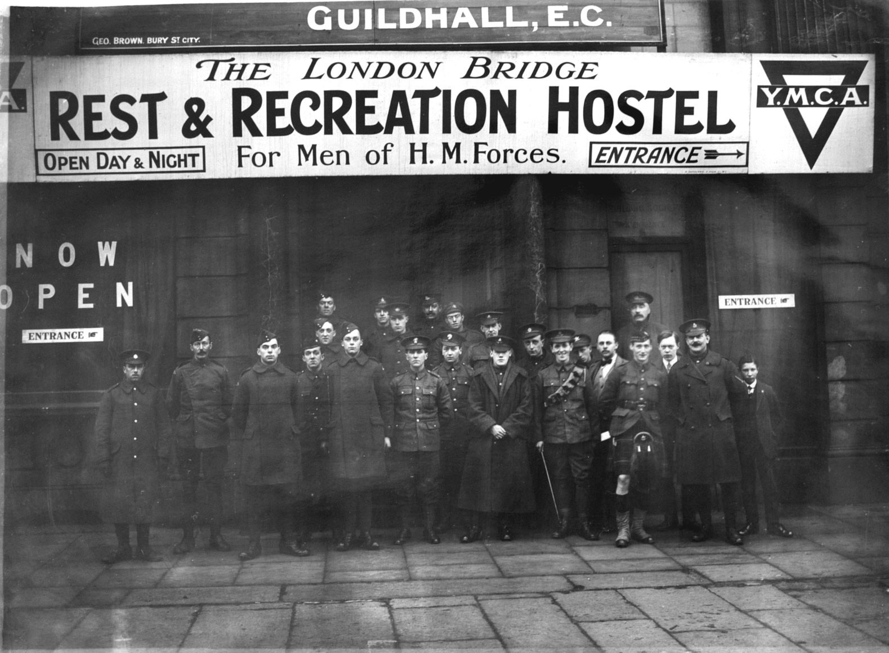

The YMCA’s journals are a particularly interesting resource: ‘The British Empire YMCA Weekly’, 1915 – 1916; ‘The Red Triangle, The British Empire YMCA Weekly’, Jan-Jul 1917; ‘The Red Triangle’ (monthly magazine) Sep 1917-1924; ‘The Red Triangle Bulletin’ (a weekly news supplement to ‘The Red Triangle’), 1917-1918.

A collection level description for the YMCA archive is available on our online archive catalogue at http://www.calmview.bham.ac.uk (Finding No: YMCA and YMCA/ACC) from where there is a link to a pdf version of a preliminary catalogue

Papers of (Benjamin) Gordon Williams, Moseley, Birmingham
A small, privately deposited collection including a manuscript journal dated November 1915-June 1918, personal correspondence, travel documents and photographs relating to B. Gordon Williams' experiences serving in Egypt and the Mediterranean during the First World War.
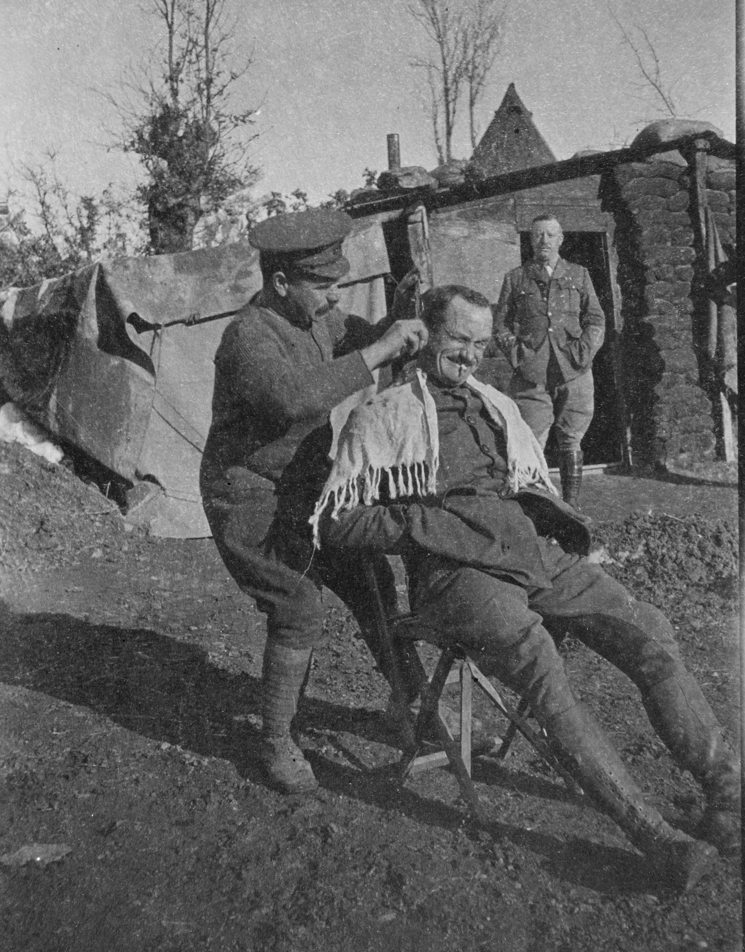

Collection level descriptions for this archive, and other privately deposited papers relating to the work of the YMCA, are available on our online archive catalogue at http://www.calmview.bham.ac.uk (Finding No: YMCA/ACC51)

Papers of Austen Chamberlain
During the war, Austen Chamberlain was Secretary of State for India 1915-17 and subsequently a member of the war Cabinet, 1918-19. Prior to 1918, he served on several Cabinet Committees. In 1915, he chaired a sub-committee of the Committee of Imperial Defence and served on a War Policy Committee when he signed a minority report in favour of universal compulsory military service. In 1916 he served on a Committee for the Co-ordination of Military and Financial Effort.

This extensive archive contains official and political papers and considerable family correspondence which covers the period of the First World War. This correspondence includes letters from Mary Endicott Chamberlain, Joseph Chamberlain’s third wife, to her parents in USA and their replies.

A full electronic catalogue of this collection is available on our online archive catalogue at http://www.calmview.bham.ac.uk (Finding No: AC)

Papers of Neville Chamberlain
Neville Chamberlain was appointed as Director General of National Service by Lloyd George in 1916 and was charged with the creation of a scheme of National Service to recruit staff for the war effort. His papers include some official correspondence and reports in relation to this role. The letters he wrote to family members give personal comment and opinion on the war in general and about his work as Lord Mayor of Birmingham and Director General of National Service. The letters also refer to his chairmanship of a tribunal for exemption from military service and his involvement with the companies Hoskins and Company, Birmingham Small Arms Company (BSA), and Elliott’s Metal Company which all supplied essential items to the armed forces during the war.

The letters he received from family members are also of considerable interest. Letters from his sisters, Ida and Hilda Chamberlain, between 1916 and 1918, while they were living in Odiham, Hampshire, contain descriptions life on the Home Front in a rural environment, reflecting the effects of food shortages and rationing, and the sisters’ involvement in communal schemes to grow vegetables and cereals to supply local communities, and in a school meals programme begun during the war to ensure fair distribution of food supplies for local children. The collection also includes letters from his cousin Norman who was serving in the army (and was killed in action) and from his brother Austen concerning his work in the Government during the war.

An electronic catalogue of the Papers of Neville Chamberlain is available on our online archive catalogue at http://www.calmview.bham.ac.uk (Finding No: NC)

Papers of Beatrice, Ida, Hilda and Ethel Chamberlain
Letters and papers of the sisters of Austen and Neville Chamberlain which include further family papers relating to the First World War.

A collection level description is available on our online archive catalogue at http://www.calmview.bham.ac.uk (Finding No: BC)

Church Missionary Society Archive
The records of the Church Mission Society (formerly Church Missionary Society) include correspondence, periodicals and other publications giving news of the Society and its staff during the First World War.

The annual reports, illustrated magazines and records of the CMS Overseas Division are an excellent place to start. Consider also the privately deposited collections held as the CMS Unofficial Papers. The latter include the Papers of Bishop Llewellyn Henry Gwynne and Papers of the Donnithorne family, also mentioned in this Guide.

There is information about these and other sources in the Guide to Using the CMS Archive. An overview of the CMS Archive and related finding aids can be seen through the online archive catalogue at http://www.calmview.bham.ac.uk (Finding No: CMS)

Papers of Bishop Llewellyn Henry Gwynne
This collection relates to Gwynne's lengthy career as clergyman and missionary. It includes an Army Book with manuscript biographical information and illustrated newscuttings about the service of army chaplains during the First World War.

A full electronic catalogue of this collection is available on our online archive catalogue at http://www.calmview.bham.ac.uk (Finding No: CMS/ACC18)

Papers of the Donnithorne family
This collection comprises personal and family letters and other papers of Vivyan and Gladys Donnithorne both before and during their service as CMS missionaries in China. It includes letters to Gladys from Oswald Chambers and her brother who were both on active service during the First World War, 1914-1917.

A full electronic catalogue of this collection is available on our online archive catalogue at http://www.calmview.bham.ac.uk (Finding No: CMS/ACC232)

The Courtney Collection
The collection of the Courtney family includes about 260 letters written home from France, Greece and Malta by Henry Gother Courtney during the First World War. Gother served as an ambulance driver with the Red Cross in France and then as an Orderly Officer in the Royal Garrison Artillery with the Mediterranean Expeditionary Force in Greece.

A catalogue is available on our online archive catalogue at http://www.calmview.bham.ac.uk (Finding No: CC)

Letters of Prince Vasily Alexandrovich Dolgorukov
Letters sent to his stepfather Count Pavel Konstantinovich Benckendorff, 1915-1916. The letters describe conditions and events at the front during the First World War in Russia. Transcripts of the letters in Russian are available.

A collection level description is available on our online archive catalogue at http://www.calmview.bham.ac.uk (Finding No: VD)

Papers of Ernest Watson, engineer
Papers include reports for Joseph Lucas Ltd on magneto design during the 1914-1918 war, and memoirs.

A collection level description is available on our online archive catalogue at http://www.calmview.bham.ac.uk (Finding No: MS34)

Diary of a British officer and his wife in India
Daily diary providing a detailed picture of the life of the British in India during 1917. This includes such aspects as their mode of life and domestic arrangements, relations with other British families and with their Indian servants and merchants, hopes of promotion, food and drink, clothes and household goods, sports and recreations and extensive travel.

A full electronic catalogue of this collection is available on our online archive catalogue at http://www.calmview.bham.ac.uk (Finding No: MS87)

Copies of albums compiled between 1906 and 1920 by Eveline Wauchope, nurse
Scanned copies of a photograph album and an illustrated, autograph album largely dating from the time when Eveline (or 'Evelyn' as she was also known) was working in Birmingham, at the General Hospital 1912-1914 and, from 1914, at the First Southern General Hospital which was established at the University of Birmingham during the First World War.
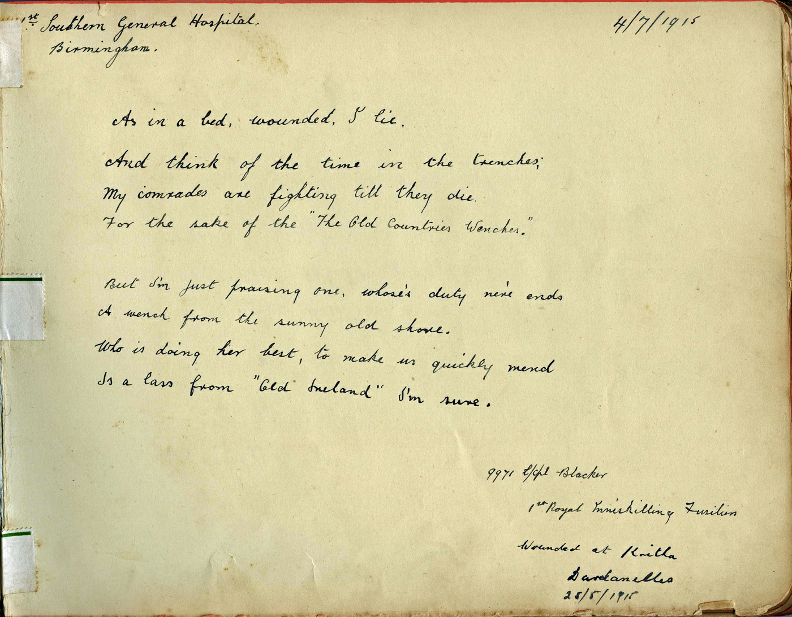
The collection includes informal photographs of patients and staff. The autograph album has numerous signed entries in which servicemen give the name of their regiment and the place and date they were wounded.

A full electronic catalogue of the collection is available at http://www.calmview.bham.ac.uk (Finding No: MS871)

Papers of E. W. Hornung
The collection comprises both literary papers (as creator of ‘Raffles’) and other material relating to his war work with the YMCA. These latter papers include typescript transcripts of Hornung's war diary, December 1917-March 1918 which relates to his work with the YMCA; letters to his friend, Shane Chichester, 1901-1921, together with typescript transcripts, illustrating, for example the work of Chichester and others in gathering and despatching books to Hornung for his YMCA libraries.

A collection level description is available on our online archive catalogue at http://www.calmview.bham.ac.uk (Finding No: MS127)

Papers of Laurence Cadbury
Collection of letters, diaries, maps, magazines, photographs, drawings, books, and ephemera relating to his service with the Friends Ambulance Unit.

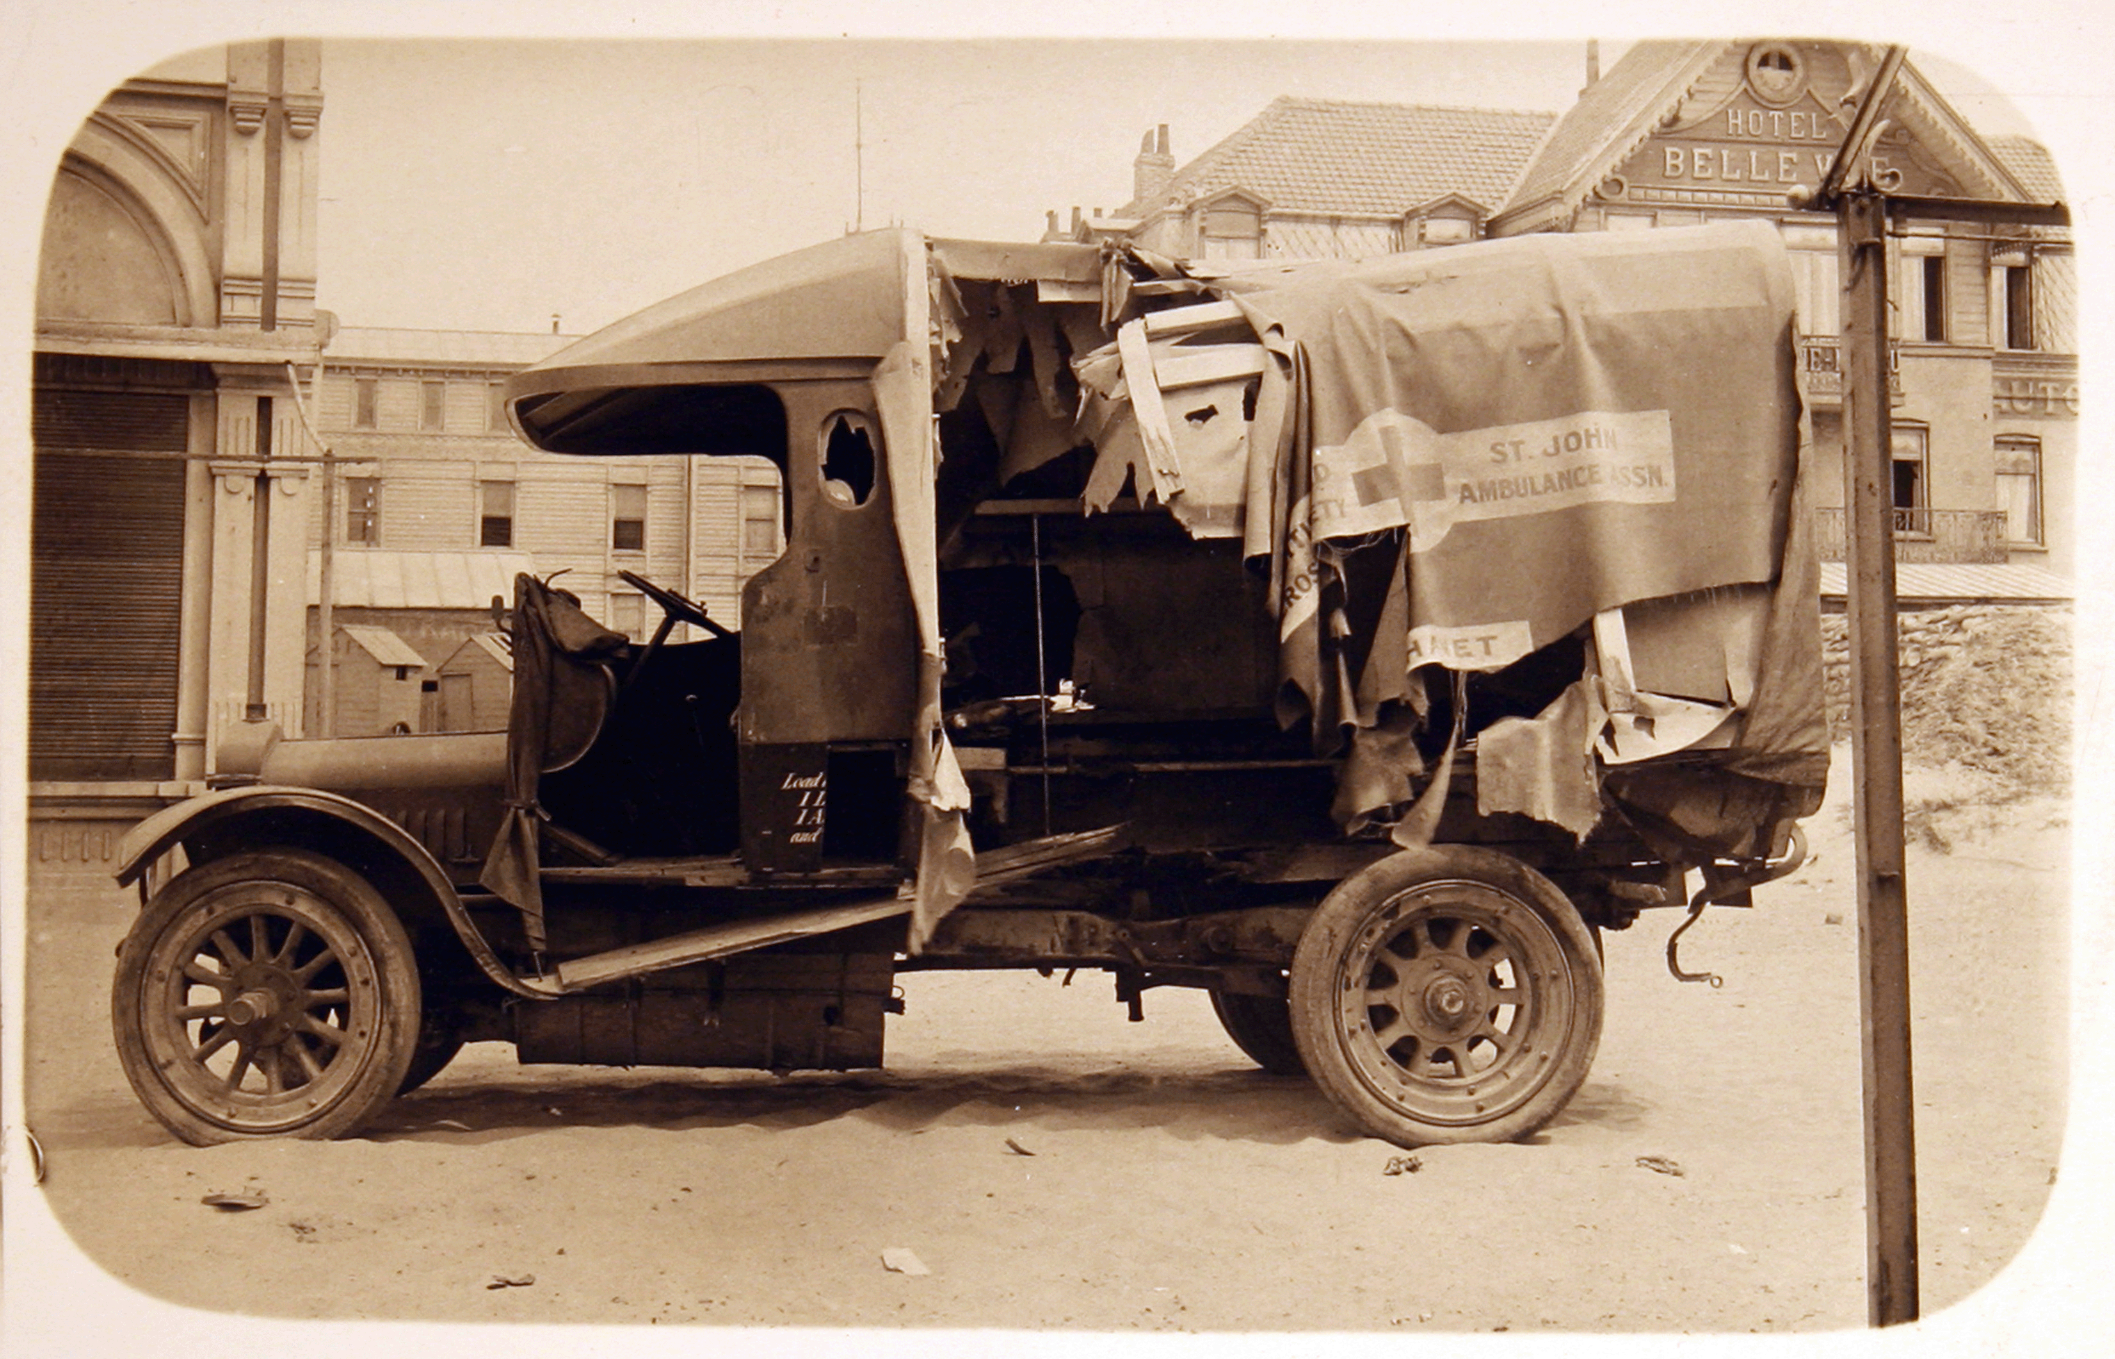

A full catalogue is available on our online archive catalogue at http://www.calmview.bham.ac.uk (Finding No: MS327)

Papers of Thomas Winter
Typescript transcript of a record, in 14 chapters, of the experiences of Thomas Winter, a YMCA worker in England, France and Italy during the First World War, compiled May 1919.

A collection level description is available on our online archive catalogue at http://www.calmview.bham.ac.uk (Finding No: YMCA/ACC11)

Papers of J. H. Swain
These papers principally comprise material relating to his service in the First World War in the 6th Battalion Machine Gun Corps.

A collection level description is available on our online archive catalogue at http://www.calmview.bham.ac.uk (Finding No: MS199)

Papers of Cynthia Mosley
The papers include a considerable quantity of personal and formal correspondence written to Cynthia Mosley (nee Curzon) relating to her public and political life. Although most of the material dates from after her marriage to Oswald Mosley in 1920, there is a substantial amount of family and other correspondence dating to the First World War. This correspondence includes letters from her sister Irene Curzon (later Baroness Ravensdale) while she was working with the YMCA in France during the last months of the First World War in 1918 and describe various aspects of her life there; letters to Cynthia from officers mostly stationed on the Western Front during the First World War, but also from Maurice Pretyman, an officer serving in the Dardanelles in 1915, and 'Rob', serving in Palestine in 1918. Some of the correspondence is from family friends; other letters to Cynthia and to her father, Lord George Curzon, appear to be from soldiers and sailors serving in the war who were likely to have been employees of the family.

These papers form part of a collection of papers of Oswald Mosley. A full electronic catalogue of this collection is available on our online archive catalogue at http://www.calmview.bham.ac.uk (Finding No: OMN/A)

Papers of the Humphreys Family
Collection of largely family and personal papers of members of the Humphreys Family, principally of Professor Humphrey Francis Humphreys (1885-1977), but also of his father, John Humphreys (1850-1937), and Evan Griffith Humphreys (1853-1917). The papers of Professor Humphreys, a graduate of the University and subsequently a Vice-Chancellor, include letters he wrote to his parents and a friend while a postgraduate at Harvard, on a world tour in 1910 and during his war service with the Royal Army Medical Corps in the Middle East, 1915-1919.

A full electronic catalogue of this collection is available on our online archive catalogue at http://www.calmview.bham.ac.uk (Finding No: MS190)

Grenade course notebook of Lance Corporal R. Lambert
Manuscript notes and diagrams made while studying on a training course at the Grenade School in Otley, Yorkshire, 1917

A full catalogue is available on our online archive catalogue at http://www.calmview.bham.ac.uk (Finding No: MS802)

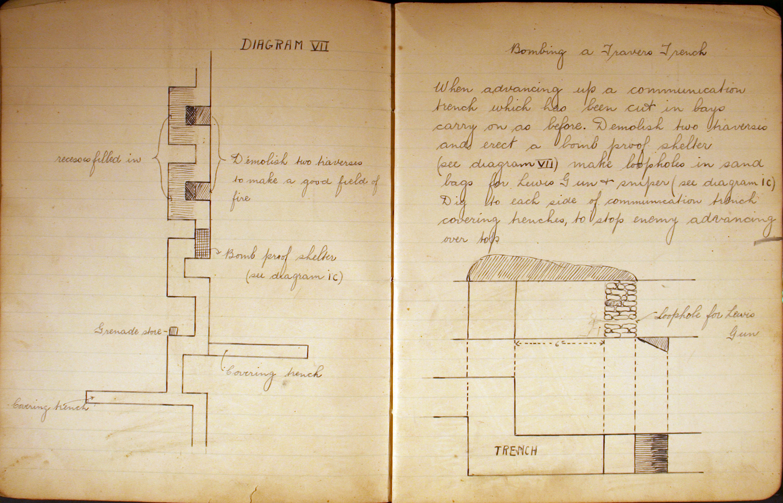

Notebook of 2nd Lt G. M. Ugg of Black Watch Regiment
Training notebook relating to field operations course covering all aspects of trench warfare and which illustrates the type of course material attended by young officers before sent to the Front in the First World War, 1915

A collection level description is available on our online archive catalogue at http://www.calmview.bham.ac.uk (Finding No: MS790)

Papers of Lance Corporal Edward H. Jones
Small collection of personal papers and photographs relates to Lance Corporal Jones's period as a prisoner of war in the German camps at Dulman, Friedrichsfeld, Sennelager and elsewhere in Germany.

A collection level description is available on our online archive catalogue at http://www.calmview.bham.ac.uk (Finding No: MS216)

Memoirs of Frank Lavender
Three volumes containing his personal account of his service on the Western Front and including sketches, newspaper clippings and some photographs.

A collection level description is available on our online archive catalogue at http://www.calmview.bham.ac.uk (Finding No: MS322)

Papers of Lieutenant Sidney Archibald Evans
War diary, trench maps and other papers relating to his service with the Royal Garrison Artillery, 1917-1918.

A full electronic catalogue of this collection is available on our online archive catalogue at http://www.calmview.bham.ac.uk (Finding No: MS366)

Letters of John Solomon Riddell Hodgson
Copies of letters sent from France and Mesopotamia to his family while serving with the Dorsetshire Regiment.

A collection level description is available on our online archive catalogue at http://www.calmview.bham.ac.uk (Finding No: MS368)

Letters to Reginald Hibbert Tupper
A small number of letters from three old friends who were serving officers in the British Navy. The letters relate to British and German naval engagements in the First World War and illustrate first hand experience of battle at sea and its personal effects, 1915-1916.

A collection level description is available on our online archive catalogue at http://www.calmview.bham.ac.uk (Finding No: MS178)

Diary of Gwen Wells
Manuscript diary of a young woman working and living in London which provides an insight into everyday life in London at the close of the First World War and which regularly mentions air-raids and bomb damage, 1918.

A full catalogue is available on our online archive catalogue at http://www.calmview.bham.ac.uk (Finding No: MS117)

Diary of Harry George Painting
Brief manuscript diary of a sick berth attendant on service on HMS Lowestoft in the North Sea, October-December 1914. His papers also include some photographs and his protection and identity certificate (1919).

A full catalogue is available on our online archive catalogue at http://www.calmview.bham.ac.uk (Finding No: MS200/6/3)

Papers of Alice Vera Knight
A section of the papers of Alice Knight relate to her work in different government departments during, and after, the First World War as a shorthand typist with the Postal Censorship branch of the War Office (MI9), and later with the Clearing Office (Enemy Debts) [of the Board of Trade]. Alice's letters relate to her experiences living in France whilst working with the American Expeditionary Force in the aftermath of the First World War.
A full catalogue is available on our online archive catalogue at http://www.calmview.bham.ac.uk (Finding No: MS843)

Papers of Kathleen Grace Lloyd
A section of the papers of Kathleen ‘Matron’ Lloyd, who worked at the 1st Southern General Hospital, a military hospital set up at the University of Birmingham during the First World War.
A full catalogue is available on our online archive catalogue at http://www.calmview.bham.ac.uk (Finding No: MS44)

Archives of the University of Birmingham
The extensive records of the University – which include minutes, reports, correspondence, publications, photographs, records of the Guild of Students, etc – provide documentary information about the functioning of higher education during the war, war time research undertaken by the staff, staff and former students serving in the armed forces and the provision of education and training for those discharged. Many of the University buildings on the Edgbaston Campus were also requisitioned for use as a Military Hospital and the archives include some information relating to this use of the buildings.

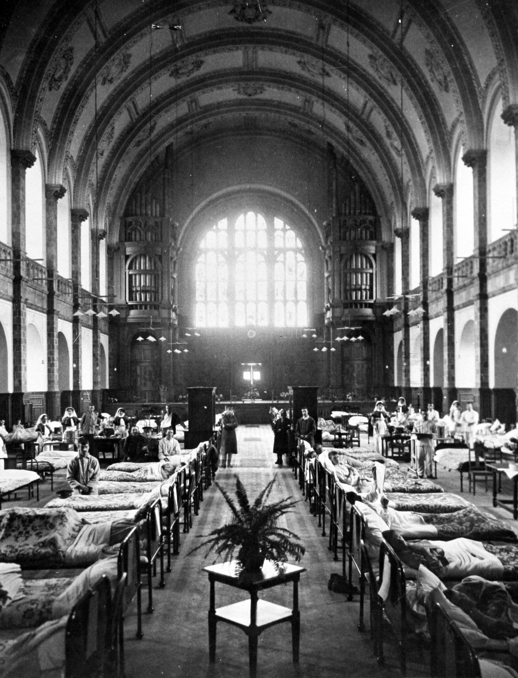

University House Papers
Records of University House, a residence for women students at the University of Birmingham, which was founded in 1904. This collection includes material relating to the use of University House as a Nurses' Hostel during the First World War – the building was requisitioned when the University became a Military Hospital.

A full electronic catalogue of this collection is available on our online archive catalogue at http://www.calmview.bham.ac.uk (Finding No: UB/HUH)

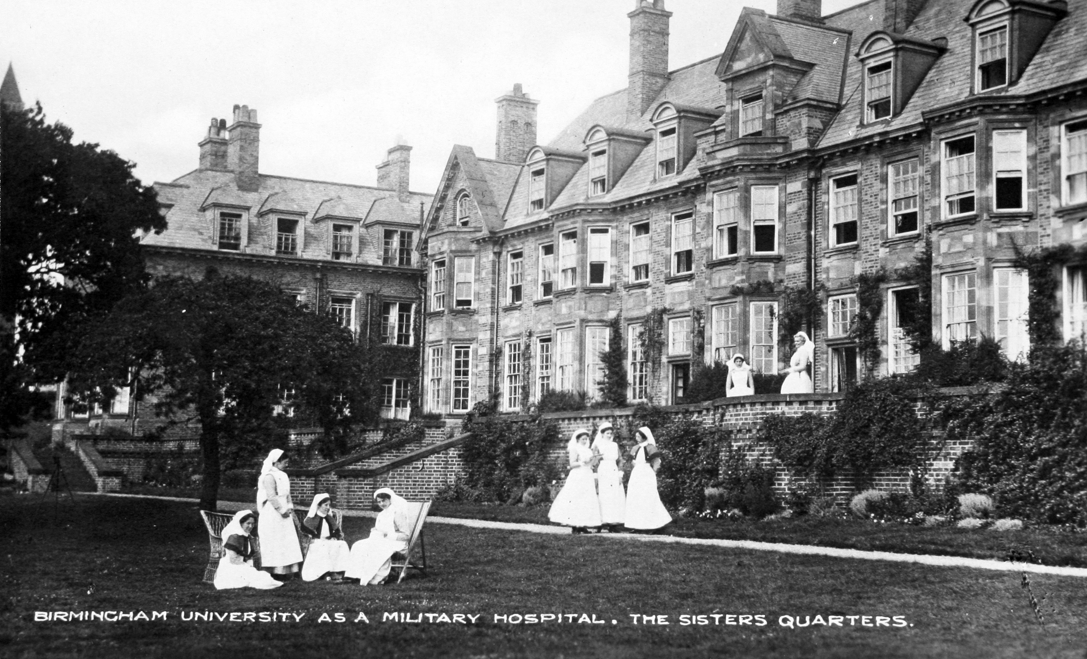

Copies of letters home of World War I soldier, Corporal A. Alan Morom
Compiled by Morom's father as a memorial to his son, contains copies of the letters written to his parents by Alan Morom, enlisted in the Public Schools Battalion, 20th and 8th Royal Fusiliers, covering the period August 1915 to November 1917, when he was killed during the Battle of Cambrai.

A full electronic catalogue of this collection is available on our online archive catalogue at http://www.calmview.bham.ac.uk (Finding No: KWH/A/164 )

Photograph album compiled by Harold de Carteret Falle
Photograph album featuring various members of the De Carteret Falle family of the Channel Islands, depicting scenes of life on Jersey, Guernsey and the British mainland. The album chronicles the family of Lieutenant H. De Carteret Falle R.N.V.R and life on the islands prior to, and during the First World War, [1907-1918].

A full electronic catalogue of this collection is available on our online archive catalogue at http://www.calmview.bham.ac.uk (Finding No: MS660)

'War journals England 1918-1919’ of Reverend G. L. [Lionel] Smith
Personal account written in the first person with numerous references to military hospitals and some commentary on the political situation in Ireland.

A full electronic catalogue of this collection is available on our online archive catalogue at http://www.calmview.bham.ac.uk (Finding No: MS869)

Memoir of William George Cadenhead
Discusses Cadenhead's First World War service as a machine gunner in the Scottish Horse Yeomanry. There is a detailed account of his being called up in August 1914 and being stationed in Doncaster and Morpeth before being sent to Gallipoli in July 1915 where he saw action in Suvla Bay. He was evacuated in December 1915 and then describes the transfer of his unit to Egypt to form part of the Imperial Camel Corps. He took part in the advance on Gaza in March 1917 where he was badly wounded and evacuated to Cairo. Following his recovery he assisted at the YMCA forces' centre near Cairo.

A full electronic catalogue of this collection is available on our online archive catalogue at http://www.calmview.bham.ac.uk (Finding No: YMCA/ACC74)

First World War correspondence of J. E. 'Jim' Richards
The correspondence is mostly written during the First World War, while Richards was serving in the forces with the majority of letters dated 1918. One letter is dated 1914 written from Paris. Letters are addressed from Halton Camp, Buckinghamshire; No 4 Aeroplane Supply Depot, BEF [British Expeditionary Force]; Hotel Florida, Paris; The Haven, Fairbourne, Wales; Blandford Camp, Dorset. Most letters written on YMCA headed notepaper; some letters written on The Salvation Army headed notepaper.

A full electronic catalogue of this collection is available on our online archive catalogue at http://www.calmview.bham.ac.uk (Finding No: YMCA/ACC75)

First World War postcards collected by John Pritchard Brewer

File of 39 photographic postcards primarily depicting military camp work in Sussex during the First World War. The postcards were collected by John 'Jack' Pritchard Brewer in his role working for the YMCA in providing support for the troops.

The postcards include a number of scenes of army camps in Sussex during the First World War, including scenes of the camps at Seaford. The two camps at Seaford, North Camp and South Camp (also known as Chyngton Camp) were built between 1914 and 1915 as an accommodation and training base for volunteers. These men formed part of Kitchener’s Third New Army, created as a response to the outbreak of the First World War. They mostly comprised units of men that represented their hometown.

A full electronic catalogue of this collection is available on our online archive catalogue at http://www.calmview.bham.ac.uk (Finding No: YMCA/ACC77)

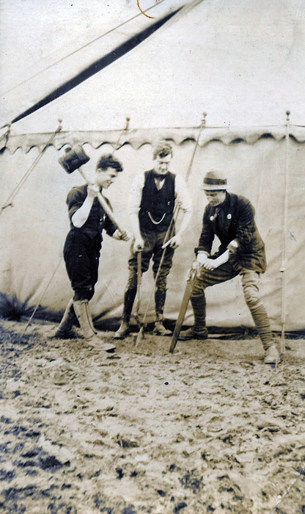

Papers of Minnie H. Evelyn-Smith
Photograph album depicting scenes of France during the First World War, compiled by Minnie H. Evelyn-Smith. Images depict buildings, seascapes and churches. A number of female YMCA/YWCA workers appear, and there are also scenes of Poperinge, ruins in Arras, ruins in Albert on the Somme, and various ruins in Ypres including the Cloth Hall.

A full electronic catalogue of this collection is available on our online archive catalogue at http://www.calmview.bham.ac.uk (Finding No: YMCA/ACC79)

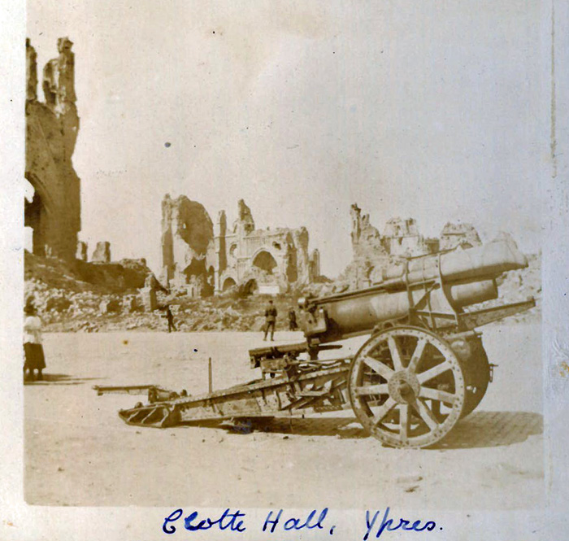

Memoir of Grace Torrington
Describes Grace Torrington’s First World War experiences supporting the activities of the YMCA at Shoreham-by-Sea and in Brighton.

A full electronic catalogue of this collection is available on our online archive catalogue at http://www.calmview.bham.ac.uk (Finding No: YMCA/ACC76)

First World War correspondence of Albert Entwistle
Letters of Albert Entwistle of Derby, written to his mother and father during the First World War. Correspondence appears to be dated 1918 although a small number of letters are undated, and seemingly sent from bases in the UK whilst Entwistle was in service with the Royal Air Force.

A full electronic catalogue of this collection is available on our online archive catalogue at http://www.calmview.bham.ac.uk (Finding No: YMCA/ACC81)

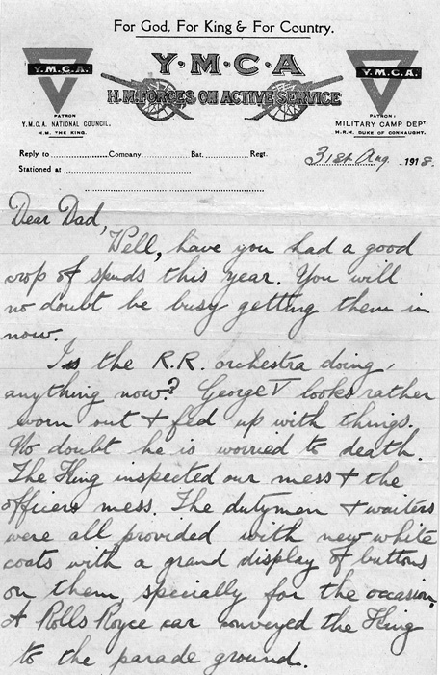

Memoir of Harold M. Gould, YMCA Secretary
Typescript memoir titled 'Through Wars and Peace: one man's work with the YMCA 1914-1955', biography of Harold M. Gould, YMCA Secretary. Includes accounts relating to the outbreak of the First World War, travelling to Boulogne and Calais in 1915, establishing centres in the First Army area, 1915; and leading the work of the St Omer District, 1917-1919.

A full electronic catalogue of this collection is available on our online archive catalogue at http://www.calmview.bham.ac.uk (Finding No: YMCA/ACC85)

Visitors book for 'Soundeville' rest camp in Equihen, France
Manuscript copy of a visitors book recording the names and regiments of visitors to the 'Soundeville' rest camp in Equihen [Equihen-Plage] near Boulogne in France during the First World War.

A full electronic catalogue of this collection is available on our online archive catalogue at http://www.calmview.bham.ac.uk (Finding No: YMCA/ACC87)

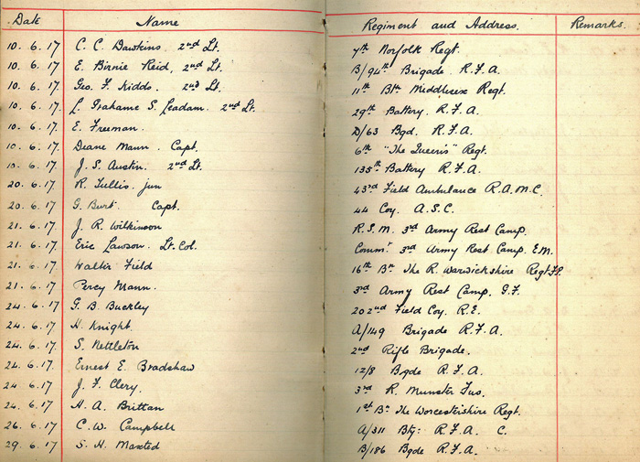

First World War correspondence sent to Reverend and Mrs Proctor of Salisbury
Two letters sent to Reverend L. O. Proctor of Fisherton Rectory, Salisbury during the First World War. Both letters are written on YMCA headed notepaper and refer to alcohol consumption, and problems associated with alcohol, in the army.

A full electronic catalogue of this collection is available on our online archive catalogue at http://www.calmview.bham.ac.uk (Finding No: YMCA/ACC89)

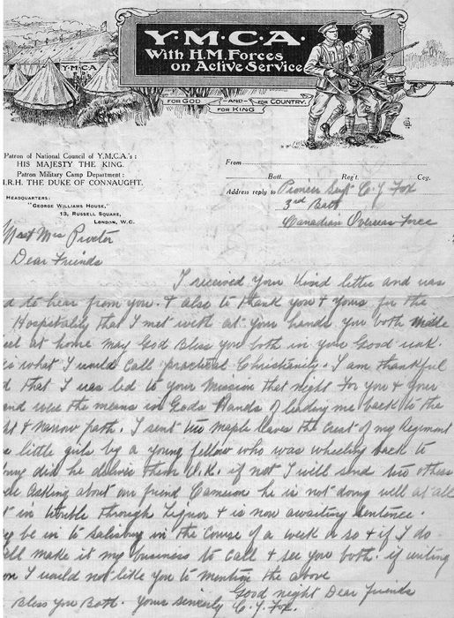

New Testament titled 'Active Service Testament'
Printed pocket New Testament Bible, 1916. Includes printed notice titled 'Lord Roberts's Message to the Troops'.

A full electronic catalogue of this collection is available on our online archive catalogue at http://www.calmview.bham.ac.uk (Finding No: YMCA/ACC99)



