A guide to cricket books held at the Cadbury Research Library

Updated March 2017

A selection of cricket books held at the Cadbury Research Library: Special Collections

This is a guide to the printed rare books held at the Cadbury Research Library on the subject of cricket.

Items in this list have been found using our catalogues and indexes, or suggested by staff members/researchers, but it is not exhaustive. Some of the books listed are not yet on the library catalogue, but you are still very welcome to consult them.

If you come across other cricket sources during the course of your research held at the Cadbury Research Library that you think should be included, we would be pleased to hear about them.

We also hold archive material related to cricket (not yet included in this guide). You can search our archive catalogue for archives, and also and our book catalogue online. Our main website gives visitor information should you wish to consult any of the items we hold.

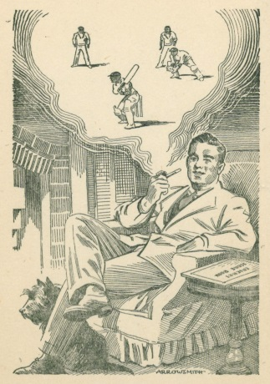
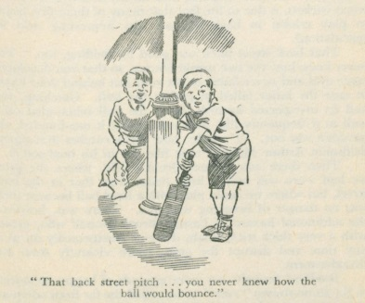
Images taken from Duckworth’s ‘Cricket from the Hearth’
Books listed in alphabetical order by surname of author:

Altham, H.S. and Swanton, E.W.
A History of Cricket
Cadbury Research Library GV 913

Arlott, John
Gone to the Cricket
Cadbury Research Library GV 923 A

Arlott, John
Maurice Tate
Cadbury Research Library GV 915.T2

Arlott, John
The First Test Match
Cadbury Research Library GV 923 A

Ashley-Cooper, F.S.
Cricket highways and byways
Cadbury Research Library GV 917 A

Bedser, Alec and Bedser, Eric
Our Cricket Story
Cadbury Research Library GV 915.B4

Binns, Richard
Cricket in Firelight
Cadbury Research Library GV 917 B

Blunden, Edmund
Cricket Country
Cadbury Research Library GV 919 B

Box, C.
The cricketer’s manual by “Bat”
Cadbury Research Library p GV 917.B69

Box, C
The theory and Practice of Cricket
Cadbury Research Library GV 913

Boxall, T
Rules and Instructions for Playing at the Game of Cricket
Cadbury Research Library GV 925

Buckley, G.B.
Fresh Light on 18th Century Cricket
Cadbury Research Library GV 913 B

Buckley, G.B.
Fresh Light on Pre-Victorian Cricket
Cadbury Research Library GV 913 F

Cardus, Neville
Cricket
Cadbury Research Library GV 917 C

Cardus, Neville
Days in the Sun
Cadbury Research Library GV 917 C

Cardus, Neville
The Summer Game
Cadbury Research Library GV 917 C

Carew, Dudley
England Over
Cadbury Research Library GV 923 C

Carr, A.W.
Cricket with the Lid Off
Cadbury Research Library GV 915.C277

Collins, W.E.W.
Leaves from an Old Country Cricketer’s
Cadbury Research Library GV 915.C585
Compton, Denis
Playing for England
Cadbury Research Library GV 915.C6

Constantine, L.N.
Cricket and I
Cadbury Research Library GV 915.C7

Constantine, Learie
Cricket in the Sun
Cadbury Research Library GV 915.C7

Daft, Richard
A Cricketer’s Yarns
Cadbury Research Library GV 915.D2
Daft, Richard
Kings of Cricket
Cadbury Research Library GV 915.D2

Daft, Richard
Kings of Cricket
Cadbury Research Library GV 915.D2

Darwin, Bernard
W.G. Grace
Cadbury Research Library GV 915.G6

De Selincourt, Hugh
The Cricket Match
Cadbury Research Library PR6007.E74C7

De Selincourt, Hugh
The Game of the Season
Cadbury Research Library GV 919 D

De Selincourt, Hugh
The Saturday Match
Cadbury Research Library PR6007.E74S3

De Selincourt, Hugh
Over!
Cadbury Research Library GV 917 D

Duckworth, L. B.
Cricket from the Hearth
Cadbury Research Library GV 917 D

Duckworth, L.B.
Cricket My Love
Cadbury Research Library GV 915.D83

Ford, W.J.
A Cricketer on Cricket
Cadbury Research Library GV 913 F

Fudge, Barnabas
Owzat?
Cadbury Research Library GV 919 F

Gale, F
Echoes from Old Cricket Fields
Cadbury Research Library GV 913 G

Gilligan, A.E.R.
Sussex Cricket
Cadbury Research Library GV 921.S87

Gordon, Sir Home
Background of Cricket
Cadbury Research Library GV 917 G

Goulstone, J.
The 1789 tour
Cadbury Research Library p GV 913

Grace, W.G.
‘W. G.’
Cadbury Research Library GV915

Grace, W.G.
‘WG’ Cricketing Reminiscences and Personal Recollections
Cadbury Research Library GV 915.G6G

Grace, W.G
Cricket
Cadbury Research Library GV 917

Grace, W.G
The History of a Hundred Centuries
Cadbury Research Library GV 915.G6

‘Gryllus’
Homage to Cricket
Cadbury Research Library GV 917 G

Guise, J. L.
Successful Cricket
Cadbury Research Library GV 917

Harris, Bruce
Jardine Justified
Cadbury Research Library GV 923 H

Harris (Lord) and Ashley-Cooper, F.S.
Lord’s and the M.C.C.
Cadbury Research Library GV 921.M3
Hawke, Lord
Recollections and Reminiscences
Cadbury Research Library GV 915.H295

Hawke, Lord
Recollections and Reminiscences
Cadbury Research Library GV 915.H39
Hawke, Lord
The Memorial Biography of Dr W.G. Grace
Cadbury Research Library GV 915.G7

Haygarth, A
Arthur Haygarth's Cricket Scores and Biographies from 1855 to 1875
Cadbury Research Library GV 925.H39

Hendren, Patsy
Big Cricket
Cadbury Research Library GV 915.H46

Henley, F.A.H.
The Boys’ Book of Cricket
Cadbury Research Library GV 917

Hobbs, J. B.
The Fight for the Ashes 1932-33
Cadbury Research Library GV 921.M3

Hodgson
Cricket Memories by a Country Vicar
Cadbury Research Library GV 915.H579

Hodgson
The Happy Cricketer by a Country Vicar
Cadbury Research Library GV 915.H579

Hodgson
Second Innings by Country Vicar
Cadbury Research Library GV 915.H579

Holmes, R.S.
The History of Yorkshire County Cricket
Cadbury Research Library GV 913

Hutchinson, Horace G. (Ed.)
Cricket
Cadbury Research Library GV 917 H

Jardine, D.R.
In Quest of the Ashes
Cadbury Research Library GV 921.M3 J

Kilburn, J.M.
In Search of Cricket
Cadbury Research Library GV 917 K
Kinross, Albert
An Unconventional Cricketer
Cadbury Research Library GV 915.K567

Larwood, Harold
Body-Line?
Cadbury Research Library GV 915.L279

Lillywhite’s Cricketer’s Companion; 1881
Cadbury Research Library GV 911.J26

Lyttleton, E
Cricket
Cadbury Research Library, GV 917

Lyttleton, E
Cricket
Cadbury Research Library, GV 917 L

Frederick Lillywhite’s Cricket Scores and Biographies of Celebrated Cricketers
Cadbury Research Library GV 913

Looker, Samuel J. (Ed.)
Cricket: a little book for lovers of the game
Cadbury Research Library GV 917

Lyon, W.R.
The Elevens of Three Great Schools 1805-1929
Cadbury Research Library, GV 915.A1

Macartney, C.G.
My Cricketing Days
Cadbury Research Library GV 915.M232

Maclaren, A.C.
A.C. Maclaren (Captain, All England, 1909) on cricket
Cadbury Research Library p GV 917

Mailey, Arthur
And Then Came Larwood
Cadbury Research Library GV 923 M

Marchant, John
The Greatest Test Match
Cadbury Research Library GV 923 M
Matthews, J
Aldridge Cricket
Cadbury Research Library GV 921.A5

Noble, M.A.
The Fight for the Ashes 1928-29
Cadbury Research Library GV 923 N

Noble, M.A.
Gilligan’s Men
Cadbury Research Library GV 923 N

Noel, E. B.
Winchester College Cricket
Cadbury Research Library GV 922.W56 N

Nyren, J.
Chronicles of Cricket
Cadbury Research Library GV 913

Nyren, J.
The Young Cricketers Tutor
Cadbury Research Library GV 925

Parker, Eric
The History of Cricket
Cadbury Research Library GV 913

Piggott, Percy
Incidents in Fifty Years of Cambridge University Cricket 1886-1936
Cadbury Research Library GV 921.C2

Pogson, Norman J.
International Wicket-Keepers of Three Countries
Cadbury Research Library GV 915.A1P

Pollock, William
The Cream of Cricket
Cadbury Research Library GV 917 P
Pollock, William
So This Is Australia
Cadbury Research Library GV 921.M3 P

Pollock, William
Talking About Cricket
Cadbury Research Library GV 917 P

Pullin, A.W.
Alfred Shaw Cricketer
Cadbury Research Library GV 915.S521/P

Pycroft, J
Cricketana
Cadbury Research Library GV 919

Pycroft, J.
The Cricket-Field, 3rd Ed.
Cadbury Research Library GV 917 P

Pycroft, J.
The Cricket-Field, 5th Ed.
Cadbury Research Library GV 917 P

Pycroft, J.
The cricket tutor
Cadbury Research Library p GV 917

Ranjitsinhji, K.S.
The Jubilee Book of Cricket
Cadbury Research Library GV 917

Roberts, E.L.
Cricket in England 1894-1939
Cadbury Research Library GV 925 R

Roberts, E.L.
Test Cricket and Cricketers 1877-1934
Cadbury Research Library GV 913 R

Robertson-Glasgow, R.C.
Cricket Prints
Cadbury Research Library GV 915.A1

Robinson, R
Between Wickets
Cadbury Research Library GV 917 R

Selkirk, G.H.
Guide to the Cricket Ground
Cadbury Research Library GV 927
Sewell, E.H.D.
Cricket Under Fire
Cadbury Research Library GV 917 S

Sewell, E.H.D.
Overthrows
Cadbury Research Library GV 917 S

Standing, Percy Cross
Anglo-Australian Cricket 1862-1926
Cadbury Research Library GV 913 S

Sutcliffe, Herbert
For England and Yorkshire
Cadbury Research Library GV 915.S873

Tate, Maurice
My Cricketing Reminiscences
Cadbury Research Library GV 915.T2

The Australians in England
Cadbury Research Library GV 923

The Blues and the Battles
Cadbury Research Library GV 923

The Cricket Bat and how to use it
Cadbury Research Library GV 917
Thorpe, James
A Cricket Bag
Cadbury Research Library GV 917 T

Trevour, P
The Lighter Side of Cricket
Cadbury Research Library GV 919

Wallis, Edward
Wallis’s instructions to cricketers
Cadbury Research Library p GV 925

Warner, P.F.
How We Recovered the Ashes
Cadbury Research Library GV 921.M3 W

Warner, P.F. (et al)
Cricket
Cadbury Research Library GV 917.W2

Warner, P.F.
Cricket in Many Climes
Cadbury Research Library GV 923
Warner, P.F. and Ashley-Cooper, F.S.
Oxford v. Cambridge at the Wicket
Cadbury Research Library GV 923 W

Warner, Sir Pelham
The Book of Cricket
Cadbury Research Library GV 917 W

Warner, Pelham
Cricket Between Two Wars
Cadbury Research Library GV913 W
Warner, Pelham
Lord’s 1787-1945
Cadbury Research Library GV 913 W
Weber, R
The Playfair book of Cricket Records
Cadbury Research Library GV 925 W

Wilmot, R.W.E.
Defending the Ashes 1932-1933
Cadbury Research Library GV 923 W

Wisden, J & Co., 1864-1879; 1882; 1887-2004
Cricketers’ Almanac
Cadbury Research Library GV 911.W5
Woods, S.M.J.
My Reminiscences
Cadbury Research Library GV 916.W66

Young, R.S.
Cricket on the Green
Cadbury Research Library GV 917 Y
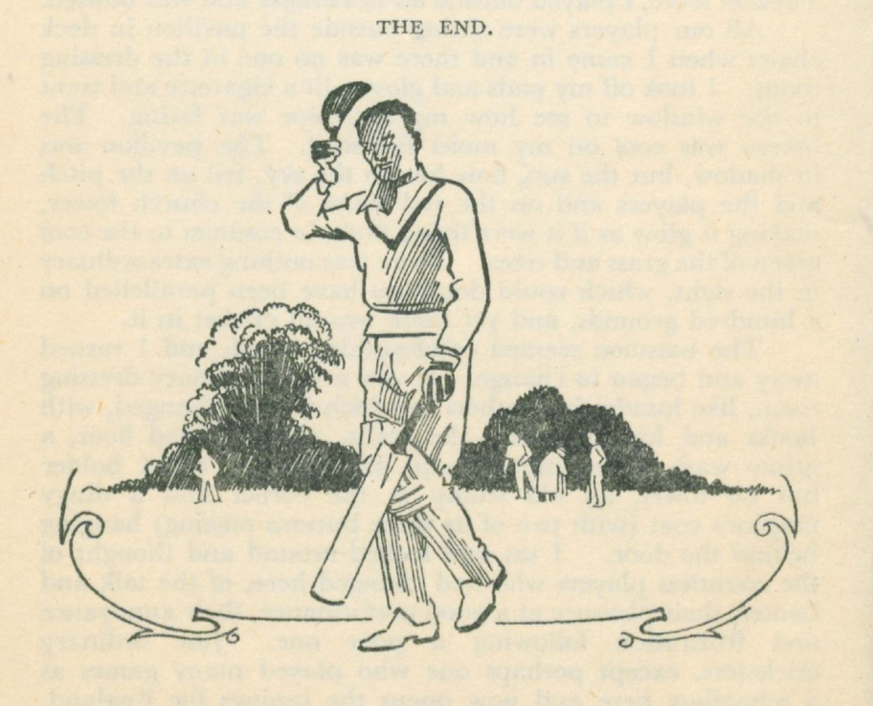
Image taken from Duckworth, L. B., Cricket from the Hearth.
Cadbury Research Library: GV 917 D

