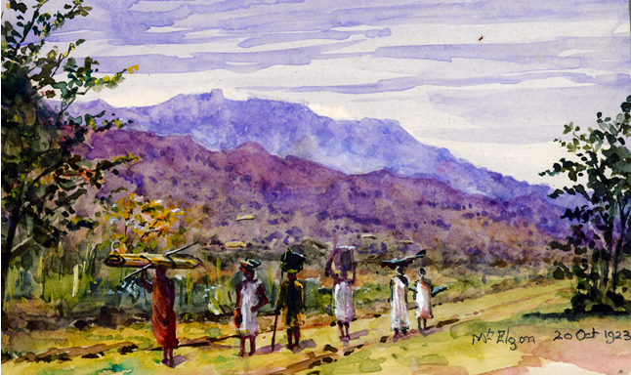

Research guide: Using the Church Mission Society Archive

Version: Microsoft Word edition (revised 2023)

Copyright of the Cadbury Research Library: Special Collections, University of Birmingham, 2023.

Alternative format

Please let us know if you would like a copy of this Guide in another format. There are three ways to contact us:
- Email: special-collections@contacts.bham.ac.uk;
- Telephone: 0121 414 5839;
- Write to: Cadbury Research Library, University of Birmingham, Edgbaston, Birmingham B15 2TT, UK.

Contents

Alternative format 1
Contents 2
Purpose of this Guide 3
The ‘Church Mission Society Archive’: introductory overview 4
CMS missions 1804-1959: overview 7
Periodicals and published works by and about the Church Missionary Society 14
Registers of Missionaries 17
Annual Report 1801-1962 (‘Proceedings’ 1801-1921) 22
CMS Historical Record 1919-1986 25
CMS Overseas (Foreign) Division 1799-1959: an overview 27
Records in the overseas mission series 1803-1959 30
Annual Letters c 1850-1959 48
Church Mission Society Unofficial Papers c 1290-2016 57
Options if you are unable to visit Cadbury Research Library 58
Examples of CMS related material held by other institutions 59
Microfilm and digital copies of material from the CMS Archive 60
Catalogue to the CMS Archive: summary list of parts and supplementary guides 65
Catalogue of the Papers of the Home Division 1840-1959 68
Finding aids for papers of the Overseas (Foreign) Division 70
Card indexes for the CMS Archive 82
Using the online catalogue to the CMS Archive 85
University of Birmingham Library catalogue 88
How to find records about a CMS missionary 89
How to find records about a CMS mission 100
Resources for the study of educational mission overseas 110
List of illustrations used in the Guide 123

Purpose of this Guide

This Guide is meant for anyone who is considering visiting the Cadbury Research Library to use the Church Mission Society Archive (hereafter ‘CMS Archive’).
There are descriptions of the publications and records that you are most likely to use.
There are practical tips to help you decide which papers you would like to see.
There is guidance on how to use the online catalogue to the CMS archive and other finding aids.
Many records and CMS periodicals have been microfilmed and digitised. Copies are usually made available in place of originals for preservation reasons and the Guide includes advice on using the copies. There is also information on how to find out about accessing microfilm or online copies if you are unable to visit the Cadbury Research Library.
The Guide draws heavily on the catalogue to the CMS Archive prepared by CMS Archivists Harry Cobb, Rosemary Keen and Ken Osborne. It is intended to be used alongside, not in place of, the catalogue and other finding aids. We hope that it is helpful but when you visit Cadbury Research Library staff are always on hand to help you make the most of your visit.

The ‘Church Mission Society Archive’: introductory overview

What is meant by ‘the Church Mission Society Archive’?

- The Church Mission Society Archive comprises the official archive of the Church Mission Society (formerly ‘Church Missionary Society’) and a number of deposited and unofficial archives.
- The official archive of the Church Mission Society is predominantly records arising from the work of the administrative departments at the Society's headquarters in the UK including thousands of items of correspondence between CMS headquarters and the missions overseas.
- The deposited and unofficial archives include:
  - records of organisations which amalgamated with CMS or otherwise passed their records to CMS headquarters: the Church of England Zenana Missionary Society; Society for Promoting Female Education in the East; Loochoo Naval Mission; Mid-Africa Ministry and the Missionary Leaves Association;
  - a few records of local UK based CMS Associations and of Diocesan Associations;
  - a few records of overseas missions originating from the records of overseas churches;
  - an artificial collection of CMS theses;
  - collections of privately deposited papers relating to the work of the Society in the UK and overseas which are held as the Church Missionary Society Unofficial Papers; this extensive and growing sequence includes the beautiful watercolour featured on the front cover of this Guide painted by Annie Emma Allen (1853-1942), CMS missionary.
- Working in the UK and overseas since 1799, the CMS has amassed a wealth of records, many of which have been retained for permanent preservation in the Archive. Over two million items are now available for research.
- This Guide focusses predominantly on the records in the official Archive.

Records arranged by administrative unit

- The records are largely grouped according to the department or division at CMS headquarters that compiled them. For example, all of the records created and kept by the CMS Finance Department are kept together and are listed in the Catalogue of the papers of the Finance Department.
- Each department at CMS headquarters worked through a committee, the secretary of the committee being the head of the department.
- For each department (or committee), there are a range of records such as minutes, correspondence, legal papers, reports, finance papers, journals, printed and other materials.
- As one of the Society's founding aims was to evangelise the world, to some extent the records of every department relate to the overseas missions and the experiences of the men and women who worked in them. However, depending on what you are looking for, the records of some departments are likely to be of more interest than others.

Other record sequences in the official archive

- In addition to the records catalogued by department, there are some further sequences in the archive, including extensive compilations of periodicals, the Annual Report, the CMS Historical Record, printed extracts of missionaries’ Annual Letters, the Registers of Missionaries, and small compilations of maps, plans, language manuscripts and other papers.

Finding Aids

- There is a typescript finding aid or entry in the online catalogue to almost all parts of the CMS Archive.
- The various deposited and unofficial archives are kept as distinct collections, each with their own catalogue.
- Guidance on using the catalogue and other finding aids is given on pages 65-88 of this Guide. Including a summary list of the different parts to the catalogue, links to the online version of the catalogue and more detailed explanations of the most heavily used ones.

- Uncatalogued sequences are described in this Guide under:
  - Printed and published works
  - Registers of Missionaries
  - CMS Annual Report
  - CMS Historical Record

CMS missions 1804-1959: overview

Where in the world did CMS work up to 1959?

- The overseas mission work of the CMS began in West Africa in 1804 but spread rapidly to Asia, the Caribbean (West Indies), Canada, Australia, New Zealand, the Middle East and the area around the Mediterranean.
- The main areas of work in Africa were in Sierra Leone, Nigeria, Kenya, Tanzania, Uganda, Rwanda and Sudan. In Asia, CMS involvement was principally in India, Pakistan, Sri Lanka, China and Japan; in the Middle East the Society worked in Palestine, Jordan, Iran and Egypt. CMS also worked extensively in New Zealand 1809-1914 and Canada 1822-1930, with smaller missions in Abyssinia (Ethiopia) 1830-1842, Asia Minor (Smyrna) 1830-1877, Greece 1830-1875, Madagascar 1863-1874, Malta 1815-1843, Mauritius 1856-1929, Seychelles 1871-1894, South Africa 1840-1843, Turkey 1819-1821, Turkish Arabia (Baghdad 1883-1919 and Mosul 1900-1919), and the West Indies 1819-1861.

Why is it necessary to know the names of the missions?

- If you are looking for records of work in a particular part of the world, you will need to identify which mission administered, or later contributed, to work in that area as most of the records in the Archive will be held under the name of the mission.

Mission names - things to beware of

- It may not be obvious from the mission name which one is relevant to the place you are interested in. For example, work in Australia was administered as part of the New Zealand Mission; work in the Seychelles came under the Mauritius Mission; the Western India Mission series includes information on work in Abyssinia (Ethiopia) and East Africa.
- In some instances, names of missions and the places that they relate to change over time. For example, in the 19th century, work in Egypt was under the CMS Mediterranean Mission from 1826-1881 then under the Palestine Mission1882-1889 before the Egypt Mission was established in 1889.

How to find out about places, dates and changes over time

- Information about mission names, places, dates and changes over time are given in the handlists and online catalogue to the overseas mission series to 1934. Suggestions as to what to look for are given in this guide under How to find records about a CMS mission.
- CMS published annual lists of missions giving not only the name of the mission but also the names of all the local mission stations through which each mission worked and summary histories. These lists can be found under four titles all of which can be consulted in Cadbury Research Library: Proceedings 1801-1921; Annual Report 1922-1961; Year Book 1962-1980, and Directory 1981-.

List of missions 1804-1959

- It is beyond the scope of this Guide to provide a definitive list of all CMS mission stations since 1804. The intention here is simply to provide a broad list of the overseas missions. In this section of the Guide the names of missions to 1959 are simply given as they have historically been used in the cataloguing of the mission series .
- There are three lists reflecting the current arrangement of the Archive:
  - mission series 1804-1880;
  - mission series 1880-1934;
  - mission series 1935-1959.
- Within each of the three date ranges, the missions are listed under the committee at CMS headquarters which administered the work for that area.
- The name of the mission is given alongside its unique mission reference number. For example, ‘A1’ is the archive reference for the West Africa Mission, the first Mission to Africa. Some but not all changes of names are given.
- The mission lists 1804-1934 are linked directly to the online catalogue (sub-sub-sub-fonds level).
- The links to the catalogue, references to finding numbers and committees are given because they will be helpful when you are using later sections of this Guide. If you want to skip ahead, you will find information about the mission series, the committees, the archive finding numbers and using the online catalogue later in the Guide.

Mission series 1804-1880

C: missions under the Committee of Correspondence 1804-1880)

- A1 West Africa Mission (Sierra Leone Mission from 1894);
- A2 Yoruba Mission (originally ‘Abeokuta Mission’);
- A3 Niger Mission;
- A4 South Africa Mission;
- A5 East Africa Mission;
- A6 Nyanza Mission;
- C1 North-West America Mission;
- C2 British Colombia Mission;
- CE Ceylon Mission;
- CH China Mission;
- I1 North India Mission;
- I1A Himalaya Mission;
- I2 South India Mission;
- I3 Western India Mission;
- I4 Punjab and Sind Mission;
- J Japan Mission;
- M Mediterranean Mission;
- MA Mauritius Mission (also ‘Mauritius and Madagascar Mission’);
- N New Zealand Mission;
- PE Persia Mission;
- W West Indies Mission.

Mission series 1880-1934

G1: Group 1 (later East Asia) missions 1880-1934

- C1 North-West Canada Mission;
- C2 British Columbia Mission;
- CH1 South China Mission;
- CH2 Chekiang Mission;
- CH3 Western China Mission;
- CH4 Fukien Mission;
- CH5 Kwangsi and Hunan Mission;
- J Japan Mission.

G2: Group 2 (later West Asia) missions 1880-1934

- CE Ceylon Mission;
- I1 North India Mission;
- I3 Western India Mission;
- I4 Punjab and Sind Mission;
- I5 Travancore and Cochin Mission;
- I6 North West Provinces Mission;
- I7 United Provinces Mission;
- I8 Central Provinces Mission;
- I9 Telegu Mission;
- I10 Tinnevelly Mission;
- MA Mauritius Mission;
- PE Persia Mission;
- TA Turkish Arabia Mission.

G3: Group 3 (later Africa) missions 1880-1934

- A1 Sierra Leone Mission (‘West Africa’1804-1894);
- A2 Yoruba Mission;
- A3 Niger Mission;
- A5 Kenya Mission (‘East Africa’ 1880-1885, ’Eastern Equatorial Africa’
1886-1904, ‘British East Africa’ 1904-1920);
- A6 Nyanza Mission;
- A7 Uganda Mission;
- A8 Tanganyika Mission;
- A9 Northern Nigeria Mission;
- A10 Upper Nile Mission (Elgon Mission from 1928);
- A11 Ruanda Mission;
- E Egypt Mission;
- N New Zealand Mission;
- P Palestine Mission;
- S Sudan Mission;
- SN Northern Sudan Mission.

Mission series 1935-1959

AF 1935/59 G3: Africa (Group 3) missions

- A1 Sierra Leone Mission;
- A2 Yoruba Mission;
- A3 Niger Mission;
- A5 Kenya Mission;
- A7 Uganda Mission;
- A8 Tanganyika Mission;
- A9 Northern Nigeria Mission;
- A10 Elgon Mission (Upper Nile);
- A11 Ruanda Mission;
- P Palestine Mission - transferred to West Asia (Group 2) in 1948;
- S Sudan Mission;
- SN Northern Sudan Mission.

AS 1935/59 G1: East Asia (Group 1) missions (ASE G1 1935-1957)

- CH1 South China (Hong Kong) Mission;
- CH2 Mid-China (Chekiang) Mission;
- CH3 West China Mission;
- CH4 Fukien Mission;
- CH5 Kwangsi-Hunan Mission;
- J Japan Mission;
- MY Malaya Mission.

AS 1935/59 G2: West Asia (Group 2) missions (ASW G2 1935-1957)

- CE Ceylon Mission;
- E Egypt Mission;
- I1 North India Mission (Bengal Mission from 1892);
- I2 South India Mission (Madras Mission from 1924);
- I3 Western India (Bombay) Mission;
- I4 Punjab and Sindh Mission;
- I5 Travancore and Cochin Mission;
- I7 United Provinces Mission;
- I8 Central Provinces Mission;
- I9 Telegu Mission;
- I10 Tinnevelly Mission;
- P Palestine Mission (Jordan Mission from 1951) - under Africa (Group 3 ) until 1948;
- PE Persia Mission;
- TA Turkish Arabia Mission.

Periodicals and published works by and about the Church Missionary Society

- Cadbury Research Library holds copies of published works relating to the history of the CMS including detailed histories written between 1896 and 1977 and published and unpublished periodicals extending for almost the full length of the Society’s history. Many are illustrated with photographs, sketches, maps, plans and first-hand accounts written by missionaries and others.
- They document the organisation’s work at home and overseas. They are an important source in themselves. They are also a useful starting point for anyone wishing to identify records in the Archive relating to a topic of interest.
- The periodicals include information on all branches of mission work, accounts of daily life, customs, local and world events and indigenous culture. Some are aimed at particular audiences, including, for example, children, women, people interested in medical work or particular parts of the world.
- Some of the key works are listed below. The location of archive or surrogate copies available for consultation by visitors to Cadbury Research library is given in brackets but staff will be able to guide you when you visit.
- Information about microfilm and online copies of printed works and other sources is given later in this Guide.

Periodicals and published works in the CMS Archive

- Eugene Stock ‘The History of the Church Missionary Society, its environment, its men and its work’, in four volumes, London: CMS, 1899-1916. The index in volume three covers all four volumes (CMS Book Collection; Cadbury Research Library Reading Room; on microfilm; online).
- Gordon Hewitt ‘The Problems of Success: a history of the Church Missionary Society, 1910-1942’, in two volumes. Published for CMS by the SCM Press, 1971-1977 (CMS Book Collection).
- Charles Hole ‘The Early History of the Church Missionary Society for Africa and The East to the end of A. D. 1814’, London: CMS, 1896. (CMS Book Collection; online).
- 'Centenary Volume of the Church Missionary Society’, London: CMS, 1902 (CMS Book Collection; online).
- ‘The Missionary Register: containing the principal transactions of the various institutions for propagating the Gospel: with the proceedings, at large, of the Church Missionary Society’ 1813-1854 (missing 1855). Indexed volumes giving news of other protestant mission organisations as well as CMS. (CMS Archive)
- The ‘Proceedings’ 1801-1921 continued as the ‘Annual Report’ 1922-1961. (CMS Archive; incomplete set on Cadbury Research Library microfilm room reference shelves; issues for 1801-1921/2 available on microfilm; miscellaneous online).
- CMS Year Book 1962-1980 later Directory 1981-1986. (CMS Archive; incomplete set on Cadbury Research Library microfilm room reference shelves).
- CMS Historical Record, 1919, 1922-1986 issued under the title ‘General Reviews of Missions’ 1919 and ‘CMS Annual Report’ 1922-1942. (CMS Archive; on microfilm; online).
- ‘The Church Missionary Atlas: containing an account of the various countries in which the Church Missionary Society labours, and of its missionary operations’. Originally in one volume covering all mission areas, later in parts. Held in the records of the CMS Home Division (CMS Archive; part on microfilm; 1862 and 1896 editions available online; Cadbury Research Library rare book collections).
- Periodicals published in the UK from 1816 onwards are listed and held with the records of the CMS Medical Department, CMS Home Division, records of the Church of England Zenana Missionary Society, Female Education Society and Mid-Africa Ministry. Miscellaneous copies can also be found in the collections of CMS Unofficial Papers. (CMS Archive; part on microfilm; part online).
- Overseas periodicals including, for example, the official organ of the Mass Movement Commission of South India, are listed and held with the records of the CMS Home Division: Editorial Department. There are also miscellaneous copies of periodicals and other printed works amongst the incoming papers in the records of the CMS Overseas (Foreign) Division, in the collections of CMS Unofficial Papers and Papers of the Mid-Africa Ministry (Archives; part on microfilm; part online).
- Additional periodicals from the collections held by the Church Mission Society in Oxford, such as the Church Missionary Gleaner 1841-1921, may be consulted in Cadbury Research Library on microfilm or online.
- Miscellaneous missionary pamphlets from the collections held by the Church Mission Society in Oxford can also be consulted in Cadbury Research Library either on microfilm or online. Published by Adam Matthew as ‘Church Missionary Society Archive: Central Records’ and arranged as India Pamphlets, Africa Pamphlets, CMS Printed Publications and Missionary Pamphlets.

Adam Matthew Guides to the microfilm and digital collections

- The company which has micro-published and digitised approximately two-thirds of the Archive has produced an excellent range of printed and online guides which may be of interest even if you are not using the microfilm or digital copies.

Miscellaneous publications in Cadbury Research Library rare book collections

- There are many printed works relating to missionaries and their work, in the University of Birmingham’s rare book collections. Search the book collections using the University of Birmingham library catalogue: FindIt@Bham.

Registers of Missionaries

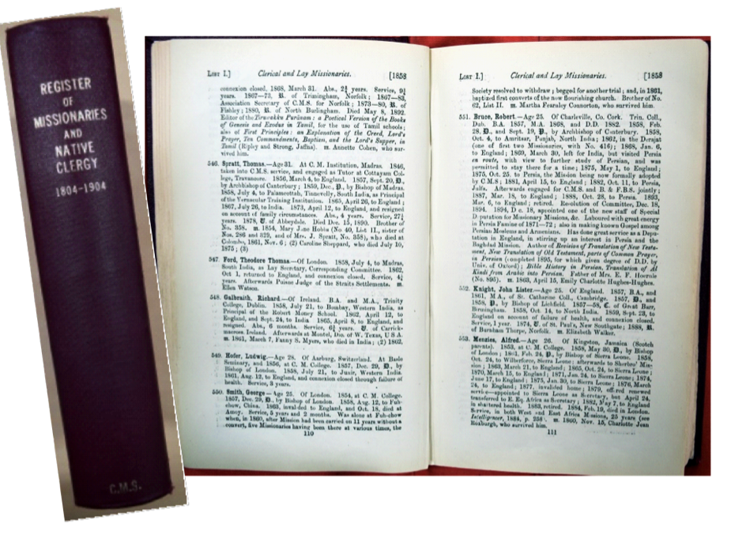

What are the registers of missionaries?

- The registers were compiled for private and confidential use by CMS headquarters.
- They are printed and manuscript lists of missionaries giving brief biographical and service details. They are a key source if you wish to find out about a CMS missionary who was accepted for service before 1929. They would also be of interest for demographic research.
- Male clerical and lay missionaries are listed separately to women missionaries and indigenous clergy (‘Native clergy’): List I, List II and List III respectively.
- Entries for women and indigenous clergy tend to be more limited in detail and there are no entries in the registers for indigenous clergy after about 1915.
- Details include:
- key life events (birth, marriage, retirement, death);
- training;
- dates overseas and when back on furlough in the UK;
- name of mission and mission station(s);
- published works;
- awards and other achievements.
- A key at the front of the register for 1804-1904 explains abbreviations used in the printed text.
- Registers for missionaries recruited 1804-1918 have been microfilmed: ‘CMS Archive: Section III: Central Records’ (Adam Matthew Publications, 1998).
- Digital copies of the registers for missionaries recruited 1804-1928 are available online through Adam Matthew Digital in the collection titled: ‘Church Missionary Society periodicals: Module I’.

Using the registers: missionaries recruited 1804-1928

- The registers have not been catalogued.
- Cadbury Research Library holds an archive set of registers for missionaries recruited 1804-1918, one non-archive hard-back copy of the 1804-1904 register and microfilm and digital copies of registers for missionaries recruited 1804-1928.
- To preserve this very heavily used resource, the archive set of registers is not made available for research. You will be able to use the non-archive hard-back copy, the microfilm or digital copies available online through the Adam Matthew Digital website.
- The microfilm reels and non-archive copy must not be taken out of the Library but there is no need to complete a request slip. You will be able to take them off the reference shelf and out of the microfilm drawers in Cadbury Research Library Microfilm Room.
- For missionaries recruited 1804-1904, use any of the three options.
- For missionaries recruited 1905-1918, use the microfilm or online copies.
- For missionaries recruited 1918-1928, use online copies.
- For indigenous clergy who joined a mission after 1904, options are more limited. You will have to use the microfilm copies of the manuscript registers of ‘Native Clergy’ for 1905-1918. An alternative source supplying much the same information for indigenous clergy beyond the date range of the registers can be found in the records of the Editorial Secretary (Catalogue to the Papers of the Home Division).

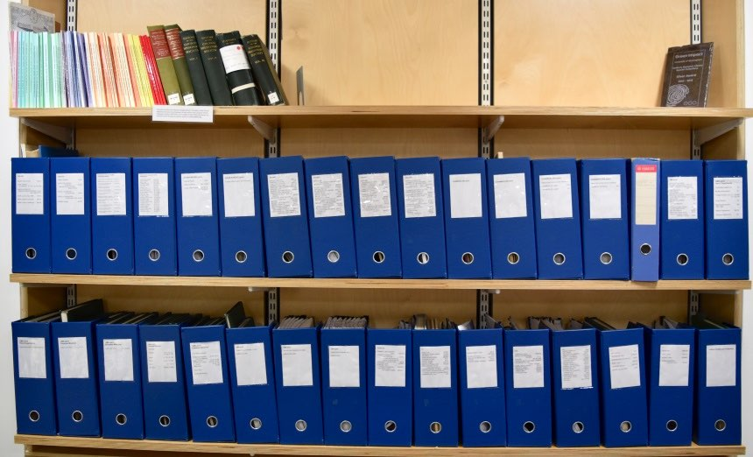

Missionaries recruited 1804-1904: hardback register

- This hardback volume is shelved with the paper copies of finding aids to the CMS Archive in Cadbury Research Library Reading Room.
- Use the indexes at the back of the volume to find the entry for the person in whom you are interested. Keep a note of the missionary’s number in the register, for example, List I number 1189. This will help if you decide to then check the microfilm or online copy of the register for the same date.
- The microfilm and digital copies of the registers were made using a set that has been retained by the Church Mission Society in Oxford. They have a slightly different format and benefit from being heavily annotated so give more detail than can be found in this reference copy.

Missionaries recruited 1804-1918: microfilm copies of the registers

- The microfilmed copies are arranged as CMS Register of Missionaries for 1804-1904 (annotated), additional registers 1804-1904 and manuscript registers 1905-1918.
- Entries are arranged in three Lists: List I: ‘Male clerical and lay missionaries’; List II: Women; List III: ‘Native Clergy’ [indigenous clergy].
- The manuscript Registers of Native Clergy 1905 – c 1915 are accompanied by a separate index volume.
- In Cadbury Research Library the microfilm reels are held in drawer D6.

Missionaries recruited 1804-1928: online copies of the registers

The online copies are arranged as:

- ‘Register of Missionaries (Clerical, Lay and Female), and Native Clergy, 1804-1904: Part I’.
This is a copy of an annotated printed volume with entries for List I, List II and
List III missionaries accepted 1804-1894. Indexes for each List are printed at the
end of the volume.

- ‘Register of Missionaries (clerical, lay and female), and native clergy, 1804-1904: Part II’.
This is a copy of an annotated printed volume with entries for List I, List II and List III missionaries accepted 1895-1904. Indexes for each List are printed at the
end of the volume.

- Manuscript registers for clerical and lay missionaries and women, 1905-1918.
There are four volumes arranged alphabetically, with entries for List 1 and List II
missionaries only:

  - Register of Missionaries 1905-1918: Men [List I] A-K
  - Register of Missionaries 1905-1918: Men [List I] L-Z
  - Register of Missionaries 1905-1918: Women [List II] A-K
  - Register of Missionaries 1905-1918: Women [List II] L-Z

- Manuscript registers for clerical and lay missionaries and women, 1919-1928.
There are eight volumes arranged by List and thereunder chronologically. The
entries are for List I and List II missionaries only:

  - Register of Missionaries 1919-1922: List I
  - Register of Missionaries 1923-1925: List I
  - Register of Missionaries 1926-1928: List I
  - Register of Missionaries 1919-1920: List II
  - Register of Missionaries 1921-1922: List II
  - Register of Missionaries 1923-1924: List II
  - Register of Missionaries 1925-1926: List II
  - Register of Missionaries 1927-1928: List II

Access to online copies: members of the University of Birmingham

- Members of the University of Birmingham have free access to the digitised copies of the registers whether on or off campus.
- Sign in to FindIt@bham, select Database Search and then ‘Church Missionary Society Periodicals’.

Access to online copies: if you are not a member of the University of Birmingham

- There are three possible options.
- You will be able to see the online copies when using the computers in Cadbury Research Library.
- If you are a member of an institution which subscribes to Adam Matthew Digital products, or if you can visit a subscribing institution, you may have access through them.
- You may be able to request a free trial from Adam Matthew Digital.

Missionaries recruited after 1928

- There are different types of records in the Archive which can provide information about a missionary’s life before, during and in some cases, after their service with CMS.
- Suggestions are given later in this Guide under ‘How to find records about a missionary’.

Annual Report 1801-1962 (‘Proceedings’ 1801-1921)

What is the Annual Report?

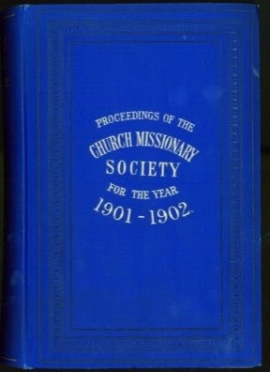
- Whatever your reason for looking at records in the Church Missionary Society Archive, it is worth considering the Annual Report, the most important of the Society’s periodicals. You will find information on all aspects of work in the UK (the ‘home’ side) and overseas, including reference to the wider socio-political context impacting on developments, lists of CMS missions and missionaries.
- Circulated under three titles:
  - ‘Proceedings of the Society for Missions to Africa and the East’ 1801;
  - ‘Proceedings of the Church Missionary Society for Africa and the East’ 1802-1921;
  - ‘Annual Report of the Committee of the Church Missionary Society for Africa and the East’ 1922-1961.
- The first volumes have detailed remarks about the earliest missionaries, the evolving missionary enterprise and names of prospective candidates. Contents vary over time but typically include:
  - Annual Report of the Committee;
  - text of the Annual Sermon;
  - statistics;
  - lists of all of the Society’s missions and mission stations;
  - lists of missionaries, business agents, ‘native’ clergymen and wives of European missionaries;
  - names of European labourers, including missionaries and others, arranged by mission station and thereunder broadly in date order from 1813 onwards;
  - marriages, births and names of missionaries who had died over the year;
  - summary history and report on the work of each mission for the year;
  - lists of Secretaries, Officers, Staff, Governors and honorary members;
  - abstracts of expenditure;
  - financial statements;
  - financial contributions.
- The lists of missionaries arranged by mission give:
  - year when the missionary first sailed or started work in the field;
  - date of ordination;
  - name of college;
  - source of funding;
  - notes identifying missionaries whose offers of service were accepted by the CMS representative in the mission rather than by CMS headquarters;
  - maiden names of wives of European missionaries, etc.
- Many volumes include an ‘Index of Special Topics’. This is particularly helpful if you are interested in different branches of mission work or the welfare of those who went overseas with CMS. Topics vary over time but include education, work among women, promotion of industry and civiliation, literary and translational work, difficulties and trials of missionary warfare.
- Many volumes have fold-out maps showing mission stations.
- The detailed reports of work in each mission become much less detailed over time but the volumes can be used alongside the highly informative ‘Historical Record’.

After 1962: successors to the Annual Report

- The Annual Report was replaced by the ‘CMS Year Book’ 1962-1980; this in turn became the ‘CMS Directory’ from 1981.
- The reports of work, sermons and detailed lists of benefactors which characterise the Proceedings and Annual Report are not present, but the Year Books are still helpful for research. They comprise annual lists of current CMS missionaries arranged by location and a list of CMS Secretaries, Officers and Staff.
- Use the Year Book alongside the ‘Historical Record’ which has detailed reports of mission work up to 1986.

How to find copies held in Cadbury Research Library

- The volumes are not listed in the online catalogue to the CMS archive.
- Depending on the dates needed, you will be able to consult a microfilm copy or the archived original. You will also have the choice to look at examples of non-archive reference copies of each of the titles.
- The microfilm reels and non-archive reference copies must not be taken out of the Library but there is no need to complete a request slip. You will be able to take them off the reference shelves and out of the microfilm drawers in Cadbury Research Library Microfilm Room, one volume or one reel at a time.

Proceedings 1801-1921

- Microfilm copies can be viewed in the Cadbury Research Library microfilm room; you will find them in microfilm drawers D10-E1.
Annual Report 1922-1961, Year Book 1962-1981 and Directory 1982-1986
- Archive copies can be requested in Cadbury Research Library Reading Room; you will need to fill in a request slip giving the title and year of volumes you wish to see.
Non-archive set of original volumes (miscellaneous copies)
- These copies of the Proceedings, Annual Report and Year Book duplicate volumes which are held in the CMS Archive or on microfilm.
- They are held on the reference shelves in Cadbury Research Library for anyone wishing to look at examples of a hard copy before proceeding to use the microfilm or archive set.
- They are not part of the CMS Archive. They were transferred from another of the University of Birmingham site libraries - the Orchard Learning and Resource Centre (OLRC).

Accessing online copies

- These volumes are not in the digital collections published by Adam Matthew Digital under the title ‘Research source: Church Missionary Society archive’ or ‘Church Missionary Society Periodicals’.
- Digitised copies of selected issues of Proceedings for 1817/18-1876/77 are available through the Hathi Trust digital library. By searching the internet, you may also find miscellaneous copies which have been digitised by other institutions.

CMS Historical Record 1919-1986

What is the Historical Record?

- These typescript volumes comprise detailed annual accounts of work in each of the Society’s missions. With lists of contents.
- They were written under three titles:
  - ‘General Review of Missions’ 1919;
  - ‘Annual Report’ 1922-1942 (not to be confused with the printed
Annual Report 1801-1962);
  - ‘Historical Record’ 1943-1986

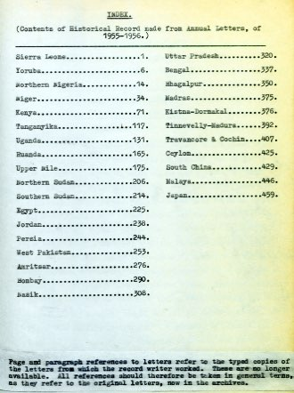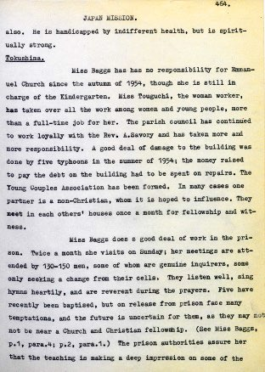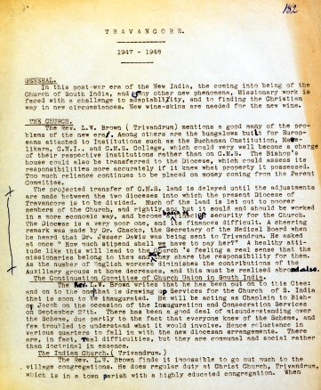

‘Historical Record’ 1955-1956 ‘Historical Record’ 1947

Why use the Historical Record?

- The volumes are a highly informative and accessible source with much on different branches of mission work, including references to named educational and medical institutions.
- They are particularly important if you are looking for news of individual missionaries and first-hand accounts of work in the missions 1960-1986 as they are largely based on the missionaries’ Annual Letters/Link Letters, the originals of which are only open for research up to 1959.

How to find the copies held in Cadbury Research Library

- The volumes are not listed in the online catalogue to the CMS archive.
- Each volume covers all of the Society’s missions so you will just need to find the volume covering the year(s) in which you are interested.
- All of the volumes have been microfilmed and digitised. To preserve this heavily used resource you will need to consult these copies rather than the originals.
- You will not need to complete a request slip.

Using microfilm copies

- All of the volumes have been micro-published under the title ‘Church Missionary Society Archive: Central Records: part 11’ (Adam Matthew Publications, 1998).
- In Cadbury Research Library the reels are held in microfilm drawer D8.
- Reels must not be taken out of the Library. You will be able to self-serve one reel at a time.

Accessing online copies

- All of the volumes have been digitised by Adam Matthew Digital. They are available online as part of the Adam Matthew Digital collection ‘Church Missionary Society Periodicals’.
- When you visit Cadbury Research Library you will be able use the computers in the Reading Room to access the digitised copies. You may also have off site access.
- To look across the whole date range you will need to search under all three titles.

CMS Overseas (Foreign) Division 1799-1959: an overview

- The Overseas Division (or Foreign Division) refers to the work of the committees at CMS headquarters that were responsible initially for administration of the Society’s overseas work and later, as local churches developed and themselves administered the work, dealt with most of the day-to-day correspondence between CMS headquarters and the churches and other bodies overseas.
- The papers include the main sequences of correspondence between CMS headquarters and the overseas missions known as the mission series or overseas mission series. They are the most heavily used of all of the CMS records and are important for understanding the work of CMS overseas and the experiences and observations of the men and women who worked there.
- When using the CMS Archive it is useful to know a little bit about the committees of this Division, what type of records were kept by the committees, how the records are arranged in the Archive and why they might be of interest. An overview of each of these is given below. This will help you to find and understand records relevant to your research. However, if you prefer, staff in Cadbury Research Library will be happy to help when you visit.

Committees of the Overseas (Foreign) Division

- A number of different committees administered the Overseas Division between 1799 and 1959. Up to 1880, there was one committee responsible for work in all mission areas - the Committee of Correspondence (later became the ‘Foreign Committee’). Between 1880 and 1957, the work was largely divided between three sub-committees, so for example, the India missions corresponded with the Secretary to the Group 2 Committee (later the ‘West Asia Committee’) whilst the China Missions corresponded with the Group 1 Committee (later ‘East Asia Committee’). From 1957-1959, work was shared between two committees - the Africa and the Asia Committee.
- Several other departments of work whose records are held in the CMS Archive also came under the Overseas Division at least for part of their history. The Medical Department, the Candidates Department, the Women’s Department and the Educational Auxiliary had committees answerable to, or working closely with, the Committee of Correspondence and the Africa and Asia Committees. Historically they have been catalogued separately and they are not discussed in this section of the Guide. The focus here is on work which over time evolved from the Committee of Correspondence to become the CMS Africa and Asia Departments.
- The names of the committees can be tricky. Some names changed over time. Also, the names do not necessarily match the geographical areas that a committee covered. For example, the New Zealand Mission was one of the missions of the Group 3 sub-committee which became the Africa Committee.
- Within the Archive there are different sets of papers for each committee. There are also some papers which cut across the work of two or more committees, for example, the General Groups archives.
- The records currently available for consultation in the Library are arranged as:
  - Committee of Correspondence archives, 1799-1880;
  - East Asia (Group 1) Committee archives, 1880-1957
  - West Asia (Group 2) Committee archives 1880-1957;
  - Africa (Group 3) Committee archives 1881-1959;
  - Asia Committee archives 1957-1959;
  - General Groups archives;
  - Africa/Asia archives
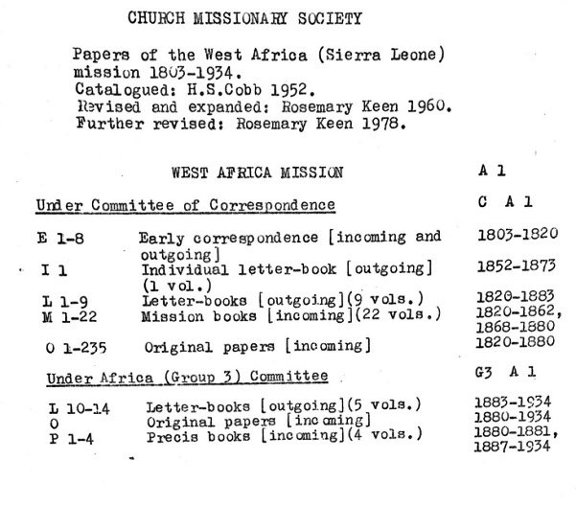
- You may need to search different parts of the Archive. For example, if you are looking for records of a missionary who worked in West Africa from 1876-1890 you will need to look at the Africa mission papers kept under the Committee of Correspondence and Africa mission papers kept under the Africa (Group 3) Committee. The image below is the contents page from the typescript catalogue to the papers of the West Africa Mission. Records compiled under the Committee of Correspondence are listed first followed by records compiled under the Group Committee. There is an equivalent entry in the online catalogue.

Type of records in the papers of the Overseas (Foreign) Division

- Records fall into two broad categories: the mission series and the general series.

Mission series

- The majority of records are arranged by individual mission. For example, up to 1880 the Society had six missions in Africa - the West Africa, Yoruba, Niger, East Africa, South Africa and Nyanza Missions - and there are separate series of papers for each of these in the papers of the Committee of Correspondence.
- In the online catalogue these are referred to as the ‘Overseas Mission Series’
- There is more information in this Guide about the type of records you will find in the mission series. See under Records in the Overseas Mission Series, Letter-books, Mission Books, Original Papers, Précis Books and Annual Letters.

General series

- This series refers to records of work which was not specific to an individual mission, for example, minutes of meetings of the Africa Committee.

Reasons for using papers of the Overseas (Foreign) Division

Interest in the work of any of the overseas missions up to 1959.

Interest in correspondence between CMS, the national churches and dioceses overseas up to 1959.

- Interest in the role played by committees at CMS headquarters which had day-to-day responsibility for administering and advancing the overseas side of work including corresponding with the mission secretaries who worked overseas.
- Interest in in-house or external issues likely to be affecting CMS work overseas, such as staffing, finance, political, socio-cultural or environmental events.

Finding Aids for searching papers of the Overseas (Foreign) Division

- There are 22 handlists for searching the papers of the Overseas Division 1799-1959. If you are interested in the mission series for records dating from before 1935 you will also be able to use the online catalogue to the CMS Archive.
- Guidance on choosing and using finding aids is given in this Guide under Finding aids for papers of the Overseas Division.

Records in the overseas mission series 1803-1959

- This section of the Guide gives detailed information about the most extensive series of records kept at CMS headquarters by the committees of the Overseas (Foreign) Division: the record series kept for each of the Society’s missions.
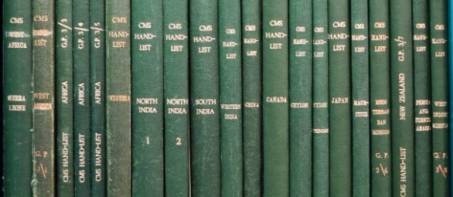

‘Incoming’ and ‘outgoing’ correspondence

- Papers in the mission series include correspondence sent to CMS headquarters from the mission and copies of correspondence sent from headquarters to the mission. They are referred to as ‘incoming’ and ‘outgoing’ correspondence respectively.
- Records vary over time and from mission to mission but incoming correspondence may include letters, minutes, reports, local publications, finance statements, personal journals, sketches (rare) and Annual Letters.
Changes over time
- Records currently available for research extend across the years when the overseas work was administered by the Committee of Correspondence 1803-1880, the East Asia (Group 1) Committee, West Asia (Group 2) Committee and the Africa (Group 3) Committee 1880-1957 and the first years of work being shared between the Africa Committee and the Asia Committee 1957-1959.
- Administrative changes are important if you are searching for papers over an extended period of time. For example, if you are interested in a missionary who worked with the Yoruba mission 1875-1892, up to 1880 you will be able to look for a file in their name in the papers of the Committee of Correspondence; after 1880 you will need to search for materials of interest using the Précis Books in the papers of the Group 3 Committee.
- There are three key time periods to be aware of: 1799-1880, 1880-1934 and 1935-1959. These date ranges are marked by changes in the type of records which were kept and the way in which the records are arranged.
- Between 1803 and 1880 the records are arranged as:
  - Early correspondence 1803-1820;
  - Individual Letter-books 1852-c 1880;
  - Letter-books 1820-1880;
  - Mission Books 1820-1880;
  - Original Papers 1820-1880.
- Between 1880 and 1934 the records are arranged as:
  - Letter-books 1880-1934;
  - Original Papers 1880-1934;
  - Précis Books 1880-1934.
- From 1935-1959 the records are arranged as:
  - [Correspondence with the mission secretary];
  - Dioceses;
  - Education (including material relating to CMS bookshops);
  - General;
  - Medical.

Archive finding numbers for records in the mission series

- Understanding the finding numbers makes it easier to use the finding aids.
- After the collection reference (‘CMS’), the finding numbers are broadly made up of three parts.
- For example: G3 A2 L10.
- The first part tells us the committee at CMS headquarters; in this instance, ‘G3’ for records kept under the Group 3 Committee.
- The next part of the finding number is the unique mission reference; in this instance, ‘A2’ for Yoruba Mission.
- The end of the finding number indicates the type of record: for example, ‘L’ for Letter-book or ‘O’ for Original Papers followed by a volume number or year.
- When using the online catalogue to search the overseas mission series 1803-1934, you will find the finding numbers for this series of records all prefixed by the letters ‘CMS/B/OMS’. So the archive finding number G3 A2 L10 in the handlist is entered in the online catalogue as: CMS/B/OMS/G3 A2 L10.

Is all the correspondence which missions sent to CMS headquarters kept in the mission series?

- The mission series refer to the most extensive, but not the only, series of papers kept by the committees of the Overseas Division. Some of the mission correspondence which arrived at CMS headquarters is filed with papers relating to more than one mission held in the Archive as the general series.
- Other departments of work at CMS headquarters corresponded with the missions so you will also find correspondence to and from mission personnel in the records of those departments, for example, the General Secretary’s Department.
- When the files were still in active use by CMS, sometimes papers from the mission series were transferred to another department. For example, if they were needed by the Finance Department. As some papers were never returned, you will find them filed in with the records of the receiving department.
- For some records, such as the missionaries’ Annual Letters, you may need to use several record series to find everything you are looking for.

Letter-books

- There are Letter-books in the records of different departments of work at CMS headquarters.
- Within the papers of the CMS Overseas (Foreign) Division, there are separate Letter-books for each of the overseas missions including Letter-books kept under the Committee of Correspondence 1820-1880 and Letter-books kept under the Group Committees 1880-1934.
- Some have been microfilmed and digitised.

What are the Letter-books in the overseas mission series?

- Letter-books are hard back volumes in which were kept copies of letters which the Secretaries at CMS headquarters wrote on behalf of the Committees. Most have indexes.
- The Letter-books in the mission series comprise copies of the correspondence sent out from CMS headquarters to missionaries and others concerned with mission affairs. In other words, the ‘outgoing’ mission correspondence.
- Many of the letters are addressed to the Mission Secretary working overseas but the correspondence includes much about individual missionaries.
- If you find an entry in the name index, it might refer to a letter addressed to that person but might also refer to a letter about them.
- From 1890, some letters are marked in red ink with cross-references to minutes of the local committee which administered the work of the mission from overseas. This committee was known as ‘the Corresponding Committee’ - it should not be confused with the ‘Committee of Correspondence’ which administered the work of the overseas missions from CMS headquarters in the UK.

Individual Letter-books in the mission series

- Between the 1850s and c 1880, some of the Secretaries at CMS headquarters kept separate volumes for their private and confidential letters to individual missionaries. These are catalogued as the ‘Individual letter-books’.
- Most of these volumes contain not only personal letters, such as those of condolence or censure, but, for some Secretaries, letters on topics in which they had a special interest.

How to find Letter-books in the overseas mission series

Archive finding numbers: the letters ‘L’ and ‘I’ are used to denote Letter-books and Individual letter-books.

- Use the online archive catalogue or whichever of the typescript handlists to the mission series is relevant to your search.
- If you are interested in letters written before 1881, you will find Letter-books towards the front of the handlists and prefixed ‘C’ (or CMS/B/OMS/C in the online catalogue).
- If you are interested in letters written 1881-1934, look for Letter-Books prefixed G1, G2 or G3 (or CMS/B/OMS G1 etc in the online catalogue).
- In the example below, two images show summary contents of the papers of the West Africa mission as they appear in online catalogue (top) and at the front of the equivalent typescript handlist (bottom). Arrows point to the Letter-books compiled under the Committee of Correspondence and under the Africa (Group 3) Committee. Alternatively follow the link to see this example in the online catalogue.
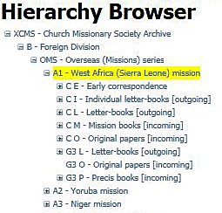

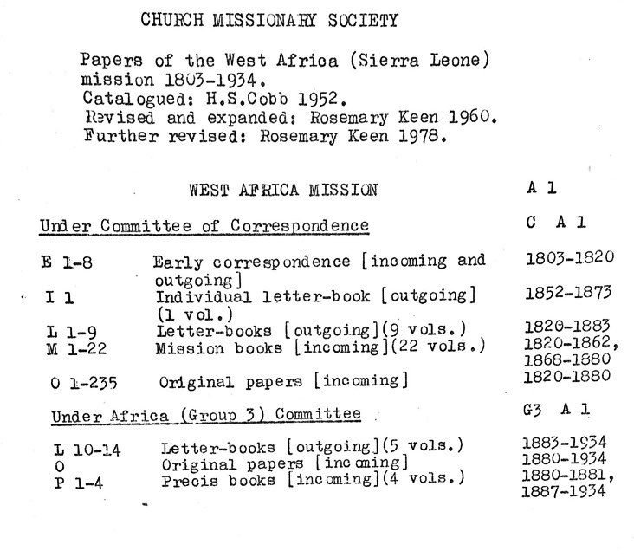

Online copies of the Letter-books

- If the Letter-books for the mission and dates that you are interested in have been digitised, when you visit Cadbury Research Library you will be able to find entries in the Letter-books by searching the website of Adam Matthew Digital. Look for the collection titled: 'Research Source - Church Missionary Society Archive’.
- You may also have off site access to Adam Matthew Digital Collections.

Handling the Letter-books

- The paper in the Letter-books is very fragile.
- Where a microfilm or digital copy of a Letter-book is not available, you will need to consult the original volume. It is important to handle each page very gently and slowly to preserve the papers in the best possible condition.

Mission Books

- Within the papers of the CMS Overseas (Foreign) Division, there are separate Mission Books for each of the overseas missions.
- They are one of the types of record compiled at CMS headquarters under the Committee of Correspondence. They were kept between 1820 and 1880.
- Some have been microfilmed and digitised.
- Most researchers interested in mission correspondence sent to headquarters 1820-1880 choose to use either the Mission Books or the Original Papers.
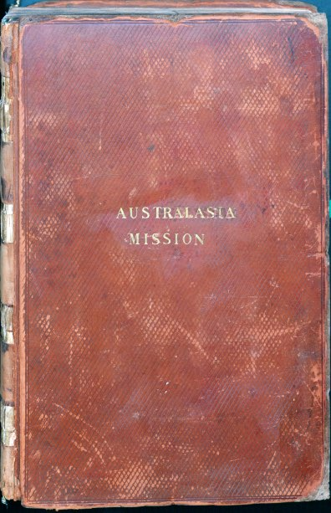
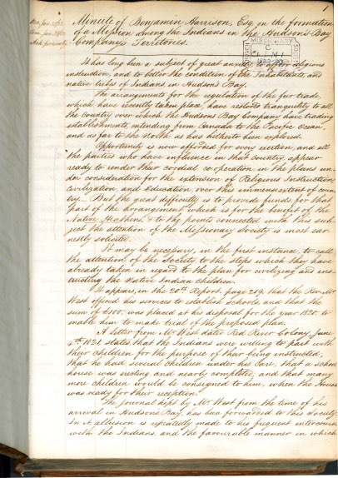
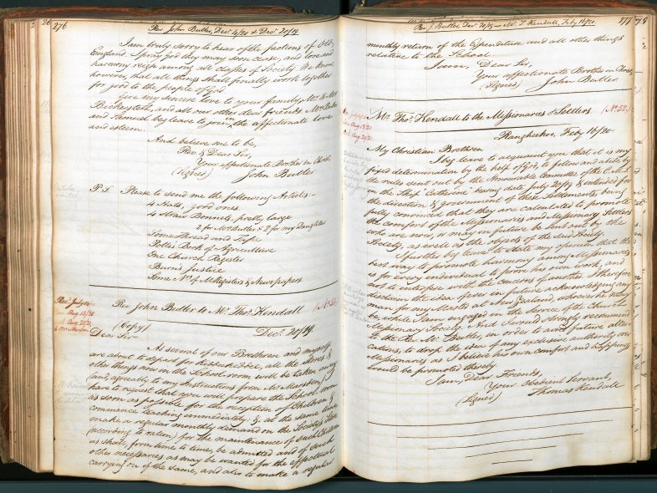

Mission Books: New Zealand Mission and North West America Mission (finding numbers: CMS/C N M1 and CMS/C C1 M1)

What are the Mission Books in the overseas mission series?

- Mission Books are hard back volumes in which staff at CMS headquarters kept office copies of the ‘incoming’ mission correspondence.
- When correspondence from the missions arrived at CMS headquarters (correspondence now held as the ‘Original Papers’) it was copied into Mission Books to provide a legible working copy for use by the Committee.
- From the 1860s the Original Papers are numbered, usually in red ink. The numbers in the Mission Book correspond with these numbers.

Why choose Mission Books instead of using the Original Papers?

- The indexes and uniformly legible script mean the Mission Books are now useful for research.
- Occasionally a Mission Book copy of an item of correspondence survives where the original document is missing from the Archive.
- Consider the Mission Books if you are interested in records dating from before 1881 and prefer to search papers arranged chronologically.

Was every document copied into the Mission Books?

- The type of correspondence copied out in full changed over time.
- Initially, all the letters and the missionaries’ journals were copied in to the Mission Books; finance papers were not copied out but a brief note was made recording that they had been received. From 1849, only the letters were copied in full.
- In the 1870s, copies of the missionaries’ Annual Letters were written or pasted in to the back of the Mission Books.

How to find Mission Books in the overseas mission series

Archive finding numbers: the letter ‘M’ is used to denote Mission Books.

- Use the online archive catalogue or whichever of the typescript handlists to the mission series is relevant to your search.
- As the Mission Books were kept under the Committee of Correspondence, if you are using the handlists, you will find them towards the front and prefixed ‘C’ (or CMS/B/OMS/C if you are using the online catalogue).
- This is illustrated below using the catalogue of the West Africa Mission papers as an example. The image on the left is the online catalogue (hierarchy view) and on the right is the contents page at the front of the typescript handlist.

Online copies of the Mission Books

- If the Mission Books for the area and dates that you are interested in have been digitised, when you visit Cadbury Research Library you will be able to find them by searching on the website of Adam Matthew Digital. You will find them in the collection titled: 'Research Source - Church Missionary Society Archive’.
- You may also have off site access to Adam Matthew Digital Collections.

Gaps in the Mission Books

- As some records were not copied out in full, you may wish to consult other record sequences, particularly the Original Papers, to follow up items of particular interest.

Original Papers

- Within the papers of the CMS Overseas (Foreign) Division, there are separate series of Original Papers for each of the overseas missions, including Original Papers kept under the Committee of Correspondence 1820-1880 and Original Papers kept under the Group Committees 1880-1934.
- The majority of letters and journals written by the Society’s missionaries can be found in the Original Papers and they are probably the most frequently consulted records across the whole of the CMS Archive.
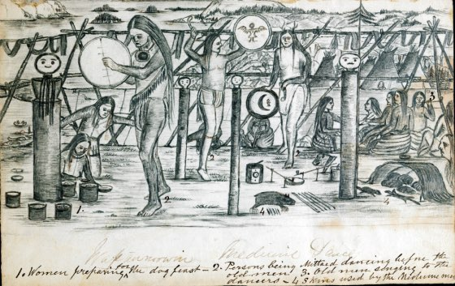
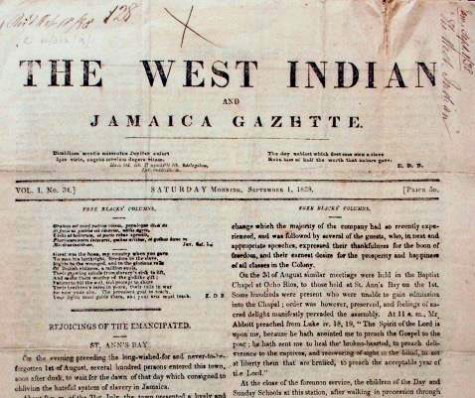
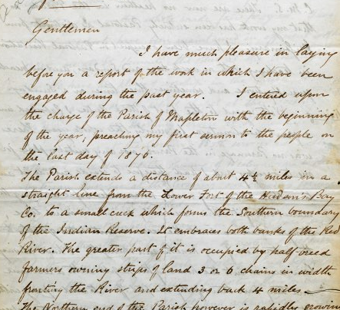
- Some have been microfilmed and digitised.

Correspondence in the Canada and West Indies Mission files (CMS/C C1 O20-21; C W O12/9/1)

What are Original Papers in the overseas mission series?

- ‘Original Papers’ is the term used for all the ‘incoming’ mission correspondence sent to CMS headquarters by the mission secretaries working overseas. This includes thousands of letters written by missionaries and others (occasionally sent directly but mostly through the secretary).
- The correspondence mainly consists of letters, journals and reports. There are also minutes and papers of local CMS committees and other printed papers.
- When the correspondence arrived at CMS headquarters, it was marked with the date of receipt and sometimes a date of answer and/or date on which the committee dealt with them. If you are looking at papers received between 1820 and 1880, you will find that many of them have also been numbered in red ink recording the order they arrived at headquarters and some are initialled by the Secretary who read or dealt with them.

How are the Original Papers arranged?

- The papers are packaged in folders.
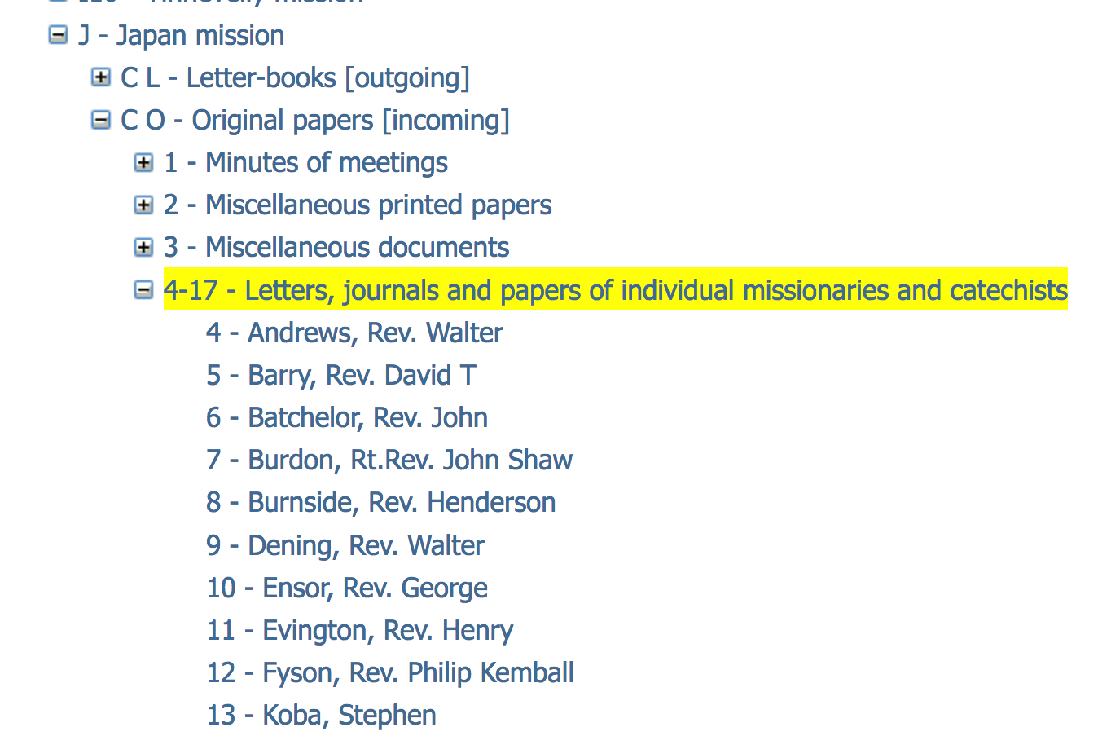
- For papers dated 1820-1880, similar items can be found filed together. For example, correspondence from bishops, education papers, minutes of local CMS conferences, etc. Letters from individual missionaries are filed together under the missionary’s name; in the handlists and online catalogue you will find them at the end of the Original Papers in a sequence titled ‘Letters, journals and papers of individual missionaries and catechists. The illustration shows part of the online catalogue to the papers of the Japan Mission (Hierarchy view).

- From 1880-1934, the papers are arranged in a single chronological sequence for each mission. Papers of a particular type, or relating to a particular individual, are interspersed amongst other papers received in the same year. Individuals are not listed by name in the catalogue.

Copies of Original Papers 1820-1880

- During the years when the work of the Foreign Division was administered by the Committee of Correspondence, the clerks at CMS headquarters copied the letters, and many of the other items of correspondence into Mission Books so that the Committee had a legible working copy. Most researchers interested in incoming correspondence of this date choose to consult either the Original Papers or the Mission Book copies.

Summaries of Original Papers 1880-1934

- Between 1880 and 1934, when work was divided amongst the East Asia (Group 1) Committee, the West Asia (Group 2) Committee and the Africa (Group 3) Committee, summaries of the Original Papers were made for meetings of the committees and copied or pasted into Précis Books. Most researchers consulting the Original Papers of this date use them alongside the Précis Books.

How to find Original Papers in the mission series 1803-1934

Archive finding numbers: the letter ‘O’ is are used to denote Original Papers.

- Use the online archive catalogue or whichever of the typescript handlists to the mission series is relevant to your search.
- For records compiled 1880-1934, there is very little detail in the catalogue. If you are interested in a particular year you may wish to look through all of the file (or files) for that year. Otherwise use the Précis Books to find records of interest.
- Illustrations below show summary contents of the papers of the West Africa Mission as they appear in online catalogue (top) and at the front of the equivalent typescript handlist (bottom). Arrows point to the Letter-books compiled under the Committee of Correspondence and under the Africa (Group 3) Committee. Alternatively follow the link to see this example in the online catalogue.

How to find correspondence sent from the missions after 1934

- The incoming mission correspondence for 1935-1959 is listed separately. You will need to use the typescript Catalogue of the papers of the Overseas Division 1935-1959.

How to find all the incoming mission correspondence for a particular year

- Papers dating from before 1880: the quickest way to find all the incoming papers for a particular time period is to use the Mission Books instead of the Original Papers.
- Papers dated 1880-1934: the Original Papers are filed chronologically by date of receipt so once you have identified the archive reference for the mission in which you are interested, you will be able to request files by giving the reference and the year. For example:
CMS/G3/A1/O 1904 for West Africa Mission Original Papers for the year 1904.
CMS/G3/A1/O 1889 for West Africa Mission Original Papers for the year 1889.
- Further guidance on finding numbers is given in the catalogue and in this Guide under: Archive finding numbers for records in the overseas mission series.

Online copies of the Original Papers

- If the Original Papers that you are interested in have been digitised, when you visit Cadbury Research Library you will be able to find items of interest by searching the website of Adam Matthew Digital. Look for the collection titled: 'Research Source - Church Missionary Society Archive’.
- You may also have off site access.
- Being able to search online is especially helpful for records dated 1880-1934 when very little detail is given in the catalogue and papers are arranged in annual files rather than similar items being filed together.
- Information about Adam Matthew Digital products is given at the end of this Guide under ‘Microfilm and digital copies of material from the CMS Archive’.

Précis Books

- Within the papers of the CMS Overseas (Foreign) Division, there are separate Précis Books for each of the overseas missions. There are also Précis Books in the general series with entries covering more than one mission area.
- Précis Books are one of the types of record used by the three committees at headquarters which administered the work of the Overseas (Foreign) Division 1880-1934.
- Some have been microfilmed and digitised.
- Most researchers use Précis Books before or alongside the Original Papers.

What are Précis Books in the mission series?

- Précis Books are hard back volumes in which were kept manuscript and typescript summaries of correspondence received from the missions.
- Between 1880 and 1934, when correspondence from one of the missions arrived at headquarters, it was filed in chronological order according to the date when it was received. This ‘incoming’ correspondence is held in the Archive as the ‘Original Papers’. A summary of each item of correspondence was prepared for meetings of whichever committee administered the work of that mission and a file copy of the summary was written or pasted into the Précis Book for that mission on the left-facing page.
- Each item entered in the Précis Book was given a running number. This same number is written in red ink on the corresponding item in the files of Original Papers. A new number sequence was started for each year.
- Committee decisions or action resulting from the discussion of the correspondence was entered into the Précis Book on the right-facing page.

Why use the Précis Books?

- Précis Books are a valuable record in themselves for the summaries of correspondence and related committee decisions.
- You may wish to use them as an index to find items of interest from amongst the hundreds of items of correspondence in the files of Original Papers.
- In some instances, you will find entries in the Précis Books where the original documents are no longer available.
- Those in the general series can fill gaps in the mission Précis Book sequences.

How to use Précis Books in the mission series

- You may choose to look at the Précis Books instead of, before, or alongside, the Original Papers.
- If you find a summary in the Précis Books of an item of correspondence which you want to read in full, use the item number in the far left-hand column and the year from the top of the page to work out the archive finding number for the corresponding document in the files of Original Papers.
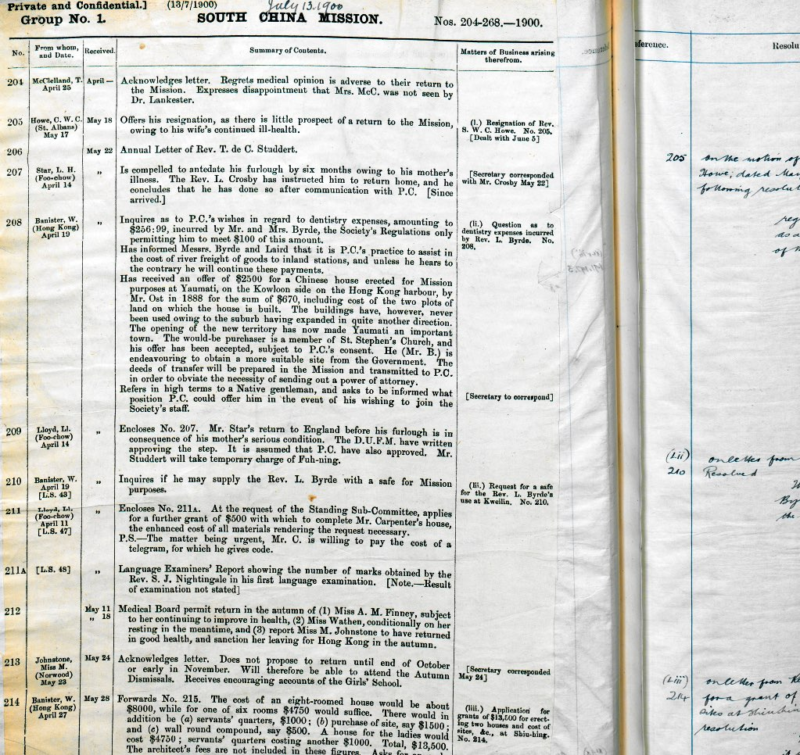

- The first part of the finding number will be the same for the Précis Books and the corresponding Original Papers. The reference is completed by simply replacing the P (for Précis Book) with O (for Original Papers) plus the year and item number. For example, the finding number for Précis Book 3 and item number 213 from the Original Papers in the South China Mission papers are respectively:
Precis Book: CMS/G1 CH1 P3
Original Papers for the year 1900, item 213: CMS/G1 CH1 O1900/213
- This example is shown in more detail on the next page. You may wish to skip this and go straight to what it means to see the Letter M in the margin of a Précis Book

Illustration of how to use a Précis Book to find an item in the Original Papers

- The first image below repeats that on the previous page. The left-hand page of Précis Book 3 from the South China Mission papers is marked with circles to show where the year 1900 is written at the top of the page and entry number 213 in the left-hand column. Keep in mind the year 1900 and number 213!
- The second image is a scan of the letter from the South China Mission Original Papers which corresponds with entry number 213 in the Précis Book.
- The original filing number which was written on to the letter when it arrived at CMS headquarters in 1900 can be seen at the top of the first page of the letter. This is 213 matching the entry for the same item in the left-hand column of the Précis Book.
- The number 213 plus the year 1900 form the end of the archive finding number for the letter: CMS/G1 CH1 O1900/213.

CMS/G1 CH1 P3

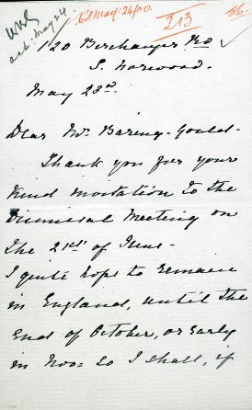
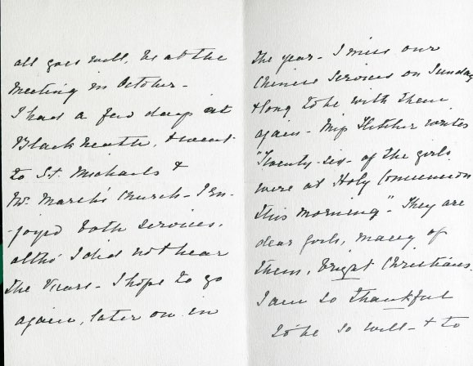
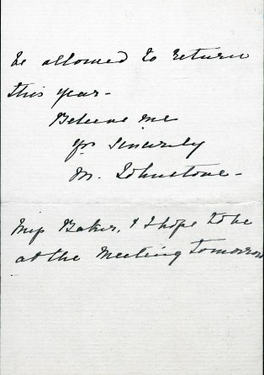

CMS/G1 CH1 O1900/213

Letter ‘M’ written in the margin of a Précis Book

- A pencilled ‘M’ indicates that you will not find the item in the corresponding sequence of Original Papers. The item is ‘Missing’ from the Original Papers because at some point when the records were still in use, it was extracted and filed elsewhere, or disposed of.
- Some of the ‘Missing’ items can now be found in the records of other CMS departments. For example, a number of papers in the records of the CMS Finance Department are annotated with clerk’s filing numbers showing that they were originally held in the overseas mission files. This is indicated in the catalogue to the records of that department by a reference to the original archive finding number.
- Where the item is a missionary’s Annual Letter, although the original can no longer be seen, edited versions can be found in the annual volumes of ‘Extracts from Missionaries Annual Letters …’ 1886-1912.

How to find Précis Books for the mission series

Archive finding numbers: the letter ‘P’ is used to denote Précis Books.

- Use the online archive catalogue or whichever of the typescript handlists to the mission series is relevant to the mission you are interested in.
- Précis Books are listed with records compiled under the East Asia (Group 1) Committee, West Asia (Group 2) Committee and Africa (Group 3) Committee with finding numbers prefixed G1, G2 or G3.
- The illustration below shows the Précis Books in the catalogue to the Papers of the West Africa Mission. The online version (Hierachy view) is to the left and typescript handlist (contents page) to the right. Alternatively use the online catalogue to the Papers of the West Africa Mission to see the same example.

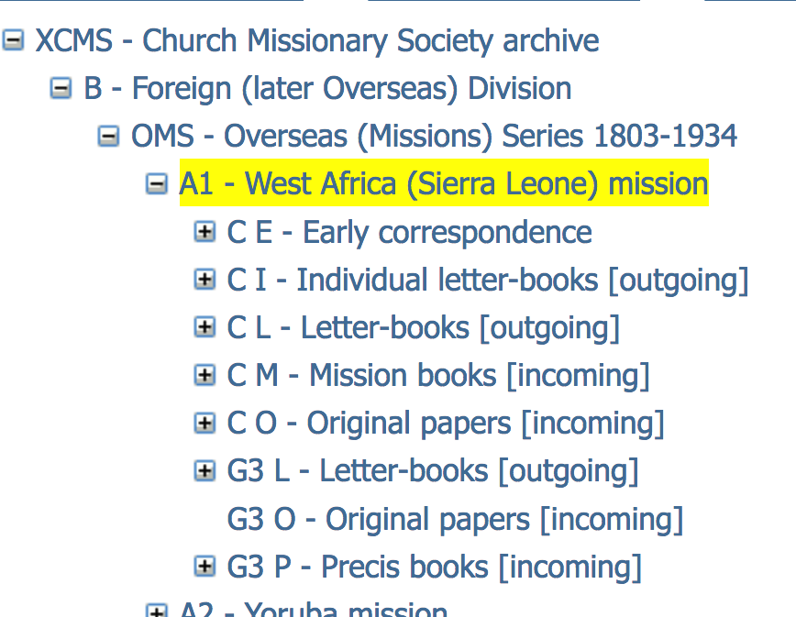

How to find Précis Books in the general series

- The volumes covering more than one mission are listed with the General Groups archives and Group 1, Group 2 and Group 3 archives in the Catalogue of the Papers of the Foreign Division 1799-1949.

Online copies of Précis Books

- If the Précis Books that you are interested in have been digitised, when you visit Cadbury Research Library you will be able to find items of interest by searching on the website of Adam Matthew Digital. The digital collection is titled: 'Research Source - Church Missionary Society Archive’.
- Information about how to access Adam Matthew Digital products is given at the end of this Guide under ‘Microfilm and digital copies of material from the CMS Archive’.

Annual Letters c 1850-1959

Overview

- Annual Letters are useful for anyone interested in missionaries, their work and life experiences overseas.
- Within the CMS Archive there are hundreds of original Annual Letters sent to CMS headquarters by the missionaries working overseas; there are also some printed volumes comprising edited copies of Annual Letters.
- Cadbury Research Library currently holds Annual Letters from c 1850-1959.
- Many have been microfilmed by Adam Matthew Publications and are available online through Adam Matthew Digital.
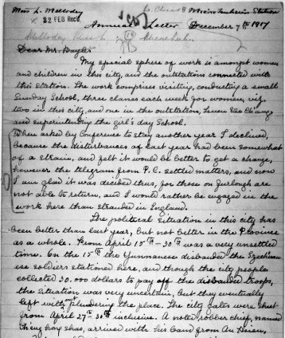
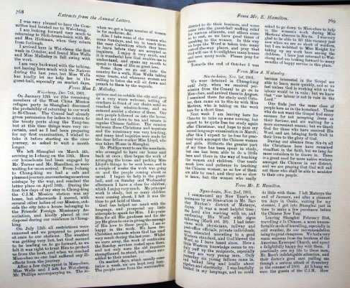

What are Annual Letters?

- From the 1850s to 1974, each year missionaries were expected to write a letter in which they reported their activities to the Secretary of the committee at CMS headquarters responsible for administering the work of the missions in their area. For example, missionaries working in China in the 1890s wrote their Annual Letters to the Secretary of the East Asia (Group 1) Committee.
- As well as news of mission work, they refer to things the missionary had seen or done, from practising the local language to being attacked by bandits.

- Although predominantly from CMS missionaries, there are Annual Letters from wives of missionaries and a few from missionaries working under other organisations including: the Church of England Zenana Missionary Society; Zenana Bible and Medical Mission; Indian Female Normal School Society and the New Zealand Church Missionary Association.
- Trying to find Annual Letters for a particular person can feel daunting because they are held in several different parts of the Archive. Details are given below but if you prefer, staff will be happy to help you when you visit.

Where in the CMS Archive are the Annual Letters?

- Annual Letters are one of the types of record you will find in the papers of the CMS Overseas (Foreign) Division. Some have been microfilmed and digitised.
- Within the CMS Archive there are also edited versions of Annual Letters which were compiled by the CMS Editorial Department and published as a series of pamphlets under the title ’Extracts from the Annual Letters of the Missionaries for the Year …’ 1886-1910 and ‘Letters from the Front’ 1911-1912. The Archive set are bound in annual volumes. All of these have been microfilmed and digitised.
- Earlier versions of ‘Extracts from the Annual Letters’ described above were issued as supplements to the CMS periodical ‘The Church Missionary Intelligencer’. Furthermore, over time Annual Letters came to be used as the foundation of the Annual Report and the Historical Record. It is often possible to find extracts of a missionary’s Annual Letters reproduced in these printed and typescript volumes. These sources can be useful if the original Annual Letter has not survived or the missionary’s handwriting is difficult to read! The ‘Church Missionary Intelligencer’ and Historical Record have been microfilmed and digitised. Early issues of the Annual Report when it was issued as the ‘Proceedings’ 1801-1921 are available on microfilm.
- There are a few Annual Letters in the CMS Unofficial Papers. These copies of Annual Letters have not been microfilmed or digitised.

What is in this section of the Guide?

- The focus here is on Annual Letters in the records of the Overseas (Foreign) Division and the printed series of ‘Extracts from the Annual Letters’ issued by the Editorial Department 1886-1912. Guidance on using the CMS Unofficial Papers, the Proceedings, the Historical Record and other periodicals is given elsewhere.

- First there are explanations of how to find Annual Letters for particular dates:
  - 1850s-1880;
  - 1881-1885;
  - 1886-1912;
  - 1913-1915;
  - 1916-1959;
  - 1960-1974.
- There is a list of archive finding numbers to use for Annual Letters 1916-1959;
- Finally there is information about online copies of Annual Letters.

Annual Letters 1850s to 1880

- Annual Letters for these dates are catalogued and filed with the Original Papers for the particular mission that they relate to.
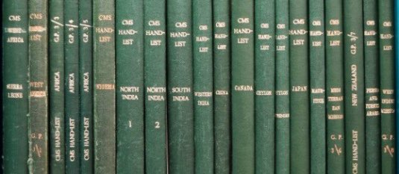
- Simply enter the name of the missionary into the online archive catalogue or use the typescript handlists to the mission series 1803-1934. Follow the steps below.

  - Step 1: find the handlist for the papers of the mission you are interested in.
  - Step 2: go to Original Papers under the Committee of Correspondence.
  - Step 3: go to ’Letters, journals and papers of individual missionaries and catechists’
  - Step 4: search for the name of the missionary: Annual Letters are grouped together within each missionary’s file as illustrated below.

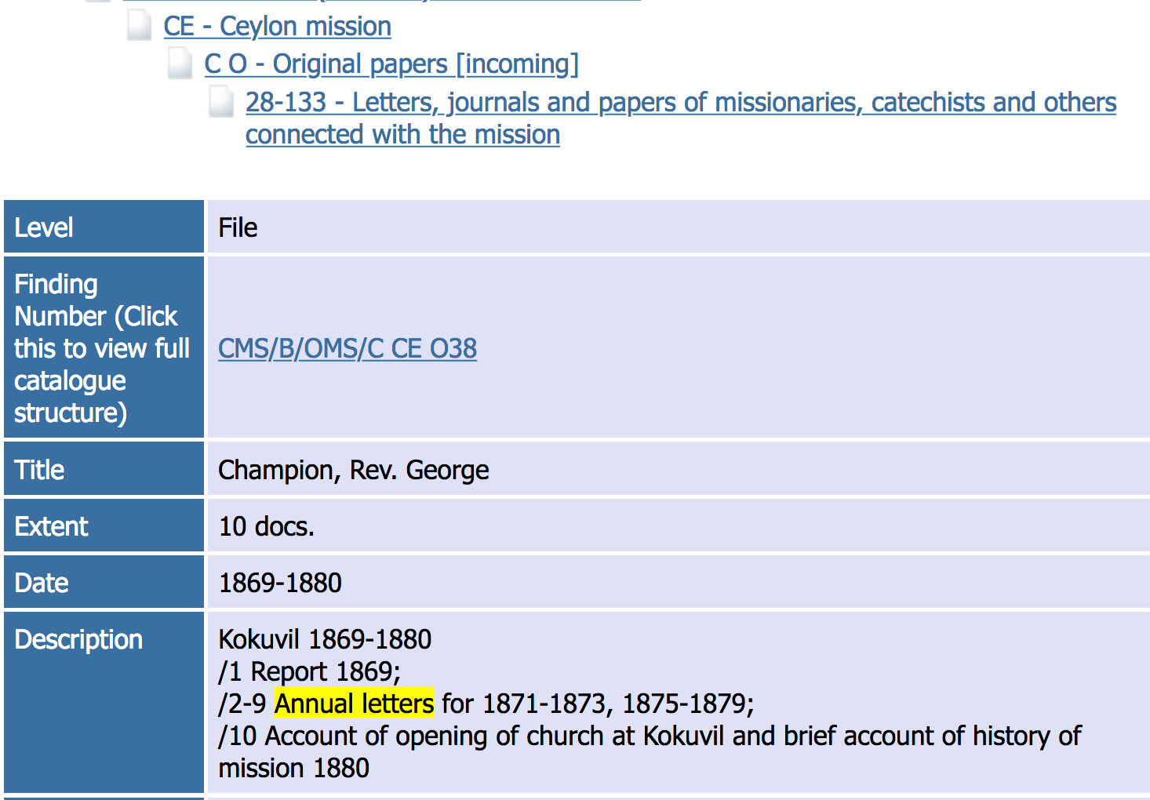

- From 1871 to 1879, you will also find Annual Letters copied in to the Mission Books. If you wish to look at these copies, use the online catalogue or the handlists to the mission series 1803-1934 as before this time look for Mission Books in the papers kept under the Committee of Correspondence.
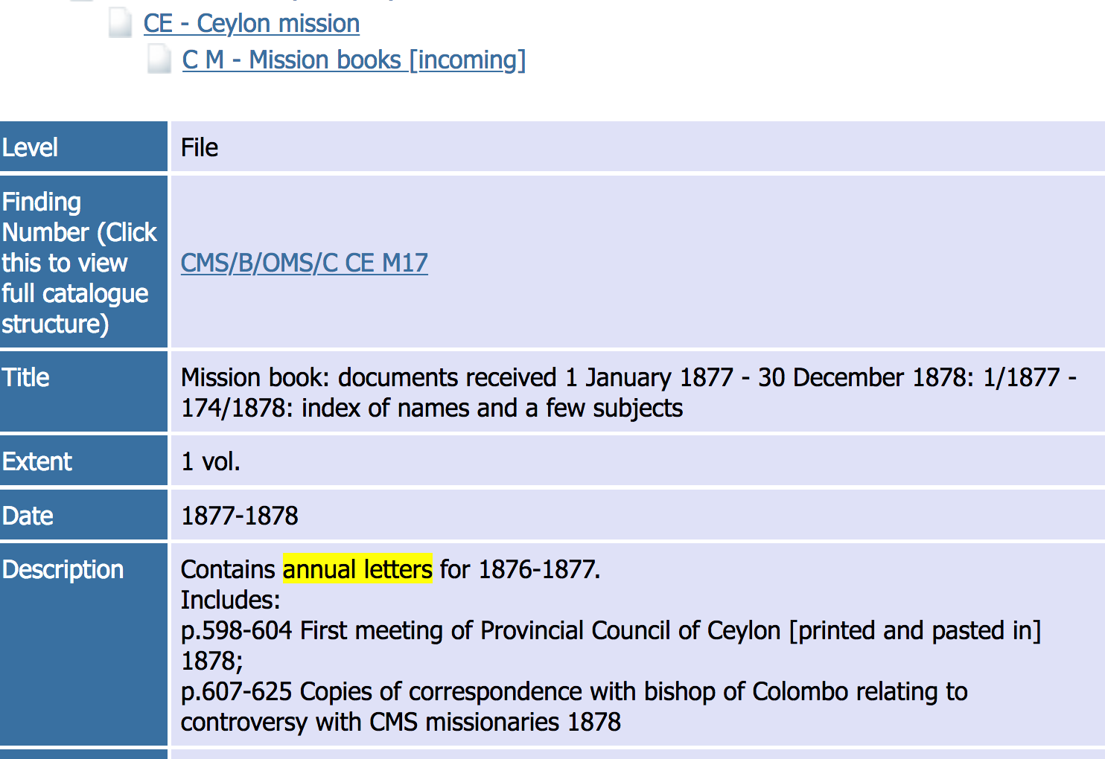

Annual Letters for 1881-1885

- Annual Letters continue to be filed with the Original Papers for the mission that they relate to. For this date range you will find them in the records kept by the three Group Committees.
- It is not possible to find Annual Letters for these dates by entering a missionary’s name in the Cadbury Research Library online catalogue or looking for their name in the handlist.
- You will need to visit the Library to search the records.
  - Step 1: use the online archive catalogue or the typescript handlists to the mission series 1803-1934 to find the Précis Books for the mission you are interested in.
  - Step 2: use the Précis Books to help you find Annual Letters.
- Alternatively, if the mission papers have been digitised and you can access Adam Matthew Digital Collections, you will be able to search online.

Annual Letters for 1886-1912

Printed extracts

- With a few exceptions there are no original Annual Letters for 1886-1912 in the Archive. It is necessary to consult the extracts published as ‘Extracts from the Annual Letters of the Missionaries for the year …’ 1886-1910 and ‘Letters from the Front’ 1911-1912.
- The volumes are not listed in the Catalogue to the CMS Archive but a two-part name index is attached to the online catalogue: index to extracts 1886-1904 (PDF 3.8 MB) and index to extracts 1905-1912 (PDF 2.1 MB). There are paper copies of the index in Cadbury Research Library Reading Room.
- Alternatively, if you can access Adam Matthew Digital Collections you will be able to find Annual Letters for particular individuals or places by searching online.
- Microfilm copies are available under the title: ‘Church Missionary Society Archive: Section III: Central Records: Part 4’ (Adam Matthew Publications, 1998). In Cadbury Research Library the reels are in microfilm drawer D7.

Surviving originals

- Any original Annual Letters for 1886-1912 which have survived will be in the mission series kept under the Group 1, Group 2 and Group 3 Committees.
- You will need to visit the Library to search the records.
  - Step 1: use the online archive catalogue or the typescript handlists to the mission series 1803-1934 to find the Précis Books for the mission you are interested in.
  - Step 2: use the Précis Books to help you find Annual Letters.
- Alternatively, if the mission papers have been digitised, and you are able to access Adam Matthew Digital Collections, you will be able to search online.

Annual Letters for 1913-1915

- No Annual Letters for these dates are held in the official archive. You may find some written in January 1913 but these report on the previous year’s work.
- Try looking for copies in the CMS Unofficial Papers or look for extracts published in the Proceedings and the Historical Record.

Annual Letters for 1916/1917-1959

- By 1916, there is a change in the way the Annual Letters are arranged. They are still held within the records of the Overseas (Foreign) Division but have moved from the mission series to the general series. You will not be able to find them by searching the papers of the mission you are interested in. The Annual Letters from different missions are grouped together.
- They are broadly arranged as:
  - Annual Letters for 1916/1917-1934;
  - Annual Letters for 1935-1939;
  - Annual Letters for 1940-1949;
  - Annual Letters for 1950-1959
- For each of these time periods, the Letters are grouped according to whichever of the Secretaries at headquarters administered work in that mission area and thereunder arranged alphabetically by surname of missionary.
For example, as the Group 1 (lEast Asia) Secretary worked with missions to China, Japan and Canada, when searching Annual Letters for a missionary who served in Japan between 1917 and 1934, you will find their Annual Letters in files which also hold Letters from missionaries to Canada and China.
- If you are not sure which of the Secretaries worked with the mission you are interested in, you will find this information in the finding aids to the mission series. Alternatively look under the lists of missions 1880-1934 and 1935-1959 given in this Guide under CMS missions 1804-1959. You will need this information to decide which finding numbers to use.

How to find Annual Letters 1916-1959

- You will not find Annual Letters for these dates by entering the missionary’s name in the online catalogue to the CMS Archive.
- There are several ways to find out if there are Annual Letters for the missionary you are interested in. Which option is best for you will largely depend on where and when the missionary worked overseas.

Annual Letters for missionaries to Japan, China and Canada 1917-1949

  - Available on microfilm and online.
  - Microfilm copies are published under the title ‘Church Missionary Society Archive: Section I: East Asia Missions: Part 20’. There are three lists of Annual Letters: 1917-1934; 1935-1939; 1940-1949. Use the accompanying printed Guides to search each list for letters in the name of a particular missionary. The guides can also be seen online. Select Contents of reels.
  - Digitised copies are part of the Adam Matthew Digital Collection titled ‘Research Source: Church Missionary Society Archive’: East Asia Missions. If you have access to this Adam Matthew Digital Collection, you will be able to find the Annual Letters by using the missionary’s name as a search term.

Annual Letters for missionaries to all other areas 1916/17-1959 and East Asia (Group 1) missions 1950-1959

  - Option 1: you can simply request and search the files of Annual Letters for the relevant dates.
Fill in a request slip using the finding numbers for Annual Letters 1916-1959 .
If you are looking for one particular person, you will only need to fill in one request slip for each series of Annual Letters relevant to their dates overseas (1916-1934; 1935-1939, etc) so you do not need to know exact dates. Letters are filed alphabetically by surname so once you have the files they are easy to search: all of the Annual Letters in the missionary’s name will be grouped together.
  - Option 2: if you don’t know where a missionary worked overseas: use the CMS name card index to identify the finding numbers for the Annual Letters you wish to see. References to Annual Letters are recognisable by having the letters ‘AL’ as part of the archive finding number, for example, G1 AL. You will need to fill in two lots of request slips - first for the card index then for the Annual Letters.
  - Option 3: if you are using the Précis Books to look for correspondence by or about a missionary, you will see entries recording the date when an Annual Letter arrived at CMS Headquarters in London. You can use these dates to decide which files of Annual Letters to request in the Reading Room (1916-1934; 1935-1939 etc). Use the finding numbers for Annual Letters 1916-1959 to fill in request slips for whichever date range is relevant. If you are not using the Précis Books for any other reason, you will probably find it quicker simply to follow Option 1.

Annual Letters for 1960-1974

- The Annual Letters written after 1959 have been retained by the Church Mission Society in Oxford. They are not currently available for research in Cadbury Research Library.
- Extracts of Annual Letters may be found in the typescript CMS Historical Record, annual volumes which are available to 1986 (issued under three titles).

Archive Finding numbers for Annual Letters 1916/1917-1959

- Finding numbers for all of Annual Letters 1916-1959 are given below although you will not need to submit a request slip if they have been microfilmed or digitised.
- Use the collection reference ‘CMS’ plus the finding numbers below followed by the surname of the missionary.
For example: CMS/G1 AL 1917-1934 Smith.
- East Asia (Group 1) missions:
  - G1 AL 1917-1934
  - G1 AL 1935-11939
  - ASE AL 1940-1949
  - ASE AL 1950-1957
  - AS AL 1957-1959

- West Asia (Group 2) missions:
  - G2 AL 1916-1934
  - G2 AL 1935-1939
  - ASW AL 1940-1949
  - ASW AL 1950-1957
  - AS AL 1957-1959

- Africa (Group 3) missions:
  - G3 AL 1917-1934
  - G3 AL 1935-1939
  - AF AL 1940-1949
  - AF AL 1950-1959

- If you are interested in Annual Letters which span more than one of the time periods, you must fill in a separate request slip for each. For example, to request Annual Letters for Reverend Smith, stationed in India 1921-1948, you will need to fill in three slips:
  - CMS/G2 AL 1917-1934 Smith
  - CMS/G2 AL 1935-1939 Smith
  - CMS/ASW AL 1940-1949 Smith

Accessing online copies

- If the Annual Letters that you are interested in have been digitised, when you visit Cadbury Research Library you will be able to find items of interest by searching Adam Matthew Digital Collections. You may also have off site access.
- The digitised copies of Annual Letters and the Extracts published 1886-1912 are available under the title 'Research Source - Church Missionary Society Archive’. The printed extracts in other periodicals can be seen through another Adam Matthew Digital Collection: ‘Church Missionary Society Periodicals’.
- Information about how to access Adam Matthew Digital products is given at the end of this Guide under ‘Microfilm and digital copies of material from the CMS Archive’.

Church Mission Society Unofficial Papers c 1290-2016

Overview

- The Unofficial Papers are privately deposited papers relating to the work of the Church Mission Society at home and overseas, missionaries and their families. With the exception of a few early deeds and records held in collections of family papers, they date from the early days of the CMS to the present day.
- They are effectively lots of little collections arranged in sequence according to when they were received for inclusion in the Archive.
- The collections vary in size from one item to more than 30 boxes.
- Many of the collections are the personal papers of CMS missionaries. There are also records of local CMS Associations, records of organisations which supported the Society’s work and research papers relating to the history of CMS.
- Some of the collections fill gaps in the official record where, for example, they include a missionary’s own copies of ‘official’ records. There are also many examples of items rarely or not at all present in the official CMS archive, including paintings, sketches, artefacts and wider family papers. The watercolour pictured below is from the same album as the image on the front cover of this Guide.

How to search the Unofficial Papers

- A paper copy of the catalogue to the CMS Unofficial Papers (in several parts) can be searched in Cadbury Research Library. Alternatively, use the online catalogue to the CMS Unofficial Papers.
- The archive finding numbers for the Unofficial Papers all begin ‘CMS/ACC’.
- For an overview of all of the collections, enter CMS/ACC* as the finding number in the online catalogue. Click on the entries to open up the different levels of the catalogue for any collections in which you are interested.
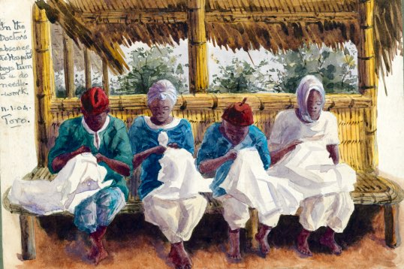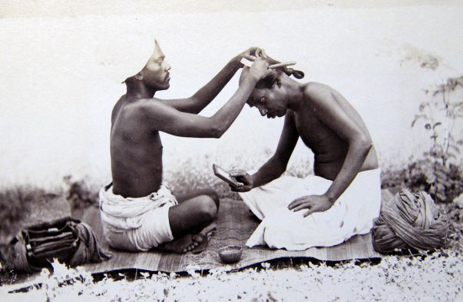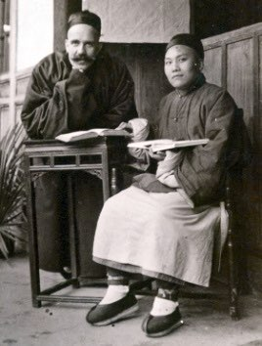

Finding numbers: CMS/ACC321 CMS/ACC21 Z1 CMS/ACC608 F1

Options if you are unable to visit Cadbury Research Library

- Thousands of items from the CMS Archive have been copied on to microfilm and digitised.
You may be able to see material from the CMS Archive if a library or archive near you holds microfilm copies.
Alternatively, you may be able to access copies which have been made available online.
There is more information in this Guide under Microfilm and digital copies of material from the CMS Archive.
- If you find something of interest in the online catalogue to the CMS Archive, you may be able to order a copy through the Cadbury Research Library Reprographics Service.
To find out about charges and how to place an order follow the links to ‘Imaging Services’ on the Cadbury Research Library website.
- The Church Mission Society has published large numbers of periodicals, pamphlets, circulars and other materials over the course of its history.
You may find local copies of these publications in a library or archive repository nearer to you.
- Other institutions hold records relating to CMS missionaries, CMS work in the UK and overseas.
A few suggestions are given in the next section of this Guide.
For institutions other than the Church Mission Society itself, it is often useful to start by entering ‘Church Missionary Society’ or ‘Church Mission Society’ as a search term.

Examples of CMS related material held by other institutions

- Church Mission Society, Oxford: the Crowther Mission Studies Library houses 29,000 books and back copies of missionary journals, including complete runs of CMS periodicals and overseas diocesan reports; it also takes about 250 current journals. CMS (Oxford) retains custody of the historical records of the Society which have not yet been transferred to the CMS Archive at the Cadbury Research Library including most of its archives dating from 1960 onwards and some earlier records.
- British Library: archives, manuscripts and published works relating to the Church Missionary Society including, for example, miscellaneous papers of Reverend Thomas Patrick Hughes; correspondence and papers of Major-General George Hutchinson; sermons of Bishop Edward Alfred Livingstone Moore; a recording of an interview by the Right Reverend Leslie Wilfried Brown; photographs of scenes of Indian life and missionary work; an unpublished memoir of Joyce M. Peel.
- British Museum: over 1,500 artefacts previously the property of CMS, many originating from overseas; many can be seen online.
- Cambridge University: manuscripts: letters of Helen Moore, missionary with the Church of England Zenana Missionary Society.
- Cambridge University: Royal Commonwealth Society Library: Church Missionary Society Photographic Collection: glass plates from the collection are available online.
- Horniman Museum: artefacts purchased from the CMS in the 1950s and 1960s including Inuit sealskin clothing and musical instruments.
- Lambeth Palace Library and Church of England records Centre: the Archbishops Papers include letters from, and about, CMS missionaries.
- Norfolk Record Office: records of Norfolk and Norwich CMS Associations.
- Royal Geographical Society: journals of Reverend J. M. Eisenberg and Reverend J. L. Krapf; correspondence between Richard Francis Burton and the CMS.

Microfilm and digital copies of material from the CMS Archive

CMS Archive on microfilm

- Approximately two-thirds of the CMS Archive was microfilmed by Adam Matthew Publications.
The microfilms are no longer available for sale but the films and accompanying printed guides are held by many institutions around the world. Digital versions of the guides are also freely available online.
- The 'Proceedings of the Church Missionary Society for Africa and the East' 1801-1921 were micro-published by East Ardsley: E. P. Microform (now Microform Imaging Limited).

Microfilm collections of Adam Matthew Publications

‘Church Missionary Society Archive’

This collection comprises copies of extensive sequences of records and publications from the CMS official archive; records of two CMS General Secretaries from the CMS Unofficial Papers; records from three of the deposited archives and additional periodicals and pamphlets from the collections held by the Church Mission Society (Oxford). It is arranged in nine sections:
  - Section I: East Asia Missions
  - Section II: Missions to Women
  - Section III: Central Records
  - Section IV: Africa Missions
  - Section V: Missions to the Americas
  - Section VI: Missions to India
  - Section VII: General Secretary's Papers
  - Section VIII: Home Papers
  - Section IX: Middle East Missions
- 'Women's Language and Experience, 1500-1940: Women's Diaries and Related Sources' (1996).
This collection brings together material from several institutions. It includes diaries from eight collections in the CMS Unofficial Papers.

How to find out if records have been microfilmed

- Option 1: use the typescript finding aids in the Cadbury Research Library Reading Room: the drawer numbers for the microfilm are written in pencil on the contents page at the front of each volume.
- Option 2: use the online archive catalogue: look under ‘Copies’ at Fonds, Sub-fonds and Sub-sub-sub-fonds level.
For example, follow the steps below to see if the Papers of the Yoruba Mission are available on microfilm:
  - Step 1: go to the Advanced Search page and enter the following details:
Finding number: CMS/B/OMS;
Level: Sub-sub-sub-fonds.
  - Step 2: click search.
  - Step 3: click on the finding number for the Yoruba Mission.
  - Step 4: scroll down to ‘Copies’.
Papers of the Yoruba Mission have been microfilmed and in Cadbury Research library the film reels are held in drawers B1 and C3.
- Option 3: use the guides to the Adam Matthew microfilm: once you have found the Section and Part relevant to what you are looking for, you will be able to search ‘Contents of Reels’. The guides do not include microfilms of the CMS Proceedings as these were published by E. P. Microform.
- Option 4: use the contents list for the Adam Matthew Digital Collection titled ‘Research Source: Church Missionary Society Archive’. This Digital Collection comprises scanned copies of the microfilm.

CMS Archive online

- Many published works, papers and some photographs from the CMS Archive have been digitised and can be seen online, including all of the papers from the official CMS Archive, and some of the CMS Unofficial Papers, which were previously microfilmed by Adam Matthew Publications.
- Some can be seen through free access websites.
- The extensive series digitised by Adam Matthew Digital Ltd are available by subscription (Adam Matthew Digital Ltd, Pelham House, London Road, Marlborough, Wiltshire, SN8 2AG, England).

Adam Matthew Digital Collections using material from the CMS Archive

- There are two key collections:
  - 'Research Source - Church Missionary Society Archive’;
  - ‘Church Missionary Society Periodicals’;
  - The digital copies are largely arranged in the same way as the Adam Matthew microfilm - in nine parts. The periodicals have been released as a discrete collection.
- Miscellaneous records from the CMS Archive are also used in the Adam Matthew Digital Collection titled 'Empire Online’.
  - This title includes women’s diaries from collections in the CMS Unofficial Papers which are not held under the two aforementioned Adam Matthew Digital collections.
  - The diaries were previously micro-published by Adam Matthew Publications under the title 'Women's Language and Experience, 1500-1940. Women's Diaries and Related Sources’.
  - Some of the diaries which were microfilmed have not been digitally published. They cannot be seen online.
- Fourteen CMS printed biographies feature in the Adam Matthew Digital Collection: China: Trade, Politics and Culture, 1793-1980 but these materials are also held in Research Source – Church Missionary Society Archive’.
- The Adam Matthew Digital collections are supported by a range of resources including an interactive map, brief biographies of CMS personnel and teaching support.

Access to Adam Matthew Digital collections: if you are a member of the University of Birmingham

- Members of the University have free access to collections featuring material from the CMS Archive whether on or off campus.
- Log in through FindIt@bham and select Database Search. As with all of the University’s eResources, you will need to sign in with your UoB username and password.

Access to Adam Matthew Digital collections: if you are not a member of the University of Birmingham

- You will be able to access the digital collections relating to the CMS Archive when you visit Cadbury Research Library.

- If you are a member of an institution which subscribes to Adam Matthew Digital products, or if you can visit a subscribing institution, you may have access through them.
- If you are not a member of a subscribing institution, and cannot visit one, you may be able to request a free trial from Adam Matthew Digital.

How to find out what is available online through Adam Matthew Digital Ltd

- Work is underway to add URL links to the online catalogue to the CMS Archive. In the meantime, lists of all the items which have been digitised can be downloaded off the Adam Matthew website:
‘Church Missionary Society Archive’: contents list (Microsoft Excel, 586KB);
‘Church Missionary Society Periodicals’: contents list (Microsoft Excel, 250KB).

Which other websites can I use to see copies of CMS publications and material from the CMS Archive?

- Miscellaneous copies of CMS periodical and other publications are free to access through the Internet Archive, Google Books, Hathi Trust digital library and the website of missiology.org.uk: a Gateway for the Study of Christian Missions. Some examples are given below. You may well find more!
- Charles Hole, ‘The early history of the Church Missionary Society for Africa and the East to the end of A. D. 1814,' London: CMS, 1896.
Available through the Internet Archive.
- Eugene Stock, ‘The history of the Church Missionary Society, its environment, its men and its work’ in four volumes, London: CMS, 1899-1916. Available through Adam Matthew Digital and through the Internet Archive.
Copies available through the Internet Archive:
History of the Church Missionary Society, volume 1;
History of the Church Missionary Society, volume 2;
History of the Church Missionary Society, volume 3 ;
History of the Church Missionary Society, supplementary volume 4.
- ‘Centenary History of the Church Missionary Society’ London: CMS, 1902.

A PDF copy is available to download off the website of missiology.org.uk: a
Gateway for the Study of Christian Missions.

- 'Proceedings of the Church Missionary Society for Africa and the East’, 1801-1921.
Copies of selected issues of the Proceedings for 1817/18-1876/77 are available through the Hathi Trust digital library.
- ‘The Church Missionary Atlas: containing an account of the various countries in which the Church Missionary Society labours, and of its missionary operations’. Selected editions are available through Adam Matthew Digital and the Internet Archive.
Copy of the Church Missionary Atlas 1862 on the Internet Archive.
- Selected images from three of the collections in the CMS Unofficial Papers have been digitised as part of the University of Bristol’s ‘Historical Photographs of China’ project. Held under the title ‘Cadbury Research Library’.
- An exhibition featuring copies of 186 photographs from collections in the CMS Unofficial Papers can be seen online through the Cadbury Research Library’s Flickr pages. Held under the title: ‘Turn of the century China: an exhibition of late 19th and early 20th century photographs’ (Cadbury Research Library, 2014).
- The Royal Commonwealth Society Library, Cambridge University holds a Church Missionary Society Photographic Collection. The glass plates from the collection have been digitised and can be seen online.

Is everything in the CMS Archive available on microfilm and online?

- Thousands of items across the CMS Archive have not been filmed, including most of the growing number of collections held as the CMS Unofficial Papers.

Catalogue to the CMS Archive: summary list of parts and supplementary guides

Introduction

- The different parts of the catalogue to the CMS Archive are listed below.
- For each of the parts there is a separate paper finding aid in Cadbury Research Library.
- Work is underway to enter all parts into the Cadbury Research Library online catalogue. In the list below, parts which can already be read online are underlined and linked directly to the catalogue.
- Suggestions on how to use the online catalogue to search the CMS Archive, are given elsewhere in this Guide under ‘Using the online catalogue to the CMS archive’.
- All the finding aids include important guidance on understanding and using the records.
- When using paper copies, use the alphabetical numerical references from the top of the page and left-hand margin to create the archive finding number.
- If you would like to have a copy of a catalogue in another format please let us know how we can help. Email: special-collections@bham.ac.uk.

Arrangement of the catalogue

- General Secretary’s Department
  - Catalogue of Papers of the General Secretary’s Department 1799-1949;
  - Catalogue of Papers of the General Secretary’s Department 1950-1959;
  - Guide to the Committee Records (PDF, 524 KB)
- Foreign/Overseas Division
  - Catalogue of Papers of the Foreign Division: general series 1799-1949;
  - Catalogue of Papers of the Foreign Division: mission series 1803-1934;
  - Catalogue of Papers of Overseas Division: general and mission series 1935-1959
- Medical Department
  - Catalogue of Papers of the Medical Department 1891-1949;
  - Catalogue of Papers of the Medical Department 1950-1959;
  - Guide to the Records of the Medical Department (PDF, 451 KB)
- Candidates Department
  - Catalogue of Papers of the Candidates Department;
  - Guide to the Records of the Candidates Department. (PDF, 401 KB)
- Home Division
  - Catalogue of the Papers of the Home Division
- Finance Department
  - Catalogue of the Papers of the Finance Department
- Educational Auxiliary
  - Catalogue of the Papers of the Educational Auxiliary
- Women’s Department
  - Catalogue of the Papers of the Women’s Department
- Miscellaneous CMS record series
  - Catalogue of the CMS Manuscripts Series;
  - Catalogue of the CMS Plans Series;
  - Catalogue of the CMS Maps Series;
  - Catalogue of the CMS Miscellaneous Papers Series
- Deposited and Unofficial Papers
  - Catalogue of the CMS Unofficial Papers;
  - Catalogue of CMS Theses;
  - Catalogue of the Records of the Mid-Africa Ministry;
  - Catalogue of the Records of the Overseas Missions;
  - Catalogue of the Records of Local CMS Associations;
  - Catalogue of the Records of Diocesan Associations;
  - Catalogue of the Records of the Missionary Leaves Association;
  - Catalogue of the Records of the Loochoo Naval Mission;
  - Catalogue of the Records of the Church of England Zenana Missionary Society;
  - Catalogue of the Records of the Society for Promoting Female Education in the East.

Catalogue of the Papers of the Home Division 1840-1959

Overview

- The volume is a catalogue of records arranged according to the 36 departments which shared the work of the CMS Home Division in 1959.
- These departments were responsible for the ‘home’ rather than overseas side of the Society’s work and there is much concerning the methods used by the Society to advance its aims and activities in the UK. As much of this concerned sharing information and the story of the Society’s overseas missions, the records have a great deal to offer if you are looking to find out about different branches of mission work and the history of CMS institutions overseas.
- The records are diverse, including highly informative circulars; periodicals produced in the UK, China, Japan, India and Sudan; illustrated pamphlets; children’s games; records relating to the CMS museum, exhibitions, deputations, anniversary and other events as well as the minutes; correspondence; reports and printed papers of the type found in other CMS departments of work.
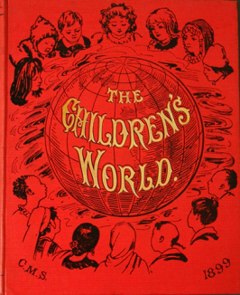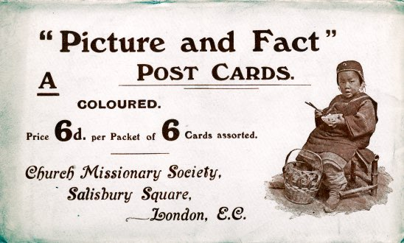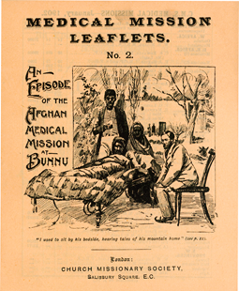

How is the catalogue arranged?

- At the front of the catalogue is a list of the departments each with their own reference number: H1-H36. This forms part of the finding number for the records.
- The bulk of the catalogue comprises a brief description of the records of each department in turn (pages 1-169). Some of the records listed in the catalogue did not survive a fire in the CMS off-site storage area in 1989 and so are not available for research. These entries are scored through.
- At the end of the catalogue there are supplementary, separately paginated lists.
- The supplementary lists include a box list of archive finding numbers and a list of volumes arranged in department order. The volumes include circular books, letter books, minute books, registers, contact prints for slide sets, records relating to work with schools, deputations and finance.
- Several of the supplementary lists expand on the entries in the main part of the catalogue under records of the Editorial Secretary. They include box lists of the extensive and diverse range of records classified as ‘Periodicals’ (archive finding number CMS/H/H5 E1) and ‘Pamphlets’ (CMS/H/H5 E2).

Records of the Editorial Secretary (CMS/H/H5)

- The term ‘pamphlets’ is used for a diverse range of material from board games to fundraising ephemera and tour reports.
- The illustrations below are cropped copies of two pages from the catalogue relating to records of the Editorial Secretary. Figure 1 (left) shows the brief entries under CMS periodicals in the main part of the catalogue including ‘South China’. Figure 2 (right) shows the type of detail given in the corresponding supplementary list of periodicals towards the back of the catalogue where South China periodicals are listed by title and date.
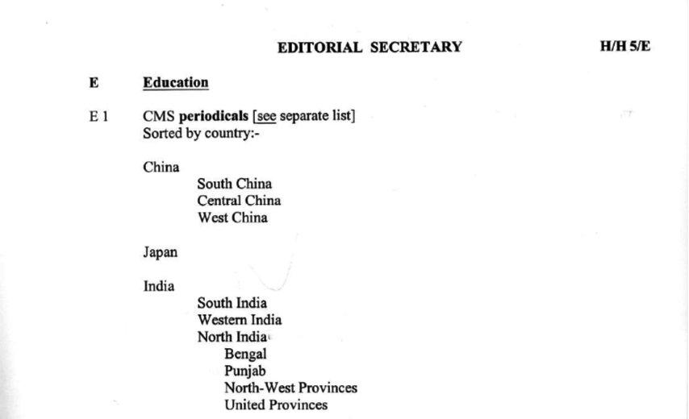
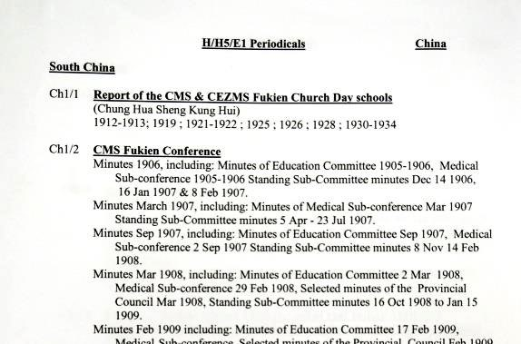
Figure 1
Figure 2

- Some volumes which you will find elsewhere in the CMS Archive were once held in the Editorial Department. The set of printed extracts from Annual Letters 1886-1912 held in Cadbury Research Library are stamped to show they are Editorial Department copies.

Can I search this catalogue online?

- This finding aid has not been entered into the online archive catalogue. You will be able to use the paper copy when you visit the Cadbury Research Library.

Finding aids for papers of the Overseas (Foreign) Division

Overview

- There are several finding aids to help you search the papers of the Overseas Division. Which ones you use will depend on which dates and which part of the world are of interest.

Search for records compiled 1799-1934

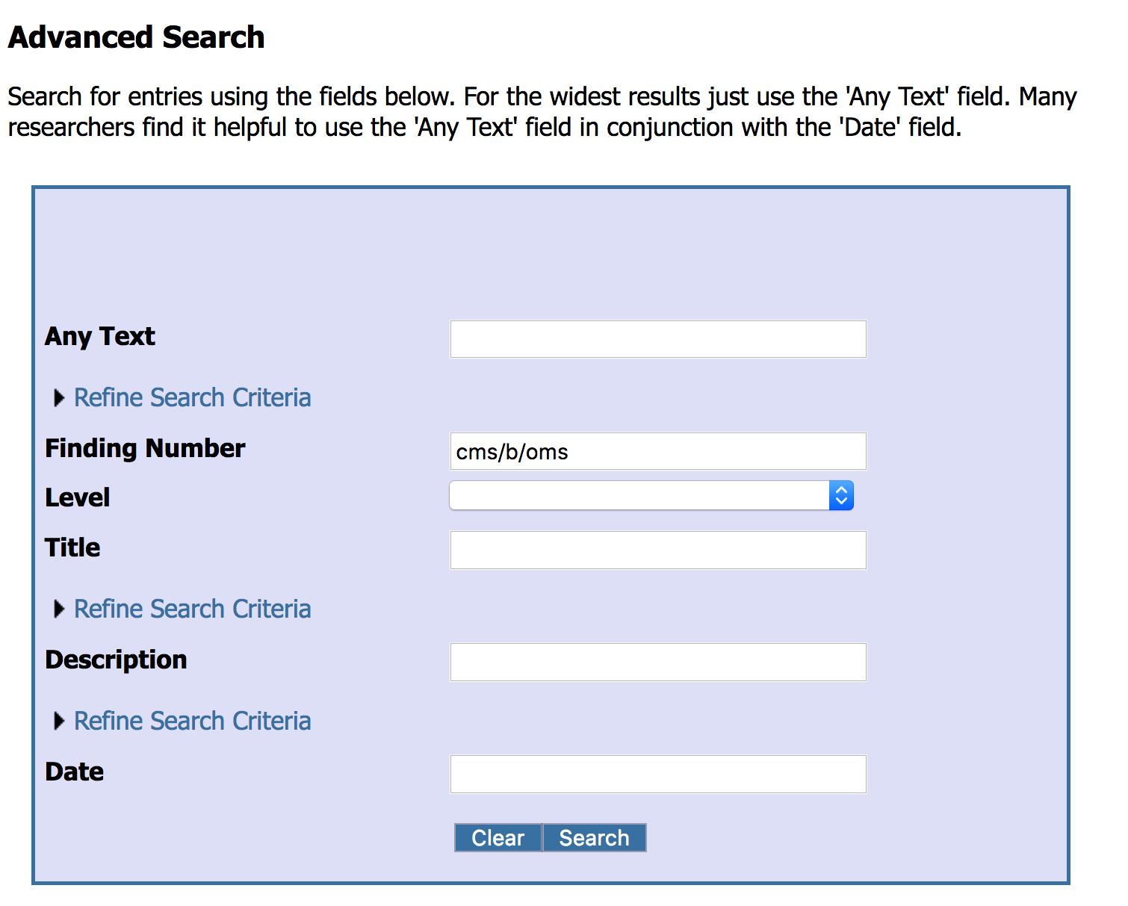
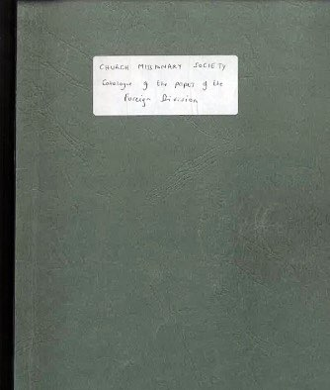
- Use the Catalogue of the Papers of the Foreign Division 1799-1949 and either the online catalogue to the CMS Archive or whichever of the 20 handlists to the mission series 1803-1934 are relevant to your research (pictured below).

+

Search for records compiled 1935-1959

- For this date range, there is just one volume to use.
- Use the Catalogue of the Papers of the Overseas Division 1935-1959.
- The Catalogue of the Papers of the Foreign Division has some entries for records dated 1935-1949 but everything that is currently available for research in Cadbury Research Library is also listed in the Catalogue of the papers of the Overseas Division.

Using Adam Matthew products to search for records

- Many of the overseas papers have been microfilmed by Adam Matthew Publications. Digitised copies of the microfilm are available online under the title: ’Research Source: Church Missionary Society Archive’.
- If papers for the mission that you are interested in have been digitised and you have access to Adam Matthew Digital Collections, you will be able to search by entering the name of a missionary, place, subject or other term on the Adam Matthew Digital Ltd website. Further information is given in this Guide under: Microfilm and digital copies of material in the CMS Archive.

Catalogue of papers of the Foreign Division 1799-1949

Overview

- This catalogue provides an overview of all the papers created and compiled by the different committees (or ‘departments’) of the CMS Foreign Division to 1949, including the general series and mission series.
- It mainly serves as the catalogue of the general series 1799-1949. If you are interested in correspondence between CMS headquarters and a particular mission, you will also need to use the handlists or online catalogue to the mission series 1803-1934 and Catalogue of papers of the Overseas Division 1935-1959.

Date range

- Most entries relate to records dated 1819-1949; a few refer to records from the 1950s.

How is the catalogue arranged?

At the front of the catalogue there is an explanation of the history of the records, their current arrangement and how to use the archive finding numbers.

- The catalogue is then arranged in six sub-sections. For most people using the CMS Archive, the important thing is simply to find the sections of the catalogue which match dates and/or missions of interest.
- The six sections are:
Committee of Correspondence archives 1799-1880: this Committee worked with all the overseas missions so the papers described in this section are potentially relevant whichever mission you are interested in; the archive finding numbers begin with ‘C’.
General Groups archives 1880-1949: potentially relevant to all mission areas; the archive finding numbers begin ‘G1-3’.
Africa/Asia committee archives 1935-1949: potentially relevant to all mission areas; the archive finding numbers begin ‘AF/AS’.
Group 1 (later East Asia) archives 1880-1949: papers of the committee which worked with missions to China, Japan, Canada and Malaya; the archive finding numbers begin ‘G1’.
Group 2 (later West Asia) archives 1880-1949: papers of the committee which worked with missions to India, Ceylon, Mauritius and Madagascar, Persia and Turkish Arabia; the archive finding numbers begin ‘G2’.
Group 3 (later Africa) archives 1880-1949: papers of the committee which worked with missions to Africa, New Zealand, Egypt and Palestine; the archive finding numbers begin ‘G3’.
- Some of the sub-sections relate to the work of a particular committee, for example, the Group 1 Committee archives. Others cut across the work of different departments of the Foreign Division, for example, the General Groups archives.

Records in the general series

- Under the Committee of Correspondence, there are copies of correspondence between the missions and the Secretaries at CMS headquarters in London, 1819-1883. Including, for example, a letter-book of correspondence with the India, Madagascar, Mediterranean and Persia missions 1870-1883.
- Under the Group Committees, the papers broadly comprise correspondence, minutes, circulars, reports, memoranda and other printed papers. Subjects include: candidates, missionaries and external organisations, much regarding educational institutions overseas, policy issues, missionaries’ pensions, correspondence with bishops, personal and confidential papers kept by each of the Group Secretaries and a few photographs.
- Some of the records in the Africa/Asia archives 1935-1959 are not currently available for research and have been retained by CMS (Oxford). Those which are held by Cadbury Research Library are listed in the Catalogue of the Papers of the Overseas Division.

Lists of the mission series

- For each of the committees represented in the catalogue there is a list giving the broad arrangement of the papers held in the CMS Archive as the mission series. For example, at the end of the Group 3 (Africa) Committee entries, there is a list of all of the missions of the Committee active between 1880 and 1934. If you were to walk through the Archive you would find boxes of papers for each of these missions. There are equivalent lists at the end of the entries for the Committee of Correspondence, the Group 1 (East Asia) and Group 2 (West Asia) Committees.
- The lists include the unique mission identifier which is used as part of the archive finding number, for example, ‘A5’ for Kenya Mission.
- Each list is cross-referenced to the 21 volumes in which you will find the catalogue for the papers in the mission series 1799-1934 and 1935-1959.
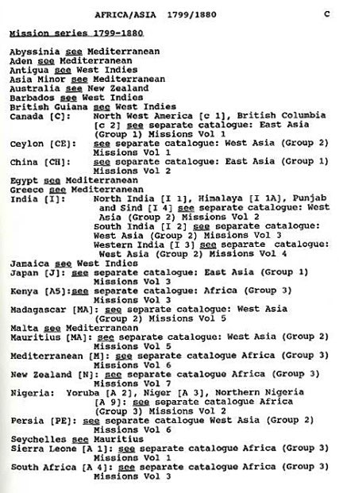
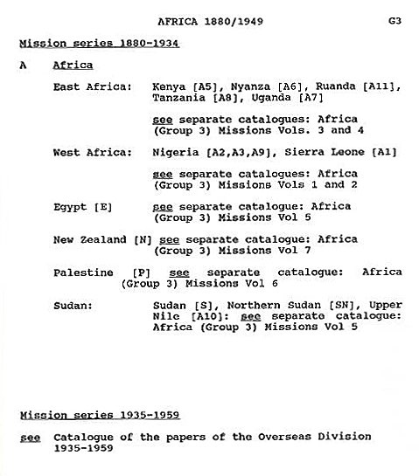
- The images below illustrate how the mission series appear in this catalogue. The first (left) is the mission series under the Committee of Correspondence, the second (right) is the mission series under the Group 3 (Africa) Committee.

Archive finding numbers

- Follow three steps to get the archive finding number for papers in this catalogue.
- The first part is always the collection reference: ‘CMS’.
- The second part is the alphabetical/numerical reference given in the top right-hand corner of the page. This refers to the committee and also sometimes the record series. For example, for papers kept under the Committee of Correspondence this would be: ‘C’. Papers in the general series kept under the Committee of Correspondence would be: ‘C/G’.
- The final part is the alphabetical/numerical reference given in the left-hand margin of the page. It indicates the specific record, For example, Individual Letter-book 1 would be: I1.
- In the illustration below, a page from the catalogue is annotated to show the information you would need to request an Individual letter-book used by Christopher Fenn 1869-1881. The identifiers from the top right-hand corner and left-hand margin of the page are circled in red. Combining these with the collection reference, ‘CMS’, gives the finding number: CMS/C/GI 1.
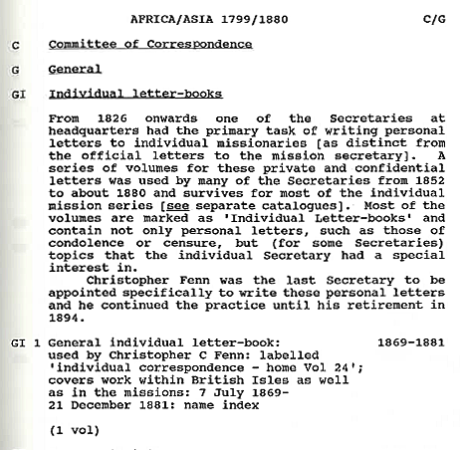

Related record series

- The Catalogue of the Papers of the Foreign Division and the handlists to the mission series 1803-1934 do not list all of the overseas correspondence which came in to CMS headquarters between 1799 and 1934.
- Other departments of work at CMS headquarters dealt with matters relating to the Society’s missionaries and work overseas so you will find also find correspondence listed in the catalogue to the records of those departments.

Handlists to papers in the mission series 1803-1934

Overview

- The committees of the Foreign Division at CMS headquarters worked directly with the overseas missions and there are separate series of papers for each individual mission they worked with. These papers include thousands of items of correspondence sent to headquarters from the overseas missions and vice versa. Within the CMS Archive they are referred to as the mission series or the overseas mission series.
- The handlists described in this section of the Guide are effectively a catalogue of the mission series files kept by the Committee of Correspondence 1803-1880 and the East Asia (Group 1) Committee, West Asia (Group 2) Committee and Africa (Group 3) 1880-1934, in 20 typescript volumes.

- The information from the handlists has been entered into the online catalogue to the CMS Archive. In the online catalogue the papers are referred to as the overseas mission series. The contents are identical whichever format you use.
- Whether you use the handlists or the online catalogue to the mission series 1830-1934, you may wish to use them alongside the Catalogue of the Papers of the Foreign Division 1799-1949.
- Guidance on using the online catalogue is covered elsewhere in this Guide. This section focusses on using the handlists.

Date range

- The handlists described here cover records created between 1803 and c 1934.
- If you are interested in the mission series 1935-1959, use the Catalogue of the Papers of the Overseas Division.

Summary list of handlists to the mission series

- The volumes are arranged according to the committee at CMS headquarters which administered work of the overseas missions and thereunder by individual mission. Details are given below but staff in Cadbury Research Library will be happy to help you find whichever one is relevant for you. The volumes for West Africa, Ceylon and North India are in two parts.
- Catalogue of the papers of missions administered by the Africa (Group 3) Committee
  - Volume 1: West Africa Mission (later ‘Sierra Leone Mission’);
  - Volume 2: Nigeria: Yoruba Mission, Niger Mission, Northern Nigeria Mission;
  - Volume 3: South and East Africa: South Africa Mission; Kenya Mission; Tanzania Mission;
  - Volume 4: East Africa: Nyanza Mission, Uganda Mission, Ruanda/Burundi Mission;
  - Volume 5: Egypt Mission, Upper Nile Mission, Sudan Mission, Northern Sudan Mission;
  - Volume 6: Mediterranean Mission, Palestine Mission;
  - Volume 7: New Zealand Mission (including Australia).

- Catalogue of the papers of missions administered by the East Asia (Group 1) Committee
  - Volume 1: Canada: North West America Mission (later ‘North-West Canada Mission’), North Pacific Mission (later ‘British Colombia Mission’)
  - Volume 2: China: China Mission, South China Mission, Chekiang Mission (later ‘Mid-China Mission’), Western China Mission, Fukien Mission; Kwangsi and Hunan Mission;
  - Volume 3: Japan Mission;
  - Volume 4: West Indies Mission.

- Catalogue of the papers of the missions administered by the West Asia (Group 2) Committee
  - Volume 1: Ceylon Mission;
  - Volume 2: North India Mission (later ‘Bengal Mission’), Himalaya Mission, Punjab and Sind Mission, North West Provinces Mission, United Provinces Mission, Central Provinces Mission;
  - Volume 3: South India Mission (later ‘Madras Mission’), Travancore and Cochin Mission, Telegu Mission, Tinnevelly Mission;
  - Volume 4: Western India Mission (later ‘Bombay Mission’);
  - Volume 5: Mauritius Mission (also Madagascar and the Seychelles);
  - Volume 6: Persia Mission; Turkish Arabia Mission.

Using the handlists

- Each handlist includes a list of contents, an explanation of the history of the records and their current arrangement. There are also explanations of the different types of record and the places covered by each mission.
- If the papers have been microfilmed, when you look at the contents page, you will find handwritten notes in pencil telling you in which drawer you will find the microfilm copy.
- Once you have found the entries for your mission area, you will find the records dating from before 1881 when the missions were administered by the Committee of Correspondence listed first. In the handlist the finding numbers for these papers all begin with the letter ‘C’.
These are followed by papers for the same mission kept by the East Asia (Group 1) Committee, the West Asia (Group 2) Committee or the Africa (Group 3) Committee1880-1934. In the handlist the finding numbers for these papers numbers begin G1, G2 or G3.

Type of records and archive finding numbers

- Information about the different types of record and the archive finding numbers which you will find in the handlists is given earlier in this Guide under Records in the overseas mission series.

Catalogue of the Papers of the Overseas Division 1935-1959

Overview

- This typescript volume is a catalogue of papers created and compiled by the different committees (or ‘departments’) of the CMS Overseas Division 1935-1959. Namely, papers of the:
  - East Asia (Group 1) Committee 1935-1957;
  - West Asia (Group 2) Committee 1935-1957;
  - Asia Committee 1957-1959;
  - Africa (Group 3) Committee 1935-1959.
- The catalogue covers papers arranged as the mission series and the general series including correspondence to, from and about all of the overseas missions.

Date range

- The catalogue mostly concerns papers from 1935-1959.
- There are some entries for records from the mission series for 1803-1934 and a few for papers dating back to 1890 and forward to 1962; these are papers which were transferred to the 1935-1959 files at some point during the time when the files were in active use at CMS Headquarters and not returned to their original files.

How is the catalogue arranged?

- At the front of the catalogue there is an important explanation of the history of the records, their current arrangement and the archive finding numbers.
- There are separate sets of papers for each committee including papers arranged in general series and papers arranged by individual mission.
- There also general series of papers arising from cross-committee work.
- General series 1935-1959
  - Some of the general series relate to the work of all of the committees, for example, the Africa/Asia general files; some relate to narrower geographical areas for example, the Africa general files.

  - The records in the general series are arranged as:
    - correspondence;
    - tours,
    - deputations;
    - conferences, meetings;
    - missionaries, bursars (or missionaries and missions);
    - policy;
    - commissions;
    - miscellaneous;
    - committee work;
    - education;
    - finance;
    - medical;
    - outside organisations;
    - politics and religious questions.

- Mission series 1935-1959
  - Incoming and outgoing correspondence on the same subject is filed together. This makes it easy to locate material for a particular branch of mission work, for example, the history of a CMS school.
  - The files for each mission are arranged in four series:
    - [correspondence with the mission secretary];
    - dioceses;
    - education;
    - general and medical.
  - The education records include material relating to CMS bookshops.

  - The files in the mission series are easily recognisable as they retain the finding numbers used from 1880 onwards when the work of the Committee of Correspondence was divided amongst three Group Committees: G1, G2, G3 plus the unique mission identifier. For example G3 A2 for the Yoruba Mission papers. The image below shows an entry in the catalogue for Yoruba Mission papers. The mission reference ‘G3 A2’ is given in the top right-hand corner of the page.

Archive finding numbers

- Follow three steps to get the archive finding number for papers in this catalogue.
- The first part is always the collection reference: ‘CMS’.
- The second part is the information given across the top of each page. For example, ‘Africa 35/59 G3 A2’ meaning Yoruba Mission papers compiled under the Africa Committee between 1935 and 1959. The committee references are usually abbreviated to ‘AF,' ‘AS,' ‘ASE,' ‘ASW’ or a combination of these.
- The final part is the alphabetical numerical reference given in the left-hand margin. It indicates the specific record.
- This is illustrated on the next page. A page from the catalogue is annotated to show the information from the top of the page and the left hand column which you would need to request papers relating to the Industrial Institute in Abeokuta 1945-1953. Archive finding number: CMS/AF 35/59/G3 A2 e1.

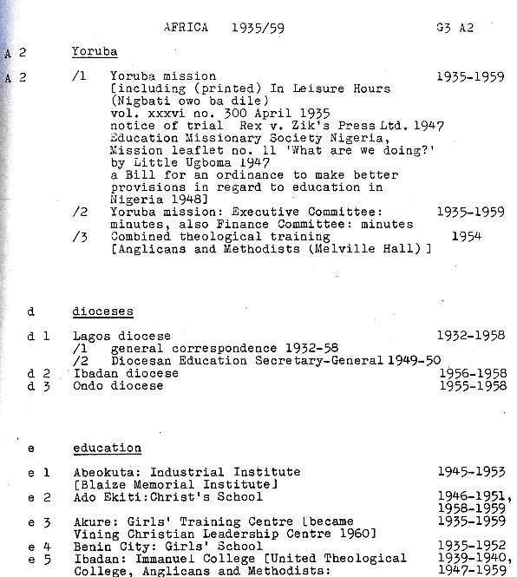

Related record series

- The Catalogue of the Papers of the Overseas Division does not list all of the overseas correspondence which came in to CMS headquarters between 1935 and 1959.
- Other departments of work at CMS headquarters dealt with matters relating to the Society’s missionaries and work overseas so you will find also find correspondence listed in the catalogue to the records of those departments.

Card indexes for the CMS Archive

Overview

- There are three card indexes for the CMS Archive. They were originally compiled by the CMS and the Church of England Zenana Missionary Society for their own use. Now you can use them alongside the catalogues to find papers of interest.

CMS name index

- An alphabetical card index with names of missionaries, of members of CMS committees at CMS Headquarters and many other people mentioned in the records. There are some cards for women who went out under the Church of England Zenana Missionary Society, an organisation which worked with CMS throughout its history and amalgamated with CMS in 1957.
- Consider this index if you want to find records for anyone connected with CMS.
- This index is particularly important where it is not possible to find the name of the person in the online catalogue. This includes people who were connected with CMS but were not missionaries. It also includes missionaries who worked overseas after 1880 as entries in the catalogue for the mission papers compiled after 1880 do not typically mention missionaries by name.
- Details include: committee roles; names of children of missionaries; cross-references to records kept by the different departments of work, to articles in CMS periodicals and to records in the CMS Unofficial Papers.
- The image below is a card for Lucy Mellodey, missionary with the Western China Mission. On this card there are cross-references to six records in the Archive. For each reference, the date of the record is given on the left-hand side and the archive finding number is given on the right-hand side, for example, G1/CH3/O 1900/8.
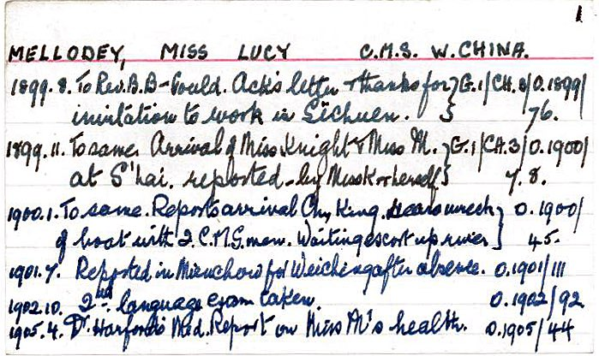

CMS place index

- A microfiche copy of an index to countries and places referenced in the CMS records and periodicals including Birmingham and other places in Great Britain. The original card index has been retained by the Church Mission Society in Oxford.
- The microfiches are accompanied by a summary list of locations. Use this summary list to identify the numbers of the microfiche relevant to your search.
- Entries are arranged by country and thereunder by place name.
- The fiches can be tricky to handle and, in most instances, it is now easier to search using the Cadbury Research Library online archive catalogue and the Adam Matthew Digital Collections. However, it is worth checking the place index if you haven’t found what you need with the other finding aids.

Index to the Records of the Church of England Zenana Missionary Society

- An alphabetical card index compiled by the Church of England Zenana Missionary Society (CEZMS) and subsequently passed to the CMS.
- Some of the missionary name cards have manuscript notes added after 1957 when the CEZMS amalgamated with the CMS.
- The index includes name cards giving brief biographical details for CEZMS missionaries, as well as cards for institutions, annual events, outside organisations, items of mission correspondence in the records of the CEZMS Foreign and Candidate Secretary's Department filed under the name of the mission, and many other subjects arranged in a single alphabetical sequence.
- Beware that the archive references on the CEZMS card index do not match all of the file references which were allocated after the records passed to the CMS and which are still used today. Guidance on how to use the card index is given in the online archive catalogue to the records of the Church of England Zenana Missionary Society.

Things to be aware of when using the card indexes

- The indexes are not comprehensive. If you find entries in the index for a particular name or place, do not assume that you have found every record of interest.
- The indexes use abbreviations which might not be clear until you become familiar with the type of materials held in the CMS Archive and the archive finding numbers. For example:
  - in the CMS place index ‘M. P.’ is used to refer to a CMS periodical: the ‘Missionary Papers’;
  - in the CMS name index, the card for Lucy Mellodey shown earlier in this section of the Guide refers to archive finding numbers used for papers in the mission series compiled under the Group 1 Committee, including ‘G1 CH3 O1899/76’.
- Before using the cards, please ask staff in Cadbury Research Library Reading Room for an introduction to the finding aids and finding numbers for the collection you are using.

Using the online catalogue to the CMS Archive

Overview

- The catalogue to several parts of the CMS Archive has been entered in to Cadbury Research Library online archive catalogue and can be searched at http://calmview.bham.ac.uk/.
- The various deposited and unofficial papers which are held as part of the wider CMS Archive are catalogued as discrete collections. When using the online catalogue, you will not find them entered under ‘Church Missionary Society archive’. Search for them by using the collection title or finding number. For example: ‘Records of the Church of England Zenana Missionary Society’; finding number: CEZ. Alternatively, use the links to the different parts of the catalogue in this Guide.
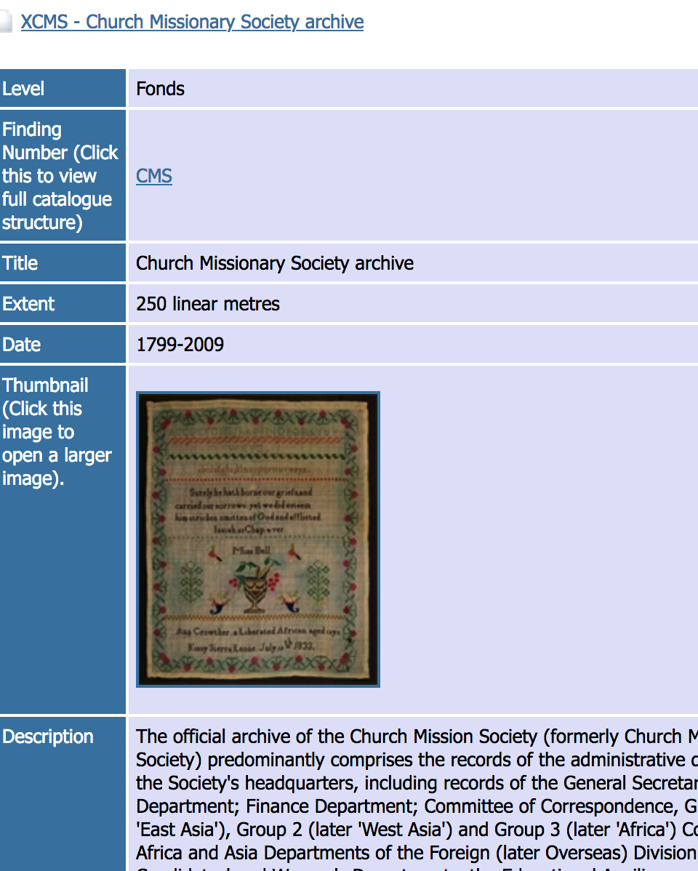
- All other parts of the catalogue can (or will) be found online entered under ‘Church Missionary Society archive’; finding number CMS.
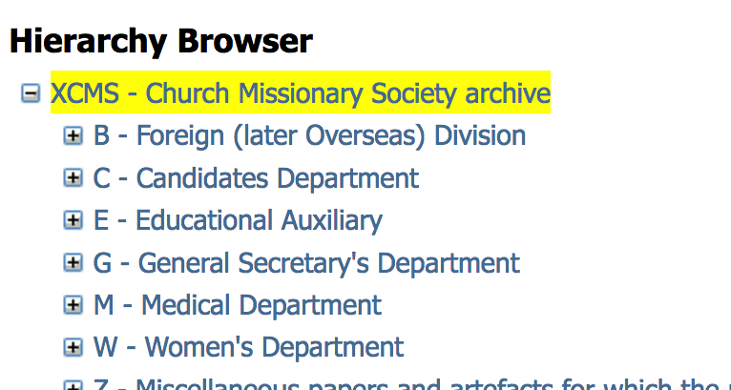

- In this section of the Guide, there are two examples to illustrate ways of using the online catalogue and tips to consider when using it.
- In both examples the start point assumes that you are already on the home page of the Cadbury Research library online catalogue.

Example 1: opening different levels of the catalogue

- Archive catalogues have levels a bit like a family tree with an overview of the whole collection at the top and smaller sections of the collection listed below.
- Follow the five steps below to open up different levels of the catalogue from an overview of the whole of the official CMS Archive to the catalogue entry for a single Letter-book in the papers of the Yoruba Mission.
- Step1: Select ‘Advanced Search’.
- Step 2: Enter ‘CMS’ in the Finding Number field
- Step 3: Find the Level field and use the drop-down list to narrow your search to ‘Fonds’ level.
- Step 4: Press Return or select Search
- Step 5: Click on the titles and highlighted text to open up successive levels of the catalogue.

Example 2: searching by key word or finding number

- Follow the four steps below to search for records relating to particular topics or people.
- Step 1: Select ‘Advanced Search’.
- Step 2: Find the ‘Any Text’ field and enter your chosen search term, for example, ‘Bombay’. Alternatively enter a CMS finding number in the Finding Number field, for example, ‘CMS/ACC33’.
- Step 3: Press Return or select Search
- Step 4: Entering a term in the Any Text field will highlight every mention of it in the online archive catalogue, regardless of collection. When the results of your search appear on the screen, use the lines of text above the blue shaded box to identify the collection and which part of the collection the item is held in. Alternatively, at Step 2, use the Finding Number field to limit your search to records in the CMS Archive by entering, for example, CMS*

Using names to search the online catalogue

- Personal names are usually entered in the catalogue with the spelling that is given in the records and place names change over time. You may need to try different spellings and terms when searching for a particular place or person.

‘Related Material’
- When using the online archive catalogue to get an overview of records held by a particular CMS committee (or department of work), use the Related Material field to find out about records held elsewhere in the collection which might also be of interest.
- For example, the Catalogue of the papers of the Educational Auxiliary lists the papers which were compiled c 1898-1917 but in the Related Material field there are suggestions as to how to find information relating to educational work throughout the Society’s history (illustrated above or see online).

Limitations of the online catalogue to the CMS Archive

- The online archive catalogue is quick to use but it is important to not assume that you have found everything relevant to your research once you have searched in this way.
- Some parts of the catalogue to the CMS Archive have not yet been entered into the online version. For example, to search the records of the CMS Finance Department, you will need to use the paper copy of the Catalogue to the Records of the Finance Department which you will find on the reference shelves in Cadbury Research Library Reading Room.
- There are some parts of the collection which have not yet been catalogued at all.

University of Birmingham Library catalogue

- To find books relating to the Church Mission Society in any of the University of Birmingham’s libraries you can search the Library catalogue: FindIt@Bham.

Search for books with the library catalogue

- Enter “Church Missionary Society” using double quotation marks, or another search term of your choice.
- Use the filters on the right hand side of the page to narrow the search to books.
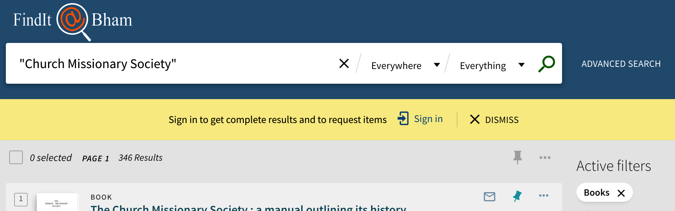
- Use the location field to check which of the University’s libraries hold the titles you want to see.

- Where the location is given as Cadbury Research Library, keep a note of the title, author and classmark. When you visit you will need to write these details on a request slip so that we can retrieve the material for you to look at.
- Where location is given as ‘Cadbury Research Library Store,' we shall need to retrieve the item for you from an off-site store. Follow the link on the website to place a Store request. Requests received before 11.15am can usually be retrieved on that day but we strongly recommend that you check before you visit.

Visitor access to the book collections

- If you are not a member of the University of Birmingham, when you visit the Cadbury Research Library you will be able to use the Cadbury Research Library book collections as well as the CMS Archive.
- Different conditions apply to using books held in other University of Birmingham libraries. Details of facilities for visitors and how to find the libraries are given on the Libraries page of the University of Birmingham website.

How to find records about a CMS missionary

The Church Mission Society sent missionaries overseas from 1804 and soon began to recruit within the countries in which it was working. Recruits included ordained and lay men from Europe, indigenous clergy (referred to as ‘Native clergy’) and women who served CMS as wives of missionaries or as missionaries themselves. Many committed their lives to working overseas, others were recruited under Short-Term Agreements. This section of the Guide suggests key record sequences where you might find information about a missionary’s life and gives tips on how to search.
- Things to bear in mind when researching a missionary
- Could I just enter the name of the missionary in the online archive catalogue?
- Could I just search online through Adam Matthew Digital Collections?
- Other resources to help you find where, when and in what capacity someone worked overseas
- Papers of the Overseas (Foreign) Division
- Records of the General Secretary’s Department
- Records of the Medical Department
- Periodicals and published works
- Records of the Finance Department
- Church Missionary Society Unofficial Papers
- Records of the Church of England Zenana Missionary Society
- Are there any records for missionaries after 1959?
- Using the Archive to find out about a missionary before they went overseas
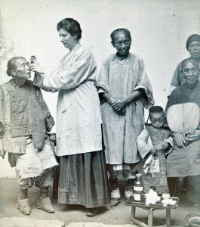
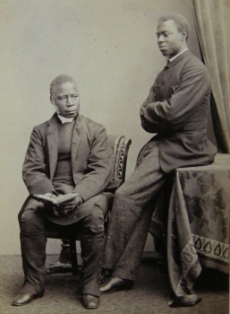
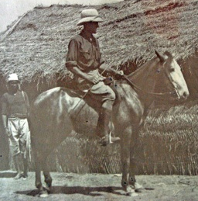
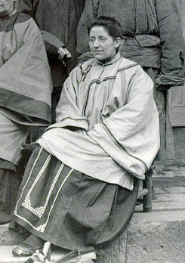
- Where else to search for records relating to CMS Missionaries

Things to bear in mind when researching a missionary

- To find records relating to a missionary, you first need to know where and when they worked with CMS.
- Some papers in the Archive relate to particular institutions or branches of mission work, so it may also help to know what sort of work they were involved with, for example, if they were a medical missionary or if they studied at one of the CMS training institutions in the UK.
- Once you know approximately when a missionary was overseas and which mission they were attached to, you will be able to decide which papers to look at and which finding aids to use.
- If there are not many papers in the name of the person you are looking for, try searching records of other missionaries who were in the mission at the same time.
- This section of the Guide is intended to help you get started and to highlight record sequences which are most likely to tell you about a missionary’s life.

Could I just enter the name of the missionary in the online catalogue?

- If you enter the name of a missionary as a search term in the online catalogue and don’t get any results this does not mean that there are no records about that person in the Archive. Equally, if you enter a name and the catalogue shows three entries mentioning that person by name, this does not mean that there is nothing more to find.
- The catalogues and other finding aids are intended to give an overview of the type and extent of records in the Archive but they do not indicate every time the name of a missionary is mentioned. Furthermore, there are some records series which are not listed in the electronic catalogue, for example, the Registers of Missionaries.
- It is usually necessary to consider what sort of records the Society might have kept for a missionary of that date and then to use the finding aids to search through the records.

Could I just search online through Adam Matthew Digital Collections?

- Approximately two-thirds of the CMS Archive can be searched and seen online in the Cadbury Research Library Reading Room and through subscription to Adam Matthew Digital.
- Whenever and wherever a missionary was overseas (up to 1959) you are likely to find something of interest in the papers which can be seen online, especially if the overseas papers of the mission that you are interested in have been digitised.
- However, there are thousands of papers in the CMS Archive which have not been digitised and so it is worth using the finding aids as well as the digital resources.

Other resources to help you find where, when and in what capacity someone worked overseas

Missionaries accepted 1804-1928

- For men and women accepted as missionaries 1804-1928, start with the Registers of Missionaries.
- The Registers give brief biographical information, the dates when the missionary entered training, dates of their service with CMS, the name of their mission station and other summary facts.
- The Registers do not include the names of everyone working in the missions. They do not, for example, record those recruited in the mission and paid under local agreement rather than through CMS headquarters in the UK.

Missionaries to China, Japan or Canada 1926-1953

- There is a file of record sheets for missionaries working overseas between 1926 and 1953 in the personal and confidential papers of the Secretary at CMS headquarters who worked with the China, Japan and Canada missions at that time - the Asia Secretary (formerly ‘Group 1’ Secretary). These records give brief biographical and service details including names and dates of missionaries’ children. Use the Catalogue of the Papers of the Foreign Division.

‘Native clergy’ c 1904-1951

- Within the papers of the Editorial Secretary, there are record sheets with biographical and service details of indigenous clergy. These are the returns compiled by the Editorial Department for preparation of List III entries in the Register of Missionaries. They were sent back to London between 1904 and 1951 and include details such as father’s occupation. The records of the Editorial Secretary are listed in the Catalogue to the Records of the CMS Home Division .

Using the card index

- Even if a missionary is not listed in the Registers, the CMS Name Index may help you to determine when, where, and in what capacity, someone served with CMS.
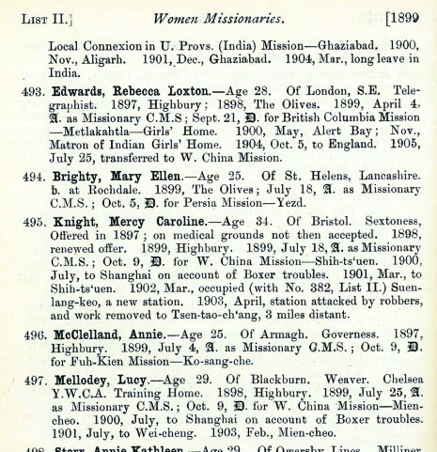
- The image below shows one of the index cards for Lucy Mellodey (left hand image). Her location is given as CMS Western China. The dates of the records listed on the card indicate that she was overseas around the beginning of the 20th century. This is confirmed by Lucy’s entry in the Register of Missionaries 1804-1904 (right hand image).

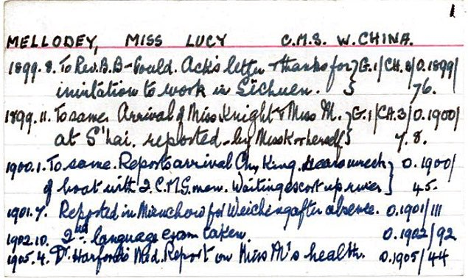

Using the Annual Report (initially ‘Proceedings’), Year Books and Directory 1801-1986

- These annual volumes include names of missionaries, business agents, native clergymen and wives of European missionaries listed alphabetically and by mission.

Papers of the CMS Overseas (Foreign) Division

- Records include letters to, from, and about individual missionaries. For some men and women, there is additional material such as personal journals which they wrote whilst overseas, committee minutes relating to their service, and reports of medical or educational institutions in which they worked. The records of this Division also include the Annual Letters which missionaries wrote back to CMS Headquarters describing their experiences in the mission over the year.
- Up to 1880, the papers in the mission series include separate files for individual missionaries. Enter the missionary’s name in to the online catalogue to the CMS Archive or use the typescript handlists. Once you have found the listing of the papers relevant to the mission you are interested in, look for Original Papers (O) kept under the Committee of Correspondence (C); then look for the file sequence titled: ‘Letters, journals and papers of individual missionaries and catechists’. The example illustrated below is a screenshot of the online catalogue (in Hierarchy View), showing North-West Canada Mission papers under the Committee of Correspondence
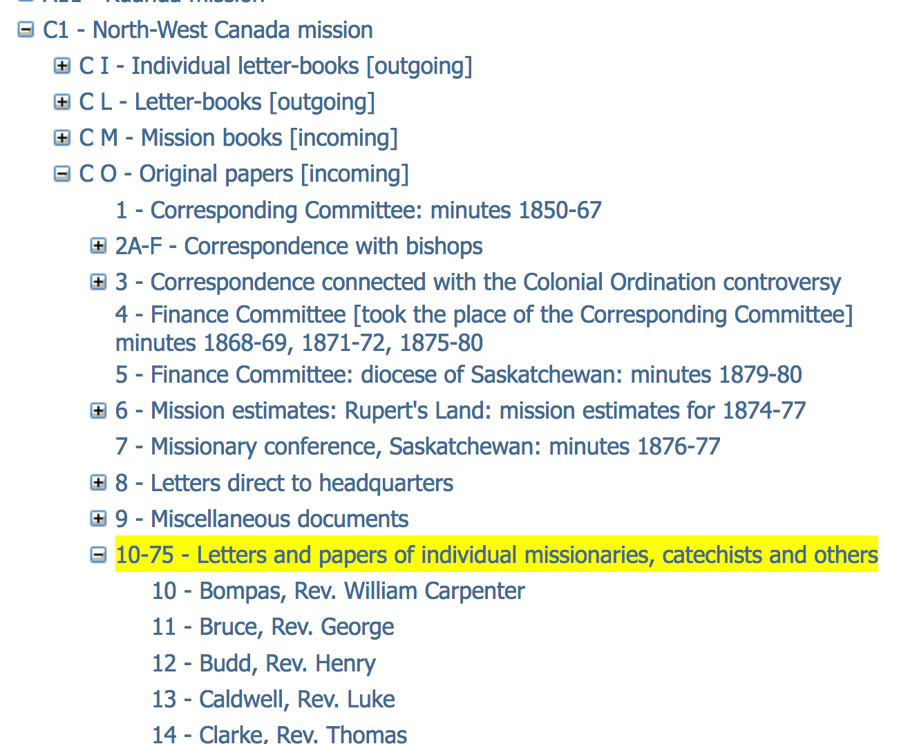

- From 1881-1934, the correspondence from the missions is filed chronologically according to the date it arrived at CMS headquarters and there is very little detail in the catalogue. Although there is a lot of correspondence from, and relating to, individual missionaries, you will not find these records by entering a name in the online archive catalogue or by looking through the typescript handlists. In most instances, you will need to visit Cadbury Research Library to search the records in person. Use the Précis Books to narrow down your search.
- If the papers of the particular mission you are interested in are amongst those which have been digitised and you are able to access the Adam Matthew Digital Collection titled ‘Research Source: Church Missionary Society’, you will be able to find correspondence in the mission series by entering the missionary’s name as a search term on the Adam Matthew website.

How can I access personal files in the records of the Overseas (Foreign) Division for missionaries who were overseas after 1935?

- From 1935, personal files were kept for each serving missionary. These files are not held by Cadbury Research Library, they have been retained by the Church Mission Society in Oxford. However, the Annual Letters which were originally held in this file sequence have been extracted and are available for consultation up to 1959.

Records of the CMS General Secretary’s Department

- The records of this Department include the earliest material relating to recruitment and training of missionary candidates; records of the Church Missionaries' Children's Home; correspondence with missionaries on leave or who had retired in the UK and personal and confidential correspondence concerning welfare of missionaries and their families overseas.
- The unbroken series of minutes for 1799-1953 can give:
  - committee decisions regarding appointments, transfers, marriage, retirement, awarding of allowances;
  - in memoriam tributes;
  - records of committee interviews with missionaries on furlough in the UK;
  - names and ages of children admitted to the Church Missionaries' Children’s Home;
  - lists of students in training (from 1826);
  - summaries of offer of service letters and testimonials (before1880);
  - dates of correspondence between the individual and CMS headquarters.

- The minutes have been microfilmed and are available online as part of the Adam Matthew Digital Collection: 'Research Source - Church Missionary Society Archive’: Central Records.
- Further suggestions for using the records of this Department are given in the Catalogue of the papers of the General Secretary’s Department 1799-1949, the typescript Catalogue of the papers of the General Secretary’s Department 1950-1959 and the Guide to the committee records of the General Secretary’s Department (PDF, 524 KB)

Records of the CMS Medical Department

- The records of the Medical Department include material relating to the health of medical and non-medical missionaries as well as news of doctors and nurses who went overseas as medical missionaries.
- The periodicals are particularly informative and easy to use. They have been microfilmed and digitised. They can be seen online as part of the Adam Matthew Digital Collection: ‘Church Missionary Society Periodicals’. The images below show the front cover and extracts from ‘The Mission Hospital’ 1926 and 1930 (Archive finding number: CMS/M/EL 2)
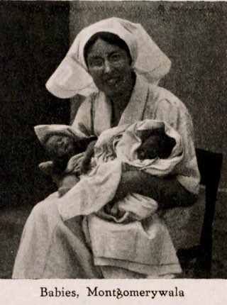
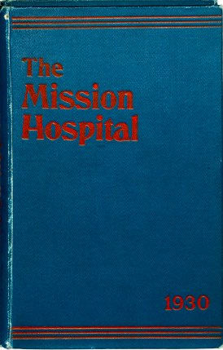

- There is a sequence of overseas correspondence which includes circular letters and appeals from medical missionaries sending news of their work to supporters back in the UK and notes of Medical Committee interviews with missionaries.
- Further suggestions for using the records of the Medical Department are given in the Catalogue of the Papers to the Medical Department 1891-1949; the typescript Catalogue of the Papers to the Medical Department 1950-1959 and Guide to the records of the Medical Department of the Church Mission Society 1863-1978 (PDF, 451 KB).

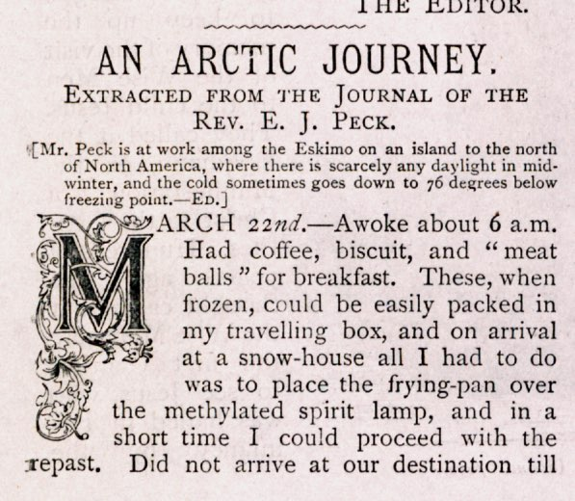
Periodicals and published works

- The CMS periodicals have numerous articles written by, or about, CMS missionaries and the Annual Report and Historical Record are illustrated with extracts of their correspondence. The example shown here is from the 1899 issue of ‘Awake’.
- Even if a missionary is not mentioned by name, the Annual Report, the Historical Record and other periodicals have accounts of local events and work in the missions giving a picture of what life was like for the missionaries.
- The records of the Editorial Department include a number of periodicals printed overseas in China, India, Japan and (less) the Sudan. These can be a good source to try when looking for information about mission workers recruited locally rather than through CMS headquarters in the UK especially as relatively few alternative sources are available in the archive. The records of the Editorial Department are listed in the Catalogue of the papers of the Home Division.
- There are small compilations of biographies and ‘Brief Sketches’ of named CMS workers within the records of the Editorial Department.
- Where there is an article by a missionary, or an obituary, in one of the main periodicals, there is usually a reference to this in the CMS card indexes.
- Most of the CMS periodicals have been microfilmed, digitised and made available online in the Adam Matthew Digital Collection titled: ‘Church Missionary Society Periodicals’.
- The biographies are on microfilm and available online in the Adam Matthew Digital Collection: ‘Research source: Church Missionary Society Archive’: Central Products: Part 13: CMS collection of Lives of Missionaries.

Records of the CMS Finance Department

- In most cases, it is not possible to use the typescript Catalogue to the Records of the Finance Department to identify records relating to individual missionaries. However, there are a number of record sequences of potential interest, for example, minutes and papers of the Personal Grants Committee 1898-1930s; papers relating to mission staff employed through the National Agents scheme1937-1951; reports of retired missionaries 1948-1949; a list of missionary children compiled in 1848; correspondence concerning candidates for grants and correspondence with the CMS missions.

Church Missionary Society Unofficial Papers

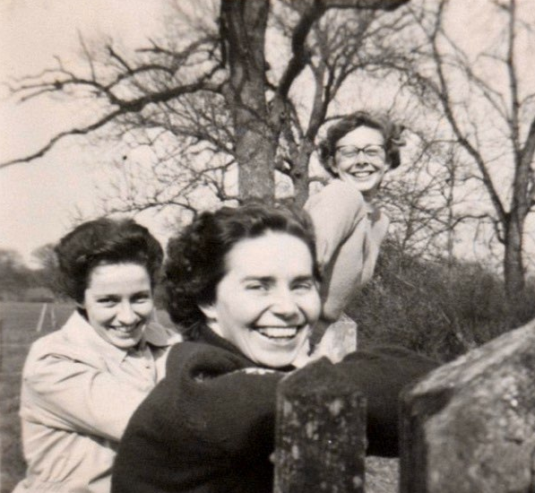

- The privately deposited collections in the wider CMS Archive can be an excellent source for records about a CMS missionary.
- They may include journals and correspondence written for personal use rather than the official record and, in some instances, records relating to wider family members.
- The Unofficial Papers are the best source to try if you are looking for original photographs of missionaries. The photograph above is from the Papers of Irene Winifred Tatham (archive finding number CMS/ACC1001).
- To find out if there are any records relevant to your search in the Unofficial Papers, enter the person’s name in the online catalogue.

Records of the Church of England Zenana Missionary Society

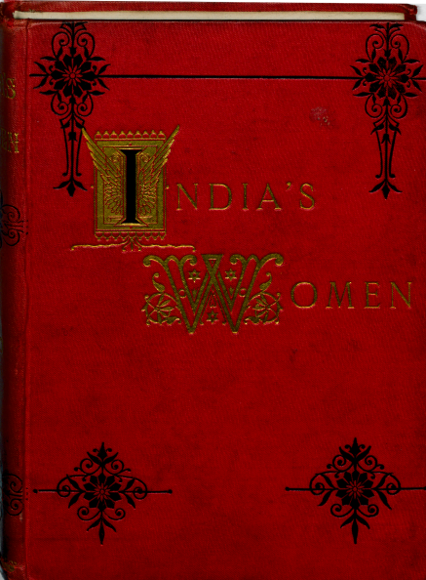
- The records of the Church of England Zenana Missionary Society (CEZMS) were transferred to CMS when the two organisations amalgamated in 1957. The Society’s main aim was to evangelise the women of India by means of ‘normal schools’ (teacher training colleges), zenana visiting, medical missions, Hindu and Muslim female schools and the local recruitment of Bible Women. From its foundation in 1880, CEZMS and CMS worked very closely and the records include references to work by missionaries from both organisations.
- The illustration above shows the front cover of a CEZMS periodical titled ‘India’s Women and China’s Daughters’. You can search the periodical for articles by, and references to, CMS men and women.
- Equally, the CMS records can be searched for information about CEZMS missionaries. For example, the CMS Name Card Index includes entries for some CEZMS missionaries. There is correspondence from CEZMS missionaries in the CMS Annual Letters and news of CEZMS in the CMS periodicals.
- Search the CEZMS card index and the Catalogue to the Records of the Church of England Zenana Missionary Society to find out more about the records and links between the two organisations.
- Almost all of the CEZMS Archive has been microfilmed, digitised and can be seen and searched online in the Adam Matthew Digital collection: ‘Research source: Church Missionary Society Archive’; look under Missions to Women and East Asia Missions.

Records for missionaries after 1959

- Most of the original documents in the CMS Archive which are currently available for research date from 1799-1959.
- The periodicals and other published works and the growing sequence of CMS Unofficial Papers mean that it is possible to find accounts of CMS work overseas into the 21st century. Of particular note is the highly informative Historical Record with references to missionaries, extracts of their correspondence and detailed accounts of work in the missions compiled annually until 1986 (under three titles).

How to use the archive to find out about a missionary before they went overseas

- Check the Registers of Missionaries for names of higher education and training institutions.
- To find out about the CMS training institutions and records relating to the training and recruitment of CMS missionaries, including missionaries’ application papers, search the Catalogue to the Candidates Department, Catalogue of the papers of the General Secretary’s Department [1799-1949], the typescript Catalogue of the papers of the General Secretary’s Department 1950-1959, and related guides.
- The records of the CMS Medical Department include minutes and papers of the Medical Board that assessed candidates' fitness for service 1863-1921, minutes of the Medical Training Home Committee 1900-1907 and brief notes of candidates' medical examinations compiled by the Society's Physician between the 1890s and 1903.

- If there is a privately deposited collection relating to the missionary in the CMS Unofficial Papers, you may find summary biographical information about their life before and after CMS in the online catalogue as in the example illustrated here which is from the online catalogue to papers of the Roberts family. Look under Administrative History.

- Obituaries in the CMS periodicals may provide further detail although, for most missionaries, they are brief. Lengthier obituaries are more often given in the minutes of the General Secretary’s Department.

Where else to search for records relating to a CMS missionary

Potentially any record sequences in the CMS Archive might have references to the missionary. Try for example:
- Catalogue to the records of the Women’s Department
- Catalogue to the records of the Educational Auxiliary
- Catalogue to the papers of the Home Division (typescript)
- Catalogue of the records of Overseas Missions (typescript)
- Catalogue of miscellaneous papers
- Other repositories which hold material relating to the CMS
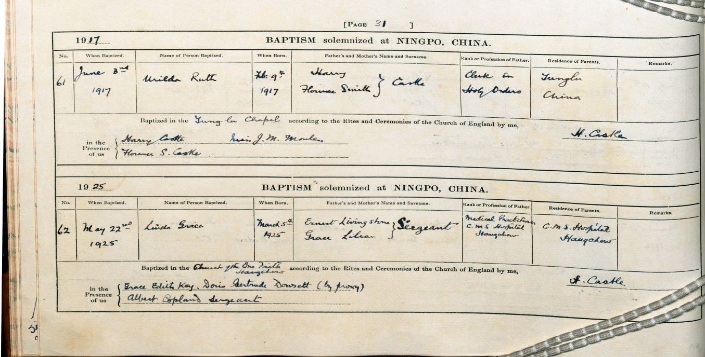
One of the records listed in the Catalogue to the records of Overseas Missions (CMS/Q/CH2/01)

How to find records about a CMS mission

As one of the founding aims of the Church Mission Society was to evangelise the world, to some extent all of the record sequences have information relating to work in the overseas missions. This section of guide gives tips on searching, including using the finding aids, and a brief overview of the main record sequences which you could use to find out about a particular mission or related geographical area.

- Things to bear in mind when looking for information about a CMS mission
- Could I just enter the name of the mission in the online catalogue?
- Could I just search online through Adam Matthew Digital Collections?
- Periodicals and published works
- The card indexes
- Papers of the CMS Overseas (Foreign) Division
- Records of the CMS General Secretary’s Department
- Records of the CMS Home Division
- Records of the CMS Finance Department
- Church Missionary Society Unofficial Papers
- Maps
- Plans of mission property
- Are there any records of work in the missions after 1959?
- CMS Archive: the deposited papers
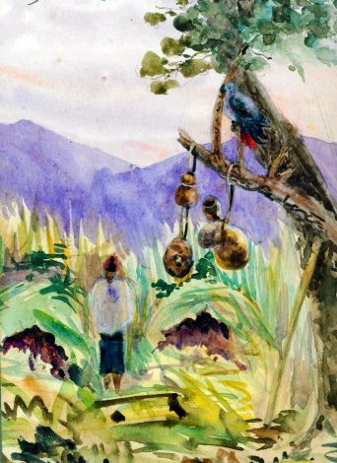
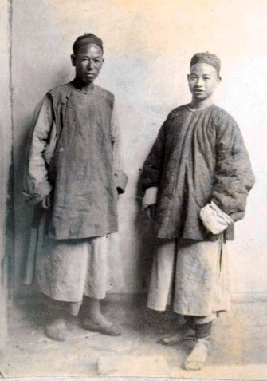
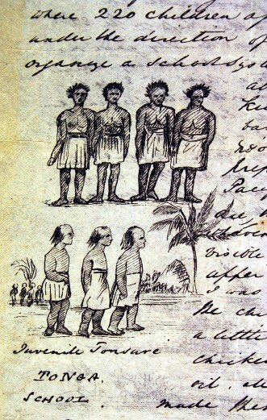
- Where else to search for records relating to areas where CMS was working

Things to bear in mind when looking for information about a CMS mission

- A lot of information about the different mission areas can be found in the printed and typescript periodicals and other published works, especially when combined with Annual Letters of missionaries working in the area. These may give you all that you need.
- As you work through the papers, keep a note of the names of missionaries working in the area in which you are interested. This will help you to find other records with information about your area of interest.
- The dates you are interested in will affect which finding aids you need to use.
- In some instances, names of mission stations, the area they covered and the committee at CMS headquarters to which they reported, changed over time. Take care to read the guidance in the catalogues so that you can be sure to locate all of the records relevant to your search.
- If you are searching the online catalogue, the sub-sub-sub-fonds level of the overseas mission series is a good place to look for an overview of where and when a mission was active (and whether the papers have been copied on to microfilm and digitised). You can follow links directly to the sub-sub-sub-fonds level from the lists of missions earlier in this Guide. The illustration below shows the entry for papers of the Mediterranean Mission (sub-sub-sub-fonds level) including a magnified extract of the ‘Administrative History’ section (right hand image).
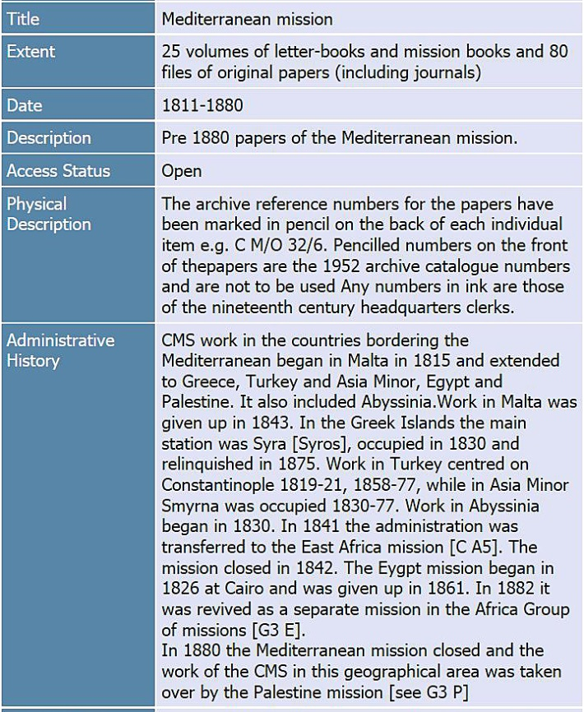
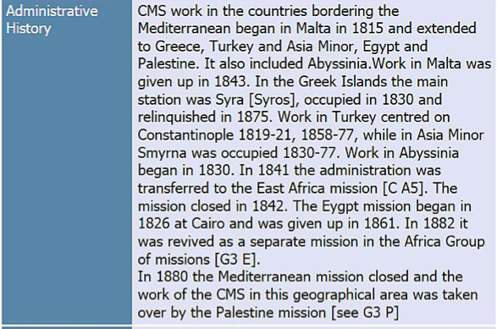

Could I just enter the name of the mission in the online catalogue?

- If you use the name of a mission to search the online catalogue and the search brings up very few entries, this does not mean that there is nothing more to find.
- There are records in the archive which are not listed in the online catalogue.
- Try different spellings/terms for the places that you are interested in, especially if these have changed over time.

Could I just search online using the Adam Matthew Digital Collections?

- Approximately two-thirds of the CMS Archive can be searched and seen online in the Cadbury Research Library Reading Room and through subscription to Adam Matthew Digital Ltd collections.
- Whichever mission you are looking for, you are likely to find something in the papers which can be seen online especially if the papers in the overseas mission series for your particular area and dates have been digitised. However, there are thousands of papers in the CMS Archive which have not been digitised and so it is worth checking the catalogue and other finding aids to the CMS Archive as well as the digital collections.

Periodicals and published works

- You can use the published works to establish when and where CMS was working overseas, what sort of issues were affecting progress of the mission (for example, health of missionaries, socio-economic or political climate, CMS finances) and the names of key personnel.
- The published histories can be a good place to start.
- Once you know the dates relevant to your search, you can search the Annual Report (or ‘Proceedings of the Church Missionary Society’) for names of mission stations and missionaries working in them, a summary history of each mission and brief report of the year’s work.
- From 1919, 1922-1986, detailed accounts of mission work are given in the CMS Historical Record. These annual volumes are especially valuable for research into educational and medical work.
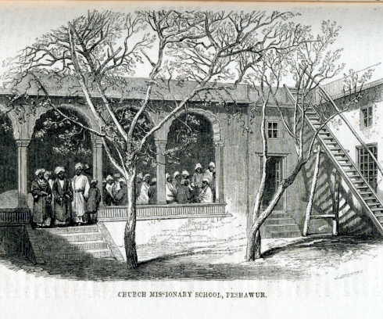
- The illustrated periodicals have articles on the Society’s missions written to engage a European audience in life and work overseas and are one of the best sources in the Archive for contemporary observations on customs and culture.
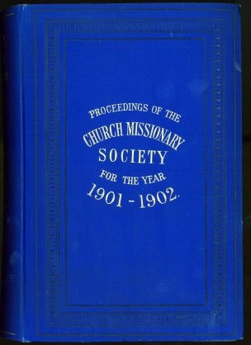
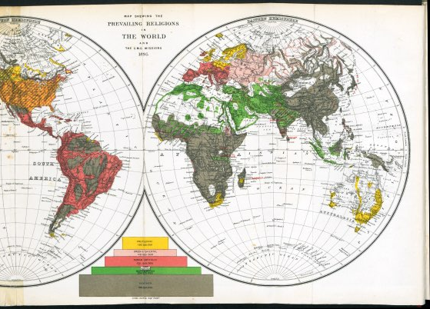

- The illustrations above show the ‘Church Missionary Gleaner’ 1857; the ‘Proceedings’ for 1901-1902 and the ‘Church Missionary Atlas’ for 1896.

The card indexes

- When you visit Cadbury Research Library you will be able to consult the microfiche copy of a card index to countries and places referenced in the CMS papers.
- The index to Records of the Church of England Zenana Missionary Society includes places where both CMS and CEZMS missionaries were working.

Papers of the Overseas (Foreign) Division

- The records which were created and compiled under the various committees of the CMS Overseas Division (initially Foreign Division) between 1799 and 1959 are a tremendous source for finding out about the CMS missions. They include the main sequences of correspondence between CMS headquarters and the mission, including letters, missionaries’ journals, reports, minutes, statistical returns, copies of local publications and other printed papers as well as minutes and papers recording the planning and decision making at CMS headquarters.
- Papers currently available for research fall into three broad date ranges: up to 1880, 1880-1934 and 1935-1959. The type of records you find, and the archive finding aids which you need to use, will be determined by which of these date ranges are relevant to your research.

- Use this Guide to find out more about the type of records you could find and how to make the most of the online and typescript finding aids relevant to the mission you are interested in.
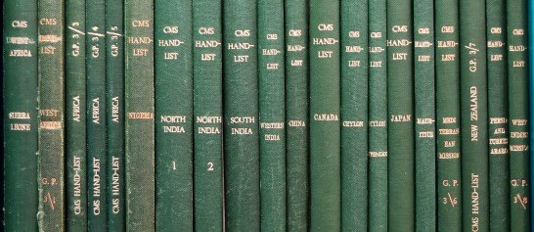

Records of the General Secretary’s Department

- The records of the General Secretary’s Department are important for studying the overseas missions because of the central role played by the General Secretary in all aspects of work in the UK and overseas.
- Records currently available for research date from 1799 to c 1960.
- Highlights include an unbroken sequence of minutes recording new developments, policy, decisions and resolutions concerning the Society’s work overseas 1799-1953. The minute books are accompanied by indexes which can be used to search for references to specific missions. The tour reports and overseas mission correspondence sequences are also particularly relevant.
- The records are arranged and catalogued in two parts: Papers of the General Secretary’s Department 1799-1949 and Papers of the Department 1950-1959.
- To find out more, search the Catalogue to the Records of the General Secretary’s Department and see the Guide to minutes in the records of the General Secretary’s Department (PDF, 524 KB). The typescript Catalogue to the Records of the General Secretary’s Department 1950-1959 is available to consult in Cadbury Research Library.

Papers of the Home Division

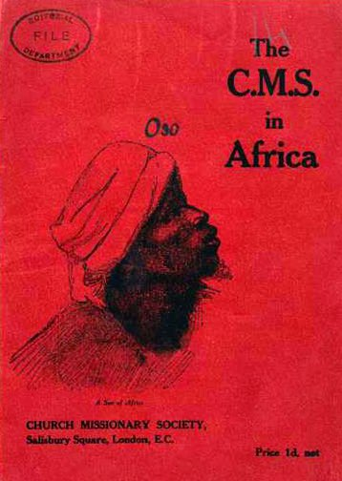
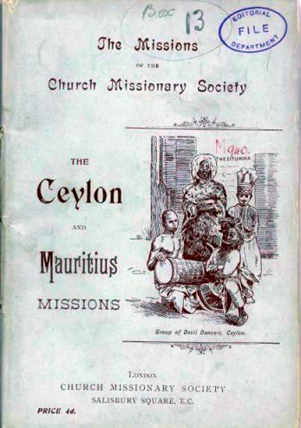
- The papers of the CMS Home Division include copies of periodicals, pamphlets and other printed material designed to raise awareness, funds and recruits for the Society’s missions.

- They are an excellent source for summary facts about the missions and different branches of work overseas including medical and educational institutions.
- The examples pictured above show printed pamphlets and a leaflet from the records of the Editorial Department (archive finding numbers CMS/H/H5 E2).
- The Catalogue to the papers of the Home Division cannot be seen online. A paper copy is available to consult in Cadbury Research Library. It is annotated to indicate those of the papers which have been microfilmed, digitised and made available online in the Adam Matthew Digital Collections titled ‘Research Source: Church Missionary Society Archive’ and ‘Church Missionary Society Periodicals’.

Records of the Finance Department

- The records are particularly useful for information on the funding of mission work and papers relating to schools, hospitals and other mission properties.
- Highlights include early correspondence with the British government, records of the Church Missionary Trust Association (an incorporated body established in 1885 to hold CMS property all over the world), building plans and property registers.
- The records of the Finance Department include some items which were originally kept by the committees administering the work of the Overseas (Foreign) Division and are now ‘missing’ from the files in the overseas mission series.

CMS Unofficial Papers

- There is much relating to missions in the collections of privately deposited papers, including sketches and paintings made by missionaries whilst living overseas and journals and correspondence written for personal use rather than the official record.
- The Unofficial Papers are the best source to try if you are looking for original photographs taken by missionaries during their time overseas. Many show scenes of everyday life, the geography and infrastructure of the surrounding area.
- To find out if there are any records relevant to your search in the Unofficial Papers, enter the name of the mission, town, region or country in the online catalogue to the CMS Unofficial Papers.

Maps

- The CMS Archive includes a small compilation of maps depicting places overseas where the Society was working. They are arranged by committee of the CMS Overseas (Foreign) Division thereunder by mission area and dated 1804-1945. A typescript catalogue of the CMS Map series is held in Cadbury Research Library. These maps are currently closed for Conservation.
- There are printed maps in the CMS periodicals, particularly the Annual Reports and the Church Missionary Atlas.
- There are some maps in the in the sequences of Original Papers compiled by the departments of the Overseas (Foreign) Division.
- Use the online archive catalogue to locate further miscellaneous copies of maps in the CMS Archive.

Plans of mission property

- The CMS Archive includes a small compilation of plans, dated [c 1870]-c 1960. The plans are arranged by committee of the Overseas (Foreign) Division thereunder by mission area. Search the typescript Catalogue of Plans held in Cadbury Research Library. These plans are currently closed for conservation.
- Printed and manuscript plans of CMS property can be found in the records of the CMS Medical Department - in the periodicals, the finance papers and overseas correspondence. Use the online catalogue to search the Catalogue of the papers of the Medical Department 1891-1949. A copy of the typescript Catalogue of the papers of the Medical Department 1950-1959 is held in Cadbury Research Library.
- There are some plans in the in the sequences of Original Papers compiled by the departments of the CMS Overseas (Foreign) Division.
- Consider also the property papers in the records of the Finance Department.
- Use the online archive catalogue to find other miscellaneous copies of plans.

Records of work in the missions after 1959

- Most of the records currently available for research date from 1799-1959. However, the periodicals and other published works, and the growing sequence of CMS Unofficial Papers, mean that it is possible to find accounts of CMS work overseas into the 21st century.
- Of particular note is the highly informative CMS Historical Record which gives a detailed account of each mission written annually 1919,1922-1986.

CMS Archive: the deposited papers

- The organisations whose records were deposited with CMS and were transferred to the University of Birmingham as part of the wider CMS Archive may include information of interest as the organisations were closely connected.
- Follow the links to the Fonds level entry in the catalogue to each of these collections to find out if any of the organisations worked in areas relevant to your research.
  - Church of England Zenana Missionary Society;
  - Loochoo Naval Mission;
  - Society for Promoting Female Education in the East;
  - Mid-Africa Ministry.

- The two images below show the Fonds level entry in the Catalogue to the Records of the Society for Promoting Female Education in the East. The magnified extract (right hand image) illustrates how information about where the Society worked is given under ‘Administrative History’.
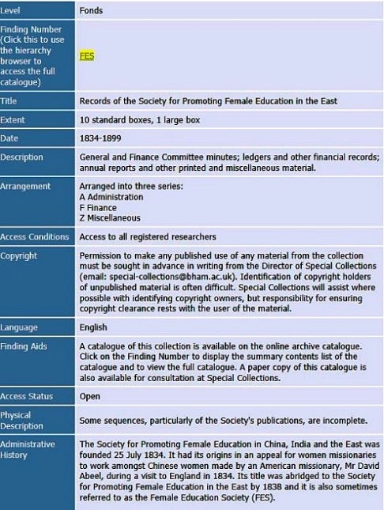

- If you are using the paper copies of the catalogues to these collections you will find the same information in the explanatory text at the front of the handlist.

Where else to search for records relating to a CMS mission

Potentially any record sequences in the CMS Archive might have references to one of the CMS missions. Try for example:
- Catalogue of the records of Overseas Missions (typescript)
- Catalogue to the records of the Educational Auxiliary
- Catalogue of miscellaneous papers.
- Other repositories which hold material relating to the CMS.

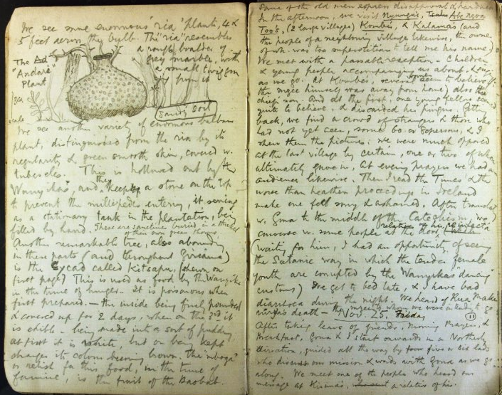

The illustration is from a record in the CMS miscellaneous papers series: double page spread of pages from a field notebook written by William Ernest Taylor (1856-1927), Swahili scholar and CMS missionary to East Africa (archive finding number CMS/Z13/2)

Resources for the study of educational mission overseas

- All missionaries of the Church Missionary Society worked towards the common goal of world evangelisation. Different methods were used to achieve this. One of the main and earliest methods was educational mission.
- This section of the Guide is intended to give anyone interested in the educational branch of overseas mission work an overview of the type of records which can be found in the CMS Archive. It should be used alongside the other sections of the Research Guide, including, ‘How to find records about a CMS mission’ and ‘How to find records about a CMS missionary’.
It is broadly arranged as:
  - an overview of the early days of CMS educational work overseas;
  - issues to bear in mind when searching for records of educational mission work;
  - examples of records relating to educational work overseas that can be found in the different parts of the official CMS Archive, the CMS Unofficial Papers, the Records of Society for Promoting Female Education in the East and the Records of the Church of England Zenana Missionary Society.
- Some of the resources listed below are available online through Adam Matthew Digital Ltd, the Hathi Trust Digital Library, the Internet Archive or the website of missiology.org.uk: a Gateway for the Study of Christian Missions. Further information about online copies is given on the websites and in this Guide under CMS Archive Online.
- Although the CMS was very actively engaged in home (UK) educational mission the focus here is on work overseas.

Early days of CMS educational mission overseas

- Educational mission was valued as a means of bringing children under Christian teaching and influence with the expectation that they would go on to influence others by training to become teachers, members of the clergy or in other spheres of life.
- Missionaries set up and worked in village schools, night-schools, boarding schools, secondary schools, colleges affiliated to universities, divinity colleges and other vocational training institutions.

- In the early days, some teaching was undertaken by missionaries who were not specifically recruited as teachers or identified as such in the Society’s ‘Register of Missionaries’.
- Some of the first work was established by wives of missionaries. As early as March 1805, Mrs [Sarah] Hartwig was writing to CMS headquarters about teaching 20 children.
- By 1811, when the Revs John Godfrey Wilhelm and Jonathan Solomon Klein went out to West Africa, they were expected to take with them the methods and tools of the ‘evolving national system of education’ in which they had been instructed whilst in London. The system pioneered by Rev Dr Andrew Bell (1753-1832) involved cascading of knowledge: a teacher taught a top group of children who then taught groups of younger or less able children; known as the Bell’s system or Madras system of education.
- One of the first lay recruits appointed as a teacher was Jellorum Harrison, a multi-lingual Susu from the Rio Pongas. Formerly a pupil at the school in Bashia, he trained as a teacher in England before arriving back to start work on the staff of the CMS mission to Sierra Leone February 1815. As an indigenous, lay member of staff he is not listed in the ‘Register of Missionaries, Clerical, lay and female, and Native Clergy, 1804-1904’ although his appointment is recorded in the ‘Proceedings of the Church Missionary Society for Africa and the East, 1813-1815’.
- Those engaged in educational mission included pioneers in provision for blind and deaf pupils. For example, Jane Leupolt, née Jones (d 1894), adapted Moon’s system of raised shapes to oriental languages; she worked in India under the Society for Promoting Female Education in the East.
- In 1815, when the Committee at CMS headquarters delivered its Annual Report to members, it advised on plans underway for a ‘Christian Institution’ to provide a place of education in Sierra Leone ‘secure under the protection of the Colonial [British] Government’. The Institution, initially established at Leicester Mountain, was a predecessor of the Fourah Bay College which was to be founded in 1827 and is now a constituent college of the University of Sierra Leone with a long history of notable staff and alumni.
- Citing figures based on annual returns of the missions for 1899, the ‘Centenary History of the Church Missionary Society’ published in 1902, notes that the CMS had 2,130 schools and seminaries overseas
- By the start of the 20th century, CMS was working in 2,130 schools and seminaries teaching 71,341 boys, 32,173 girls and 683 seminarists.

Things to bear in mind when looking for educational mission records

- Records relating to educational work are not all filed or listed together. It is necessary to look for them amongst the other records of the Society’s overseas work. To find records of interest, follow the guidance under How to find records about a CMS mission and How to Find records about a CMS missionary. Suggestions on record series which might be of particular interest are listed over the following pages.
- Women played a vital, and in many cases, lead role in education work but the extent of their contribution is not immediately obvious in the records. This is especially so where the women engaged in teaching went out as wives of missionaries or were recruited locally rather than through CMS headquarters.
  - Some of the most important records of CMS work overseas are those kept by the departments of the CMS Overseas (Foreign) Division. When using them for evidence of educational mission, it may be necessary to look for references to women in the correspondence of the mission secretary or a husband’s mission file.
  - When searching digitised records, try entering the surname rather than a title and surname. For example, Nylander rather than “Rev Nylander”. Alternatively try adding ‘Miss’ or ‘Mrs’ to a surname.
  - The CMS periodicals are an excellent source for articles by women, including those intended written for children, such as the CMS Juvenile Instructor.
- The majority of records in the CMS Archive relating to educational missions were created by, or sent to, CMS headquarters. They do not typically include day to day working records of educational establishments such as school attendance registers, student record cards, examples of pupils’ work, timetables or completed exam papers. Where such records have survived, they are likely to have been kept in the country of origin either with the institution, in a local or national archive repository. Where miscellaneous examples can be found in the Archive they tend to be from the earliest years of overseas work, for example, the South India mission files include a list of students at Cottayam College in 1839 giving the name, age, religion, residence, connection with missionaries or mission, profession of father, date of admission and other remarks.

CMS periodicals and published histories

- Provide edited news of educational work presented in an accessible way, over the full length of the Society’s history. Available for research into the 21st century. The earliest annual reports date back to 1801.
- The periodicals include articles and extracts of letters written by men and women engaged in educational work sharing news of individual institutions, staff and, to a limited extent, pupils and former pupils. There are summary accounts of the history, purpose and progress of educational work overseas alongside news of other events and developments. Most of the periodicals are illustrated with sketches or photographs.
- Information about how to access periodicals and published histories is given earlier in this Research Guide Research. Examples of some of the titles relevant to the study of educational mission are given below.
- Eugene Stock ‘The History of the Church Missionary Society, its environment, its men and its work’, in four volumes, London: CMS, 1899-1916.
  - Includes, for example, an account of the CMS Educational Auxiliary, volume 4, pages 526-528; use of Bell’s system of instruction, volume 1, page 232; chapters on the different mission areas including the history of local CMS educational provision.
  - Available online.

- 'Centenary Volume of the Church Missionary Society’ (London: CMS, 1902)
  - Lists CMS institutions including educational establishments; also gives summary findings of a three year review initiated by CMS headquarters which reflected on the success and challenges of all branches of mission work, including educational mission, and suggested plans for advance in to the 20th century.
  - Available online.

- Gordon Hewitt ‘The Problems of Success: a history of the Church Missionary Society, 1910-1942’, in two volumes. Published for CMS by the SCM Press, 1971-1977.

- ‘Proceedings of the Church Missionary Society’ 1801-1921 retitled ‘Annual Report’ 1922-1961
  - Gives names of educational institutions and lists of staff in the different mission areas as well as news of work. Some staff are not named, particularly those recruited locally rather than through CMS headquarters, London.
  - Some issues give summary statistics for the different mission areas including numbers of clerical and lay teachers and assistants, numbers of non-Christian teachers, native seminarists and scholars.
  - Some issues have an ‘Index of special topics’: educational mission work is one of the special topics.
  - The early 19th century reports of the Committee have much on the early days, motives and expectations for Educational Mission.
  - Miscellaneous copies available online.

- CMS Historical Record, 1919, 1922-1986. Issued as ‘General Review of Missions’ 1919 and ‘CMS Annual Report’ 1922-1942.
  - Detailed accounts of work in each mission area including news of individual educational institutions and staff.
  - Available online.

- ‘Church Missionary Atlas’, London: CMS: in a number of editions 1853-1896.
  - The summary histories arranged by geographical area include details about named educational institutions and statistics including numbers of scholars and schools at different points in time.
  - The volumes give a perspective of changes over time and make reference to other Protestant mission societies working in the same areas.
  - Some editions available online.

- Weekly, monthly and quarterly periodicals published by CMS headquarters 1816-.
  - Long-running examples include:
    - the Church Missionary (Quarterly) Paper issued from March 1816;
    - the Church Missionary Record 1830-1875;
    - the Church Missionary Intelligencer (A monthly journal of Missionary Information) 1849-1906 which became the Church Missionary Review 1907-1927, the Church Overseas 1928-1934 and later East & West Review 1935-1964;
    - the Church Missionary Gleaner issued 1842-1921 became the Church Missionary Outlook 1922-1972 and later ‘YES’ 1973-.
  - Many, including all those listed above, are available online.

- Overseas periodicals printed in China, India, Japan and the Sudan
  - A small but important compilation of periodicals in the records of the CMS Home Division. Particularly helpful for news of staff recruited locally and local issues which were not published in the periodicals issued from CMS headquarters in London. The full list of titles is given in the Catalogue to the Records of the Home Division available to consult in the Cadbury Research Library.
  - Examples of titles held in the overseas periodicals sequence:
    - Report of the CMS and CEZMS Fukien Church Day Schools, 1912-1934;
    - CMS Fukien Conference including minutes of the education sub-committee;
    - Church Mission School for Blind Boys, Northgate, Foochow, China, 1931;
    - From Month to Month: magazine of the Hong Kong Church Missionary Association, 1899-1906;
    - Fukien Christian University: regulations for admission and graduation, 1927-1928.
  - Some titles available online.

Papers of the CMS Overseas (or Foreign) Division

- The type of records kept by the different departments of the Overseas Division varies across missions and over time but, whatever the date, there are records in the mission series and the general series relating to educational work.
- There is correspondence between staff of educational missions and CMS headquarters. There is also correspondence with overseas mission secretaries reporting on wider issues affecting the progress of educational work such as local government policy on education.
- Correspondence may include:
  - minutes of the local corresponding committee recording decisions about educational work and staff;
  - annual returns including statistics relating to school work;
  - half yearly school reports;
  - ‘Annual Letters’ of staff of educational missions;
  - school syllabuses;
  - regulations;
  - end of year reports;
  - school or college anniversary literature;
  - lists of pupils and staff;
  - locally printed newsletters;
  - requests for school supplies;
  - correspondence over school property;
  - reports of staffing issues;
  - journals written by educational missionaries;
  - school accounts;
  - ‘Instructions to missionaries’ issued by the Committee at CMS headquarters indicating what their focus should be.

- When researching educational establishments active between 1880 and 1959, it can be helpful to work backwards rather than forwards in time through the mission files. From 1935 onwards, the records relating to educational institutions are grouped together within the mission files rather than being filed chronologically amongst records of other types of work.
- Many mission papers have been digitised as part of the Adam Matthew Digital Collection: ‘Research Source: Church Missionary Society’. If the mission papers are amongst those which have been digitised and you are able to access the Adam Matthew Digital Collection you will be able to find correspondence in the mission series by entering the name of an institution, educational missionary or broader terms such as ‘education’, ‘school’, ‘pupils’ or ‘regulations’ on the Adam Matthew website.

Records of the CMS General Secretary’s Department

- An excellent source of information for policy and progress of educational work from the foundation of the Society to the 1950s.
- Examples of records relating to educational work include:
  - correspondence with the British Government and with educational missionaries whilst in the UK in the ‘Home’ correspondence;
  - minutes recording new developments, policy, decisions and resolutions concerning the Society’s educational work overseas up to 1953;
  - a Precis book for meetings of the Educational Committee 1901-1909;
  - tour reports in which visiting staff reported back on work overseas observations on educational institutions and staff;
  - files of overseas mission correspondence;
  - circulars and other printed papers including, topics such: 'The case for educational missions’, 1902; these papers also include copies of some of the Instructions given to missionaries about to go overseas;
  - a series of ‘Education and information’ files which include, for example, reference to books for theological colleges.
  - Some of these records have been digitised and can be seen online by anyone with access to the Adam Matthew Digital Collection: 'Research Source - Church Missionary Society Archive’: Central Records. Digitised records include circular books, many of the minutes, selected index volumes and selected papers in the files of overseas correspondence.

Records of the CMS Home Division

- Records of different departments of the Home Division are relevant to educational mission overseas.
- Most notably, records of the Editorial Secretary are an excellent source of printed literature. As well as periodicals mentioned earlier in this resource list, pamphlets, booklets and circulars disseminated to attract recruits, raise funds and share evidence of need and success include a great deal of information about educational missions.
- Examples of records include:
  - illustrated pamphlets on individual schools and other educational establishments (CMS/H/H5/E2);
  - papers on educational work in a box of pamphlets held under the heading ‘Mission Field’ (CMS/H/H5/E2)
  - essay by Miss K. D. Flood, Bishop Otter College, ’The contribution of Christian Missions to the Education of British West Africa, [written 1930s] (CMS/H/H3/A3);
  - report of a tour of South India and Ceylon by the Education Secretary, 1946-1947 (CMS/H/H5/AD 1);
  - materials relating to exhibitions, audio-visual aids and study packs for use in UK include reference to education work overseas (for example, CMS/H/H15/E6);
  - records of overseas visitors studying in the UK (CMS/H/H16);
  - correspondence about the re-building of St Mary’s School, Khammamett 1953 (CMS/H/H18/A4);
  - correspondence about the Kistna Teacher Scheme [South India], (CMS/H/H18/AC 1);
  - the Information Officer’s papers include a file on the rural training centre, Asaba, Nigeria 1955-1961, a printed report of the principal Alliance High School Kikuyu, 1957 and other information and facts sheets of note (CMS/H/H35).

Records of the CMS Educational Auxiliary

- A small sequence of papers, dated c 1898-1917.
- The Educational Auxiliary was established to rouse interest amongst supporters in the UK for CMS work in schools and colleges overseas and to raise financial support.

Records of the CMS Finance Department

- Records kept by the Finance Department include property papers for schools buildings and correspondence with British Government over funding for CMS schools.

Other record series within the CMS Archive

- A few items relating to education overseas can be found in other record series within the CMS Archive.
- The miscellaneous papers series includes samplers stitched by pupils at CMS schools in Africa and school books.
- The collection of CMS Theses includes several papers relating to education overseas.
- The registers of despatches and correspondence in the records of the CMS Women’s Department include references to educational work.
- Consider also records in the papers of the overseas mission secretaries which form part of the records of the overseas churches (CMS/Q).

Church Missionary Society Unofficial Papers

- The privately deposited collections held as the CMS Unofficial Papers hold a wide variety of materials including papers relating to missionaries involved in education work overseas.
- Examples of records include:
  - photographs, postcards and sketches of educational institutions, pupils and staff;
  - personal papers of educational missionaries including diaries, letters and other family papers;
  - printed ephemera relating to educational institutions, for example, a fundraising pamphlet for the Wad Medani Church of England Girls’ school; newscuttings reporting school events;
  - personal memoirs of educational missionaries;
  - teaching notes;
  - teacher training certificates;
  - exam papers
  - school prospectus
  - ground plan
  - a video copy of a cinefilm made by Wing-Commander Pratt whilst holidaying in Kashmir, including a visit to the CMS Boys’ school in Srinagar

Records of the Church of England Zenana Missionary Society

- Founded in 1880, the Society amalgamated with CMS in 1957.
- The main object of the Society was to evangelise the women of India and educational mission was one of the principal methods used to achieve this goal.
- Educational mission undertaken by the women of the CEZMS primarily involved work in normal schools (teacher training colleges), zenanas, Hindu and Muslim female schools. It included industrial work and work with blind and deaf students.
- Areas of work: India, China, Japan, Ceylon [Sri Lanka], Malaya.
- Examples of record sequences relevant to educational mission: incoming and outgoing correspondence with missions; annual reports and statistical returns; printed literature including illustrated periodicals; papers and correspondence relating to property owned or used by the CEZMS.
- The catalogue to the records of the Church of England Zenana Missionary Society is available online.
- Digitised copies of almost all of the records are available online through Adam Matthew Digital Ltd: ’Research Source - Church Missionary Society Archive: Missions to Women', 'Research Source - Church Missionary Society Archive: East Asia Missions' and 'Church Missionary Society Periodicals'.

Records of the Society for Promoting Female Education in the East

- Formerly ‘The Society for Promoting Female Education in China, India and the East ‘. Also known as the Female Education Society, the Society was active 1834-1899.
- The records held by the Cadbury Research Library comprise a small, very incomplete collection. They are nevertheless important for the history of educational mission overseas as the principal object of the Society was the establishment and superintendence of schools in China, India and adjacent countries. The first missionary went out in 1836.
- Areas of work: India, China, Japan, South Africa, Palestine, Bethlehem, Shelf Amr, Syria, Lebanon and Mauritius. The Society also supported schools throughout India and China as well as Ceylon [Sri Lanka], Sierra Leone, Nigeria, Burma [Myanmar], Penang, Greece, Turkey, Algeria and throughout the Levant.
- The catalogue to the records of the Society for Promoting Female education in the East is available online.
- Digitised copies of the records are available online through Adam Matthew Digital Ltd: 'Research Source: Church Missionary Society Archive: missions to women’; Church Missionary Society Periodicals’ and 'Empire Online'.

Records of CMS educational mission in other collections

- Cadbury Research Library holds the papers of Caroline Cuffley Giberne, CMS missionary teacher, South India (DA18) and Papers of Dorothea Jane Stephen, educational missionary to South India (DA53).

Sources used to compile the notes on early history for this section of the Guide

- Records from the CMS Archive: circular book, CMS/G/AZ 1/1; letter from Mrs Hartwig, CMS CA1 E1/9 [14]; ‘Proceedings of the Church Missionary Society for Africa and the East, 1813-1815’ (CMS periodicals, unnumbered);
- Bruce L. ‘Origins of Church Missionary Society Accommodation to Imperial Policy: The Sierra Leone Quagmire and the Closing of the Susu Mission, 1804-17. Journal of Religion in Africa, volume 39, 4, 2009, pages 375–402. JSTOR, www.jstor.org/stable/20696829; accessed 23 July 2020.
- Wikipedia https://en.wikipedia.org/wiki/Andrew_Bell_(educationalist).; accessed 23 July 2020;
- Blackpast website https://www.blackpast.org/global-african-history/fourah-bay-college-1827/.
- Miles, M. ‘Blind and Sighted Pioneer Teachers in 19th Century China and India’, April 2011 (revised edition) available at www.independentliving.org/docs7/miles201104.html; accessed 27 July 2020.

List of illustrations used in the Guide

Photographs, artwork and other papers from the CMS Archive

Front cover: Mount Elgon, 20 October 1923: painting from an album of watercolours by Annie Emma Allen (1853-1942), CMS missionary to Uganda (CMS/ACC321).
Page 16: ‘Register of missionaries (clerical, lay & female) and native clergy from 1804 to 1904’ Church Missionary Society, 1905 (CMS periodicals, unnumbered).
Page 21: ‘Proceedings of the Church Missionary Society for the Year1901-1902’ (CMS periodicals, unnumbered).
Page 24: CMS ‘Historical Record’ 1955-1956; 1957 (CMS periodicals, unnumbered).
Page 35: Mission Books from the papers of the New Zealand Mission (CMS/C N M1) and North-West America Mission (CMS/C C1 M1).
Page 38: Correspondence from the papers of the North-West Canada Mission and West Indies Mission (CMS/C C1 O20-21; CMS/C W O12/9/1).
Page 43: Précis Book 3 from the papers of the South China Mission, 1900-1913 (CMS/G1 CH1 P3).
Page 44: Signed manuscript letter from the papers of the South China Mission, 1900 (CMS/G1 CH1 O1900/213).
Page 47: Signed ‘Annual Letter’ of Lucy Mellodey, Western China Mission, 1917 (CMS G1 AL 1917 Mellodey).
Page 56: Painting from an album of watercolours by Annie Emma Allen, Uganda, [c 1920] (CMS/ACC321).
Page 56: Photograph of a barber from Miss Edith Baring-Gould’s album of photographs relating to winter missionaries to India, [c 1888] (CMS/ACC21 Z1).
Page 56: Photograph captioned ‘Mr Hamilton and his teacher’, [China 1899] (CMS/ACC608 F1).
Page 66: Papers of the Home Division: ’The Children’s World’; “Picture and Fact” Post Cards; ‘An Episode of the Afghan Medical Mission at Bannu’ CMS Medical Mission Leaflets, number 2; CMS game: ‘What Next?’ (CMS/H/H5 E2).
Page 92: Photograph of Bishop Samuel Adjai Crowther and son, [c 1860] (CMS/ACC314 Z1).
Page 92: Photograph of Lucy Mellodey, Western China, [c 1900] (CMS/ACC608 F1).
Page 92: Photograph of Reverend George Townshend Fox, Nigeria, [c 1910] (CMS/ACC182 Z1).
Page 92: Photograph of Christine Carleton in her dispensary, Western China, [c 1900] (CMS ACC608 F1).
Page 95: ‘Register of missionaries (clerical, lay & female) and native clergy from 1804 to 1904’ Church Missionary Society, 1905 (CMS periodicals, unnumbered).
Page 98: Front cover and printed extract from CMS periodical ‘The Mission Hospital’ 1930 (CMS/M/EL 2/34).
Page 98: Photograph of a nurse and babies at Montgomerywala in ’The Mission Hospital’ 1926 (CMS/M/EL 2/30).
Page 99: Article titled ‘An Arctic Journey: Extracted from the Journal of the Rev. E. Peck’ CMS periodical ‘Awake,' 1899 (CMS/H/H5 E2).
Page 100: Photograph from the Papers of Irene Winifred Tatham (CMS/ACC1001).
Page 100: CEZMS periodical ‘India’s Women and China’s Daughters’ (CEZ/G/EL 1/2).
Page 102: Baptism register: entry for the daughter of Ernest and Grace Sergeant, Hangchow, China, 1925 (CMS/Q/CH2 O1).
Page 104: Letter from Bishop of New Zealand, Tonga Tabu, to his father William Selwyn, 1848 (CMS/Z29).
Page 104: Manuscript map from the mission file of Rev Johannes Rebmann, 1848 (CMS/C/A5 O24 52c).
Page 104: Photograph of mission staff from an album owned by Mary Alice Thompson, CMS Mid-China Mission, [c 1900] (CMS ACC608 F1).
Page 104: Painting from an album by Annie Emma Allen, missionary to Uganda, [c 1920] (CMS/ACC321 F1).
Page 107: CMS periodical: ‘Church Missionary Gleaner’, 1857 (from the collections at CMS, Oxford).
Page 107: CMS periodical: ’Proceedings of the Church Missionary Society, 1901-1902 (from the collections at CMS, Oxford).
Page 107: CMS periodical: ‘Church Missionary Atlas’, 1896 (from the collections at CMS, Oxford).
Page 107: Pamphlet: ‘The Ceylon and Mauritius Missions’ (CMS/H/H5 E2 Mission Field).
Page 107: ’The C.M.S. in Africa’ (CMS/H/H5 E2 Mission Field).
Page 107: Medical Mission Leaflets, number 2: ‘An Episode of the Afghan Medical Mission at Bannu’ (CMS/H/H5 E2 Medical).
Page 112: Field notebook of William Ernest Taylor (1856-1927), Swahili scholar and CMS missionary to East Africa, [1887] (CMS/Z13/2).

