Guide to using student accommodation records in the University of Birmingham archives

Created October 2016

Guide to using student accommodation records in the University of Birmingham archives
The University of Birmingham archives include a variety of records that relate to the provision, management, and operation of residential accommodation for students. Some of these records were created and kept by individual halls of residence; others are records of central University committees with responsibility for student accommodation, including managing accommodation owned by the University, and overseeing the supply and conditions of private lodgings which students rented.
All these records can be used to study aspects of student life and experience as well as providing important sources of information about the University’s policy on student accommodation and its involvement in issues relating to student welfare, and allow the researcher to track how the institution’s approach changed over time.
This guide contains an overview of the history of student accommodation provision at the University of Birmingham, gives details about the types of records the archive holds, and suggests some ways of using the records and topics for research
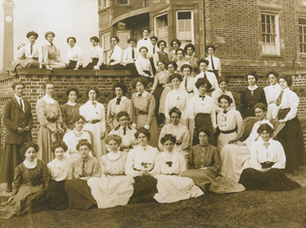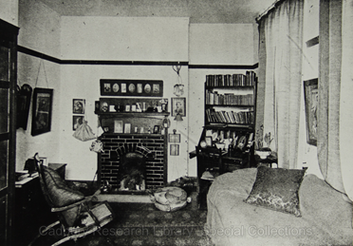
University House residents and interior UB/HUH/A/8/4-5
Development of student accommodation
1900-1922
The University of Birmingham was one of a number of ‘civic’ universities founded in major towns and cities in Britain during the late 19th and early 20th centuries. Unlike Oxford and Cambridge, and other older universities, the majority of the students attending these new institutions lived in the local area, and so could continue to live at home while studying. Most students attending university at this time were men and, although there were some students who came to the University from outside the West Midlands and, in some cases, outside Britain, most of these lived in private lodgings across Birmingham. The University provided a list of ‘approved’ lodgings but otherwise expected students to find their own accommodation.
There was an exception to this general principle, when the University attempted to replicate aspects of the ‘collegiate’ system that operated in Oxford and Cambridge by establishing a hall of residence for men students, using accommodation in the Queen’s College building on Paradise Street in Birmingham city centre, very close to the University buildings on Edmund Street. This was known as the Queen’s College Hall of Residence, and was open between 1907 and 1910. There are suggestions that it remained in use in the 1920s and 1930s, but as overflow accommodation only.
The only surviving record of Queen’s College Hall of Residence is a volume of minutes of the committee which managed it. These minutes are a unique source of information about conditions in the hall and provide glimpses into aspects of student life for men students during this period
Although there were relatively small numbers of women students studying at Birmingham during this early period, the University was keen that they should not live in private lodgings and, if they were living away from home, advised that they should stay with an approved relative or friend. This protective attitude towards women students is reflected in the campaign to fund and build a dedicated women’s hall of residence at the University of Birmingham, though it also reveals the level of support for greater opportunities for women in higher education. Temporary accommodation on the Hagley Road was rented for women students in 1904, and Margery Fry was appointed Warden. A dedicated building, called University House, was constructed on Edgbaston Park Road and was opened in 1908. It was initially open to students of Birmingham School of Art, School of Cookery, and to women staff at the University, as well as to students at the University who were taking a degree or training to be teachers in the University’s Day Training Department
The University House building was used by the War Office during the First World War, to provide accommodation for nurses working at the 1st Southern General Hospital, a temporary military hospital occupying the Aston Webb complex of buildings on the Edgbaston campus. Students and staff at University House moved to Wyddrington, a house in Church Road, Edgbaston, offered as temporary accommodation by the executors of John Edward Wilson
- Queen’s College Hall of Residence committee minutes UB/COM/22
- Records of University House, including correspondence and accounts relating to the University House Building Fund 1904-1912; minutes of University House committee and Junior Common Room committee; residents registers; photographs; Wardens papers; brochures; copies of University House Association newsletters with information about former students UB/HUH
1922-1945
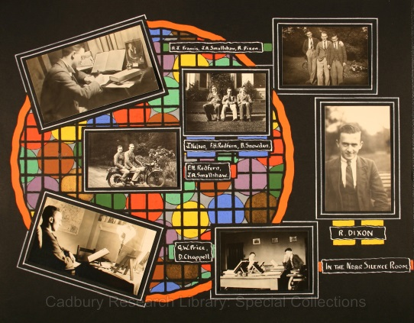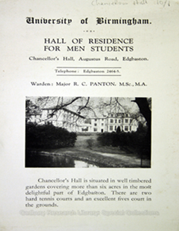
Scrapbook kept by student resident at Chancellor’s Hall 1930s, USS30; Chancellor’s Hall brochure UB/HCH/A/4/1
After the failed experiment of Queen’s College Hall of Residence, it was several years until the University attempted to establish another hall of residence for men students. Chancellor’s Hall was opened in 1922, in a building on Augustus Road, Edgbaston. It provided accommodation in a mixture of dormitories and single bed-sitting rooms, and could accommodate up to around 100 students. It appears that the University was again attempting to re-create some of the atmosphere and social amenities of the Oxbridge Colleges, though the records suggest that Chancellor’s Hall always found it difficult to recruit enough students to make it financially viable to run, and that many men students preferred not to accept the rules and higher costs associated with institutional living, but rented privately, even though they still had to accept restrictions placed on them by householders.
University House, by contrast, was popular with women students, and did not face the same kinds of recruitment difficulties. There is some evidence in the records of University House that the social events organised in the hall became less popular once the Guild of Students building opened on the other side of Edgbaston Park Road in 1930, as the women residents preferred to attend mixed social events there
University House and Chancellor’s Hall both remained open to students during the Second World War, though most of the accommodation in Chancellor’s Hall was offered to Royal Engineers in training as there were far fewer men students studying for a full length degree at this time. There was high demand for accommodation at University House, and the hall of residence had to use additional accommodation in Winterbourne House, which was bequeathed to the University in 1944
Most men students, and some women students, continued to live in private lodgings in the 1920s, 1930s, and 1940s. Minutes of the Lodgings committee survive from the late 1920s onwards, and these records, which include annual reports, contain useful information about the number of students living in approved lodgings and other accommodation, the names and addresses of householders, the distribution of lodgings across Birmingham, and the sort of living conditions that students renting rooms expected. They also mention the provision or lack of air raid shelters for students in private lodgings during the Second World War
- Records of Chancellor’s Hall, including minutes of Chancellor’s Hall committee; residents registers; photographs; and brochures UB/HCH
- Records of University House, including minutes of University House committee, and Junior Common Room committee; residents registers; photographs; Wardens papers; brochures; copies of University House Association newsletters with information about former students UB/HUH
- Records of Lodgings committee, including minutes of the Women Students' Lodgings committee 1927-1929; and minutes of general Lodgings committee from 1930 onwards, including annual reports on inspections of lodgings UB/COM/30/1

1945-early 1960s
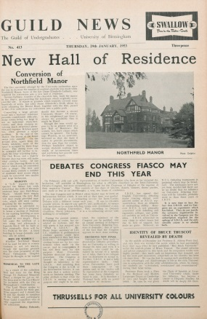
Students at Manor House, 1950s UB/HMH/A/1/3; Guild News article 1954 UB/GUILD/F/4
In 1945, Chancellor’s Hall and University House were the only halls of residence available for students. University House continued to be popular with women students, but Chancellor’s hall struggled to recruit and retain enough residents to make it profitable. Minutes of the University Halls of Residence committee mention complaints about the high cost of rooms, the poor standards of accommodation, and the distance from the Edgbaston campus.
The University was able to provide additional residential accommodation for men students from 1954 at Manor House, the former home of the Cadbury family which was donated for use as a hall of residence. It also rented Chad Hill, a large house in Edgbaston, to provide residential accommodation for postgraduate students, including a high proportion of international students
Towards the end of this period the University launched a fund raising campaign to build new halls of residence on the Vale site, which it had purchased in 1946. The student population was growing, and the Robbins Report, published by the government in 1963, recommended the immediate and future large-scale expansion of higher education which meant that the University had to commit to increasing its provision of residential accommodation to accommodate the much higher numbers of students who came from outside the West Midlands to study at Birmingham
By the early 1960s, work was underway to construct the new halls of residence on the Vale site. Chancellor’s Hall was even less popular than before, and minutes of the Halls of Residence committee cite the lack of central heating and electric power points, presenting a clear contrast with the facilities in the newly built halls
Although University House was also based in an older building, it continued to expand during the 1950s, and in 1964 it was decided that it would also admit men students, becoming the University’s first mixed hall. The process by which this change happened, and can be traced through the records of University House which document the opinions of staff and students at University House and in the wider University
The Lodgings committee continued to inspect private lodgings, and to produce annual reports on their inspections of properties during this period, and these records document the shortage of accommodation across Birmingham, particularly in the years immediately after the Second World War because of the amount of bomb damage to homes
Both Chancellor’s Hall and University House were largely self-governing up to the 1950s, though the University Council had established committees to which both halls reported. In 1955 the University set up a committee with wider-ranging responsibility for all the student accommodation it managed, and to discuss the development of student accommodation in the future. This committee received annual reports of the sub-committees of individual halls of residence, and so these minutes can provide a useful overview
- Records of University House, including minutes of University House committee, and Junior Common Room committee; Wardens papers; correspondence and administrative files; copies of University House Association newsletters with information about former students UB/HUH
- Records of Manor House, including group photographs and committee minutes UB/HMH
- Records of Chancellor’s Hall, including minutes of the Junior Common Room; residents registers; and photographs UB/HCH
- Records of Chad Hill committee, 1950-1965 UB/COM/27
- Records of Lodgings committee, including annual reports on inspections of lodgings UB/COM/30/1
- Records of University Halls of Residence committee, 1955-1964 UB/COM/24
- Records of University House sub-committee, 1955- UB/COM/28
- Records of Chancellor’s Hall sub-committee, 1922- UB/COM/23
1962-1982
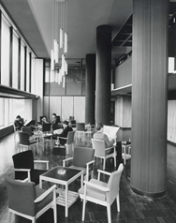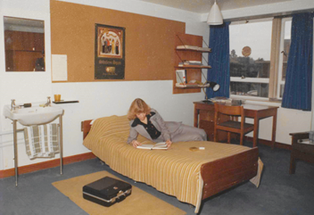
High Hall common room, UB/PH/A/1/3/87; student room at Mason Hall UA10/6
The new halls of residence built on the Vale site were intended to be run very differently from the older, smaller, halls like University House and Chancellor’s Hall which tried, to varying degrees, to emulate aspects of the traditional Oxbridge collegiate structure and ethos. The University still hoped to foster a sense of community and integration, and the presence of academic staff in the new halls as Senior Common Room members and non-academic tutors was supposed to contribute to this aim. For most of the 1960s, 21 was the age of majority and so the University placed restrictions governing independence and behaviour on first year students living in the new halls of residence.
The new halls were built in pairs, with separate buildings housing men and women students but with shared dining facilities operating as self-service canteens. Ridge Hall (for women students) and High Hall (for men students) were the first to open, in the 1964-1965 academic session. Wyddrington Hall (for women students) and Lake Hall (for men students) opened in 1965-1966, and Mason Hall (for women students) and Chad Hall (for men students) opened in 1966-1967, though the following year these last two buildings combined to form a mixed hall called Mason Hall. Ridge and High halls eventually combined to form Chamberlain Hall, and Wyddrington and Lake halls became Shackleton Hall in the 1990s
The new buildings on the Vale housed much larger numbers of student residents, particularly Mason Hall, which accommodated over 500 students. Mason Hall is the only one of the 1960s built residences for which records survive, though copies of annual reports and the handbooks and rule books of the other Vale halls are included in minutes of University committees set up in the 1960s to manage them. Using a combination of these minutes and the substantial surviving records of Mason Hall makes it possible to follow the development of the management structure of each of the halls, and to trace the University’s changing attitudes about the extent to which the institution controlled student behaviour, seen through the gradual relaxing of regulations and growing reluctance to make moral judgements. These records are also a useful and interesting source of information about student life and changing social and cultural views in the 1960s and 1970s
Reduced funding from the University Grants Committee, and growing student preferences for accommodation in self-catering flats, rather than in halls of residence, prompted the University to build a complex of flats called Griffin Close in the grounds of Manor House between 1970 and 1973. This self-catering accommodation represented a new relationship between the University and its student body. No facilities were provided other than those normally found in commercial flats, and the University acted as landlord, with all running and management costs covered by residence fees.
The flats were initially intended for older students and postgraduates, and there were flats reserved for married couples with children, so it was not thought appropriate to have a system with hall tutors and a Warden. However, by the late 1970s, the University’s policy changed to guarantee all first year students a place in University accommodation and so first year students were allocated places at Griffin Close. A management committee took responsibility for general organisation and admissions. There is little in the minutes about student life at Griffin Close, though they are a useful source of information for charting the development of the University’s attitude towards the provision of accommodation, financial cuts to the higher education sector during this period, and changing student expectations about the kind of accommodation they wanted
The success of Griffin Close prompted the construction of a similar development at Maple Bank on the Vale site which opened in 1976-1977, and later the Tennis Courts flats development on Edgbaston Park Road, and additional accommodation for postgraduate students was established at Lucas House on Pritchatts Road in 1967. Some students at Maple Bank were associate members of Lake and Wyddrington halls, and students at Tennis Courts could be associate members of Mason Hall. This scheme allowed for some element of supervision while retaining the freedoms associated with self-catering accommodation
The Lodgings committee continued to monitor the availability and standards of accommodation that students rented privately, and to produce annual reports
Halls of Residence committees and the Lodgings committee were replaced in 1982 by a Student Accommodation committee which had general responsibility for all university-owned residential accommodation
- Records of University House, including minutes of University House committee; correspondence and administrative files; Wardens papers; copies of University House Association newsletters with information about former students UB/HUH
- Records of Manor House including group photographs and ephemera UB/HMH
- Records of Mason Hall including minutes; administrative files; brochures and handbooks; student records; student magazines UB/HMA
- Records of Senate committee on Halls of Residence, 1962-1966 and 1973-1982 including annual reports and handbooks of individual halls UB/COM/25
- Records of Joint Senate and Council committee on Halls of Residence, 1966-1972 including annual reports and handbooks of individual halls UB/COM/26
- Records of University House sub-committee, to 1981 UB/COM/28
- Records of Griffin Close sub-committee, 1970-1981 UB/COM/29
- Records of Financial sub-committee on student residences, 1972-1987, dealing with catering UB/COM/31
- Records of Lodgings committee, to 1981 UB/COM/30
1982-
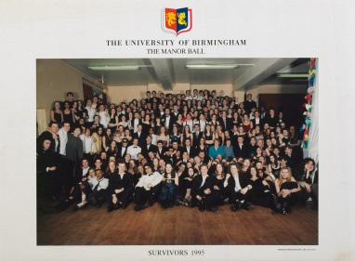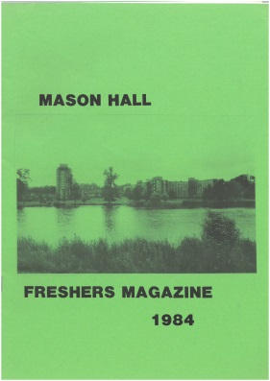
Manor House students 1995 UB/HMH/A/1/2; Mason Hall Freshers’ magazine 1984 UB/HMA/E/1
Although University House, Manor House, the Vale halls of residence, and the self-catering flats at Griffin Close, Maple Bank, and the Tennis Courts all remained in use through the 1980s and 1990s, there are few surviving records for the researcher to study for this period. No records of the Student Accommodation committee survive in the University Archives, and so the only sources are the records of individual halls of residence. University House closed in 2002 and the building was converted for use as the University Business School. Mason Hall closed in 2006, and the hall was demolished and rebuilt as self-catering flats. Chamberlain Hall (the former Ridge Hall and High Hall) was also demolished and rebuilt in the same way. Manor House closed in 2007, and the empty building was badly damaged by fire in 2014.
The University built new accommodation in Selly Oak in the 2000s but these residences, together with the rebuilt and refurbished student accommodation on the Vale site, operated under very different rules to the traditional halls. Residents Associations manage some aspects of communal life, and the University is a landlord only rather than acting in loco parentis. There are no records relating to any of this accommodation in the University Archives
- Records of University House, to 2002, including correspondence and administrative files; Wardens papers; copies of University House Association newsletters with information about former students UB/HUH
- Records of Mason Hall, to 2006, including minutes, administrative files; brochures and handbooks; student records; student magazines UB/HMA
Other useful records in the University Archives
- Student newspapers ‘Guild News’ (1936-1962) and ‘Redbrick’ (1962-) contain articles about student accommodation and give students’ views, mostly about events and issues relating to halls of residence and self-catering flats, but also about issues relating to the availability of private lodgings and to costs and living conditions UB/GUILD/F/4 and UB/GUILD/F/5
- Diaries of Raymond Priestley, Vice-Chancellor from 1938 to 1952 describe problems with Chancellor’s Hall during the 1940s and contain some references to life in University House during the same period, as well as incidental references to student accommodation in general US38/2
- Copies of letters from a Law student living in a rented bed-sitting room in Kings Heath in the early 1960s, describing aspects of his life and experiences USS103
- Oral history interview with Jenny Stokes, a student at the University between 1970 and 197,3 recounting her experiences of living in privately rented accommodation and giving her opinions about halls of residence (with transcript) USS76
- Presentation by Jan Tasker on student accommodation at the University of Birmingham in the 1960s with the main focus on Mason Hall, available via YouTube (transcript available from Cadbury Research Library)
https://www.youtube.com/watch?v=EZBMPPnotvI
- Photographs of halls of residence on the Vale site, 1960s UB/PH/A
Research uses
Student accommodation can be used to explore a wide range of topics, and what follows is not a complete list but is intended to suggest some ideas. Look at the online archive catalogue http://calmview.bham.ac.uk/ and use ‘Advanced Search’ to carry out keyword searches, or to enter the references beginning ‘UB’ listed in this guide, in the ‘Finding Number’ field. You can also get in touch with us at special-collections@bham.ac.uk if you want to discuss possible topics in further detail before starting to use these records
- Studies of student life and experience during particular periods of the 20th century, encompassing issues relating to social and cultural change, using records of one or more halls of residence, together with committee minutes and associated records
- Comparative studies looking at different types of accommodation, for example, purpose-built and converted buildings or traditional halls and the 1960s constructions on the Vale site and, more broadly, the ways in which student behaviour was regulated and the extent to which dining and social facilities were different
- Comparative studies looking at the governance of University House and Chancellor’s Hall from the 1920s to the 1960s when University House became a mixed hall; contrasting the success and popularity of University House with the difficulties faced by Chancellor’s Hall
- Studies exploring student influence over the governance of halls of residence, for example, Junior Common Room involvement in the management of life in halls, programmes of activities organised, and student activism
- Comparative studies between the experiences of students living in halls of residence and those living in private rented accommodation
- Studies of changing trends in the provision of student accommodation over the 20th century, using the University of Birmingham as a case study, with scope to expand research to look at other universities in the UK

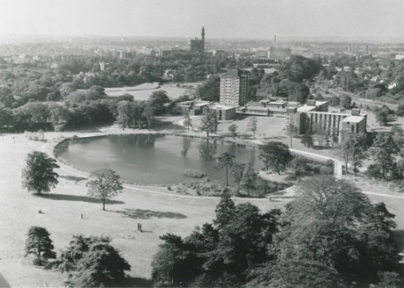
Halls of Residence on the Vale site, 1960s UA/10/6

