Guide to the records of the Guild of Students, University of Birmingham archives

Last updated July 2016

Guide to the records of the Guild of Students, University of Birmingham archives

Finding Number: UB/GUILD

The University of Birmingham archives contain substantial records of the Guild of Students and of the students union at Mason Science College, the predecessor of the University of Birmingham. Records date from the 1880s to the 1990s, with a small amount of material from the 2000s, and recent and current issues of the student newspaper ‘Redbrick’. This guide contains an overview of the history and development of the Guild of Students, gives details of the types of records the archive contains, and suggests some topics for research (Last updated July 2016).

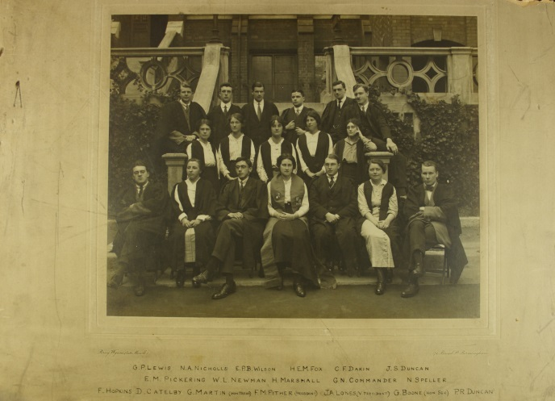

Guild of Undergraduates Committee, 1914-1915 UB/GUILD/I/16

The students union at Mason Science College was established during the first academic session of the institution in 1880-1881. It was an association for current and former students, and members of staff also attended meetings. The Mason College Union was managed by a committee which included the editor of Mason College Magazine, established in 1883. Most meetings of the union took the form of social events, and the union was run much more like a student society than an administrative body. Lectures, debates, plays and musical evenings were regular features of meetings, and members of staff and their wives participated as well as students.

Following the establishment of the University of Birmingham, Mason College Union became Birmingham University Union. The union continued to be run by a committee and to organise social events. The ‘union’ was primarily understood to mean the facilities used by the student body rather than the student body itself. When the Guild of Students building was completed in 1930 it was known as the ‘union’.

The Guild of Undergraduates was formed in 1900 to represent the interests of undergraduate students at the University and was managed by the Guild of Undergraduates Committee. A Students’ Representative Council was also set up in 1901 to manage non-educational aspects of student life like the Athletics Club, student societies, and the student magazine. The Students’ Representative Council was dissolved in 1903, and from this point onwards the Guild of Undergraduates and its committee began to take on responsibility for both the educational and social needs of its members.

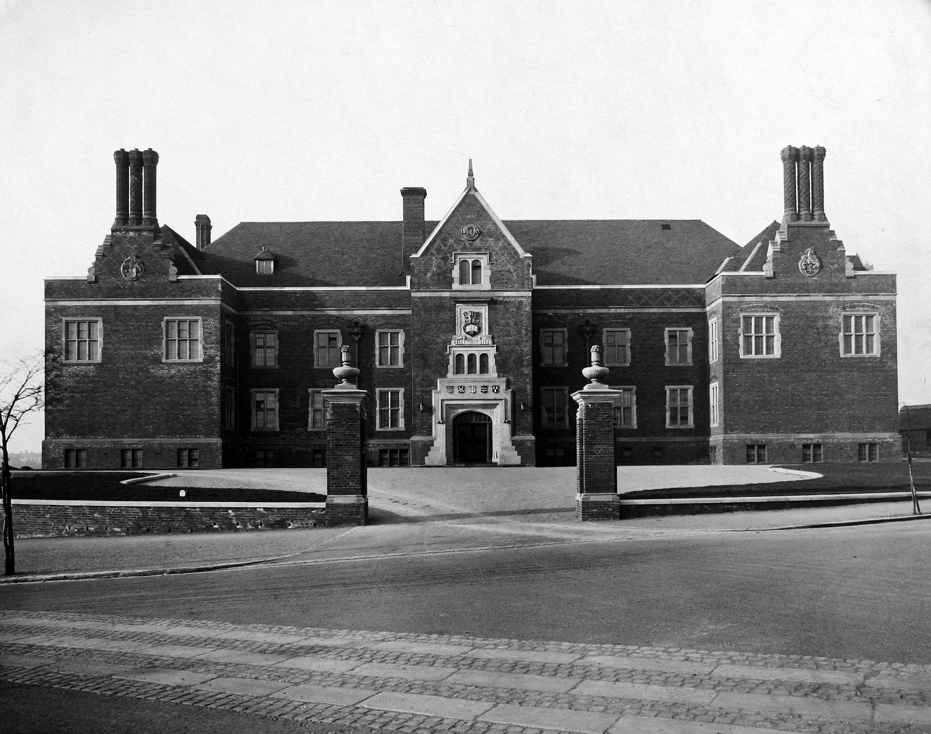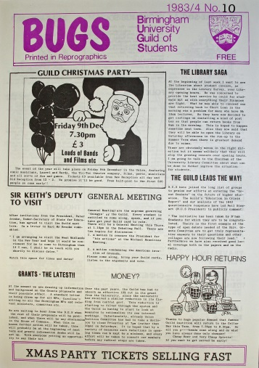

Guild of Students building, 1930 UB/GUILD/I/1 BUGS student newsletter 1983 UB/GUILD/F/9/6

The Guild of Undergraduates Committee was replaced with Guild Council in 1930 as part of a more general reorganisation of the Guild and its constitution which included preparations for the opening and management of the first dedicated building for student use on the Edgbaston campus, the Guild or ‘union’ building on Edgbaston Park Road. Money for the construction of the building was provided by Sir Charles Hyde and it was opened in October 1930.

Before this date students used the Men’s Club rooms on Great Charles Street in the city centre, and the Women’s Club rooms on Edmund Street which were both part of the old Mason College buildings. After 1930 the club rooms continued to be used by students studying in departments which had not yet moved to Edgbaston.

The building at Edgbaston and the rooms used by students at the Edmund Street site were managed by committees which reported to Guild Council. A number of other sub-committees or standing committees which managed other student activities and facilities also reported to Guild Council. Guild Council was run by the Guild President, elected annually, and other officers elected from the student body. The Guild also employed a number of permanent staff including a Warden, Secretary, and Treasurer.

Types of Records

The records contain information about the organisation and management of the Guild of Students and about activities and facilities provided for students at the University of Birmingham and Mason Science College. They comprise

- Minutes and meeting papers, 1881-1991
- Financial records, 1917-1979
- Reports and other papers of Guild committees, 1901-1991
- Correspondence and administrative files, 1899-1911
- Publications, 1897-2009
- Student newspapers and magazines, 1881-2011
- Flyers, leaflets and other ephemera, 1905-1991
- NUS material and publications of other students unions, 1910-1989
- Photographs, 1912-2000
- Plans, 1973-1988
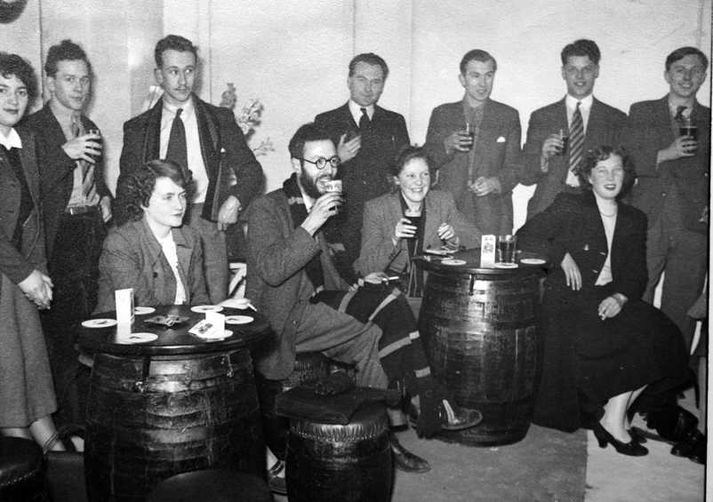
Opening of the Mermaid bar, February 1950 Carnival magazine, 1945
UB/GUILD/I/10 UB/GUILD/F/10/1

Research uses of the records

- The history and organisation of the Guild of Students, the development of its facilities, and its relationship with the university authorities
- Student life at Mason Science College, particularly social and cultural activities
- The changing student demographic from the 1880s onwards particularly the increase in numbers of women students over the period covered by the record
- The history of student societies and sports teams and the development of student leisure interests during the twentieth century
- Student engagement with political, cultural, and campaigning groups and activities in the city of Birmingham and beyond.
- The effects of the First and Second World Wars on student life at the university
- Gender relations during the twentieth century, particularly as reported in the student newspapers ‘Guild News’ and ‘Redbrick’
- Political activism within the student body and the role of the Guild in national and international political campaigns affecting students post 1945 and particularly during the 1980s
- Student involvement in charity and social welfare work in Birmingham
- Societal and cultural changes reflected in the student experience during the twentieth century

Other records relating to students

The archives of the University of Birmingham also contain records of a number of departmental and social student societies, some of which were established by students at Mason Science College before 1900, and continued to function into the late twentieth century. These records will give a more comprehensive view of the activities and membership of student societies than is found in the Guild of Students records, but we do not hold records for all the student societies that are known to have existed.

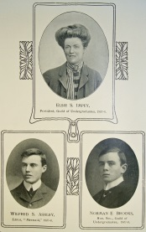

Photograph from ‘Mermaid’ student magazine, 1908 showing members of the editorial board UB/GUILD/F/3/6

Special Collections holds papers of former students which typically consist of material relating to individuals’ time at the university and can include course notes, essays and examination papers, correspondence, photographs and ephemera including brochures, event programmes and press cuttings. These can be a useful source to complement material found in the records of the Guild of Students. Further information about these holdings can be found on our website
http://www.special-coll.bham.ac.uk/documents/uarchive_students.pdf

