PhD APPLICATION FORM

PERSONAL INFORMATION

FIRST NAME: _________________________ SURNAME: _____________________________

NATIONALITY: ________________________ E-MAIL ADDRESS: ________________________

PHONE NUMBER: _____________________ SKYPE ACCOUNT: ________________________

EDUCATION, QUALIFICATIONS AND AWARDS
TITLE | LOCATION | COUNTRY | YEAR | QUALIFICATION

PROFESSIONAL EXPERIENCE
JOB TITLE | LOCATION | COUNTRY | TIME PERIOD

PUBLICATIONS, CONFERENCES AND OTHER SCIENTIFIC ACHIEVEMENTS
TITLE | JOURNAL/CONFERENCE- LOCATION

REFEREE 1
NAME & POSITION
ADDRESS
EMAIL

REFEREE 2
NAME & POSITION
ADDRESS
EMAIL

CHOICE OF PROJECT
PROJECT CODE | HOST INTITUTION | PROJECT TITLE | COUNTRY

IF YOU ARE ELIGIBLE (see below) AND YOU WOULD LIKE TO BE CONSIDERED FOR OTHER PROJECTS PLEASE INDICATE WHICH AND RANK THEM BY PREFERENCE (1, 2, 3, 4, ...)
Project Code | HOST | TITLE | COUNTRY | RANK
RTP1 | UoB | The role of the meiotic chromosome axis in the formation of crossovers in Brassicas | United Kingdom
RTP2 | UoL | Investigating synaptonemal complex morphogenesis in polyploid wheat | United Kingdom
RTP3 | UoC | Chromatin and recombination landscapes in the bread wheat genome | United Kingdom
RTP4 | INRA | Production of HyperRec genotypes in Brassica crops | France
RTP5 | CNRS | Break-Rec | France
RTP6 | UCM | Analysis and modulation of DSB formation in wheat | Spain
RTP7 | UoA | High throughput analysis of crossover distribution in crops | The Netherlands
RTP8 | UoW | Use of optical mapping to study the influence of genome structure on recombination | The Netherlands
RTP9 | KIT | Cas9- based induction of site specific meiotic crossovers (COs) in tomato | Germany
RTP10 | IPK | Identification of chemical compounds influencing the frequency and distribution of meiotic recombination events in barley (Hordeum vulgare) by single-pollen genotyping | Germany
RTP11 | UoH | Control of meiotic recombination in maize | Germany
RTP12 | UoV | Targeted meiotic DSB formation in Brassica crops | Austria

MEICOM Initial Training Network will fund 12 Early Stage Researchers (ESRs, PhDs) across the partnership. The project commences on 1st January 2018. ESRs are expected to start their PhD on or before June 2018.

The Network operates an equal opportunities recruitment policy.

HOW TO APPLY

Please complete the form and send:
- one copy to the first choice RTP leader as indicated in the table below
- and a second copy to the MEICOM Project Manager Rachael Batchelor at r.a.batchelor@bham.ac.uk

PROJECTS | LOCATION | PIs | EMAIL ADDRESS
ESR1 | University of Birmingham, UK | Dr Eugenio Sanchez-Moran  Dr Lindsey Leach  Prof Chris Franklin | e.sanchezmoran@bham.ac.uk
ESR2 | University of Leicester, UK | Dr James Higgins | jh555@leicester.ac.uk
ESR3 | University of Cambridge, UK | Dr Ian Henderson | irh25@cam.ac.uk
ESR4 | Institut Jean-Pierre Bourgin  INRA-AgroParisTech , France | Dr Eric Jenczewski | eric.jenczewski@inra.fr
ESR5 | University Blaise Pascal Clermont (CNRS-BP) CNRS2, France | Dr Charles White  Prof Maria Gallego | Charles.white@uca.fr
ESR6 | University Complutense Madrid  Spain | Dr Monica Pradillo  Prof Tomas Naranjo | pradillo@bio.ucm.es
ESR7 | University of Amsterdam, The Netherlands | Dr Paul Fransz  Dr Maike Stam | p.f.fransz@uva.nl
ESR8 | University of Wageningen  The Netherlands | Dr Sander Peters  Prof Dick de Ridder  Dr Aalt-Jan van Dijk  Dr Gabino Sanchez-Perez | sander.peters@wur.nl
ESR9 | Karlsruhe Institute of Technology, Germany | Prof Holger Puchta  Dr Annika Dorn | holger.puchta@kit.edu
ESR10 | Leibniz Institute Plant Genetics & Crop Plant Research IPK, Germany | Dr Stephan Heckmann  Dr Andreas Houben  Dr Jorg Fuchs  Dr Veit Schubert | heckmann@ipk-gatersleben.de
ESR11 | University of Hamburg, Germany | Prof Arp Schnittger  Dr Reinhold Brettschneider | arp.schnittger@uni-hamburg.de
ESR12 | University of Vienna, Austria | Assoc Prof Peter Schloegelhofer | peter.schloegelhofer@univie.ac.at

ELIGIBILITY CONDITIONS

Early-Stage Researchers must (at the time of recruitment by the host organisation): be in the first four years (full-time equivalent research experience) of their research careers and have not yet been awarded a doctoral degree.

Full-time equivalent research experience is measured from the date when the researcher obtained the degree entitling him/her to embark on a doctorate (either in the country in which the degree was obtained or in the country in which the researcher is recruited, even if a doctorate was never started or envisaged).

Mobility: at the time of recruitment by the host organisation, researchers must not have resided or carried out their main activity (work, studies, etc.) in the country of the recruiting beneficiary for more than 12 months in the 3 years immediately before the recruitment date. Compulsory national service, short stays such as holidays, and time spent as part of a procedure for obtaining refugee status under the Geneva Convention1 are not taken into account. For international European interest organisations or international organisations, recruited researchers must not have spent more than 12 months in the 3 years immediately before the recruitment date at the same appointing organisation.

Note: the mobility rule applies to the partner where the researcher is recruited, and not to partners to where the researcher is may be seconded as part of their training.

ESR SALARY

Living Allowance: This refers to the basic, gross amount for the benefit of the researcher to be paid to the researcher in monthly instalments. For this MSCA call launched in 2016-2017, the amount for an ESR is €3,110 per month (€37,320/year – 100%). This amount is then adjusted through the application of a country correction coefficient to the living allowance of the country in which the researcher will be recruited. The final amount will not change in case of secondments to another beneficiary or partner organisation. The country correction coefficients are indicated in the following tables.

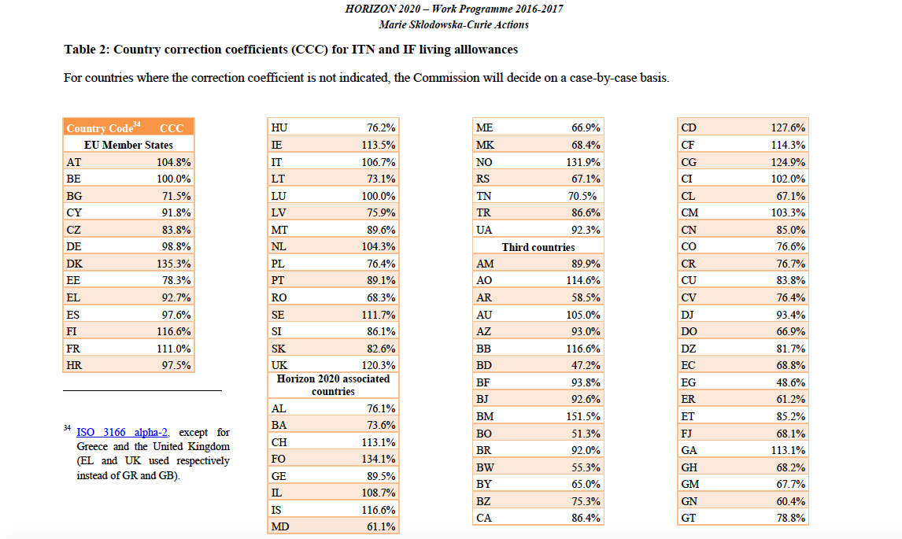
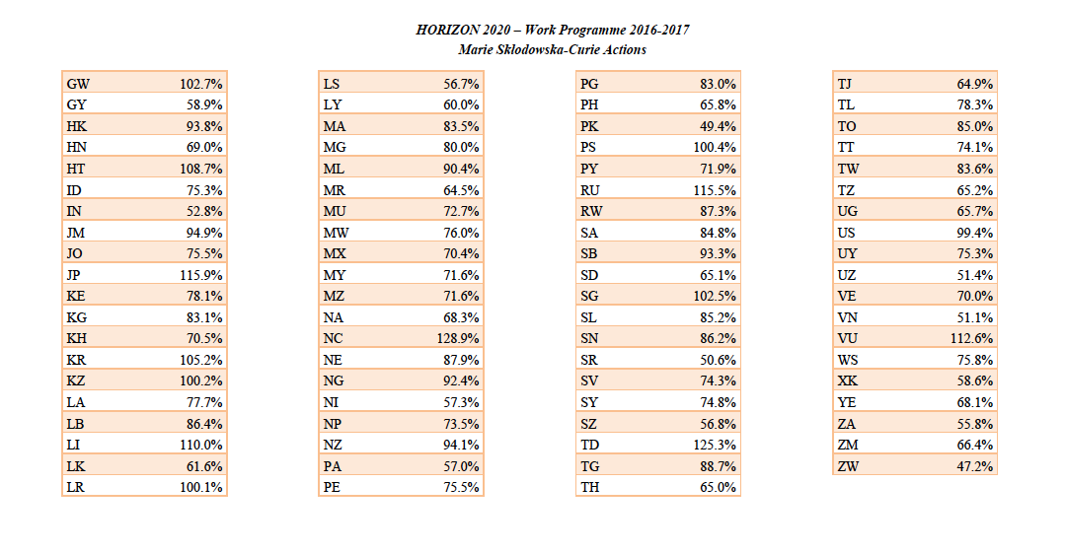
The living allowance is a gross EU contribution to the salary costs of the researcher. Consequently, the net salary results from deducting all compulsory (employer /employee) social security contributions as well as direct taxes (e.g. income tax) from the gross amounts.

Mobility Allowance: All eligible researchers recruited within an ITN are entitled to receive this allowance. It contributes to the mobility related expenses of the researcher. The amount of the mobility allowance for the calls 2016-2017 amounts to €600 per month.

Family Allowance: A family allowance of €500 per month will be paid should the researcher have family, regardless of whether the family will move with the researcher or not. In this context, family is defined as persons linked to the researcher by (i) marriage, or (ii) a relationship with equivalent status to a marriage recognised by the national or relevant regional legislation of the country where this relationship was formalised; or (iii) dependent children who are actually being maintained by the researcher.
The family status of a researcher will be determined at the date of their (first) recruitment in the action and will not evolve during the action lifetime.

The mobility and family allowances are fixed amounts, regardless of the country of recruitment, and may be excluded from taxation, where this is in line with national legislation. The full amount of these allowances, minus compulsory deductions, should be paid to the researcher for their own use. Therefore no flights or accommodation related to the activities in the action (e.g. conferences, secondments) can be charged under this category.

For further information please visit www.birmingham.ac.uk/meicom

