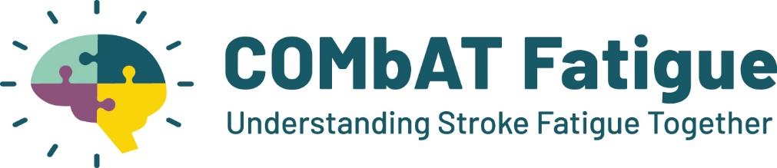
What is the research?
   | We are doing some research  It is about stroke and fatigue (extreme tiredness)  We are designing a support programme to help people cope better with their fatigue.

Why me?
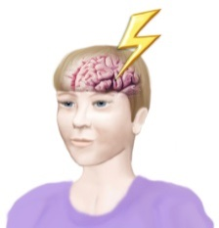 | You have had a stroke  You have fatigue (extreme tiredness)

Who is doing the research?
      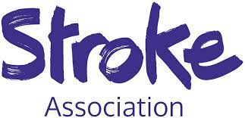 | The research is run from the University of Birmingham  The National Institute for Health and Care Research and the Stroke Association are paying for this research

Why are we doing the research?
   | There is very little support to help people cope with fatigue after stroke  We don't know enough about it  This research will help us to learn more

What happens in the research?
   | We want to talk to people who have had a stroke and their family  We will ask about fatigue after their stroke  We will use what they tell us to design a support programme to help people cope better with their fatigue.

What will I have to do?
  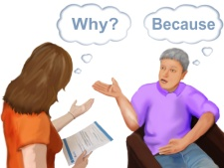 | In the research you will  have an group meeting  If you prefer, you could have a interview  You will answer some questions and share your opinions and ideas
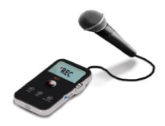     | We will take sound recordings  The recording will be typed up.  We will take out your name and personal details from the written version.  This helps us to remember what you said  Only the researchers will access the recordings and written version.  They will be kept safe

Where will the research happen?
 | The research will happen in community locations across England  We will find a location convenient for you  Or you could join a video call
How long will the research last?
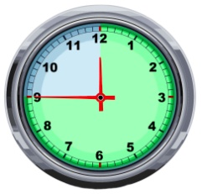 | The group meeting will last 60 minutes  You can have a break during the meeting

Will I get paid?
 | We will pay for any travel  We will give you £25 in vouchers if you take part  This is to thank you

Do I have to take part?
 | You can decide  You don't have to
   | If you change your mind, you can stop at any time during the group meeting or interview  You can change your mind up to 14 days after the group meeting or interview  After this time your data will be integrated into our data set.  You don't have to give a reason  If you stop you will still get your normal help
    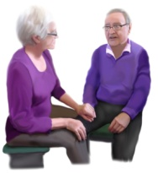 | You don't have to decide now, you can think about it  You can take your time  You can read the information again  You can talk to your family to help you decide  There are limited spaces available for the research, it may not be possible for everyone to take part.

Who will see the information about me?
 | We will keep the information about you safe  The project will be run in accordance with the Data Protection Act 2018.
 | We may share your information with other researchers  This helps with other research about stroke  We will take out your name and personal details

What might be good about taking part?

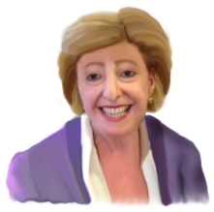 | You may enjoy taking part
 | You may find it interesting
 | You will help people in the future  They will get better help


What might be difficult about taking part?

    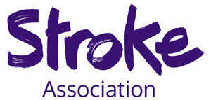 | You may find it tiring  You may find it distressing  It will take up your time  The Stroke Association can provide support if you need it:  Stroke Helpline: 0303 3033 100 or helpline@stroke.org.uk  Website: https://www.stroke.org.uk/stroke/support  If you are not happy with how you have been treated during the study, contact the University of Birmingham ethics committee  Email: ethics-queries@contacts.bham.ac.uk

What if I don't take part in the research?
 | You will still get your normal help

What will happen after the research?
 | The researchers will look at the results
 | The results will help design a support programme to help people cope better with their fatigue

What will happen to the results?
 | We will give you the results of the research
   | We will share the results  with other researchers  at conferences and meetings  in academic journals  with other people who have a stroke
 | The results will not use your name
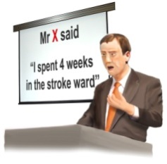 | The results may include what you said  but not who said it

What next?
 | Do you want to take part?  You need to decide
      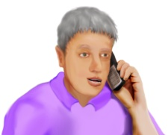   | You may want more information  Contact: Grace Turner  They will answer your questions  Let us know if you want to take part  You can contact us at  combat-fatigue@trials.bham.ac.uk  07483342912  <insert website>  We will ask you to fill in a questionnaire
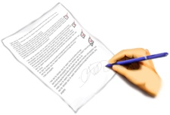   | If you decide to take part  you will need to sign a consent form  This says that you understand the research and you agree to take part  You will be contacted by the researchers to arrange a date for the group meeting or interview

