Information about the study
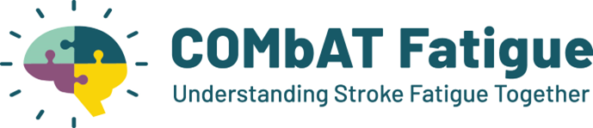

Summary
We are developing a self-management programme to support people with post-stroke fatigue. We would like your input to help design the programme and how it could be implemented in the NHS.

What would taking part involve?
- Attend a focus group with other healthcare providers, stroke service managers and commissioners.
  - How long? Around 60 minutes.
  - Where? Online or at a location convenient for you.
- If you can’t attend a group meeting, you could take part in a one-to-one interview.
- We would like to hear your perspective about how to support people manage fatigue after stroke and mini stroke.

Taking part is completely optional. This information sheet will explain why the study is being conducted and how you can help.

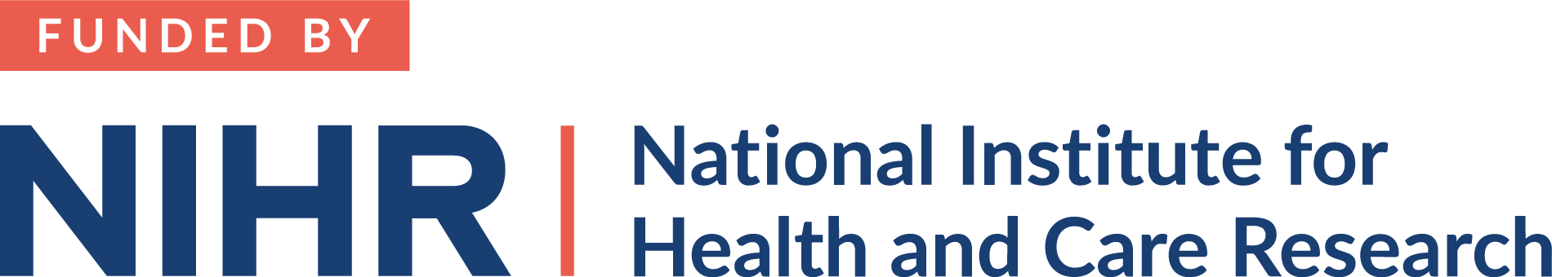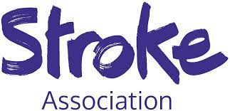

Why is the study needed?
Fatigue is very common after stroke and mini stroke. Around 50% of people after stroke experience fatigue, lack of energy or increased need to rest every day or nearly every day. This makes it difficult to take part in everyday activities.
Many people describe fatigue as the most difficult and upsetting problem caused by their stroke.
We don’t know the best way to manage fatigue after stroke and many people don’t receive any information or support.
“[fatigue] that’s the other biggest impact because I literally, I can’t do too much” [TIA patient].*
*Turner, G.M. et al. BMC Fam Pract 20, 176 (2019)

Who can take part?
- Healthcare providers from primary, secondary and community care;
- Stroke service managers;
- Commissioners;
- Other stakeholder with expertise relevant to stroke or fatigue.

What would taking part involve?
You would be asked to take part in a focus group with around 6-8 other stakeholders. If you can’t attend a group meeting, you could take part in a one-to-one interview.
You would be asked questions about current care pathways, barriers to fatigue management and implementation challenges.
The session will last about 60 minutes for the focus groups and 30-45 minutes for individual interviews.
If you travel anywhere, we will pay for all travel costs. You will receive a £25 voucher as a thank you.
The conversations will be recorded, this helps us remember what has been discussed, and the recording will be typed up by a professional company.

Where would it take place?
The focus groups will either be in-person or by video call (Zoom/ Teams). The in-person groups will be held in different locations across England. The research team will let you know the locations, dates and times.

The one-to-one interviews will be in-person, by telephone or video call (Zoom/ Teams). The in-person interviews will be at a location convenient for you, such as the University of Birmingham or a local community centre.
Scan the QR code to visit the website

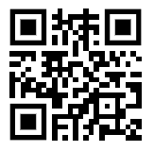
What should you do if you want to take part?

You can either:

Visit the website https://bit.ly/3wp4YzD

Email the research team: combat-fatigue@trials.bham.ac.uk
Phone the research team: 07483342912
You will be asked to complete an Expression of Interest Form with your name and contact details, and a short questionnaire about you, such as age and ethnicity. After this, someone from the research team will contact you to give you more information about the study and arrange a date and time for the focus group or interview.
Please be aware that there are a limited number of spaces available for the groups or interviews so it may not be possible for everyone to participate.

What will happen to the results of the study?
- Share our findings at scientific conferences and publish the results in scientific journals. We will also share summaries of what we learnt with the stroke community and general public.
- Develop a self-management programme: We will use the information to help us develop a self-management programme to support people to manage their fatigue after stroke and mini stroke.
Fatigue is common in other long-term conditions. There are some approaches that have been found to help improve fatigue in these conditions.
People with Multiple Sclerosis can access a self-management programme called FACETS (Fatigue: Applying Cognitive behavioural and Energy effectiveness Techniques to LifeStyle). We will explore if this programme could help people manage fatigue after stroke. We will use the findings of this research to help us understand how we would need to change or adapt FACETS for the stroke community and what is the best way for people to access the programme. We will work with people who have had a stroke, their relatives, healthcare professionals and other experts to develop the programme. If you are interested in being involved in this, please contact us using the details at the end of the booklet.
We have funding over the next 5 years to:
- Get initial feedback about whether the fatigue programme is easy to use and helpful.
- Do a small study to see if the fatigue programme and our study design are practical and acceptable.

What are the possible benefits of taking part?
You will receive a £25 voucher as a thank you.
Some people find it rewarding to take part in research that has potential to benefit other people in the future. It can also be helpful to hear from other people who have an interested in post-stroke fatigue. If you travel anywhere, we will pay for all travel costs.

Are there any disadvantages or risks of taking part?
Taking part in group conversations or interviews can be tiring. We encourage you to rest before and after the session. You would be able to take a break at any point or stop completely if needed.
If the researcher becomes concerned for your wellbeing during the interview, they will discuss their concerns with you and working in partnership with you to determine the best course of action.
You can access further support from NHS websites: https://www.nhs.uk/mental-health/self-help/guides-tools-and-activities/
This project and its participants are covered by an indemnity insurance policy provided by the University of Birmingham.
If you do wish to complain or have any concerns about any aspect of the way you were approached or are treated during the study, you can contact the independent University of Birmingham ethics committee: ethics-queries@contacts.bham.ac.uk

What will happen if I don’t want to carry on with the study?
You are free to withdraw your data from the study without giving a reason up to 14 days after the interview. This is because after 14 days the data will be integrated into our data set. If you withdraw your data, it will not affect your current or future employment. If you would like to withdraw your data after the interview, please contact the researcher using the contact details at the end of this booklet.

Will my information be kept confidential?
Yes.
The recording of the groups discussions or interview will be typed up, but will be anonymised (all names and other identifiable information will be removed). The recording will be transferred onto a secure computer at the University of Birmingham and then deleted from the recorder. A professional company will type up the recording, which will be transferred to them through a secure file transferring website. The professional company are also bound by strict adherence to confidentiality.
All the information that you provide will be kept confidential. Your data may be viewed by the research team, sponsor representatives and regulatory authorities. Your anonymised data will form the basis of our research and may be shared with other researchers (if you consent to this).
We will store your data in a secure, locked building at the University of Birmingham. Your contact details will be deleted after the final report for the study is written. Your anonymised data will be stored for ten years. The project will be run in accordance with the Data Protection Act 2018.

Who is organising and funding the research?
The research is a collaboration between experts at the Universities of Birmingham, Cambridge and Bournemouth, and clinicians from hospitals, GP practices and community settings in the West Midlands. We are also working with people who have experienced strokes and mini stroke to design the research.
The study funded by the National Institute for Health and Care Research (NIHR) and the Stroke Association.
This research has been approved by the University of Birmingham Science, Technology, Engineering and Mathematics Ethical Review Committee (Reference: ERN_2052-Mar2024)

What does COMbAT Fatigue stand for?
COMbAT Fatigue is the name of the study. It stands for: COproduction and evaluation of a self-MAnagemenT intervention for post-stroke Fatigue
For more information, visit our website: https://bit.ly/3wp4YzD
Further information and contact details:
Dr Grace Turner
Email: combat-fatigue@trials.bham.ac.uk
Phone call or text: 07483342912

Scan the QR code to visit the website

